Cosas que te pueden interesar para leer e insertar fotos tipo BLOB desde php

realizo la llamada de la función get.php

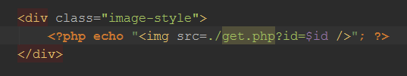

fichero get.php
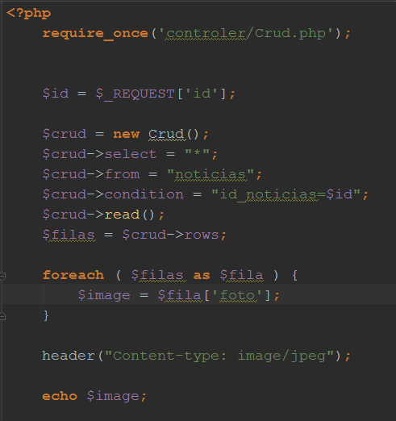

fichero CRUD para poder leer y insertar datos de la BD

public function create() {
$con = $this->conectar();
$con->query("SET NAMES 'utf8'");
$insertInto = $this->insertInto;
$insertColums = $this->insertColums;
$insertValues = $this->insertValues;
$sql = "INSERT INTO $insertInto ($insertColums) VALUES ($insertValues)";
$consulta = $con->prepare($sql);
if ( !$consulta ) {
$this->errorMesage = "Error al crear el registro";
} else {
$consulta->execute();
$this->errorMesage = "Registro creado correctamente";
}
$this->desconectar();
}
public function read() {
$con = $this->conectar();
$select = $this->select;
$from = $this->from;
$codition = $this->condition;
$con->query("SET NAMES 'utf8'");
//$sql = "SELECT $select FROM $from $codition";
if ( $codition != "" ) {
$codition = " WHERE ".$codition;
}
$sql = "SELECT $select FROM $from $codition";
$consulta = $con->prepare($sql);
$consulta->execute();
while ( $fila = $consulta->fetch() ) {
$this->rows[] = $fila;
}
$this->desconectar();
}

