IV. Temporal Analysis (Task 2)

A. Design of the Temporal Views
Task 2 asks how group membership and the attributes defining each group change over time. We built a Plotly Dash [3] module with three coordinated views that read the groups brushed in Task 1 (G1, G2, G3) through a shared RecordID–Group file, using the eight attributes selected in Section II from the UCI Air Quality dataset [1], [2].
View 1 (calendar heatmap) places date on the x-axis and hour of day on the y-axis, with colour encoding the attribute chosen from a dropdown. Mapping the two time scales to orthogonal axes makes the daily cycle (horizontal bands) and the seasonal cycle (vertical drift) visible at the same time. We used the perceptually uniform Viridis colour map [6] so that equal steps in value read as equal steps in colour, and left missing values as grey gaps rather than imputing them. This view serves as the overview.
View 2 (membership heatmap) aggregates the data into a month × hour grid. Colour lightness encodes the percentage of grouped hours in each cell that belong to the selected group. We chose lightness because it is an ordered visual variable suited to quantitative data [4], [5]. A companion stacked bar chart (View 2b) shows each group's share of hours per month, using hue, an associative variable [5], to separate the groups with the same colours as Task 1.
View 3 (small multiples) draws one parallel-coordinates panel [8] per month with all eight attributes. Small multiples let the analyst compare months side by side without relying on memory [7]. All panels share a global min–max scale, so a given height means the same value in every month. The PT08.S3(NOx) axis is inverted because a lower reading indicates more NOx. To reduce overplotting, individual hours are drawn as thin translucent lines and each group's median as a thick line.
The interaction follows the "overview first, zoom and filter, then details on demand" mantra [9]. Dropdowns switch the attribute and group, a month-range slider filters all views together, and clicking a View 2 cell highlights those hours in black in View 3, linking the aggregate pattern back to the individual records.

B. Finding 1: Group Membership Changes Over Time
View 2b (Fig. 5) shows that the three groups replace one another through the year. G2 occupies March to August 2004, peaking at about 25% of hours in June, and almost disappears in September and October. G3 appears only from September to November 2004. G1 appears from November 2004 and persists until April 2005. The sequence G2 → G3 → G1 places the transition between September and November 2004, which we pass to Task 3 (Section V) as a candidate critical moment.
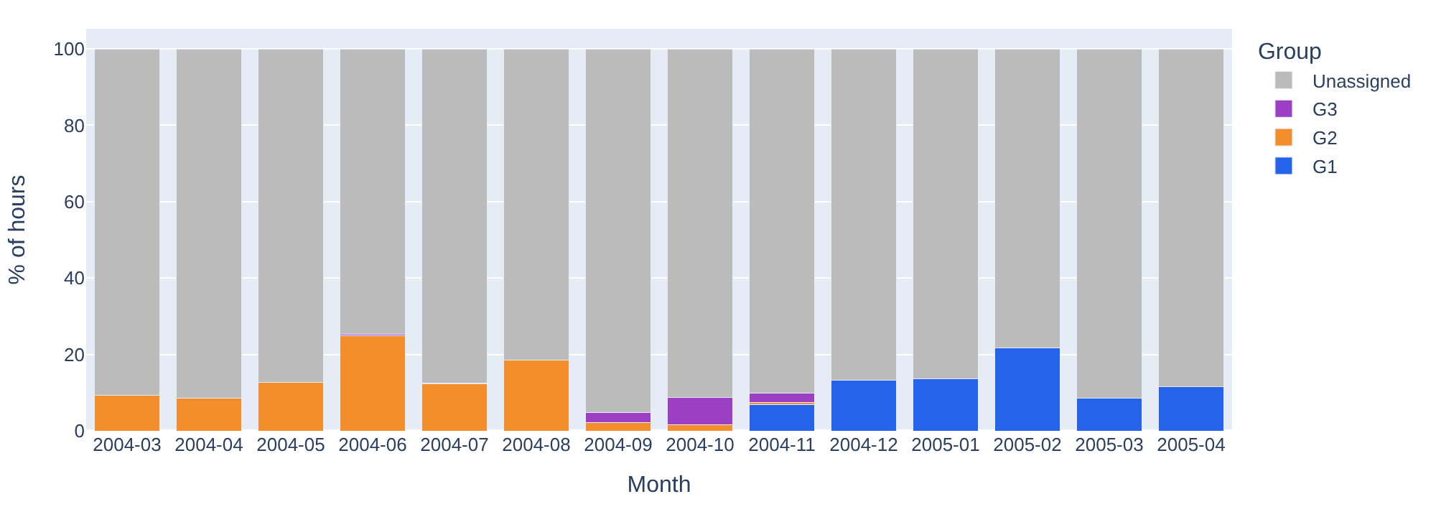
Fig. 5. View 2b: share of hours in each group per month. G2 (orange) dominates March–August, G3 (purple) appears September–November and G1 (blue) from November onwards; grey hours belong to no group.
Selecting G3 in View 2 (Fig. 6, left) shows that membership also changes within the day. In September, G3 hours are concentrated in the morning (7–9h) and evening (17–20h) peaks; in October they spread across most daytime hours; in November the cells become lighter as G1 appears in the same hours. Clicking the October 19:00 cell (n = 10 hours, 100% G3) highlights these hours in View 3 (Fig. 6, right), where all ten black lines follow the G3 median, confirming the grouping visually.
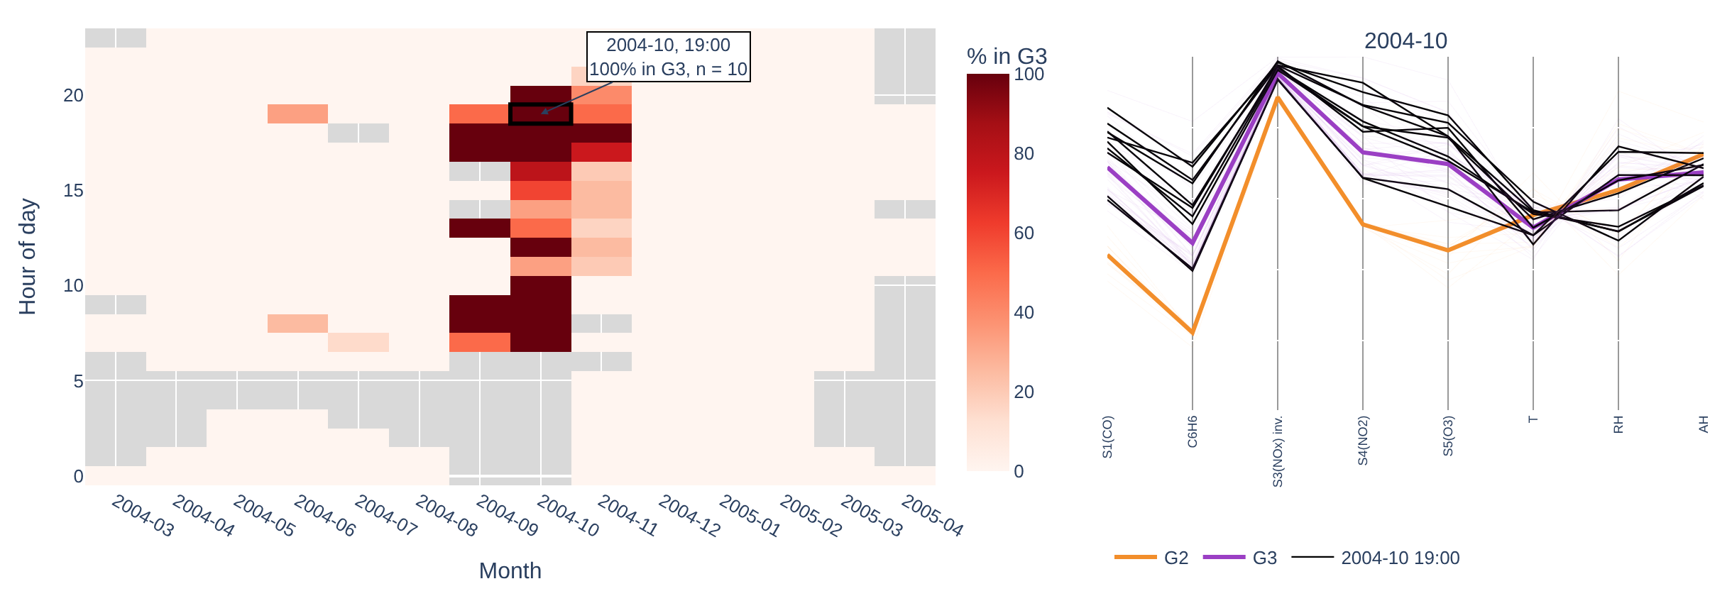
Fig. 6. Left: View 2 with G3 selected; the outlined cell (October 2004, 19:00) was clicked. Right: the linked View 3 panel for October 2004, where the ten clicked hours (black) follow the G3 median (purple).
Because each month contains different records, these changes describe how the profile of an hour category moves between groups, not the same observations moving.

C. Finding 2: Defining Attributes Change Over Time
View 3 (Fig. 7) shows that some attributes define the groups consistently while others change in importance. In every month, G1 and G2 have similarly low C6H6 but are clearly separated on S4(NO2) (normalised median ≈ 0.20 vs ≈ 0.55) and on AH. In contrast, the inverted S3(NOx) axis sits between 0.76 and 0.97 for all groups, so it does not distinguish them.
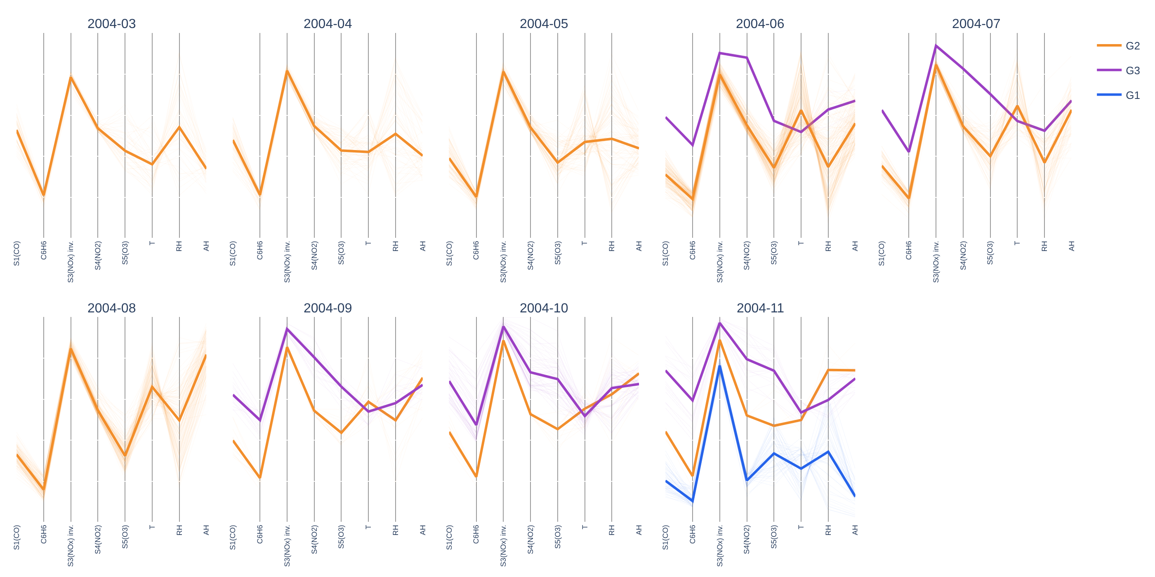
Fig. 7. View 3 for March–November 2004 on a shared min–max scale (thick lines are group medians). G2's pollutant axes stay stable while its T, RH and AH values shift between spring, summer and autumn.
G2's pollutant profile stays stable, but its weather combination shifts across seasons. In spring (March–April), G2 has moderate temperature (0.36–0.42) and relatively high RH (≈ 0.5). In summer (June–August), temperature rises to 0.62–0.66 and AH to 0.56–0.82. In autumn (October–November), temperature falls from 0.55 to 0.50 while RH rises to 0.74 and AH stays high (≈ 0.73).
Temperature therefore loses importance in separating G2 from G1, while humidity gains importance. A smaller shift appears for G1 in April 2005, with higher temperature and lower RH than in winter, but this month contains only 10 grouped hours, so we treat it as tentative.

D. Limitations
Only 12.9% of hours (1,205 of 9,357) belong to one of the three groups, so the findings describe the composition of grouped hours rather than all hours. Several month–group combinations are small: G3 in June and July (2 and 1 hours), G2 in November (5 hours) and G1 in April 2005 (10 hours), so their medians are not reliable.
Grey cells mean different things in different views. In View 1 they are missing sensor readings (3.9% of hours), which we did not impute. In View 2 they are month–hour cells with no grouped hours, not missing data.

References
[1] S. De Vito, E. Massera, M. Piga, L. Martinotto, and G. Di Francia, "On field calibration of an electronic nose for benzene estimation in an urban pollution monitoring scenario," Sensors and Actuators B: Chemical, vol. 129, no. 2, pp. 750–757, 2008.
[2] S. De Vito, "Air Quality," UCI Machine Learning Repository, 2008. [Online]. Available: https://doi.org/10.24432/C59K5F
[3] Plotly Technologies Inc., "Dash Python User Guide." [Online]. Available: https://dash.plotly.com
[4] T. Munzner, Visualization Analysis and Design. Boca Raton, FL, USA: CRC Press, 2014.
[5] J. Bertin, Semiology of Graphics: Diagrams, Networks, Maps, W. J. Berg, Trans. Madison, WI, USA: Univ. of Wisconsin Press, 1983.
[6] S. van der Walt and N. Smith, "mpl colormaps," 2015. [Online]. Available: https://bids.github.io/colormap/
[7] E. R. Tufte, The Visual Display of Quantitative Information. Cheshire, CT, USA: Graphics Press, 1983.
[8] A. Inselberg, "The plane with parallel coordinates," The Visual Computer, vol. 1, no. 2, pp. 69–91, 1985.
[9] B. Shneiderman, "The eyes have it: A task by data type taxonomy for information visualizations," in Proc. IEEE Symp. Visual Languages, 1996, pp. 336–343.

