III. TASK 3 — Analysis of Critical Moments and Hypothetical Scenarios
A. Identification of Critical Moments
Task 3 aims to identify potential critical moments in air quality data by analysing the changes over time in the clusters identified through visualisation and their defining attributes. This study utilises the representative records G1, G2 and G3 identified in Task 1, and combines them with the complete hourly air quality data for analysis.
We selected 1–8 November 2004 as the focus period for this study. On 1 November, Task 1 selected five representative records belonging to G2; whilst on 8 November, two representative records belonging to G1 were selected. These two clusters exhibit distinct differences in sensor responses and environmental attributes, particularly in PT08.S4 (NO₂), temperature (T) and absolute humidity (AH).
To investigate attribute changes around the beginning and end of the candidate critical period, we compared data from two time windows: 1–4 November 2004 and 8–11 November 2004. During these two periods, the median value of S4 fell from 1,721.5 to 1,207.0, the median temperature fell from 20.4 °C to 10.2 °C, and the median absolute humidity fell from approximately 1.50 to 0.79.
These observations suggest that early November can be regarded as a candidate critical period during which a combination of multiple attributes changed.
However, G1, G2 and G3 represent only a subset of records selected through visual inspection, rather than a complete grouping of all hourly data. Consequently, these results cannot directly prove that certain records actually shifted from G2 to G1.
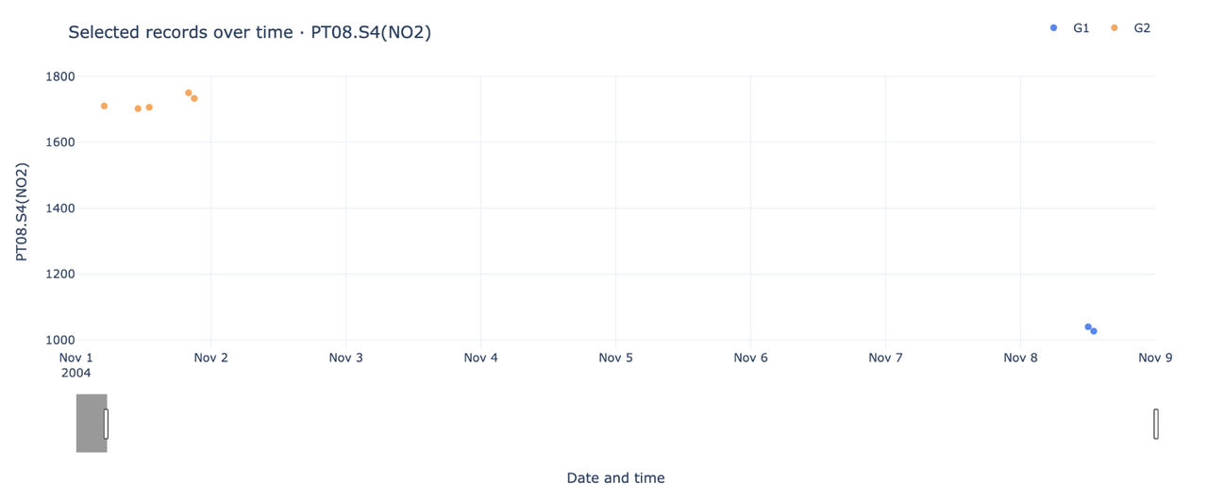
Fig. 1. Critical moment visualisation from the final Task 3 dashboard.
B. Visual Analysis of Group Characteristics
To investigate this key period further, we developed an interactive time-series scatter plot using Plotly Dash.
This tool allows users to select different attributes, adjust the date range, and display the full dataset as a grey background, thereby enabling them to observe representative records for each group against the backdrop of the overall temporal distribution.
In addition, we have constructed a comparison chart of eight attributes to compare the median attribute profiles of five representative G2 records from 1 November 2004 with those of two representative G1 records from 8 November.
The eight analytical attributes comprise four sensor responses: PT08.S1 (CO), PT08.S3 (NOx), PT08.S4 (NO₂) and PT08.S5 (O₃), one reference benzene concentration measurement, C6H6 (GT), and three environmental attributes: temperature (T), relative humidity (RH) and absolute humidity (AH).
The visualisation results indicate that G2 representative records typically exhibit higher S4 responses, temperatures and absolute humidity than G1. Among all the representative records selected by A:
Attribute | G1 Median | G2 Median
S4 | 997 | 1763
Temperature T | 8.1°C | 25.7°C
Absolute humidity AH | 0.43 | 1.35

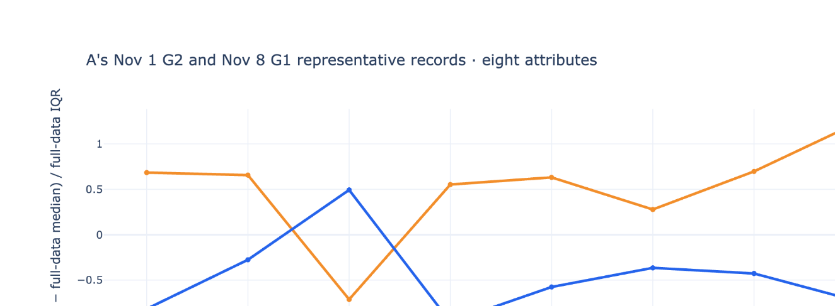
Fig. 2. Eight-attribute comparison of G2 and G1 representative records.
These differences indicate that S4, T and AH are key attributes for distinguishing between the representative characteristics of G1 and G2.
We therefore propose a further hypothesis:
If environmental conditions in early November remain at the warmer, wetter levels observed in late October, is it still possible for the model-predicted sensor attributes to exhibit the characteristics of G2?
This hypothesis forms the basis for the subsequent ‘what-if’ analysis.
C. What-if Scenario Modelling
To investigate the relationship between environmental conditions and sensor responses, we have developed an interactive ‘What-if’ analysis tool based on regression models.
The tool offers two prediction methods: Linear Regression and Random Forest Regression.
Both ‘Weather-only’ models utilise three environmental attributes as inputs: temperature (T), relative humidity (RH) and absolute humidity (AH).
The models predict five air-quality-related attributes: S1, C6H6, S3, S4 and S5.
The data are divided chronologically into training, validation and test sets to evaluate predictive performance on later held-out observations.
It should be noted that the reference record selected for this study, dated 8 November 2004, falls within the model’s training period. Consequently, the ‘what-if’ analysis conducted on this record is primarily intended to illustrate how the model’s predictions vary under different environmental conditions, and should not be regarded as an independent out-of-sample validation. The model’s predictive performance must still be evaluated using an independent holdout test set.
In the ‘What-if’ interface, we fix a representative G1 record from 13:00 on 8 November 2004 as the reference time.
Users can select actual weather conditions observed between 15 October and 1 November 2004 via an interactive slider and input these as alternative scenarios into the model.
For example, the actual S4 response for the reference record on 8 November was 1027.
In the linear regression model:
What-if scenario results
Observed S4 response
1027
Model-predicted S4 response under actual weather conditions
1368.5
Model-predicted S4 response under alternative weather conditions
1743.7
Alternative weather: actual environmental conditions at 12:00 on 31 October 2004
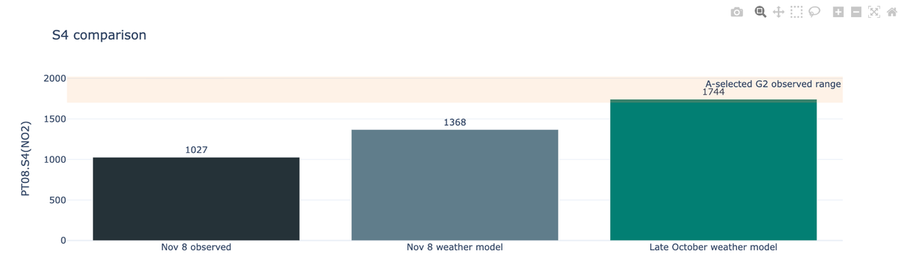
Fig. 3. S4 comparison for the selected What-if scenario.
Under actual weather conditions, the model predicts S4 to be 1368.5.
When we substitute the environmental inputs with the actual observed weather at 12:00 on 31 October, the model predicts S4 to rise to 1743.7.
This predicted value falls within the S4 observation range (1700–2021) of the G2 representative records selected by A.
Furthermore, the system utilises an eight-attribute comparison chart to display the predicted values of four sensor responses and C6H6 under the alternative weather conditions, as well as the variations in T, RH and AH, and compares these with the G2 representative profile.
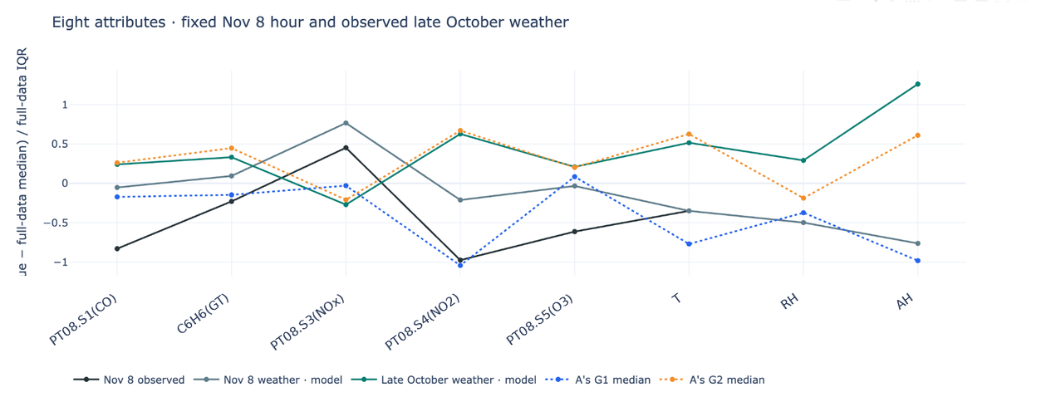
Fig. 4. Eight-attribute What-if comparison in the final dashboard.
This result indicates that, under the assumptions of the regression model, warmer and more humid environmental conditions can produce predicted results that align with some of the characteristics of the G2 representative profile.
However, the fact that S4 falls within the G2 range does not mean that the model has demonstrated that the complete G2 grouping is maintained.
D. Findings and Limitations
Through interactive visualisation, this study identified a candidate key period in early November 2004 characterised by marked multi-attribute changes.
During this period, attributes such as S4, temperature and absolute humidity showed a decline, whilst the representative records selected for Task 1 also exhibited distinct differences in characteristics between G2 and G1.
Through ‘what-if’ analysis, we further found that under certain alternative environmental conditions characterised by warmer and more humid conditions, the S4 response predicted by the regression model would increase significantly, falling within the range observed in the representative records of G2.
However, this study has the following limitations.
Firstly, the predictive power of the regression model is limited.
In the hold-out test set, which was divided chronologically:
Model | S4 MAE | S4 R²
Linear Regression | 294.0 | -0.532
Random Forest | 223.3 | -0.053

A negative R² indicates that the model performs worse on the test set than the test-set mean reference predictor used to define R², which is distinct from the dashboard’s previous-hour baseline; therefore, the accuracy of its predictions for future periods cannot be guaranteed.
Secondly, the range of G2 attributes is not a formal classification threshold.
For example, 1700–2021 represents the actual range of S4 values within the G2 representative records selected by A, rather than a confirmed Tableau filtering threshold.
Consequently, even if a predicted value falls within this range, it cannot be directly concluded that the record definitely belongs to G2.
Finally, regression models cannot prove causality.
We have observed a statistical correlation between weather attributes and sensor responses, but we cannot assert on this basis that changes in temperature or humidity will necessarily lead to changes in pollution levels, nor can we prove that such changes would prevent groupings from shifting in reality.
In summary, the ‘what-if’ visualisations in this study provide exploratory evidence: under the model’s assumptions, alternative environmental conditions may shift some predicted attributes towards the G2 representative profile; however, the existing evidence is insufficient to prove that the complete grouping is maintained.

