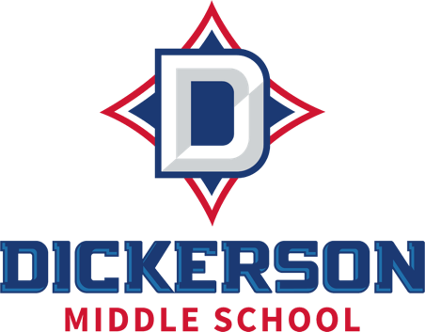
MUSIC TECHNOLOGY 6-8
Course Syllabus 2026-2027
MR. WILLINGHAM

Lawton.Willingham@cobbk12.org
Course Content: | Music Technology  https://inspire.gadoe.org/standards  Music Technology teaches students how to use digital tools and resources to create, perform, respond, and connect to music. Across the course, students record and edit a podcast, design original sound effects, build beats using MIDI, learn to read music, write an original melody, remix a classical piece into a modern style, and add sound to an animated film — preparing them for careers in music, media production, and more.
Grading Practices: | Grades are in two categories: summative (40%) and formative (60%). Formative grades are taken frequently and include learning checks, warmups, minor projects, etc. Summative grades are taken near the end of each unit of work and come in the form of projects and/or quizzes.
Materials Needed: | Agenda  Pencil or pen
Late Work: | Late work will be assessed a one-time 20% penalty.
Absences/Make-up work: | It is the student’s responsibility to ask the teacher about make up work once s/he has returned from an absence. Make up work may be requested from the front office once a student has been absent for three consecutive days. It is recommended to check CTLS during any absence.  Student work is not provided early. Teachers will assign a grade of zero for any work missed. When work is completed (as scheduled by the teacher), the grade will be updated.
Resources: | All class resources are available through ctlslearn.cobbk12.org.  Grades and due dates can be found in Synergy (aka Student VUE or Parent VUE)
Student Expectations | Students will listen to and follow instructions.  Students will respect and support their peers and adults.  Students will work to the best of their ability.

