Logan, T.M., Anderson, M.J. & Reilly, A.C. (2023). Risk of isolation increases the expected burden from sea-level rise. Nature Climate Change, 13, 397–402. https://doi.org/10.1038/s41558-023-01642-3

This paper solves questions related to network performance evaluation under disruptive events, the social dimension of sustainable development, accessibility evaluation of land-use and transport strategies, global and regional sea level rise scenarios for the United States, and innovations in science and engagement.

This paper used a combination of data sources to analyse the risk of sea-level rise in the continental United States. These sources included population data, sea-level rise projections, and topographic data. The authors used a network nearest distance algorithm to calculate the risk of isolation for each location. They also used a dynamic adaptive pathways planning approach to identify triggers and signals for interventions.

The main findings of this paper are that relying on the risk of inundation while ignoring the risk of isolation and the interdependence of the environment with networked infrastructure may underestimate the number of people significantly burdened by SLR and when that burden may start. Additionally, for localized investments in adaptation to be effective, they need to consider the composite SLR risk in coastal areas to ensure resources are expended in a manner that reflects needs and realistic projections of how long the area remains habitable. Finally, the findings have implications for adaptive planning approaches, suggesting that triggers and signals should be in terms of a metric that locally captures when the burden of SLR might commence.

The implications of this paper are that relying on the risk of inundation while ignoring the risk of isolation and the interdependence of the environment with networked infrastructure may underestimate the number of people significantly burdened by sea-level rise (SLR) and when that burden may start. It is possible that those burdened and who can afford to relocate will do so, resulting in exacerbated inequalities and localized economic decline should early interventions not be taken. Additionally, for localized investments in adaptation to be effective, they need to consider the composite SLR risk in coastal areas to ensure resources are expended in a manner that reflects needs and realistic projections of how long the area remains habitable. An approach that relies on consensus building will ensure that adaptation is not piecemeal or collectively inefficient. Finally, trigger and signal points should be in terms of a metric that locally captures when the burden of SLR might commence.

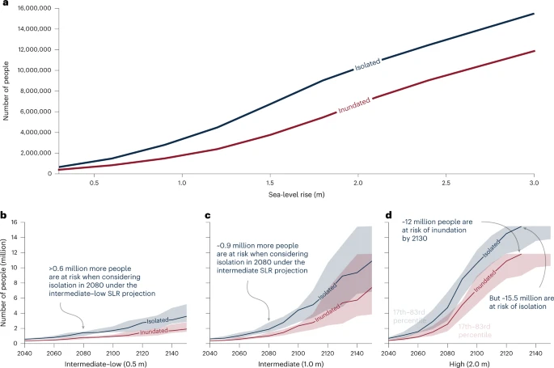

Fig 1 shows a graph showing the difference between population at risk of isolation and inundation during MHHW with 1.8 m of SLR for different counties. An interactive web dashboard showing these data at county and tract levels for all SLR increments between 0 and 3 m is available at https://research.urbanintelligence.co.nz/slr-usa/.

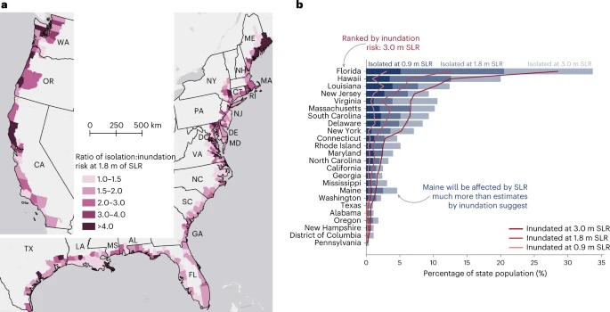

Fig 2 shows a graph showing the difference between population at risk of isolation and inundation during MHHW with 1.8 m of SLR for different counties. An interactive web dashboard showing these data at county and tract levels for all SLR increments between 0 and 3 m is available at https://research.urbanintelligence.co.nz/slr-usa/.

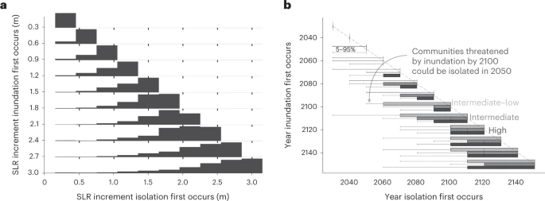

Fig 3 shows the number of people at risk from inundation and at risk from isolation due to MHHW for SLR between 0.3 and 3.0 m.

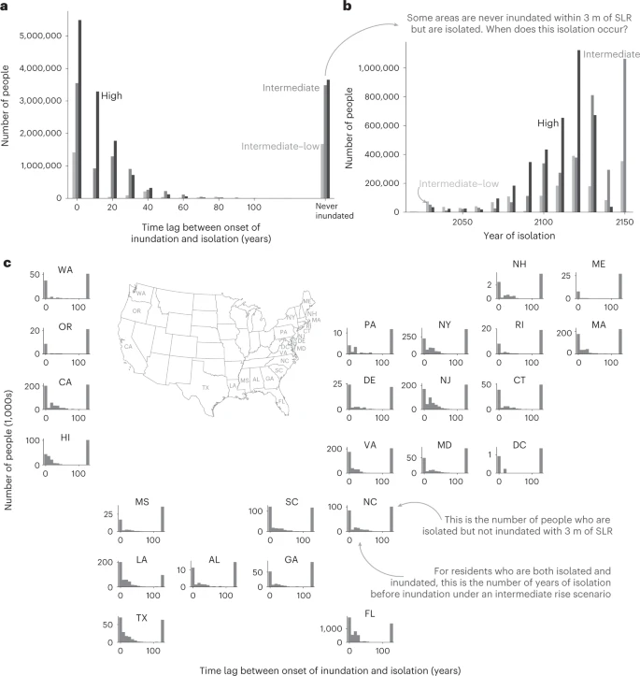

Fig 4 shows a histogram of the lag time for the risk of inundation, demonstrating how nearly 4 million residents are at risk of isolation but are never at risk of inundation for 3 m or less SLR. It also shows the year that these residents are first isolated under intermediate and high scenarios.