Increasing the Impact of Rice Breeding Programs

Incorporating drought tolerance as a rice breeding objective

Introduction
Worldwide, approximately 20-25 million ha of rainfed rice are frequently affected by water stress. Among the largest, most frequently and severely affected rainfed areas in Asia are:

- The eastern Indo-Gangetic plain, with over 20 million ha of rainfed rice. Drought losses are most severe in the ricebowl states of Chhattisgarh, Madhya Pradesh, Bihar, Jarkhand, Orissa, and Uttar Pradesh, as well as in neighboring areas of Nepal.
- Northeastern Thailand and Laos, with over 7 million ha of drought-prone rainfed rice

Although drought is among the most important constraints to rainfed rice yield, few rice breeding programs try to develop cultivars with higher yield under drought stress. Recent research has shown considerable genetic variation for yield under drought stress exists within the cultivated rice germplasm, and that gains for yield under drought stress at both the vegetative and reproductive stages can be made through conventional breeding techniques. This Unit outlines ways in which rainfed rice breeding programs can incorporate drought tolerance as a breeding objective.

Learning objectives

- Clarify the ways in which water shortage reduces grain yield in rice.
- Describe screening methods that are practical for rainfed rice breeding programs
- Review evidence that screening for yield under stress can be effective
- Identify tolerant cultivars and potential sources of tolerance

Unit content

How does water shortage reduce yield in rice?

Water shortage affects rice yield in upper toposequence fields, in fields with light-textured soils that do not form a hardpan when worked, and, often, in all but the lowest, heaviest-textured fields in regions receiving less than 1000 mm rainfall annually. In rainfed systems, stress can occur at any time of the season, but direct drought damage is usually associated with stress that occurs either intermittently at several times during the season, or during reproductive development and early grain-filling. Among the largest, most frequently and severely affected rainfed areas in Asia are:

- The eastern Indo-Gangetic plain, with over 20 million ha of rainfed rice. Drought losses are most severe in the ricebowl states of Chhattisgarh, Madhya Pradesh, Bihar, Jarkhand, Orissa, and Uttar Pradesh, as well as in neighboring areas of Nepal.
- Northeastern Thailand and Laos, with over 7 million ha of drought-prone rainfed rice

Yield reductions due to crop management disruption caused by water shortage

In most rainfed production areas, yield is strongly associated with rainfall in the last 2 months of the growing season. Early-season stress that is severe enough to directly reduce yields is relatively rare. However, especially early in the season, the word “drought” means, to a rice farmer, not only physical water shortage that effects plant growth and development, but a lack of sufficient water to support critical aspects of crop management. These include:

- land preparation
- transplanting
- weed control operations such as the eastern Indian practice of beushening (uprooting the standing crop by plowing, followed by re-rooting), weed suppression after transplanting
- fertilizer application.

All of these operations are dependent on the presence of a standing water layer in the paddy. If they are delayed or skipped, large yield losses often ensue, even though plants have not suffered physiological water stress. Losses from these management disruptions may be as great as those from direct drought damage. Even high-rainfall regions that are not considered drought-prone, such as southern Cambodia, may experience severe and frequent losses due to delayed transplanting resulting from an early-season pause in the monsoon. Large areas of eastern India suffered yield losses due to delayed transplanting that resulted from a 20-day pause in the monsoon in late August and early September, 2004.

Avoidance of or tolerance to the early-season crop management problems associated with water shortage can be important breeding objectives. In transplanted systems, breeders can select for tolerance to delayed transplanting to identify cultivars that can remain in the seedbed during periods of water shortage, yet still produce an acceptable yield when transplanted as aged seedlings (60 to 90 days old) after paddies fill. Many drought problems associated with transplanting failure can also be avoided by direct seeding in dry soil, without puddling. Seedling and vegetative tolerance to dry soil conditions are important to successful establishment by dry direct seeding. Because weeds grow more quickly that most rice varieties in dry soil, the ability to germinate quickly and accumulate seedling biomass rapidly under dry conditions is an important element of weed competitiveness (Zhao et al. 2006).

Yield reduction due directly to vegetative and reproductive-stage drought stress

Drought also occurs frequently in fields in which rice has already been successfully established by transplanting or direct seeding. There are two main ways in which yield loss occurs.

(i) Yield loss due to reduced biomass production due to continual or intermittent soil drying

In upper, well-drained fields with light-textured soils, standing water is rarely retained for more than a few days after a rainfall. Such fields are often in an unsaturated condition in the root zone for much of the growing season. Several experiments have shown a very close relationship between yield and the proportion of the season that the soil surface is dry:
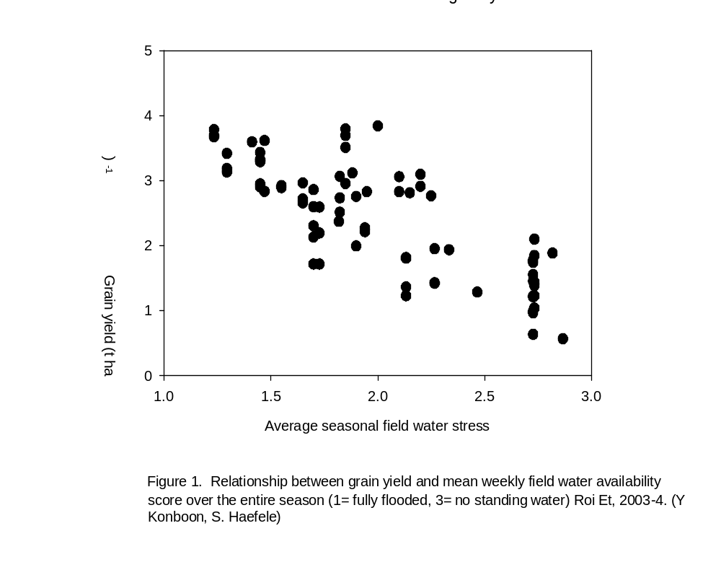
Intermittent soil drying substantially reduces biomass production, and therefore total yield potential. IRRI research has shown that there is substantial genetic variation in the ability of upland or lowland rice cultivars to maintain biomass accumulation in dry soils. For example, in a set of cultivars evaluated at IRRI under intermittently drained conditions in the wet season of 2005, yields averaged 1.6 t/ha, a reduction of over 50% relative to the fully irrigated control. In this trial there was a range in total biomass production among cultivars of 2.6 to 6.7 t/ha. Variation in total biomass production was more closely related to final grain yield than was harvest index (HI) in this trial.

    - Yield loss due to disruption of spikelet fertility when severe stress occurs around flowering

Drought is especially damaging when it occurs immediately before and during flowering (Ekanayake et al., 1990; Garrity and O’Toole, 1994). This is particularly true in upland rice, where brief periods of drought around flowering can result in near-complete spikelet sterility. For this reason, much research on drought tolerance has focused on tolerance to stress at the flowering stage. Genetic variation exists within O. sativa for the trait (e.g. Atlin et al. 2006). Some varieties have a high degree of tolerance to short periods of stress around flowering, whereas others experience markedly reduced seedset and harvest index. For example, a set of varieties was evaluated at IRRI under rainfed upland conditions in the wet seasons of 2004 and 2005. In both seasons, drought at flowering resulted in severe stress between panicle initiation and anthesis. For a subset of lines with similar days to flower under non-stress conditions, mean yield and harvest index are presented in Table 1.

Table 1. Mean yield and harvest index of rice cultivars exposed to severe reproductive-stage stress under upland conditions at IRRI during the wet seasons of 2004-2005

Designation | Days to flower- nonstress | Yield (kg ha⁻¹) | HI
 | Non-stress | Stress
IR 71525-19-1-1 | 85.9 | 2343 | 0.22
PSBRC 82 | 87.4 | 668 | 0.11
IR 71700-247-1-1-2 | 87.6 | 1138 | 0.16
IR 77298-12-7 | 89.3 | 1195 | 0.17
IR 77298-14-1-2 | 89.3 | 939 | 0.12
PR 26406-4-B-B-2 | 89.4 | 814 | 0.09
CT 6510-24-1-2 | 90.0 | 2034 | 0.19
IR 72875-94-3-3-2 | 90.4 | 727 | 0.11
UPL RI 7 | 90.4 | 1902 | 0.16
APO | 90.7 | 1736 | 0.18
LSD.05 |  | 728 | 0.06

In this set of lines, yields ranged from 668 to over 2300 kg ha⁻¹. Nearly all of the variation in yield was explained by variation in harvest index; lines that are high-yielding under stress, like IR 71525-19-1-1 and CT 6510-24-1-2, were able to maintain a high level of seedset under stress at flowering. The physiological basis for this differential tolerance is unknown.

2. Practical approaches to screening for drought tolerance in a cultivar development program

Screening for drought tolerance is screening for yield under stress

For a farmer, a drought-tolerant cultivar is one that produces a relatively high yield under stress. Screening for drought tolerance is therefore a matter of screening for yield under conditions as similar as possible to those experienced by farmers. The hydrology of the screening environment should mimic that of a drought-prone field. The drought screen itself is a yield trial that should be managed in the way that effective yield trials are usually managed, i.e., it must be adequately replicated and uniformly managed. Because drought screening is yield screening under stress, and replicated trials are needed, drought tolerance screening cannot be effectively applied at very early stages in a pedigree breeding program. It is appropriate to begin drought screening at the initial replicated yield testing stage.

Developing varieties combining high yield potential with tolerance to drought

Farmers do not usually want cultivars that are drought tolerant but low in yield potential in favorable years. They want cultivars that respond to favorable conditions but that “protect” an economically useful yield under drought conditions. Therefore, breeding lines should be screened under both stress and non-stress condtions. Mean yield of stress trials should 20-40% of the yield in non-stress trials. At these yield levels, cultivars with genes for tolerance can be distinguished from those that simply have high yield potential. The aim of the stress screening protocol should thus be to reduce mean yield by 60-80% relative to a fully irrigated control trial. Selections should be made on the basis of yield under both stress and non-stress conditions. It is fortunate that most studies show that there is a low but positive correlation between yield under stress and yield potential. It is therefore possible to identify varieties with both high yield potential and relatively high yield under stress.

Screening for tolerance to intermittent stress bracketing the flowering stage.

Because flowering is the stage when rice is most susceptible to drought damage some researchers devote a lot of effort to trying to ensure that each cultivar in the trial is subjected to water stress at the same phenological stage. This can be done by planting each variety in a separate basin or irrigating each variety separately using drip irrigation equipment, permitting irrigation to be discontinued for individual varieties at the optimum moment. These methods are not practical in a breeding program which must screen hundreds of lines. The IRRI breeding program screens for drought tolerance using protocols (described below), where stress is imposed before the first genotypes in the trial flower. Lafitte and Courtois (2004) reported that variety means in screens of this type are highly correlated with means from trials in which stress is precisely applied to target the sensitive flowering process.

Screening for tolerance to lowland drought stress

Lowland fields regularly affected by drought are usually upper fields with light soil texture. These fields are usually without standing water for most of the growing season, and may dry out repeatedly. If this type of field is the target environment, then screening should mimic these conditions. The following protocol may be used:

- Lowland drought screening trials should be conducted in a level, well-drained field at the top of the toposequence. There should be no irrigated or flooded trial planted above the drought screening site.
- A ground-water tube 1 m deep should be installed in each replicate.
- Lines should be screened in trials with at least 3 replicates. Plots should be at least 2 rows.
- Trials should be transplanted into puddled soil. The field should be that drained about one week after transplanting.
- The field should be allowed to dry until soil cracks and/or the surface is completely dry. The field should not be irrigated again until the local check variety is wilting, and the water table is at least 1 m below the surface. If tensiometers are installed, the field should be irrigated when soil water tension = -40 kPA at a depth of 20 cm.
- One day after re-irrigation, the field should be drained again.
- Steps 5 and 6 should be repeated until harvest.
- Yield and harvest index should be determined.

Screening for tolerance to upland stress

This screen may be used in either the dry or wet season. Upland varieties are usually photoperiod-insensitive, so if temperatures permit, dry season screening is the preferred option for reliably imposing stress. The following protocol may be used:

- Upland drought screening trials should be conducted in an unbunded, well-drained field at the top of the toposequence. There should be no irrigated or flooded trial planted above the drought screening site.
- A ground-water tube 1 m deep should be installed in each replicate.
- Lines should be screened in trials with at least 3 replicates. Plots should be at least 2 rows.
- Trials should be direct-sown into dry soil. The field should be irrigated to maintain soil at field capacity or above until canopy closure, or for about 30 DAS.
- At 30 DAS, the frequency of irrigation should be reduced. Fields should be allowed to dry until the surface is completely dry. The field should not be irrigated again until the local check variety is severely wilted, and the water table is at least 1 m below the surface. If tensiometers are installed, the field should be irrigated when soil water tension = -50 kPA at a depth of 30 cm.
- When the target level of soil dryness and plant stress are reached, the field should be liberally irrigated. Enough water should be applied to saturate the root zone. This is likely to require 60-80 mm of water.
- Steps 5 and 6 should be repeated until harvest.
- Yield and harvest index should be determined.

3. Evidence that managed-stress screening is predictive of cultivar performance under natural stress in the TPE.

There is some evidence that differences in drought tolerance measured in the screens described above predict differences observed under natural stress in the target population of environments. For example, at IRRI, 30 varieties were screened under severe upland stress artificially imposed at IRRI in DS 2005. These same varieties were screened under rainfed upland conditions at IRRI in WS 2004 and WS 2005. In both of these years, severe drought stress occurred at flowering. The correlation between variety means for grain yield in the dry season stress screen and under natural stress in the wet season was 0.87, indicating that the ability of the artificial drought screen to predict performance under natural stress was high.

Selection of random breeding lines under artificial stress has been shown to result in gains under natural stress in the wet season. Venuprasad et al. (accepted for publication in Crop Sci.) screened several hundred lines from the crosses Apo/IR 64 and Vandana/IR64 in the dry season of 2003. The lines were evaluated for grain yield under both severe upland stress and irrigated control conditions. Selected lines from both the stress and the irrigated control screens were then evaluated under natural stress at IRRI in the wet seasons of 2004 and 2005. Yield gains under natural stress were greater in the subset of lines selected under artificial stress than under fully irrigated conditions. Selection under stress gave no gains under non-stress conditions (Table 2).

Table 2. Yield (g m⁻²) of stress-selected, non-stress-selected, and random lines and checks in Apo/IR64 and Vandana/IR64 populations in selection response trials: IRRI, 2004 dry and wet season.

 | Evaluated under:
 | Non-stress  (DS 2004) |  |  | Natural stress  (WS 2004)
 | Apo/  IR64 | Vandana/  IR64 |  | Apo/  IR64 | Vandana/  IR64
Lines
Stress-selected | 236 | 185 |  | 101* | 105
Non-stress-selected | 255 | 217* |  | 74 | 92
Random | 234 | 186 |  | 75 | 98
Parents
Apo | 322 | 235 |  | 179 | 73
IR64 | 346 | 284 |  | 78 | 26
Vandana | 93 | 50 |  | 192 | 206
Trial mean | 242 | 196 |  | 86 | 98
* significant difference of a selected set from random set, p=0.05 level

Drought tolerance of some widely-grown varieties and potential donors

Below is a list of some varieties and their relative drought tolerance as determined in testing over several seasons at IRRI or in countries of origin. These levels of tolerance are approximate only. Lines with high and low levels of tolerance should be included as checks in drought screening trials.

Table 3. Relative levels of reproductive and vegetative drought tolerance of selected lowland- and upland-adapted genotypes.

Cultivar | Origin | Adaptation | Approximate duration at IRRI in wet season (days) | Level of vegetative-stage tolerance | Level of reproductive-stage tolerance
Vandana | India | Upland | 85 | High | High
IR 71525-19-1-1 | Philippines | Upland | 110 | High | High
Apo (IR55423-01) | Philippines | Upland | 115 | Moderate | Moderate
CT6510-24-1-2 | Colombia | Upland | 115 | Moderate | Moderate
IR 74371-54-1-1 | Philippines | Upland | 105 | Moderate | High
Azucena | Philippines | Upland | 120 | Moderate | Low
UPL RI-5 | Philippines | Upland | 120 | Low | Low
Kalinga III | India | Upland | 85 | Low | Low
Brown Gora | India | Upland | 85 | High | High
Safri 17 | India | Lowland | 140-150 | Unknown | Moderate
Swarna | India | Lowland | 140-150 | Unknown | Moderate
Sambha Mahsuri | India | Lowland | 140-150 | Unknown | Very low
IR57514-PMI 5 | Thailand | Lowland | 130 | Moderate | High
KDML 105 | Thailand | Lowland | 150 | Moderate | High
IR 77080-34-3 | Philippines | Lowland | 115 | Moderate | Moderate
IR 70213-10-CPA 4-2-2 | Thailand | Lowland | 120 | Moderate | Moderate
IR 72176-140-1-2 | Philippines | Lowland | 115 | Moderate | Moderate
IR 36 | Philippines | Lowland | 115 | Low | Very low
IR 64 | Philippines | Lowland | 115 | Low | Low
IR 72 | Philippines | Lowland | 120 | Low | Low
PSBRC 80 | Philippines | Lowland | 120 | Low | Low
PSBRC 82 | Philippines | Lowland | 115 | Low | Low

Summary

- Breeding cultivars with improved drought tolerance is possible by selecting for grain yield under artificially-imposed stress.
- Yield under stress is a quantitative trait with H similar to yield under non-stress conditions. It must be measured in replicated trials.
- Drought tolerance screening should be initiated after pedigree line development, at the replicated yield evaluation stage.
- Large sets of breeding lines can be evaluated in screens where drought stress is imposed intermittently from transplanting (lowland) or maximum tillering (upland) through harvest by irrigating only when soil is dry (below field capacity) in the root zone. Yields in the stress trial should be reduced to 20-40% of yields under non-stress conditions.
- Screening using repeated intermittent stress bracketing the flowering stage gives results that are similar to screens targeted precisely at flowering. Repeated intermittent stress is therefore an appropriate method for screening large breeding populations with a range of flowering dates. However, an effort should be made to group lines according to similar flowering date in drought screens.
- Yield under managed stress is predictive of yield under natural stress. Gains from direct selection from yield under managed stress have been demonstrated.

Some selected references (not all have been cited above, but all are useful)

Atlin, G. N., and H. R. Lafitte. 2002. Marker-assisted breeding versus direct selection for drought tolerance in rice. In: N. P. Saxena, and J. C.O’Toole (ed.) Field screening for drought tolerance in crop plants with emphasis on rice. p. 208. Proceedings of an international workshop on field screening for drought tolerance in rice, 11–14 Dec 2000, ICRISAT, Patancheru, India. 502 324, and The Rockefeller foundation, New York, 10018-2702, USA.
Atlin, G. N., and K. J. Frey. 1990. Selecting oat lines for yield in low-productivity environments. Crop Sci. 30: 556-561.
Atlin, G. N., H. R. Lafitte, D. Tao, M. Laza, M. Amante, and B. Courtois. 2006. Developing rice cultivars for high-fertility upland systems in the Asian tropics. Field Crops Res. 97:43-52
Atlin, G. N., H. R. Lafitte, R. Venuprasad, R. Kumar, and B. Jongdee. 2004. Heritability of mean grain yield under reproductive-stage drought stress and correlations across stress levels in sets of selected and unselected rice lines in the Philippines, Thailand, and India: implications for drought tolerance breeding. p. 85-87. In: D. Poland, M. Sawkins, J. -M. Ribaut, and D. Hoisington (ed.) Resilient crops for water limited environments: Proceedings of a workshop held at Cuernavaca, Mexico, 24-28 May 2004. CIMMYT, Mexico D.F.
Babu, R.C., B. D. Nguyen, V. P. Chamarerk, P. Shanmugasundaram, P. Chezhian, S.K. Jeyaprakash, A. Ganesh, S. Palchamy, S. Sadasivam, S. Sarkarung, L. J., Wade, and H. T. Nguyen. 2003. Genetic analysis of drought resistance in rice by molecular markers. Crop Sci. 43:1457-1469.
Fukai, S., and M. Cooper. 1995. Development of drought-resistant cultivars using physiomorphological traits in rice. Field Crops Res. 40: 67-86.
Fukai, S., G. Pantuwan, B. Jongdee, and M. Cooper. 1999. Screening for drought resistance in rainfed lowland rice. Field Crops Res. 64:61-74.
Huke, R.E., and E.H.Huke. 1997. Rice Area By Type Of Culture: South, Southeast, and East Asia. IRRI, Los Baños, Philippines.
Jongdee, B., S. Fukai, and M. Cooper. 2002. Leaf water potential and osmotic adjustment as physiological traits to improve drought tolerance in rice. Field Crop Res. 76: 153-163.
Lanceras, J., G. Pantuwan, B. Jongdee, and T. Toojinda. 2004. Quantitative trait loci associated with drought tolerance at reproductive stage in rice. Plant Physiology. 135: 384-399.
O’Toole, J. C. 1982. Adaptation of rice to drought prone environments. p 195-213. In: Drought resistance in crops with emphasis on rice. IRRI, Los Baños, Philippines.
Pandey, S., D. Behura, R. Villano, and D. Naik. 2000. Economic costs of drought and farmers’ coping mechanisms: a study of rainfed rice systems in eastern India. IRRI discussion paper series number 39. IRRI, Los Baños, Philippines.
Pantuwan, G., S. Fukai, M. Cooper, S. Rajatasereekul, and J.C. O’Toole. 2002a. Yield response of rice (Oryza sativa L.) to drought under rainfed lowlands 1. Grain yield and yield. Field Crop Res. 73: 153-168.
Pantuwan, G., S. Fukai, M. Cooper, S. Rajatasereekul, and J.C. O’Toole. 2002b. Yield response of rice (Oryza sativa L.) to drought under rainfed lowlands 2. Selection for drought resistance genotypes. Field Crop Res. 73: 169-180.
Pantuwan, G., S. Fukai, M. Cooper, S. Rajatasereekul, and J.C. O’Toole. 2002c. Yield response of rice (Oryza sativa L.) to drought under rainfed lowlands 3. Plant factors contributing to drought resistance. Field Crop Res. 73: 181-200.
Price, A., and B. Courtois, 1999. Mapping QTLs associated with drought resistance in rice: progress, problems, and prospects. Plant Growth Regul. 29:123-133.
Price, A. H., and A. D. Tomos, 1997. Genetic dissection of root growth in rice (Oryza sativa L.). II Mapping quantitative trait loci using molecular markers. Theor. Appl. Genet. 95: 143-152.
Toorchi, M., H.E. Shashidhar, T.M. Gireesha, and S. Hittalmani. 2003. Performance of backcross involving trangressant doubled haploid lines in rice under contrasting moisture regimes: yield components and marker heterozygosity. Crop Sci. 43: 1448-1456

