Marker assisted breeding for rice improvement

Bert Collard & David Mackill
PBGB Division, IRRI

Introduction
The development of DNA (or molecular) markers has irreversibly changed the disciplines of plant genetics and plant breeding. While there are several applications of DNA markers in breeding, the most promising for cultivar development is called marker assisted selection (MAS). MAS refers to the use of DNA markers that are tightly-linked to target loci as a substitute for or to assist phenotypic screening. By determining the allele of a DNA marker, plants that possess particular genes or quantitative trait loci (QTLs) may be identified based on their genotype rather than their phenotype.

Learning objectives
- Learn about marker-assisted selection – theory and practice concepts.
- Learn about MAS schemes in plant breeding
- Learn about IRRI’s current MAS research
- Discuss current obstacles for MAS

1. Advantages of marker-assisted selection
Marker-assisted selection may greatly increase the efficiency and effectiveness for breeding compared to conventional breeding. The fundamental advantages of MAS compared to conventional phenotypic selection are:

- Simpler compared to phenotypic screening
- Selection may be carried out at seedling stage
- Single plants may be selected with high reliability.

These advantages may translate into (1) greater efficiency or (2) accelerated line development in breeding programs. For example, time and labour savings may arise from the substitution of difficult or time-consuming field trials (that need to be conducted at particular times of year or at specific locations, or are technically complicated) with DNA marker tests. Furthermore, selection based on DNA markers may be more reliable due to the influence of environmental factors on field trials. In some cases, using DNA markers may be more cost effective than the screening for the target trait. Another benefit from using MAS is that the total number of lines that need to be tested may be reduced. Since many lines can be discarded after MAS at an early generation, this permits a more effective breeding design.
The greater efficiency of target trait selection which may enable certain traits to be ‘fast-tracked’, since specific genotypes can be easily identified and selected. Moreover, ‘background’ markers may also be used to accelerate the recovery of recurrent parents during marker-assisted backcrossing (discussed later).

2. Importance of QTL mapping for MAS
The identification of genes and quantitative trait loci (QTLs) and DNA markers that are linked to them is accomplished via QTL mapping experiments. QTL mapping thus represents the foundation of the development of markers for MAS. Previously, it was generally assumed that markers could be directly used in MAS. However, there are many factors that influence the accuracy of QTL mapping such as population size and type, level of replication of phenotypic data, environmental effects and genotyping errors. These factors are particularly important for more complex quantitative traits with many QTLs each with relatively small effects (e.g. drought tolerance, yield). Therefore, in recent years it has become widely-accepted that QTL confirmation, validation and/or additional marker testing steps may be required after QTL mapping and prior to MAS. These steps may include:
- Marker conversion - may be required such that the marker genotyping method is technically simpler for MAS or so that the reliability is improved.
- QTL confirmation – testing the accuracy of results from the primary QTL mapping study
- QTL validation - generally refers to the verification that a QTL is effective in different genetic backgrounds
- Marker validation – testing the level of polymorphism of most tightly-linked markers within a narrow window (say 5 - 10 cM) spanning a target locus and also testing the reliability of markers to predict phenotype.

3. MAS schemes in plant breeding
3.1 Marker assisted backcrossing
There are three levels of selection in which markers may be applied in backcross breeding. In the first level, markers may be used to screen for the target trait, which may be useful for traits that have laborious phenotypic screening procedures or recessive alleles. The second level of selection involves selecting backcross progeny with the target gene and tightly-linked flanking markers in order to minimize linkage drag. We refer to this as ‘recombinant selection’. The third level of MAB involves selecting backcross progeny (that have already been selected for the target trait) with ‘background’ markers. In other words, markers can be used to select against the donor genome, which may accelerate the recovery of the recurrent parent genome. With conventional backcrossing, it takes a minimum of five to six generations to recover the recurrent parent. Data from simulation studies suggests that at least two but possibly three or even four backcross generations can be saved by using markers.

1
2
3
4
Target locus
1
2
3
4
‘RECOMBINANT’ SELECTION
1
2
3
4
‘BACKGROUND’ SELECTION
‘TARGET GENE/QTL’ SELECTION
Figure 1. Three levels of selection during marker-assisted backcrossing.

3.2 Marker assisted pyramiding
Pyramiding is the process of simultaneously combining multiple genes/QTLs together into a single genotype. This is possible through conventional breeding but extremely difficult or impossible at early generations. Using conventional phenotypic selection, individual plants must be phenotypically screened for all traits tested. Therefore, it may be very difficult to assess plants from certain population types (e.g. F2) or for traits with destructive bioassays. DNA markers may facilitate selection because DNA marker assays are non-destructive and markers for multiple specific genes/QTLs can be tested using a single DNA sample without phenotyping. The most widespread application for pyramiding has been for combining multiple disease resistance genes in order to develop durable disease resistance.

3.3 Early generation marker assisted selection
One of the most intuitive stages to use markers to select plants is at an early generation (especially F2 or F3). The main advantage is that many plants with unwanted gene combinations, especially those that lack essential disease resistance traits and plant height, can be simply discarded. This has important consequences in the later stages of the breeding program because the evaluation for other traits can be more efficiently and cheaply designed for fewer breeding lines (especially in terms of field space).

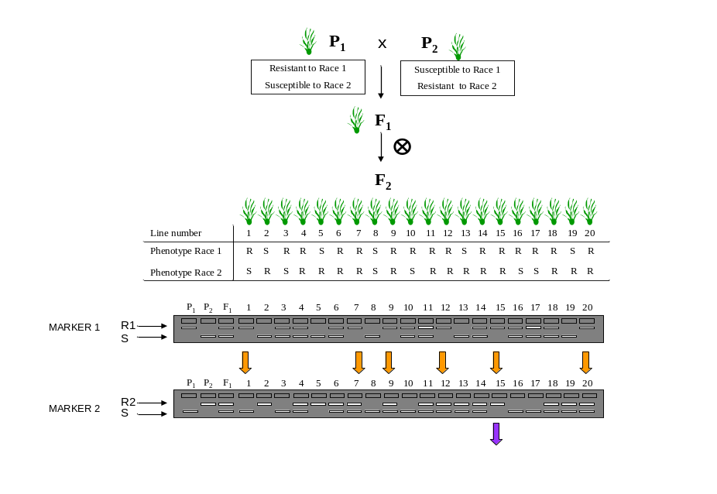
Figure 2.
Marker assisted pyramiding of two disease resistance genes. Note that homozygotes can be selected from the F2 population.
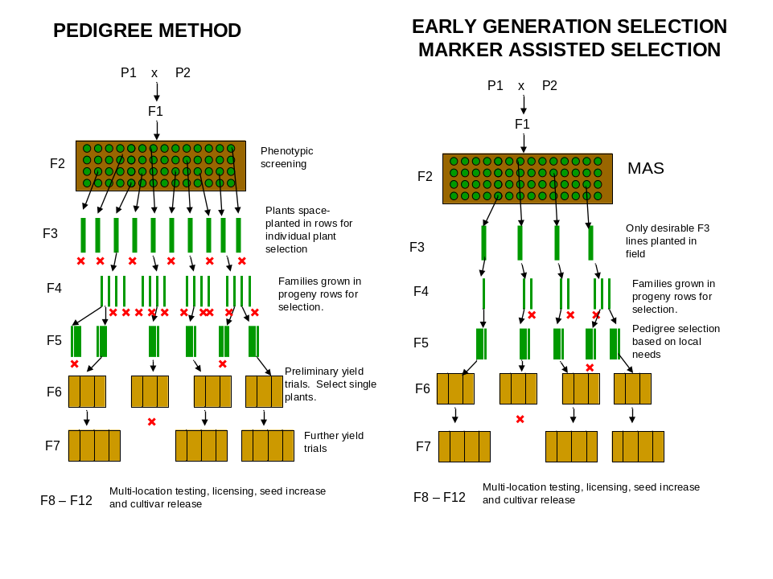
Figure 3.
Early generation selection scheme (proposed by Ribaut & Betran (1999). Note that many lines can be discarded in an early generation which permits the evaluation of fewer lines in later generations.
4. Current obstacles for the adoption of MAS
There are many barriers to the adoption of MAS in plant breeding. Currently, one of the most important barriers for MAS in rice today is the prohibitive cost. Although there are only a small number of reports analyzing the economics of MAS versus conventional breeding in the literature, the cost-effectiveness of using MAS compared to conventional plant breeding varies considerably between studies. Two additional factors need to be considered for cost-analysis: (1) the equipment and consumables required to establish and maintain a marker lab is considerable; and (2) there is a large initial cost in the development of markers which is seldom reported. For marker assisted backcrossing, the initial cost of using markers would be more expensive compared to conventional breeding in the short term however time savings could lead to an accelerated variety release which could translate into greater profits in the medium to long term.
Another important factor obstructing the successful application of markers for line development is the low reliability of markers to determine phenotype. This is often attributable to the ‘thoroughness’ of the primary QTL mapping study. Even QTLs that are detected with high LOD scores and explain a large proportion of the phenotype may be affected by sampling bias (especially in small populations), and therefore may not be useful for MAS. Furthermore, the effect of a QTL may depend on the genetic background. This emphasizes the importance of testing the QTL effects and the reliability of markers (i.e. QTL/marker validation) before MAS is undertaken.
Finally the level of integration between molecular geneticists and plant breeders (and scientists from other disciplines) may not be adequate to ensure that markers are effectively applied for line development.

5. Future of MAS in rice breeding
We believe that despite the relatively small adoption of markers in rice breeding to date, there will be a greater level of adoption within the next decade and beyond. Factors that should lead to a greater adoption of MAS in rice include:
- establishment of facilities for marker genotyping and staff training within many rice breeding institutes in different countries
- currently available (and constantly increasing) data on genes/QTLs controlling traits and the identification of tightly-linked markers
- development of effective strategies for using markers in breeding
- establishment and curation of public databases for QTL/marker data
- available resource for generating new markers from DNA sequence data arising from rice genome sequencing and research in functional genomics.

It is also critical that future endeavours in MAS are based upon lessons that have been learnt from past successes and (especially) failures in using MAS. Further optimization of marker genotyping methods in terms of cost-effectiveness and a greater level of integration between molecular and conventional breeding (especially in designing efficient and cost-effective strategies) represent the main challenges for the greater adoption and impact of MAS on rice breeding in the near future.

6. Suggested reading
Chen S, Lin XH, Xu CG, Zhang QF (2000) Improvement of bacterial blight resistance of 'Minghui 63', an elite restorer line of hybrid rice, by molecular marker-assisted selection. Crop Science 40, 239-244.

Collard BCY, Jahufer MZZ, Brouwer JB, Pang ECK (2005) An introduction to markers, quantitative trait loci (QTL) mapping and marker-assisted selection for crop improvement: The basic concepts. Euphytica 142, 169-196.

Dreher K, Khairallah M, Ribaut J, Morris M (2003) Money matters (I): costs of field and laboratory procedures associated with conventional and marker-assisted maize breeding at CIMMYT. Molecular Breeding 11, 221-234.

Hittalmani S, Parco A, Mew TV, Zeigler RS, Huang N (2000) Fine mapping and DNA marker-assisted pyramiding of the three major genes for blast resistance in rice. Theoretical and Applied Genetics 100, 1121-1128.

Holland JB (2004) Implementation of molecular markers for quantitative traits in breeding programs - challenges and opportunities. In 'Proceeding of the 4th International Crop Science Congress.' Brisbane, Australia.

Mackill DJ (2006) Breeding for resistance to abiotic stresses in rice: the value of QTLs. Plant breeding: The Arnel R Hallauer International Symposium.

Mackill DJ, Collard BCY, Heuer S, Ismail AM (2006) QTLs in rice breeding: examples for abiotic stresses. In '5th International Rice Genetics Symposium'. Manila, Philippines. (International Rice Research Institute).

Mackill DJ, Nguyen HT, Zhang J (1999) Use of molecular markers in plant improvement programs for rainfed lowland rice. Field crops research 64, 177-185.

Melchinger AE, Utz HF, Schon CC (1998) Quantitative trait locus (QTL) mapping using different testers and independent population samples in maize reveals low power of QTL detection and large bias in estimates of QTL effects. Genetics 149, 383-403.

Mohan M, Nair S, Bhagwat A, Krishna TG, Yano M, Bhatia CR, Sasaki T (1997) Genome mapping, molecular markers and marker-assisted selection in crop plants. Molecular Breeding 3, 87-103.

Morris M, Dreher K, Ribaut JM, Khairallah M (2003) Money matters (II): costs of maize inbred line conversion schemes at CIMMYT using conventional and marker-assisted selection. Molecular Breeding 11, 235-247.

Ribaut J-M, Hoisington D (1998) Marker-assisted selection: New tools and strategies. Trends in Plant Science 3, 236-239.

Ribaut JM, Betran J (1999) Single large-scale marker-assisted selection (SLS-MAS). Molecular Breeding 5, 531-541.

Sharp PJ, Johnston S, et al. (2001) Validation of molecular markers for wheat breeding. Australian Journal of Agricultural Research 52, 1357-1366.

Singh S, Sidhu JS, Huang N, Vikal Y, Li Z, Brar DS, Dhaliwal HS, Khush GS (2001) Pyramiding three bacterial blight resistance genes (xa5, xa13 and Xa21) using marker-assisted selection into indica rice cultivar PR106. Theoretical and Applied Genetics 102, 1011-1015.

Young ND (1999) A cautiously optimistic vision for marker-assisted breeding. Molecular Breeding 5, 505-510.

Content of this lecture outline has been based on an invited review paper submitted to Philosophical Transactions of the Royal Society of London Series B (2006).

