Screening and trait-based selection for drought resistance in rice

R. Serraj

Outline:
- Introduction: the drought challenges
- Types of drought & functional definition of drought ‘resistance/tolerance’ (DR)
- Considerations in designing a drought screening program
- Design & management of field drought experiments
- Direct selection for yield under stress
- Trait-based selection for drought resistance
- Examples and case studies
- Conclusions

Introduction
Plant responses to drought stress are very complex as stress itself involves various climatic, soil and agronomic factors, frequently complicated by substantial variation in timing of occurrence, duration and intensity. The general complexity of drought is often aggravated under rainfed conditions in marginal areas by erratic and unpredictable rainfall, and by the occurrence of high temperatures, high levels of solar radiation, and poor soil characteristics. This high variability in the nature of drought stress, aggravated by an insufficient understanding of its complexity, has made it difficult to identify specific physiological traits required for improved crop performance under drought, consequently limiting plant breeding efforts to enhance crop drought tolerance. It is highly probable that optimal drought-adaptation requires the combination of several morphological, physiological, and phenological processes, which depend on a multitude of genes and varies within each target environment.

In addition to its direct effects on yield, drought can also reduce the potential beneficial effects of improved crop management practices such as fertilizer application or pest and disease management. Given the increasing scarcity of water resources, and competition for them, irrigation is not a practical option for alleviating drought in most of the rainfed areas. Drought management strategies therefore need to focus on maximizing extraction of available soil moisture and the efficiency of its use in crop establishment, growth, biomass and grain yield. However, agronomic and genetic options that do not involve external inputs of irrigation can only partially alleviate drought effects, because yield will always be lower than what can be achieved with irrigation.

This paper will discuss, from a physiological and breeding perspective, some of the current challenges and opportunities in genetic enhancement of drought resistance in rice and introduce some of the screening tools and methods.

Challenges in manipulating drought resistance (DR) genes
  - Most physiological and metabolic processes are affected by water deficits: cell growth, stomata, photosynthesis, translocation, etc..
  - A very large number of genes regulated by drought
  - Large genetic populations required
  - Even component traits are difficult to screen
  - Logistical challenges for dealing with a large number of genes even when identified

Characterization of the target environment and drought definition

Importance of timing, duration and intensity of stress occurrence.
Use historical climate series, crop simulation and water balance models to define the breeding target: Germination, crop establishment, vegetative growth and tillering, flowering, grain filling.

The functional definition of ‘drought resistance’ should be based on yield stability under water defictits. Drought resistance/tolerance has to be researchable, breakable into simpler levels (e.g. floret sterility and ASI in maize, rooting effects vs. rooting pattern..), and should focus on heritable genetic variation, linked to yield, feasible

Is rice more drought sensitive than other crops/cereals? Rice has generally a Lowland and semi-aquatic adaptation, a shallow compact root system (especially in lowlands), Deep roots not very efficient at water extraction, Higher tissue sensitivity to water deficit? High sensitivity of grain set to stress, Very sensitive to timing of stress, Other mechanisms?

Drought screening environments

1. Artificially create stress in the "normal" growing season: avoids genotype x season problems, excluding water is costly/difficult (reproducibility). But no control of stress occurrence (timing, severity and duration)

2. Manage water-deficits in a non-growing season: application of uniform, repeatable and controlled stress environment, possibility to maximize genetic component of the observed variation. BUT the extrapolation of results to ‘natural’ target environment can be difficult.

The main objectives of a screening system should be:
- Focus on target environment and adaptation to major stress constraints
- Minimize problems in detecting heritable differences in drought resistance (DR)
- Yield under stress is as function of: yield potential, escape, and drought response, therefore the use drought sensitivity index (DSI) can help to distinguish DR from escape and yield potential
- Ultimately, DR should be viewed as the ability to maintain yield components in stress compared to non-stress: maintenance of grain number, grain size, biomass, yield, harvest index.
In addition, screening system should: (i) differentiate among genotypes: degree of yield reduction (+ 50%), manage ‘escape’ effects, use period of max evapotranspiration (ET) demand, time initiation of stress carefully, adjust for differences in escape, (ii) apply uniform stress (drought nursery approach): “uniform” soil water profile, uniform pre-stress crop growth, water application & water use, (iii) be repeatable: with standard planting time and management procedures, initiate stress by phenological stage, stable water use environment, dedicated field facility, well-established management practices

Screening systems should also take into account the following parameters/criteria: variations in crop phenology and morphology, the growth stage at which stress occurs, the severity and duration of stress, the management options and levels (e.g. fertilizer applications), the plot size and experimental design, all potential interacting factors such as biotic and other abiotic stresses (e.g. temperature), crop quality and economic factors

Control of field irrigation:

Method | Freq | Advantages | Disadvantages
Surface / Furrow | variable  3 x wk | Robust components  Efficient water use  Easy to measure | Inefficient water use  Requires land leveling  Hard to measure amount of water  Requires raised beds  Row spacing too wide for rice
Sprinkler | 3 x wk | Robust components  Efficient water use  Easy to measure | Uneven distribution pattern  same timing of stress for all entries  Large border areas needed  Leaks, blockages and wind
Drip | daily | Differential irrigation/ plot  Efficient water use  Uniform application | Expense of components (filters etc)  Limits weed control options  Labor cost: check quality of irrigation

Screening Tools and Methodologies

- Line-source irrigation
- Rain-out shelters
- Drained paddy (lowland)
- Continuous intermittent stress (upland)
In order to identify sources of drought resistance it is necessary to develop screening methods that are simple and reproducible under the target environment conditions. Therefore, managing drought-screening nurseries requires a careful analysis of likely sources of non-genetic variation among plots, replications and repeated experiments, and establishing procedures for minimizing these factors. Several field and laboratory screening methods have been used successfully to screen for drought resistance, including line-source sprinkler irrigation, rainout shelters, and measurement of drought susceptibility index (DSI). The line-source sprinkler irrigation method creates a gradient of drought stress, and allows the evaluation of large numbers of genotypes at varying intensities of drought in a given environment. However, where response to applied water is linear, simpler stress/no stress techniques provide a more efficient, means of conducting preliminary evaluations. The drought susceptibility index (DSI) proposed by Fisher and Maurer (1978), for cases where the yield performance under stress was not related to days to 50% flowering, was calculated based on yield under rainfed conditions and potential yield under irrigated conditions. The lower the DSI, the greater is the drought tolerance of the line.

The drought breeding strategies

Both conventional and trait-based approaches have been used in breeding programs for drought tolerance. The empirical breeding approach is based on selection for yield and its components in a given drought environment. While such an approach has been partly successful, it requires large investments in land, labor, and capital to screen a large number of progenies plus the difficulty of sampling even a part of the expected range of variability in stress occurrence in the target environment. In addition, there is evidence of increasingly marginal returns from conventional breeding, suggesting a need to seek more efficient methods for genetic enhancement of drought tolerance. On the other hand, the ability to associate drought adaptive responses with the expression of specific physiological mechanisms has the potential to help greatly in establishing screening protocols and permit better management of genotype × environment (G × E) interactions. However, it has been argued that a focus on very basic mechanisms is likely to be at the cost of the linkages to final grain yield, and increased measurement costs, thereby complicating conventional and molecular breeding for drought tolerance.

Recent research developments in biotechnology have revived interest in targeted drought tolerance breeding and use of new genomics tools to enhance crop drought resistance. Marker-assisted breeding is making possible the improvement of field crops, particularly for traits where phenotyping is only possible late in the season, is difficult, or is prohibitively expensive. As a complement to the recent rapid progress in genomics, a better understanding of physiological mechanisms of drought response will also contribute to the progress of genetic enhancement of crop drought tolerance. It is now well accepted that the complexity of the drought syndrome can only be tackled with a holistic approach that integrates physiological dissection of crop drought avoidance and tolerance traits using molecular genetic tools such as MAS, microarrays and transgenic crops, with agronomic practices that lead to better conservation and utilization of soil moisture, and better matching of crop genotypes with the environment.

Crop Yield and plant water use

Generally, the response of plants to soil water deficits can be described as a sequence of three successive stages of soil dehydration (Fig. 1). Stage I occurs at high soil moisture when water is still freely available from the soil and both stomatal conductance and water vapor loss are not limited by soil water availability. The transpiration rate during this stage is therefore determined by environmental conditions around the leaves. Stage II starts when the rate of water uptake from the soil cannot match the potential transpiration rate. Stomatal conductance declines, limiting the transpiration rate to a rate similar to that of uptake of soil water, resulting in the maintenance of the water balance of the plant. Finally, stage III begins when the stomata are no longer able to limit the transpiration to that water available from the soil even through stomatal conductance is at a minimum. At this time the plant must resort to other mechanisms of drought adaptation if the plant is to survive.
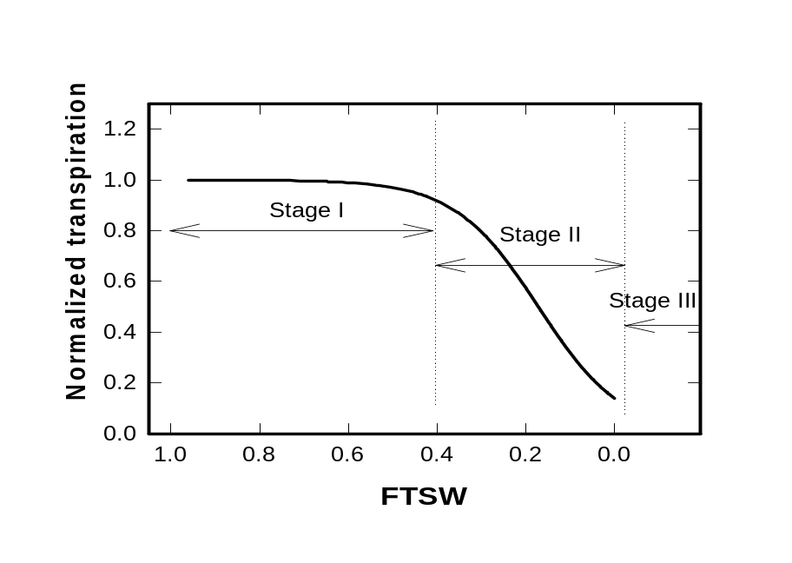
Virtually all major processes contributing to crop yield including leaf photosynthetic rate, leaf expansion and growth are inhibited late in stage I or in stage II of soil drying. At the end of stage II, these growth-supporting processes have reached zero and no further net growth (i.e. increase in biomass) occurs in the plants. The focus of stage III is survival and water conservation mechanisms which will allow the plant to endure under these severe conditions must be used if available. Plant survival is a critical trait in natural dry-land ecosystems, but for most agricultural situations, stage III often, but not always has little relevance to questions about increasing crop yield. Consequently, the amount of water available up to the end of stage II for all practical purposes determines the cumulative growth and yield on a particular soil. Recovery from stage III can only be of relevance to yield performance if water is added to the system while there is still sufficient time for growth. Therefore, options involving mechanisms to enhance crop survival, thus do not usually mean any increase in crop yield under severe drought stress conditions. Increased crop yields and water use efficiency generally require the optimization of the physiological processes involved in the critical early stages (mainly stage II) of plant response to soil dehydration.

Characterization of drought resistance traits
Several physiological, morphological and phenological traits/mechanisms have been associated with drought stress adaptation, either in stage-I, stage-II or stage III processes of soil drying including:
- Plant emergence characteristics/vigor
- Phenology/ Elasticity of development
- Nutrient acquisition/Uptake efficiency
- Water use efficiency
- Photosynthesis, Radiation Use Efficiency
- Carbon Discrimination (¹³C )
- Deep Root development
- Hormonal regulation (ABA, GA, Ethylene)
- Osmotic Adjustment/RWC
- Canopy temperature
- Staygreen/ Delayed senescence
- Grain number maintenance
- Grain fill duration and rate
- HI under Drought
- Yield and its components, Etc.
Despite many decades of research on ‘drought tolerance’ in several crops, little progress has been reported in terms of genetic enhancement of crop productivity under water-deficits environments. Plant physiologists do not always pay enough attention while evaluating the adaptive role of a particular physiological mechanism to grain yield or biomass production under drought. Also, there is no unanimity in relation to what constitutes drought tolerance. Only limited progress has been reported in developing near iso-genic lines (NIL) or recombinant inbred lines (RILS) for specific traits of drought resistance. Another limitation is that lab physiologists have been reluctant to adapt their trait assessment protocols to allow phenotyping of sufficiently large number of individual plants that progenies can be segregated in sufficient numbers for good screening experiments to demonstrate that their target traits are indeed heritable. Plant breeders on the other hand are unwilling to invest much of their time and resources pursuing traits without this basic information. Breeders and crop physiologists need to work closely in testing the viability/validity of the trait-based approaches for drought tolerance. This has not happened to any great extent previously, thus missing a good opportunity for advancement. Applied breeding programs always want a clear demonstration of the value of a trait before considering incorporating it as a selection criterion. However, without breeder’s participation, development of genetic stocks with specific traits incorporated into locally-adapted genetic backgrounds to test the hypothesis of the value of a trait is very difficult.

Identification of simple to observe morphological and phenological traits, reflective of mechanisms and processes that confer drought tolerance is a priority activity in drought research. An appropriate screening trait for drought stress tolerance should fill the following criteria: (i) a strong link with higher or more stable grain yield in the target stress environment, (ii) a high level of heritability, and (iii) the expression of tolerance must be easily measurable, with adequate replication.

Integrated drought management options

Given the increasing scarcity and competition for water resources, irrigation is generally not a possible option to alleviate drought problems in most rainfed areas. Therefore, drought management strategies, whether agronomic or genetic, therefore need to focus on maximum extraction of available soil moisture and its most efficient use in crop establishment, maximum crop growth, and for increasing biomass and seed yield. In order to plan crop yield improvement programs for a given target drought-prone area the following steps are essential:
• Characterize the major patterns of drought stress and their frequency of occurrence in the target environment.
• Evaluate crop response to the major drought patterns (simulation modeling)
• Match crop phenology (growth period, sowing, flowering, and seed filling) with most favorable period of soil moisture and climatic regimes
• Develop a strategy for the optimal use of supplementary irrigation, when available
• Increase available soil water to crop through agronomic management practices
• Identify plant traits that would maximize (i) use of available soil moisture in transpiration (ii) production of biomass per unit water transpired, and (iii) partitioning into seed, thereby conferring enhanced crop water productivity.
Agronomic and genetic options that do not involve external input of irrigation can only partially alleviate drought effects, because yield is always lower than what can be achieved with irrigation.

Final conclusions

- Good knowledge of the target environment is essential in drought breeding: what type of stress is more frequent?
- Yield stability under drought scenarios and crop water productivity (ratio of yield achieved per water used) should be the target
- Drought screening systems should be uniform, repeatable and differentiate genotypes
- Field and irrigation management are critical for drought screening
- Screening procedure are function of targets, needs and means. Each breeding program should adapt procedures to won environment and conditions.
- Trait-based improvement needs careful choice and requires integration of breeding and other disciplines

