2005 Unit 3: Choosing parents and managing a pedigree breeding program

Introduction

Most rice breeders consider parent choice and the development of fixed lines in their pedigree nurseries as the most important aspect of their work. Experienced breeders choose parents carefully, and manage the development of fixed lines in a systematic way. There are only a few firm rules about parent choice, and many effective ways to manage a pedigree nursery. Pedigree nurseries should be managed to generate a high frequency of adapted lines with the quality, plant type, biotic and abiotic stress resistances, and duration preferred by farmers in the TPE. This unit will consider the principles by which pedigree programs can be planned to achieve these goals. Later in the course, we will observe in more detail the methods and systems used by one of the world’s most successful cereal breeding programs – IRRI’s irrigated rice breeding program. We will also examine the structure of several of IRRI’s other pedigree breeding programs.

Learning objectives for Unit 4

- To outline strategies for choosing parents for particular objectives
- To understand the relative advantages of 2-way crosses, 3-way crosses, and backcrosses in generating breeding populations
- To understand the effect of F₂ population size on the probability of recovering desired recombinants.
- To review the nomenclature by which crosses and derived generations are described.
- To weigh the benefits of pedigree versus bulk selection in early generation.
- To identify the kinds of traits that are most usefully selected for in pedigree breeding programs.
- To consider the factors involved in determining how many generations to continue pedigree selection before initiating replicated testing.
- To consider practical features of pedigree nursery design for controlling field variability

Unit content

Strategies for choosing parents

Particularly in the early days of modern rice breeding, many varieties that became widely used by farmers were developed from crosses between parents that were exotic to the region in which they were later released. For example, Mahsuri, once the most widely-grown rainfed lowland cultivar in South Asia, was derived from the cross Taichung 65/Mayang Ebos 80. Neither of these cultivars was used as a rainfed lowland variety in South Asia. But it is getting hard to replicate this achievement; a first and even a second generation of improved varieties has now been widely adopted in many rainfed areas, and it is difficult to make significant improvements on these farmer-preferred cultivars by using only parents from other regions. Parents should be chosen carefully to fulfill the objectives of the breeding program.

Use at least one adapted, farmer-preferred parent

In an earlier unit it was noted that successful rainfed rice breeding programs have very specific objectives, and often aim to develop a replacement for a currently popular variety. For example, a program may wish to replace a popular variety having one or more defects with one of similar quality and adaptation, but with improved lodging resistance or shorter duration. It follows from this that crosses should generally be between locally adapted and preferred lines and donors carrying the traits that are to be improved in the current variety. Often, a backcross to the adapted parent is advisable, in order to increase the frequency of progeny lines with appropriate plant type and quality.

In general, the donor line should be as high-yielding, high-quality, and adapted as possible while still expressing the trait of interest. It is very difficult (but sometimes necessary!) to use parents that are agronomically poor or of unacceptable quality as donors and still recover useful recombinants. For example, the African landrace ‘Moroberekan’ is highly drought tolerant, but it is also tall, prone to lodging, and very low yield potential under irrigated conditions. Many efforts have been made to use this cultivar as a source of drought tolerance, but very few varieties acceptable to Asian rice farmers have resulted. Several cycles of “pre-breeding” are likely to be necessary before unadapted materials of this type can be used. Using non-adapted donors is especially difficult if the trait they contribute is controlled by several genes. If the trait is controlled by a single gene whose location is known, it can be incorporated into the adapted parent via marker-aided selection (MAS). The submergence-tolerant landrace ‘FR13A’ is an example of such a donor. Although it is agronomically poor, its high level of submergence tolerance is largely due to a single gene, Sub1, whose location has recently been mapped with very high precision. This is allowing MAS to be used to move Sub1 from the donor into adapted cultivars via backcrossing.

Focus on quality

Special care should be taken to ensure that at least one parent in each cross should be of the quality preferred by farmers in the TPE. Crosses between two low-quality parents should usually not be made, unless the objective is pre-breeding, or the development of a “stop-gap” variety to overcome an extremely serious pest or disease problem. In some situations, where cooking and eating quality is an overriding factor in variety acceptance, it is likely that repeated backcrossing to the high-quality parent will be needed before selection is started. This has been the case in northeastern Thailand, where the dominant non-glutinous variety for over forty years has been the variety ‘KDML-105’, a high quality jasmine rice much sought-after in export markets. The variety has many weaknesses, including susceptibility to blast and lodging, but it has proven very difficult to replace it because most derivatives of crosses between ‘KDML-105’ and agronomically superior lines have not had high enough quality to be attractive to farmers or millers, even when they were much better agronomically. Recently, IRRI and the Thai national program have mounted a large backcross breeding program with ‘KDML-105’ as the recurrent parent.

What kinds of crosses are most likely to produce superior lines?

Two-way, three-way, and double crosses

Breeders often formulate crosses to ensure that all the desirable characteristics they are seeking will be present in the resulting segregating population. This means that breeders mainly use 2-way crosses (crosses between 2 pure lines), 3-way crosses (crosses between pure lines and an F₁, also called topcrosses), and double crosses (crosses between two F₁s). 3-way and double crosses are used when the breeder wishes to combine a complex set of traits, usually disease, pest, or stress resistances, that cannot be found in any two lines. Some varieties have been successfully developed from such crosses. However, all complex crosses, and even conventional 2-way crosses, have a major disadvantage in that they break apart favorable linkage blocks that have been painstakingly assembled through previous cycles of crossing and selection. The probability that the complex package of genes that makes an elite rice cultivar will occur by chance in the progeny of a double, 3-way, or even conventional 2-way cross is very low. This is why rice breeders tend to use large F₂ populations for their initial selections

Backcrosses
Backcrossing is usually considered to be a strategy suitable mainly for introducing one or a few disease or insect resistance genes into an elite cultivar. Many breeders make few backcrosses in their main cultivar development programs, but there is strong evidence that backcross populations should be used more often in rainfed rice breeding. Because the excellent performance and quality of elite pure-line cultivars is the result of very complex combinations of alleles at hundreds or even thousands of loci, breeders should use crossing strategies that keep these gene combinations largely intact, but that still allow the introduction of a few favorable genes. Backcross populations allow breeders to make incremental improvements in an elite, adapted variety used as a recurrent parent by introducing a relatively small number of genes from a donor parent with some characteristics that complement the elite variety’s deficiencies. BC₁ or BC₂ crosses can be used to generate segregating populations that have a high frequency of alleles and allele combinations from an adapted recurrent parent. BC Several important rainfed varieties have been developed from BC₁ populations, notably the widely-grown south Asian variety Samba Mahsuri (RP5/Mahsuri//Mahsuri).

Recently, the IRRI breeding program has successfully used backcross methods to improve several elite cultivars, retaining their favorable features while improving them in several important respects. In collaboration with the Thai national program, a BC₂ derivative of the high-quality rainfed rice cultivar KDML 105 was developed after selection in the BC₁ and BC₂ generations for the blast resistance and early maturity of the donor and the quality of the recurrent parent. This high-quality, short-duration line will be highly suitable for drought-prone upper fields where it is currently very risky to grow any of the high quality Thai rices.

Another promising application of the backcross breeding approach at IRRI is selection for drought tolerance in BC₂ populations in the Molecular Breeding Program (so-called because DNA markers are used to track the introgression of donor segments into the recurrent-parent background genotype). In this experiment, the recurrent parent was IR64. Several different donor lines were used. BC₂ populations were created by crossing 20-25 BC₁F₁ plants back to IR64. BC₂F₂ plants, with 87.5% of their genes derived from IR64 and 12.5% from the donor, were then screened under severe drought stress applied at the flowering stage as illustrated below:

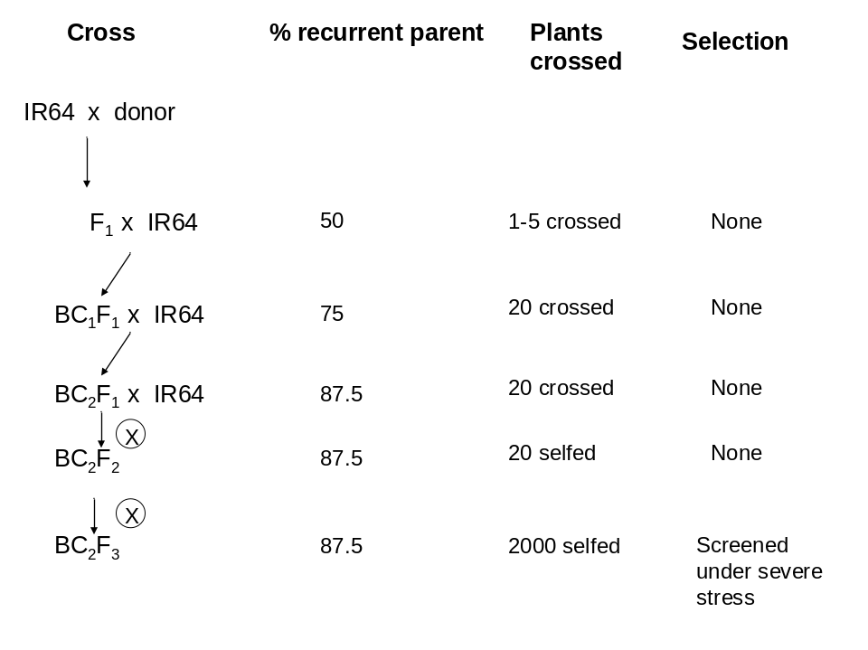

BC₂F₂-derived F₃ lines selected from BC₂F₂ plants that set seed under severe stress exhibit significantly improved yield under drought stress, but, because they are 87.5% derived from the recurrent parent, are usually similar to IR64 in yield and quality under non-stress conditions. The screening of BC₂-derived populations is somewhat difficult, because many crosses of the segregating BC₁F₁ to the donor are needed to ensure that all donor genes are represented in the BC₂F₂ population that undergoes selection. But much of the benefit of the scheme might still be derived if selection were initiated from the BC₁F₂ instead. Selection under stress in BC populations is a promising way to improve stress tolerance in elite rainfed lowland backgrounds, while retaining most of the favorable features of the original recurrent parent.

How many crosses to make?

The number of crosses made by a breeding program will depend largely on the resources it has available. Breeders often feel they need to explore many crosses, but careful choice of parents can reduce the number of crosses needed. Several breeding programs have achieved success using a small number of very diverse crosses, in which very large F₂ populations were screened. For example, J. Witcombe and collaborators in India and Nepal have developed several popular, locally-adapted varieties by crossing the short-duration upland variety Kalinga III with the irrigated variety IR64, and screening large populations with the participation of farmers in different environments (Witcombe, 2002). An intermediate approach, where a moderate number (10-30) of carefully-chosen crosses is explored each year through the use of large F₂ or BC₁F₂ populations, is probably optimal for small rainfed breeding programs.

2. The effect of F₂ population size on recovering recombinants

If the parents differ by more than a few important genes, as is usually the case, large F₂ populations must be screened to ensure that desired recombinants are recovered. For every locus that is heterozygous in the F₁, there is a 75% chance that any F₂ plant will carry the desired allele, and a 25% chance that it will not. For any number of loci, n, segregating for desired major genes, the probability tha any F₂ plant will carry all the desired genes in the heterozygous or homozygous condition is approximately:

P = (.75)^{n}

If there are 10 loci segregating for major genes affecting quality, duration, and pest resistances, then the probability that any F₂ plant will be carry the desired gene is about 0.056, or about 1 in 19. If, at the end of our pedigree line development process, we want to have 100 advanced lines carrying the desired traits, each descended from a different F₂ plant, available for replicated yield testing, we need about 19 x 100 F₂ plants from which to select. This corresponds well with the practical experience of many breeders, who usually recommend a minimum population size of about 2000 in the F₂. If a 3-way or double cross is used, population sizes need to be increased; for crosses of this type, F₂ populations of 3000-5000 plants should be screened, if possible.

3. Describing crosses and lines

Crosses

The “slash” nomenclature is useful for describing crosses. In this system, crosses are represented by the “/” symbol. The most recent cross made receives the highest number of slashes. Thus, if IR64 is crossed to Moroberekan, the cross is described as:

IR 64/Moroberekan

If this F₁ is crossed to PSBRC 80, the resulting three-way cross is written:

IR 64/Moroberekan//PSBRC 80

Backcrosses are denoted by a number indicating the number of doses of the recurrent parent, followed by an asterisk or multiplication sign. Thus, if Kalinga III is crossed to IR64 and then backcrossed, the cross is described as:

Kalinga III/2*IR64

Lines

It is important to track the development of lines carefully through a pedigree breeding program. New crosses should be given a unique identifier by which the population is tracked. For example, the cross Primavera/IR55423-01 carries the unique IRRI cross number IR76569. In each generation after the F₁ in which a line is extracted via single-plant selection, the selected plant number should be attached to the pedigree via a dash. For example, if 100 panicles are selected in the F₂ derived from IR76569, the line derived from the 35th selected F₂ panicle is denoted:

IR76569-35

If the F₂ is advanced in bulk, then the bulk population is denoted:

IR76569-B

The 12th F₃ plant selected from this bulk would give rise to a line described as:

IR76569-B-12

If the line from IR76569-B-12 is harvested in bulk, the resulting line is:

IR76569-B-12-B.

Describing the homozygosity of a line

The proportion of loci that were heterozygous in the F₁ and that are homozygous in F_{n} is simply 1-0.5^{n-1}.

e.g., in the F₄ generation, the proportion of homozygous loci is, on average, 1-0.5³, or 0.875.

Describing the homogeneity of a line

The genetic homogeneity of a line, or the proportion of loci (relative to those that were heterozygous in the F₂) fixed in it, is determined by the level of homozygosity of the plant from which the line was selected. Thus, in an F₆ line derived from an F₅ plant, it is expected that, of the loci that were heterozygous in the F₁, the proportion that are fixed is 1-0.5⁴, or 1-0.0625 = 0.9375.

Nomenclature to characterize both the homozygosity and homogeneity of a line

To completely describe the genetic structure of a line, it is necessary to know two things:

- The number of generations of inbreeding
- The inbreeding generation in which the line was established (that is, when it was derived from a single-plant selection.

An F₇ line derived from an F₆ plant is described as an F_{6:7} (or F₆-derived F₇) line. Such a line is both highly homozygous and highly homogeneous. An F₇ line derived from an F₃ plant by bulking the intermediate generations has the same level of homozygosity, but is much less homogeneous, because the F₃ plant from which it was derived was still heterozygous at many loci.

4. Pedigree versus bulk selection

Most rice breeders use pedigree selection from the F₂ generation onward. However, it may be more efficient to inbreed without selection, either in a bulk plot or a rapid-generation-advance facility, until plants are relatively homozygous, allowing homogeneous lines to be established. If bulk generation advance is used in the F₂ or later, care must be taken to maintain a large population, so that genetic variability is retained through the inbreeding process. It is generally efficient to advance about 2000 plants per generation by harvesting a single panicle per plant, and bulking the harvested plants. Mild selection for grain type, height, duration, and freedom from leaf disease is often applied in retaining plants for the bulk

5. What traits should be the focus of pedigree breeding?

Pedigree breeding is mainly based on visual selection, rather than on agronomic measurements. Therefore, selection should focus on highly heritable traits that are easily visually identified in a small plot or controlled-environment screen. These include, but are not limited to:

- Height
- Maturity and flowering date
- Panicle type
- Grain size and shape
- Amylose content, gelatinization temperature, chalkiness, and aroma
- Seedling submergence tolerance
- Bacterial blight and leaf blast resistance

Selection for low-heritability agronomic traits like grain yield, seedling vigor, and weed competitiveness is difficult to do effectively in pedigree nurseries because of the large effect of environmental heterogeneity on these traits. The objective of a pedigree breeding program is to generate a large set of uniform lines that are acceptable in terms of the highly heritable traits listed above. This set is the raw material for selection for yield in replicated trials.

6. For how many generations should pedigree selection continue?

There is considerable variation among breeders of pure line crops in the number of generations used for pedigree selection. Varieties have been released from lines as early as F₂-derived, and as late as F₁₀-derived or later, but most rice lines are probably derived from single F₅, F₆, or F₇ plants. There are two issues to consider when deciding the generation in which to cease pedigree selection and begin replicated testing:

  - The degree of genetic variance left within lines upon which to perform selection;
  - The phenotypic uniformity of lines.

In terms of genetic variability remaining within lines, most is exhausted by the F₄ generation. An F₄ plant is homozygous at 87.5% of the loci that were heterozygous in the F₁. Thus, 87.5% of the genetic variation in a breeding population is found among F₄-derived lines not within them. In terms of increasing response to selection, there is little benefit from carrying pedigree breeding on past the F₄ or F₅.

The main reason to continue pedigree selection to advanced generations (F₆ or later) is to achieve adequate visual uniformity of lines that may be segregating for height, duration, grain type, awns, or other easily-observed traits. Even a small number of segregants for these traits can make a line look ragged and ununiform. Both farmers and breeders like a “flat-top” uniform appearance in new varieties, although farmers are often able to accept considerable variation within landraces. Lines established from F₆ or F₇ plants are likely to be highly visually uniform.

Exercise

Construct a table for lines established from the F₂ through the F₇ generation indicating the proportion of segregating loci expected within the line.

7. Controlling field variability in pedigree nurseries

Repeated checks and gridding

Pedigree nurseries can be laid out in any way that permits convenient rating, scoring, and selection. Repeated check varieties should be included at regular intervals for visual reference, permitting the effects of field variability to be assessed, but it is important not to devote too much field space to checks. Generally, a check plot after every 10-20 pedigree lines should be adequate.

Field variation can affect even highly heritable traits like height and days to flowering. In addition to the use of repeated checks, field variation can be controlled by gridded selection, or the practice of making selections only among nearby pedigree lines.

Family selection

Field variability can also be controlled by separating the sublines selected from the same line in a previous generation and planting them in different blocks in the field. This can be done with F₄ lines within F₃ families, or F₅ lines within F₄ families. The individual lines within families can be treated as replicates of the same family. This is because closely related sister lines share most of their genes; much more genetic variation occurs among than within families derived from the F₃ generation onward. For example, two sister F₄ lines derived from the same F₃ plant have a coefficient of coparentage (the probability that an allele drawn from 1 line will be identical to that from the other by descent) of 0.75. For F₅ lines from the same F₄ plant, the coefficient is 0.875) If F_{4:5} or F_{5:6} sister lines are handled as replicates of the same family (that is, planted in different blocks) the advanced pedigree nursery can then be treated as an observational yield trial. Only the best lines within the best families are selected. This method is being used in the aerobic rice breeding program, where improving grain yield under aerobic conditions is the main objective.

Summary

Most successful crosses have at least 1 high-quality, adapted parent that is preferred by farmers in the TPE. It is often difficult to use unadapted donor parents directly to develop varieties. Pre-breeding may be needed.
- BC₁- or BC₂-derived populations may be more efficient in terms of generating high-quality, high-yield lines than two-way, three-way, or double crosses because they leave adapted gene blocks in the elite recurrent parents intact.
- At least 2000 plants should be screened in the F₂ (more, if 3-way or double crosses are used.
- A standard pedigree description system should be used, to facilitate exchange of information with other breeding programs.
- Bulk inbreeding in the F₂ and F₃ generations is used by some breeders to inexpensively produce relatively uniform lines in which to begin pedigree selection.
- Pedigree selection should focus only on highly heritable, easily-scored traits. The goal is to produce a large sample of adapted lines of appropriate quality to submit to replicated yield testing.
- Pedigree selection through the F₆ or F₇ generation may be needed to produce visually uniform lines, but there is little genetic variability among F₆ sister lines derived from the same F₅ plant.
- Regularly occurring checks should be included in pedigree nurseries, but their frequency should not exceed 10% of the total number of plots.
- Selection among families of closely-related lines can be used in advanced pedigree generations. Individual lines in a family can be treated as replicates, and planted in different blocks to overcome the effect of field variability. This design combines the features of an advanced pedigree nursery and an observational yield trial.

Training aids required

- Computer projector
- Overhead projector

