Question from a to c
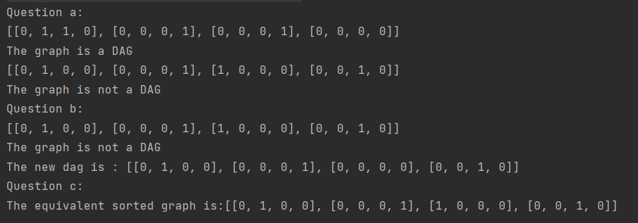

Question d
H does not equal to G

The sort_dag function takes a directed acyclic graph (DAG) as input and returns a topologically sorted version of the same graph. This means that the nodes in the sorted graph will be ordered in such a way that for every directed edge u -> v, node u will appear before node v in the sorted list which may not be a DAG. On the other hand, the make_dag function returns a DAG representation of the same graph. Therefore, G does not equal to H.

