Questions a to e

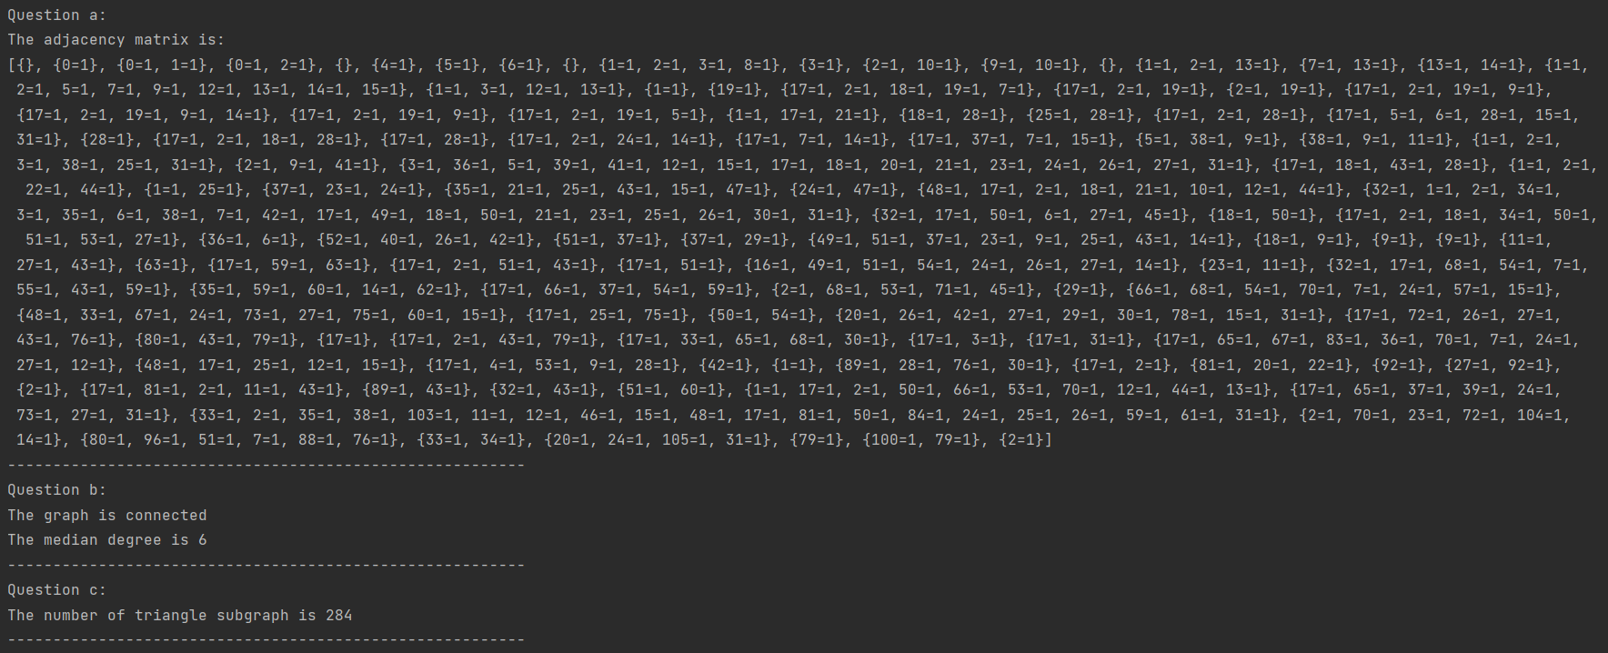

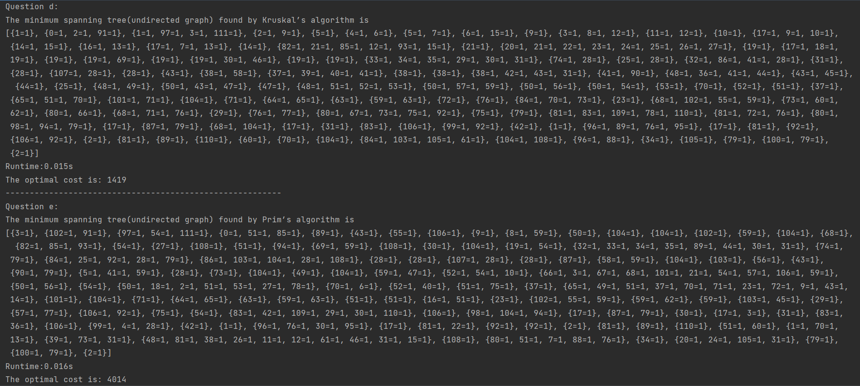

Question f

The running time, optimal cost, and the optimal solution are shown as above. The reason why the time is different is that the two algorithms have different time complexity

Question g

$x_{ij}$ indicates the network flow on edge (i,j) is in the tree.

For each vertex i, ensure that exactly one incoming and one outgoing edge are present: Out degree constraint: $\sum_{j}{x_{ij}}$ = 1 for all vertices i. In degree constraint: $\sum_{j}{x_{ji}}$ = 1 for all vertices i

Objective function: Minimize the sum of the edge weights in the tree

$\sum_{i}{\sum_{j}{c_{ij}x_{ij}}}$ $c_{ij}$ is the cost of edge (i,j), and $x_{ij}$ is the network flow on edge (i,j) is in the tree.