1. prepare your sd card, the mp3 files should put into folders, see blow image.
Touch-to-MP3 code for the [Bare Conductive Touch Board](http://www.bareconductive.com/shop/touch-board/) playing a random track from fixed folders on the micro SD card. Touch electrode 0, a random MP3 from folder **E0** on the micro SD card plays. Touch electrode 1, a random MP3 from folder **E1** plays from the micro SD card, and so on. The naming of the MP3 files does not matter, provided that they have the .mp3 extension and are placed in folders named **E0** to **E11**.

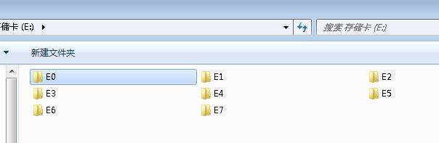
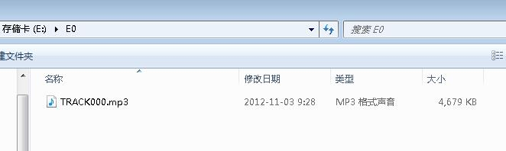
2.Upload Random_Touch_MP3 sketch to your Touch Board.
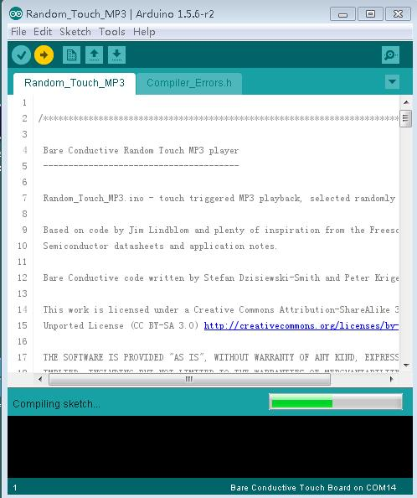
Open the serial monitor and touch the pin, you will get the out put.
