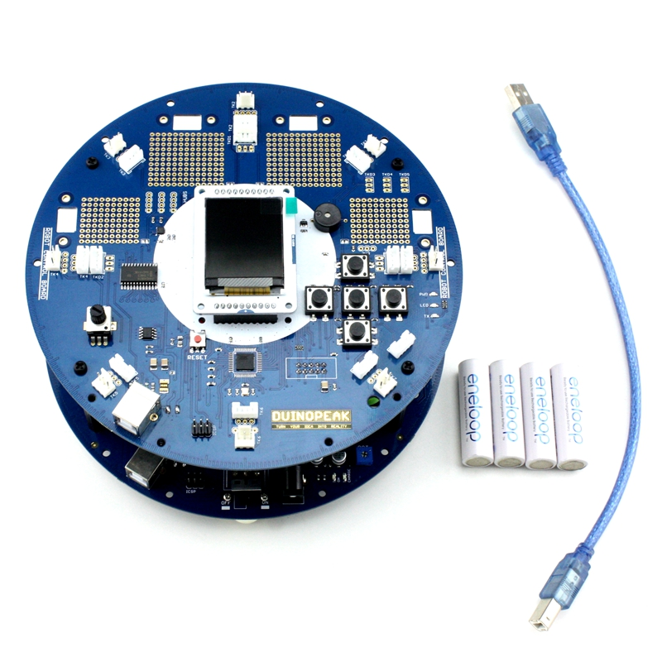

As the image above, we need four Nickel metal hydride batterys for power supply, and a USB cable for programming the Robot, and the most important is the micro-sd card that for robot display images and texts as well as playing music.

OK, we got everything ready. first of all we need prepare the SD card for the Robot.

What we need to do is just copy the content to the micro-sd card, you need download the prepared content, please download [here](http://duinopeak.com/wiki/index.php?title=%E6%96%87%E4%BB%B6:ArduinoRobot_SdContent.zip). Then exact the files and copy to your micro-sd card and the file structure should be like this:

OK, now plug the micro-sd card into your SD soket of the Robot's TFT lCD module.Next, install the batteries to the Robot's battery case.

So, let's start to test our Robot, place the Robot on a flat surface. Open the power switch, you got the Robot alive.

**Note**:The Robot pre-programing with the LOGO sketch, and the routeline of LOGO sketch as below.

* Show the LOGO on the TFT LCD.
* Calibrate the onboard Compass module so the Robot can turning and know its orientation.
* Show the operation instructions.

That is to say the robot will be turning when you powering up the Robot for calibarate the compass. You can press the up, down, left and right buttoons when you see the operation instruction print on the TFT LCD, and press enter(center button) to make robot excute the command.