Prepare

Software: [Balanbot Sourcecode](http://wiki.duinofun.com/images/3/3c/Balanbot.zip)

Driver : [BalanbotPC_Driver](http://wiki.duinofun.com/images/0/07/BalanbotPC_Driver.zip) (include widows, linux and mac)

Hardware:

* USB Cable.
* Balanbot.
* 3S Lipo battery pack.

Setup arduino dev environment.

Please use arduino 1.56 or above. Otherwise will get a compile error.

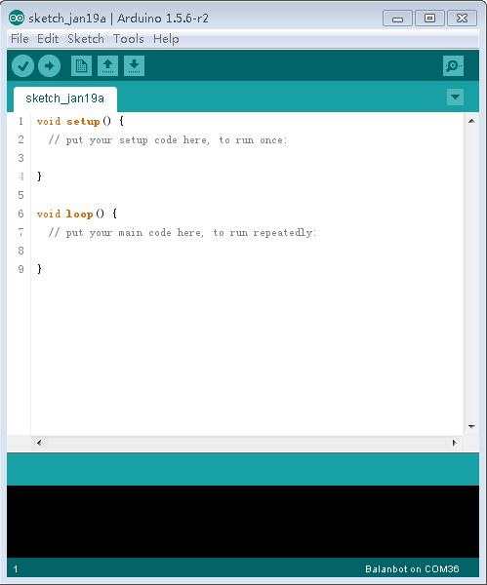

Unpack the Source code file to your local disk. The file structure should same as follow.

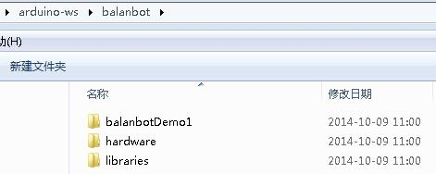

Set arduino work path to your source folder.

Open File->Preferences, Sketchbook location, click OK and reopen your arduino ide.

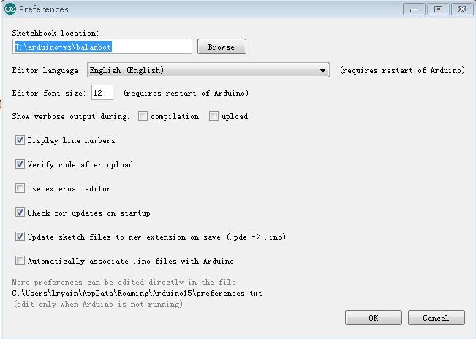

Then connect USB cable to your balanbot, for windows, will popup new hardware installation.

Upack the driver to your local disk and locate the driver path to driver path of the new hardware installation. After install a new Serial port will appear, see your device management.

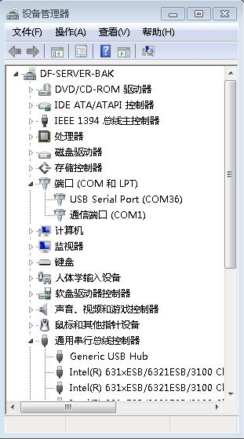

Next open the demo, Open File-> Sketchbook->balanbotDemo1.

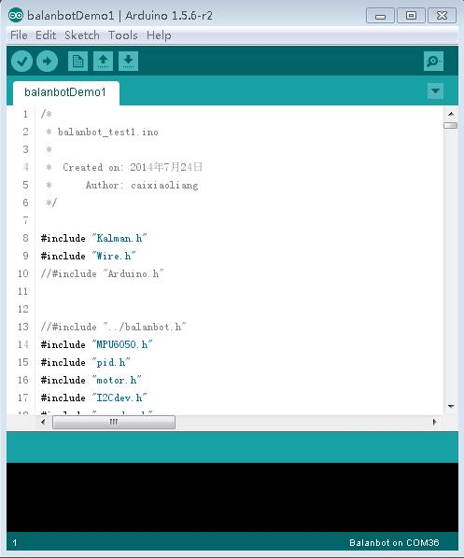

Before next step make sure your ide Tools->Board has Balanbot menu. If this not appear check your Sketchbook folder contains hardware folder.

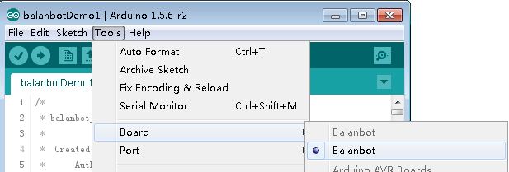

And choose the newly installed Serial port, my is COM36.

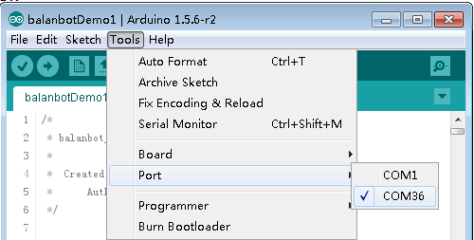

OK, we can upload the demo code now. Click the upload icon to upload. When uploading the rx and tx led of balanbot near the USB socket.

We could see arduino ide says:"Done uploading." when it's done.

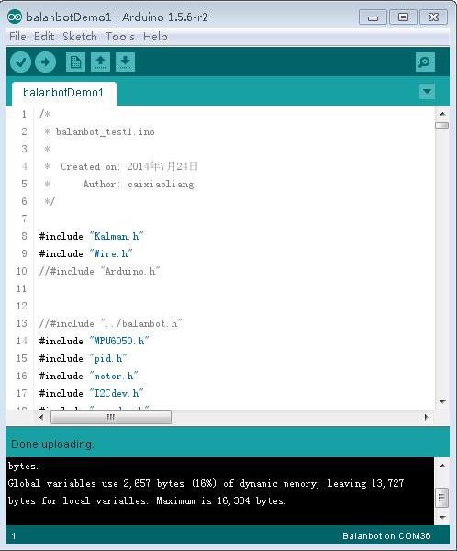

Next we need do a step which was very important.

Open the serial monitor, also you will hear a "Beep", indicate the initial was succeed.

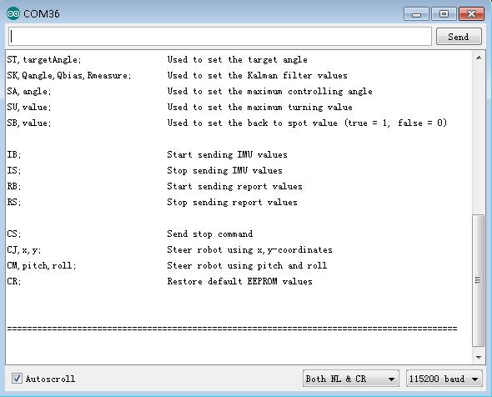

Type CR; and press Enter to restore default EEPROM values.

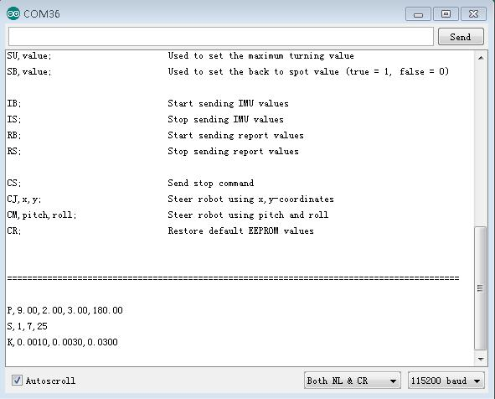

**Note:** When you got your a new balanbot or replace the main IC with new one. You need do this step.

Next we need calibrate motors, before calibrate motors you need place balanbot's wheel upward. Then type MC; and press Enter in Serial monitor.

Now will print the both motor encoder readings.

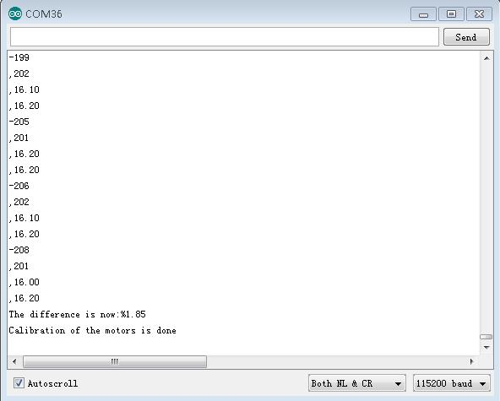

According the tips complete calibrate motors.

Now you got you balanbot ready to go.

Now pull out usb cable and plug in bluetooth dongle to balanbot USB host socket.

Connect your 3S Lipo to balanbot, horizontal your balanbot and turn on power switch. Your will hear a "Beep" when balanbot initial success.

Then install the apk and open your andorid app and enjoy it.

Note:

* Everytime balanbot need calibrate it's sensor. And the initial position is put the balanbot on the it's side.
* Balanbot initial success will make a "Beep".
* You should connect balanbot's bluetooth before it's lift.