The bottom
First of all we need assembly the bottom of the Balanbot.
Prepare the following parts.
Bottom Check List of Balanbot
1 | DC Motor | 2pcs | Different encoder cable
2 | Aluminum motor holder | 2pcs | For fixing motor
3 | Screw M3*12mm | 8pcs | For fixing motor holder
4 | Anti slip M3 nut | 8pcs | For fixing motor holder
5 | Screw M3*5mm | 8pcs | For fixing motor
6 | Shaft coupling | 2pcs | Inner diameter 6MM
7 | Screw M3*6mm | 2pcs | For fixing shaft coupling
8 | Screw M4*6mm | 2 pcs | For fixing wheels
9 | 10mm Copper pillar | 4pcs | For fixing the controller
10 | M3 nut | 4pcs | For fixing the controller
11 | Screw M3*6mm | 4pcs | For fixing the controller
12 | 35MM Copper pillar | 8pcs | For supporting the body acrylic plate
13 | Anti slip M3 nut | 4pcs | For fixing acrylic plate
14 | Screw M3*6mm | 4pcs | For fixing acrylic plate
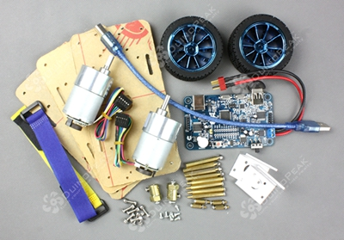
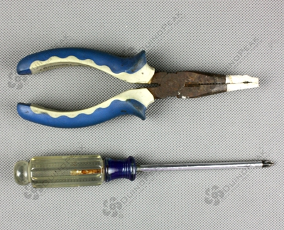
And you also need some tools, screwdriver and pliers. Everything is ready here we start.
1. The bottom layer.
1 | DC Motor | 2pcs | Different encoder cable
2 | Aluminum motor holder | 2pcs | For fixing motor
3 | Screw M3*12mm | 8pcs | For fixing motor holder
4 | Anti slip M3 nut | 8pcs | For fixing motor holder
5 | Screw M3*5mm | 8pcs | For fixing motor
Refer to the below image to assemble.
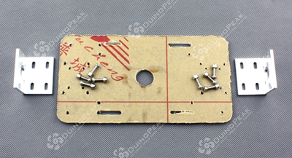
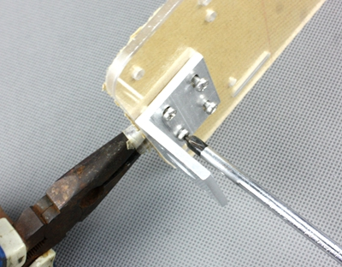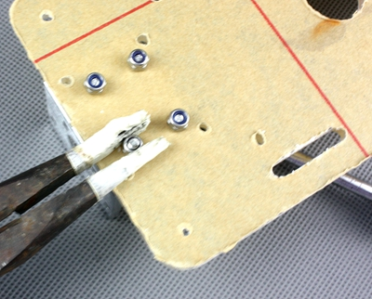
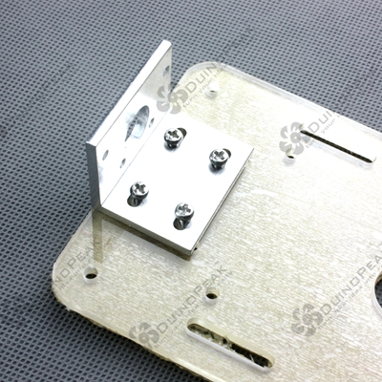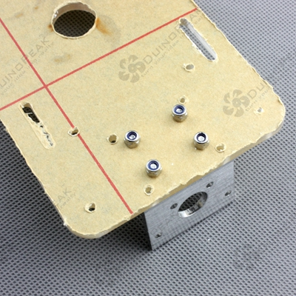
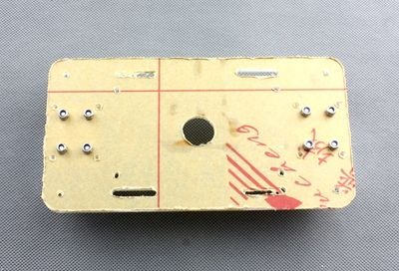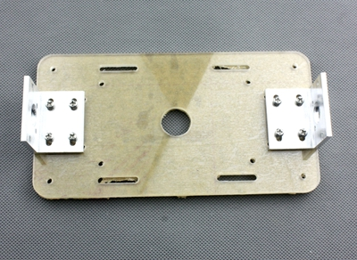
2.Install the motors.
Before installing the motor, we recommend to check whether the motor can rotate smoothly, because it may cause the encoding disc displacement of the motor during transportation. If not adjust the encoding disc displacement of the motor will fixing it.

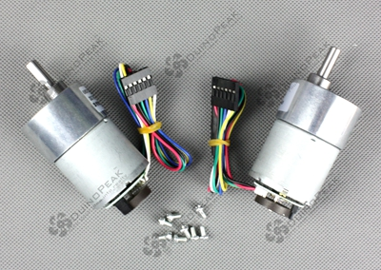
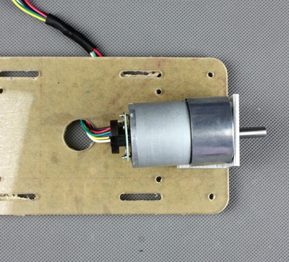

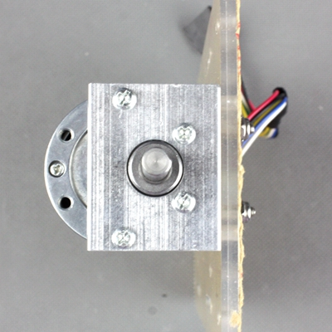
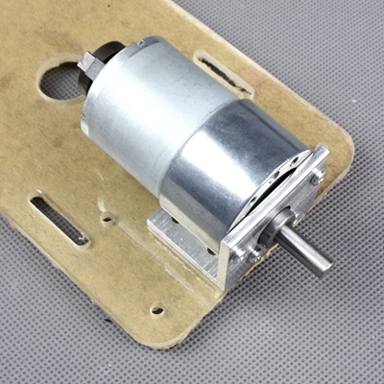
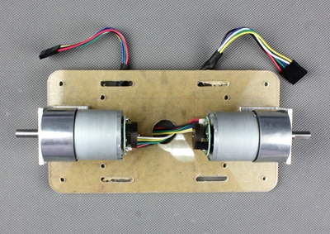
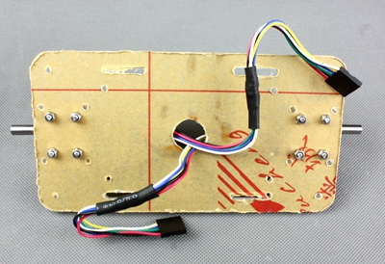

Install the Controller board.
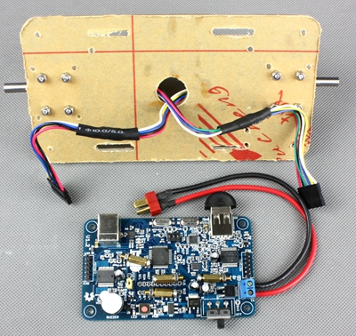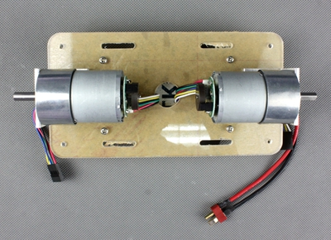

Screw four nuts and plug the encoder cable strictly according to the image.
Important: the two motor's encoder cable has different line order, so make sure your plug the right side of the controller board.

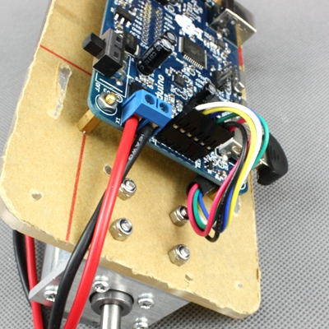
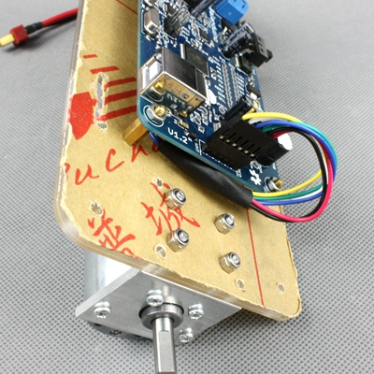

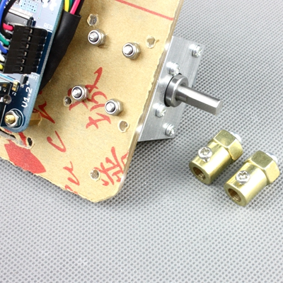
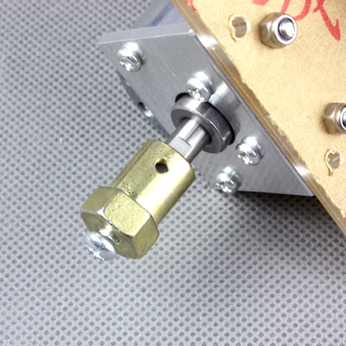
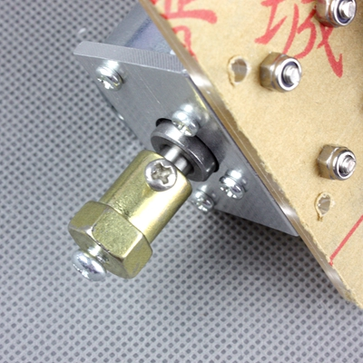
done!