轻触开关

产品简介
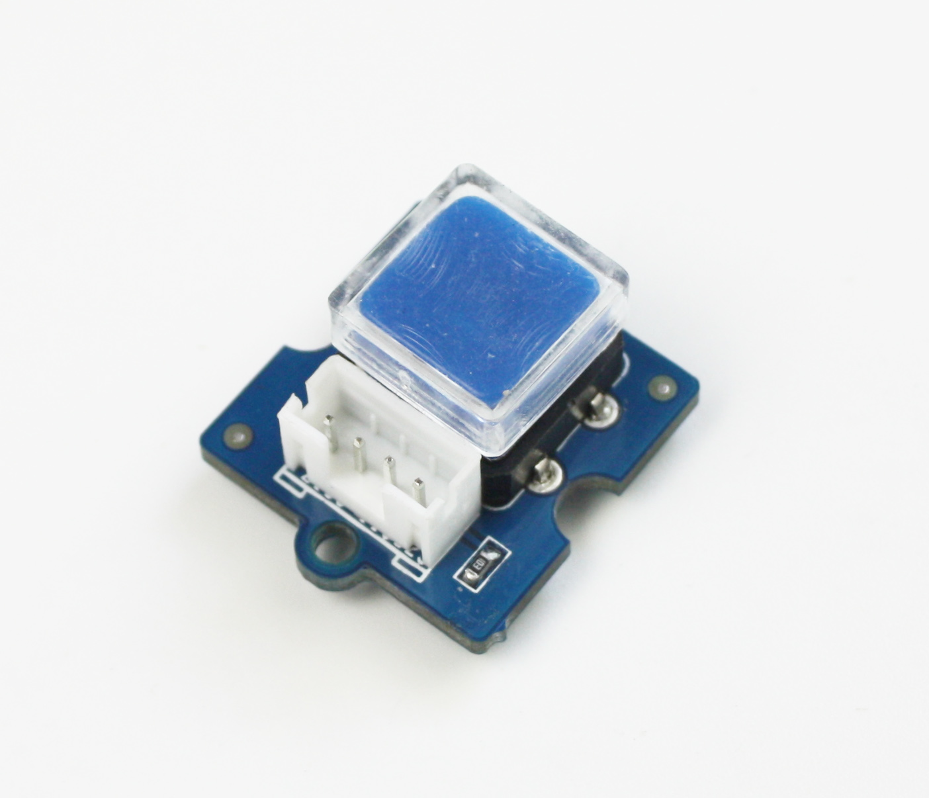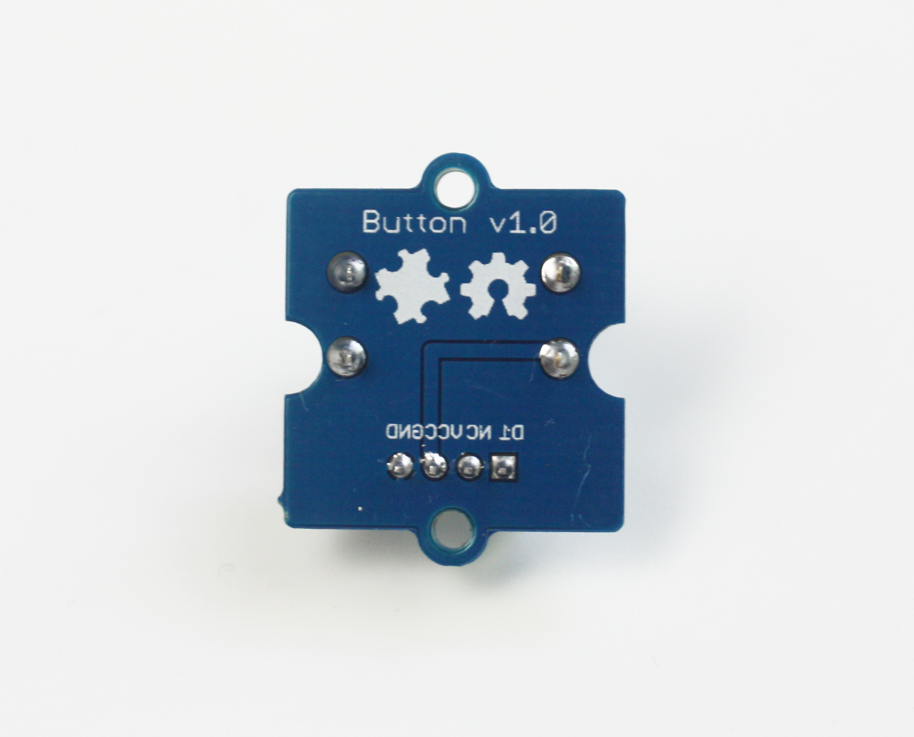

Puzzle - Button是一个瞬时按键。一般情况输出LOW。我们备有两个型号的Puzzle- Button。另一个是Puzzle - Button，它们只有在Puzzle座子的方向上有所不同。
规格参数
* LED 从13端口连接至地
* 按键从+5v连接至端口2
* 10k的电阻从地连接到端口2
* 几乎每块arduino板上都有一个LED连接至端口13

应用示例
下面的例子演示了如何用Puzzle- Button来开或关LED。

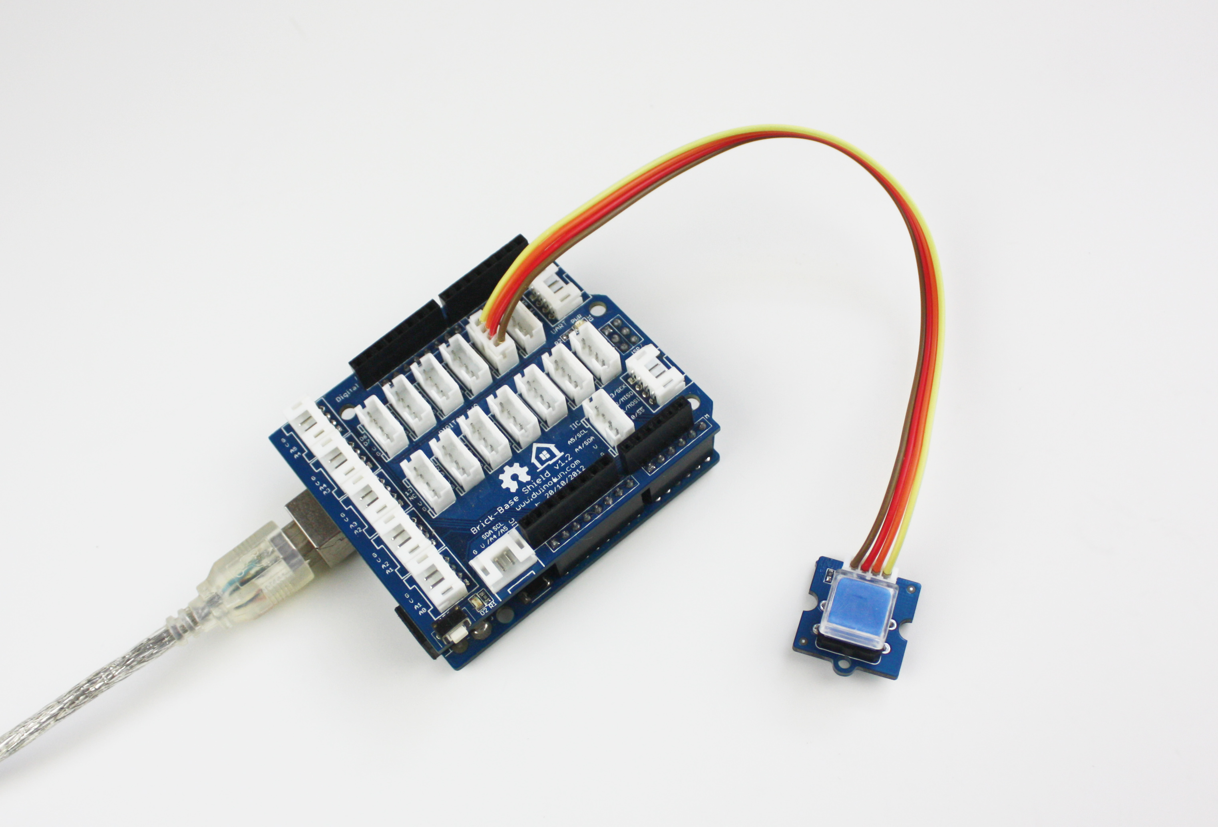
//Turns on and off a light emitting diode(LED) connected to digital pin 13, when pressing a pushbutton attached to pin 2.
/*
The circuit:
* LED attached from pin 13 to ground
* pushbutton attached to pin 2 from +5V
* 10K resistor attached to pin 2 from ground
* Note: on most Arduinos there is already an LED on the board
attached to pin 13.
This example code is in the public domain.
http://www.arduino.cc/en/Tutorial/Button
*/
// constants won't change. They're used here to
// set pin numbers:
const int buttonPin = 2; // the number of the pushbutton pin
const int ledPin = 13; // the number of the LED pin
// variables will change:
int buttonState = 0; // variable for reading the pushbutton status
void setup() {
// initialize the LED pin as an output:
pinMode(ledPin, OUTPUT);
// initialize the pushbutton pin as an input:
pinMode(buttonPin, INPUT);
}
void loop(){
// read the state of the pushbutton value:
buttonState = digitalRead(buttonPin);
// check if the pushbutton is pressed.
// if it is, the buttonState is HIGH:
if (buttonState == HIGH) {
// turn LED on:
digitalWrite(ledPin, HIGH);
}
else {
// turn LED off:
digitalWrite(ledPin, LOW);
}
}

Support
If you have questions or other better design ideas, you can go to our "forum":http://www.seeedstudio.com/forum or "wish":http://wish.seeedstudio.com/ to discuss.

