Puzzle - LED
Introduction
Puzzle - LED is designed for the beginners of Arduino/duinofun to monitor controls from digital ports. It can be mounted to the surface of your box or desk easily and used as pilot lamp for power or signal. Its brightness can be adjust by potentiometer.
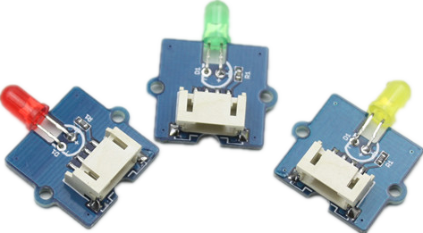
There are four products which can light different colors. They have the same work principle.
Features
- 3.3V/5V Compatible
- Adjustable LED orientation
- Adjustable LED brightness
Specification
Item | Discription
LED Control Mode | Digital Pin of Arduino
Working Voltage | 5V

Usage
Here we show how to use Arduino to control the state of the LED.
1. Connect the LED to Base Shield's digital port 2 with 4pin Puzzle Cable.Of course you can change to other valid digital ports if it's necessary and the definitions of the port should be changed too.
2. Plug it onto the Arduino/duinofunuino. Connect the board to PC using USB cable.
3. Copy the demo code to your sketch, then upload to Arudino or duinofunuino board. Please click here if you do not know how to upload.
You will see the LED blink every second.

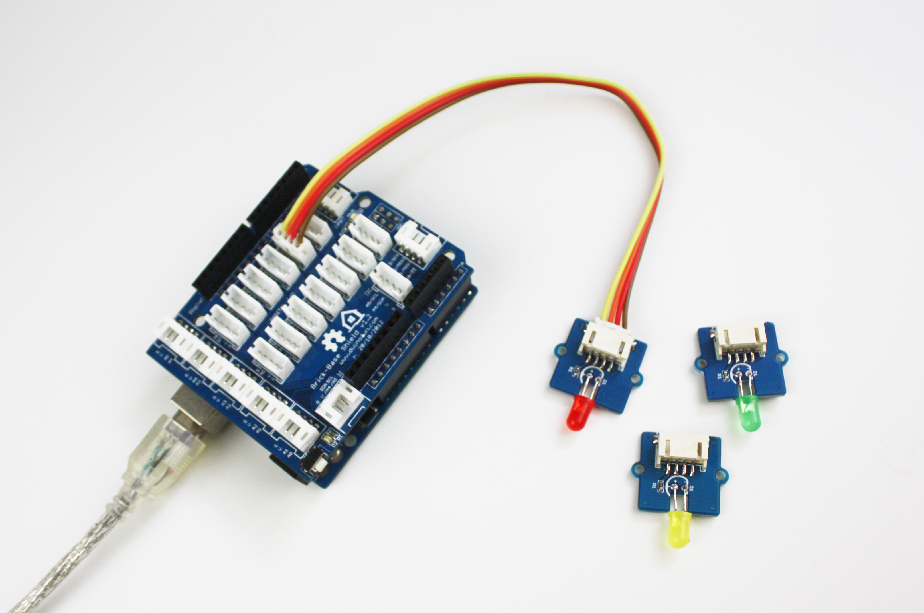
/************************* 2014 duinofun **************************
* File Name : PuzzleLEDDemoCode.ino
* Version : V1.1
* Date : 2014-07-14
* Description : Demo code for Puzzle - LED
*************************************************************************/

#define LED 2 //connect LED to digital pin2
void setup() {
// initialize the digital pin2 as an output.
pinMode(LED, OUTPUT);
}

void loop() {
digitalWrite(LED, HIGH); // set the LED on
delay(500); // for 500ms
digitalWrite(LED, LOW); // set the LED off
delay(500);
}

Resources
PuzzleLEDDemoCode
Puzzle LED eagle files
Puzzle-LED Socket Kit

Support
If you have questions or other better design ideas, you can go to our forum or wish to discuss.

