MajorDoMo

created by [hek](https://www.mysensors.org/user/1/projects/hek), updated

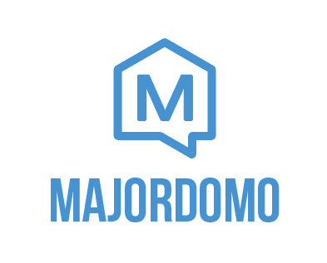MajorDoMo (Major Domestic Module) is an open-source home automation platform aimed to be used in multi-protocol and multi-services environment.

It is based on a web-technologies stack and ready to be delivered to any modern device. Flexible in configuration with OOP paradigm used to set up automation rules and scripts.

MySensors is supported through the [Serial Gateway](https://www.mysensors.org/build/serial_gateway), [Ethernet Gateway](https://www.mysensors.org/build/ethernet_gateway) and [MQTT Gateway](https://www.mysensors.org/build/mqtt_gateway)

[Homepage](http://majordomohome.com/) [Online Demo](http://demo.majordomohome.com/) [Support Forum](http://forum.mysensors.org/category/22)

Features

* Easy to install.
* Cross-platform (Linux/Windows).
* Free for personal and/or commercial usage.
* Hardware support (MQTT, ZWave, 1-wire, ModBus, SNMP, Ethernet).
* Multi-lingual interface.
* Flexible API.
* Web-based interfaces for any device.
* GPS-tracking and geofence support.
* Voice notifications and speech recognition with Android client application.
* Push notifications using Pushbullet.
* 3rd party services/web-sites integration.
* Multimedia control.
* Advanced security model.
* Learn and Share with Connect web-site.
* CloudSync (access from anywhere).
* One-click update.
* Web-technologies in place (PHP/HTML5/CSS).
* Classes/Objects/Properties/Methods.
* Scripting with PHP and/or Blockly.
* Advanced debug and self-diagnostics.
* Plugins market.