CDS524 Assignment 1 Report - Snake Game with Tabular Q-Learning
Student: Li Ya
Submission date: 3 March 2026

1. Introduction
This project implements a classic Snake-style reinforcement learning (RL) game using tabular Q-learning. The goal is to demonstrate a complete RL workflow—game specification, state/action design, reward engineering, learning algorithm implementation, and evaluation—while keeping the environment simple enough to train quickly and to explain clearly. Snake is a useful benchmark because the agent must make sequential decisions under safety constraints (avoid collisions) while pursuing a moving objective (food). To make tabular learning feasible, I use a compact feature-based state representation rather than the full grid image. The resulting Q-table remains small and interpretable, and the learned policy can be demonstrated in a lightweight UI.
2. Game Design
Objective and rules. The environment is a 12x12 grid. The snake starts near the center with length 3. At each time step, the agent selects one action to change the heading, then the snake moves forward by one cell. If the snake head reaches the food, the snake grows by one segment and a new food item spawns uniformly at random on an empty cell. An episode terminates immediately if the snake collides with the wall or its own body. To prevent endless loops, an episode also ends when a maximum step limit (500) is reached.
State space. Using the full grid as a state would create an enormous state space that is not suitable for a tabular Q-table. Instead, I encode the game into a compact discrete feature vector that still captures the key decision factors:
• danger_straight, danger_left, danger_right: three binary flags indicating whether moving in that relative direction would cause an immediate collision
• food_up, food_down, food_left, food_right: four binary flags indicating the food's position relative to the snake head
• direction: the current heading of the snake in {UP, RIGHT, DOWN, LEFT}
This representation yields at most 2^7 * 4 = 512 discrete states, which is small enough for tabular Q-learning while still allowing the agent to react to local hazards and to move toward the food.
Action space. I use three relative actions rather than four absolute directions: STRAIGHT, TURN_LEFT, and TURN_RIGHT. Relative actions avoid invalid moves such as reversing into the snake's neck and make the policy easier to learn because the same action has consistent meaning across headings.
Stochastic dynamics (food spawning). The transition dynamics are deterministic given the current snake body and action, except for food placement. After each food is eaten, the next food location is sampled uniformly from empty cells, which introduces stochasticity across episodes. The agent must therefore learn a general policy rather than memorizing a single fixed trajectory.
Reward function. I used a shaped reward that is simple to explain but strong enough for fast learning:
• Step cost: -0.05 per time step (encourages efficiency)
• Food reward: +10 when the snake eats food
• Collision penalty: -10 and episode termination on wall/self collision
• Distance shaping: +0.1 if Manhattan distance to food decreases after the move, else -0.1
The distance shaping term provides dense feedback so the agent can improve even when food is not reached during early exploration.
User interface. For demonstration, a simple Pygame UI renders the grid, snake body, and food. It displays the current score, step count, most recent action, and the immediate reward. This satisfies the requirement that the UI shows state, actions, and rewards/penalties.

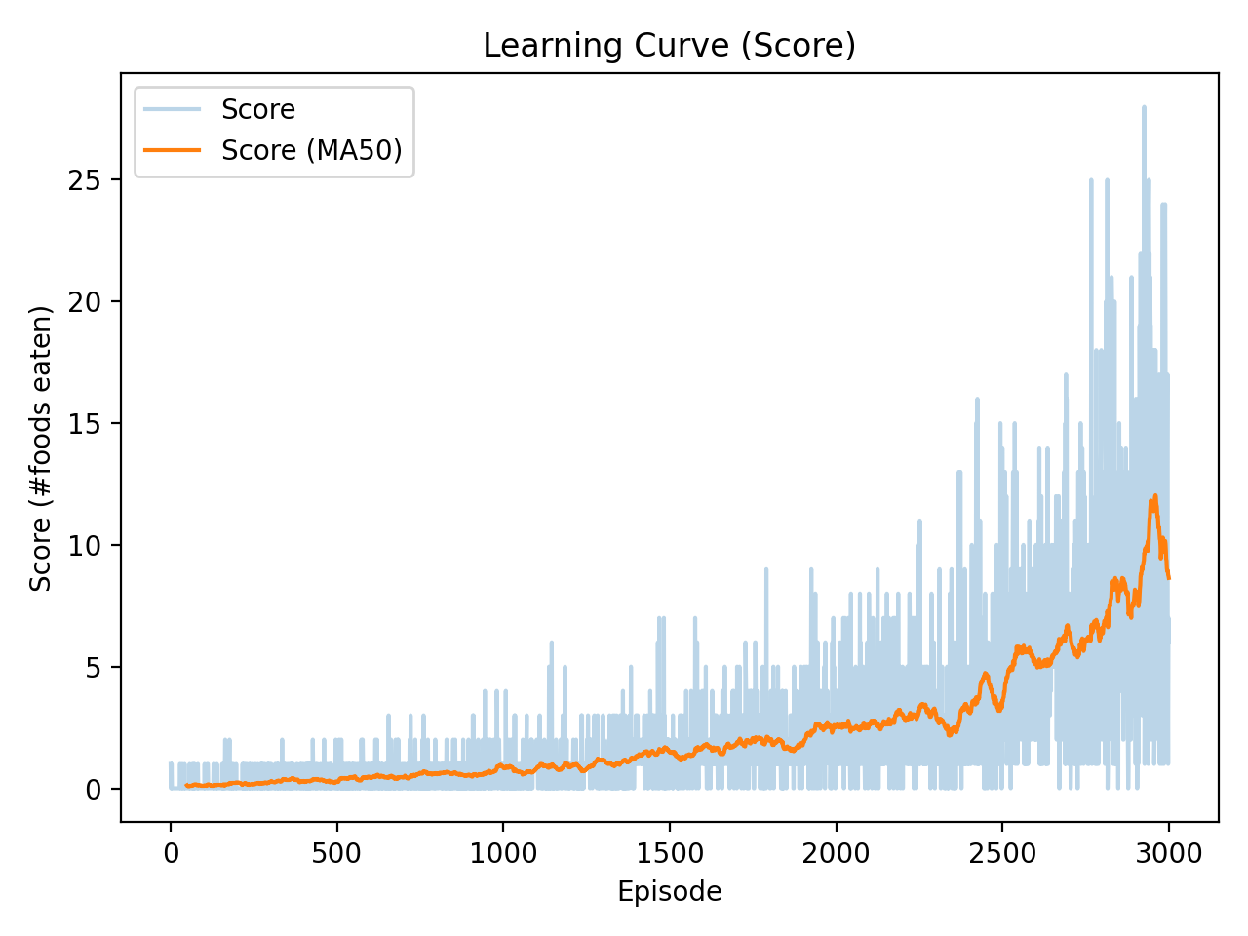
Figure 1. Training learning curve for score (foods eaten) over episodes.

3. Q-Learning Implementation
Algorithm. Q-learning is a model-free, off-policy, value-based RL algorithm. It learns an action-value function Q(s,a) estimating the expected discounted return when taking action a in state s and then acting greedily thereafter. The update rule is:
Q(s,a) <- Q(s,a) + alpha * [ r + gamma * max_{a'} Q(s',a') - Q(s,a) ]
where alpha is the learning rate, gamma is the discount factor, r is the reward, and s' is the next state.
Exploration strategy. I used epsilon-greedy exploration: with probability epsilon the agent selects a random action; otherwise it selects argmax_a Q(s,a). Epsilon decays linearly from eps_start to eps_end over a fixed number of episodes, encouraging broad exploration early and more exploitation later when the Q values stabilize.
Hyperparameters. The final run used: alpha=0.10, gamma=0.95, eps_start=1.00, eps_end=0.05, episodes=3000, max_steps=500, and grid size=12. These values balance stability and speed: a moderate learning rate supports steady improvement, while a high discount factor rewards long-term survival and planning.
Implementation details. The Q-table is implemented as a dictionary mapping discrete feature states to a 3-element action-value vector. Unseen states are initialized to zeros. During each step, the environment computes the next state, reward, and termination flag, and then the Q update is applied. Training logs store episodic return and score, and the learned Q-table is saved to disk so it can be loaded by the UI demo.
4. Evaluation and Results
Evaluation protocol. After training, I evaluated the greedy policy (epsilon=0) for 300 episodes with the same environment settings. I report the average score (foods eaten), average episode length (steps survived), and average return. I also report the training mean score over the last 200 episodes with epsilon fixed at eps_end (which includes occasional exploratory actions).
Results. In the training run of 3000 episodes, the mean score over the last 200 episodes was 9.07. In greedy evaluation over 300 episodes, the agent achieved an average score of 19.16 (std 6.60), with median score 18.0, 90th-percentile score 27.1, and maximum score 43. The average episode length was 181.7 steps (std 75.5). The average discounted return was 184.5 (std 66.7).
Learning behavior. The learning curve (Figure 1) shows a clear upward trend: early episodes yield low scores because random exploration quickly leads to collisions, while later episodes achieve substantially higher scores as the policy learns to avoid local hazards and to approach food reliably. In qualitative tests using the UI, the learned policy tends to move directly toward food when safe, and it takes conservative turns when a straight move would cause an immediate collision.

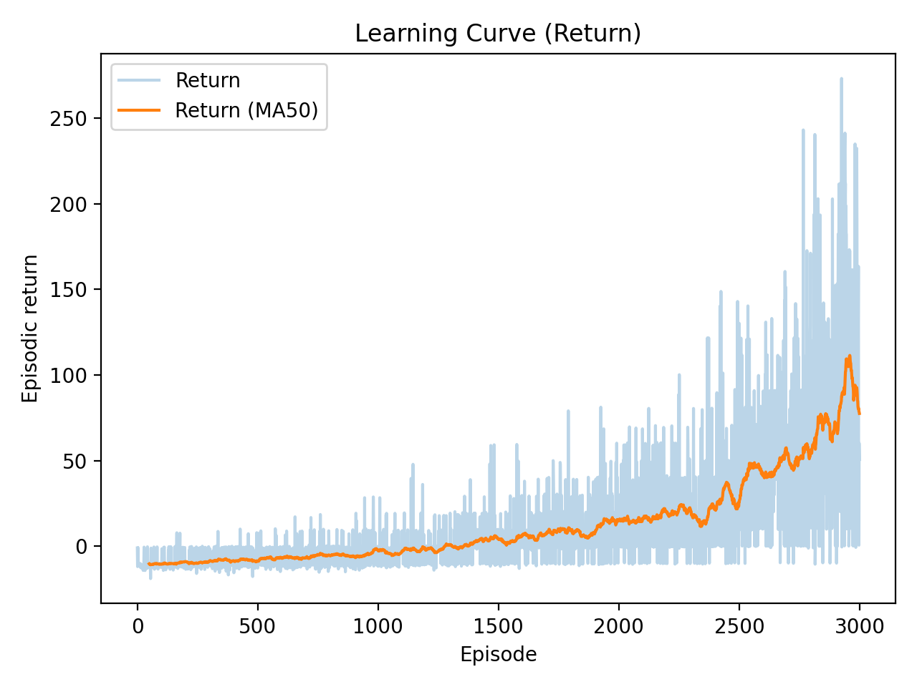
Figure 2. Training learning curve for episodic return over episodes (raw values and moving average).
5. Challenges and Solutions
State representation trade-off. A naive state definition that includes the entire grid would be infeasible for tabular learning. The compact feature state solves the scalability issue but discards long-range geometry of the snake body. I mitigated this by including three immediate danger flags, which capture the most important collision risks for short-horizon decision making.
Sparse rewards and exploration. If reward is only given when food is eaten, learning is slow because early random policies rarely reach food. To accelerate learning while keeping the objective intact, I used a small per-step cost and a distance-to-food shaping term. This provides dense feedback and reduces the number of episodes needed to reach stable improvements.
Exploration schedule. If epsilon decays too fast, the agent can converge prematurely to a timid policy that survives but eats little food. If epsilon decays too slowly, the score remains noisy and learning is inefficient. I used a linear decay to eps_end over most of training, which preserves exploration long enough to discover food-seeking strategies while allowing exploitation near the end.
6. Conclusion
This project delivered a complete RL game using tabular Q-learning on a Snake environment. The game objective and rules are clear, the state and action spaces are compact and discrete, the reward function is interpretable, and the epsilon-greedy exploration strategy enables efficient learning. Evaluation results show that the learned policy can consistently survive and collect multiple food items, demonstrating that a carefully designed feature state can make Snake solvable with tabular methods. Future work could incorporate richer state features (e.g., relative tail direction or longer-range obstacle cues) or compare with function approximation methods such as DQN.
7. References
1. Sutton, R. S., and Barto, A. G. Reinforcement Learning: An Introduction (2nd ed.).
2. GitHub repository and notebook for this submission (see README for links).
3. Pygame documentation (UI rendering).

