Case Study 9 Worksheet

Add screenshot of the calculator with the run line.



Screenshot of calculator file when executed

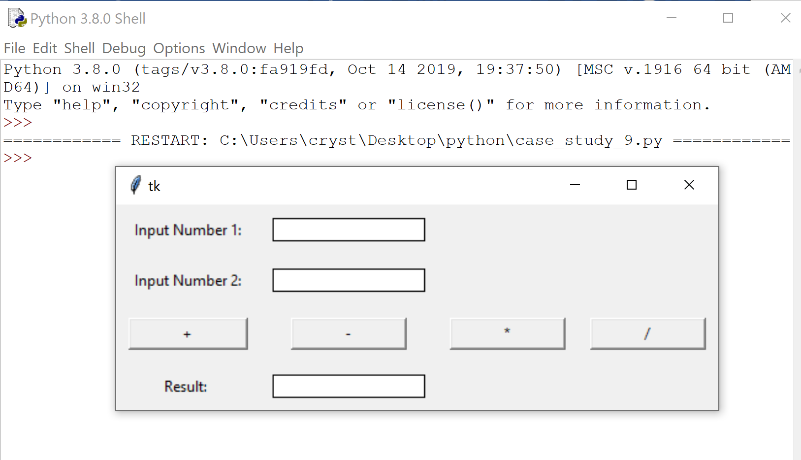

Upload the python source file(s)