1开启mysql慢查询日志
查看是否开启慢查询日志：show variables like '%slow%'
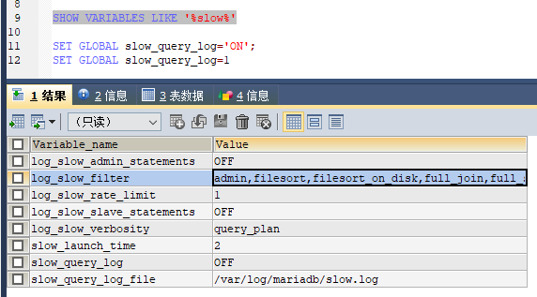

开启慢查询日志：set global slow_query_log=1;
关闭慢查询日志：set global slow_query_log=0;

查看慢查询，阈值时间：show variables like '%long_query_time%'，默认10s
设置：set global long_query_time=1

2统计sql执行语句耗时
查看是否开启： show variables like "%pro%";
设置开启方法： set profiling = 1;
查询查询耗时：show profiles

3explain详解

4mysql语句优化
SELECT * FROM user100w_optimizition WHERE copy_id=9

1000w条数据，没建立索引之前需要全表扫描，耗时：5.98s

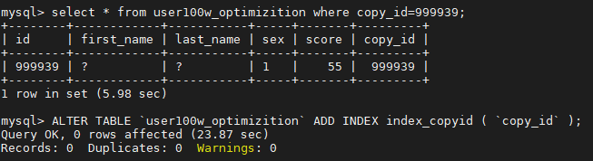

针对copy_id字段，建立普通索引：
ALTER TABLE `user100w_optimizition` ADD INDEX index_copyid ( `copy_id` )

耗时：0.00s

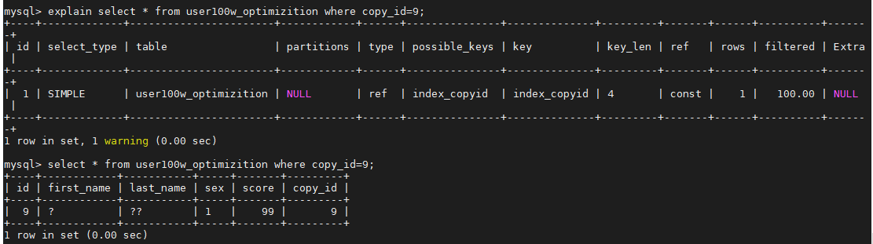

5创建1000w用户数据

CREATE TABLE user100w_optimizition(
id INT NOT NULL AUTO_INCREMENT,
first_name VARCHAR(10) NOT NULL,
last_name VARCHAR(10) NOT NULL,
sex VARCHAR(5) NOT NULL,
score INT NOT NULL,
copy_id INT NOT NULL,
PRIMARY KEY (`id`)
);

DROP PROCEDURE IF EXISTS add_user_optimizition;
DELIMITER //
CREATE PROCEDURE add_user_optimizition(IN num INT)
BEGIN
DECLARE rowid INT DEFAULT 0;
DECLARE firstname CHAR(1);
DECLARE name1 CHAR(1);
DECLARE name2 CHAR(1);
DECLARE lastname VARCHAR(3) DEFAULT '';
DECLARE sex CHAR(1);
DECLARE score CHAR(2);
SET @exedata = "";
WHILE rowid < num DO
SET firstname = SUBSTRING('赵钱孙李周吴郑王林杨柳刘孙陈江阮侯邹高彭徐',FLOOR(1+21*RAND()),1);
SET name1 = SUBSTRING('一二三四五六七八九十甲乙丙丁静景京晶名明铭敏闵民军君俊骏天田甜兲恬益依成城诚立莉力黎励',ROUND(1+43*RAND()),1);
SET name2 = SUBSTRING('一二三四五六七八九十甲乙丙丁静景京晶名明铭敏闵民军君俊骏天田甜兲恬益依成城诚立莉力黎励',ROUND(1+43*RAND()),1);
SET sex=FLOOR(0 + (RAND() * 2));
SET score= FLOOR(40 + (RAND() *60));
SET rowid = rowid + 1;
IF ROUND(RAND())=0 THEN
SET lastname =name1;
END IF;
IF ROUND(RAND())=1 THEN
SET lastname = CONCAT(name1,name2);
END IF;
IF LENGTH(@exedata)>0 THEN
SET @exedata = CONCAT(@exedata,',');
END IF;
SET @exedata=CONCAT(@exedata,"('",firstname,"','",lastname,"','",sex,"','",score,"','",rowid,"')");
IF rowid%1000=0
THEN
SET @exesql =CONCAT("insert into user100w_optimizition(first_name,last_name,sex,score,copy_id) values ", @exedata);
PREPARE stmt FROM @exesql;
EXECUTE stmt;
DEALLOCATE PREPARE stmt;
SET @exedata = "";
END IF;
END WHILE;
IF LENGTH(@exedata)>0
THEN
SET @exesql =CONCAT("insert into user100w_optimizition(first_name,last_name,sex,score,copy_id) values ", @exedata);
PREPARE stmt FROM @exesql;
EXECUTE stmt;
DEALLOCATE PREPARE stmt;
END IF;
END //
DELIMITER ;

//创建1000w用户数据
call add_user_optimizition(10000000);

