Native Markdown-to-Word for AI-Assisted Writing
Jane Doe, John Smith
Abstract
Academic writing in the age of AI assistants needs a text-first source of truth. This demo shows the same manuscript compiled to a publication-ready Word file: numbered headings, a three-line table, a captioned figure, a centred equation with a right-aligned number, and an automatically generated bibliography.
Markdown, Word, typesetting, citations, reproducible research

Introduction
Writing with an AI assistant means writing in Markdown: plain text, versioned in Git, diffable line by line (Smith & Doe, 2024). The deliverable, however, is still a .docx that a journal or an institution will accept (Doe, 2023). This demo is the shortest path between the two.

Method
The pipeline reads a fixed Markdown dialect, builds a document model, and writes OOXML directly — no external binary is called. Citations come from a .bib file and a CSL style; everything else comes from a plain-text requirements file.
Table 1. What each input file contributes
Input | Role | Edited by
paper.md | content and structure | the author
refs.bib | bibliography entries | reference manager
format.txt | fonts, spacing, page setup | the institution
Note. Only the first row is written by hand; the bibliography is generated.

Equations and cross-references
The model is deliberately simple:
$y=β_{0}+\sum_{k}{β_{k}}x_{k}+ε$ (1)
As shown in Equation (1), the relation is linear in the coefficients.
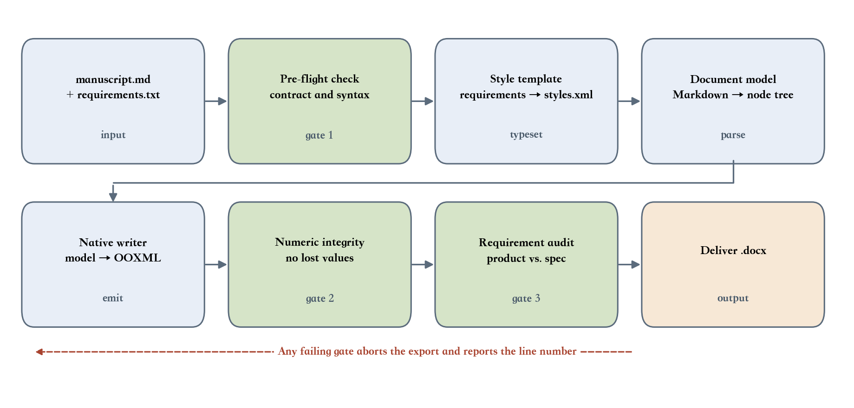
Figure 1. From Markdown source to a Word deliverable

Discussion
Two properties matter more than any single feature. First, the source stays readable: a paragraph is one line, and a style is a line prefix, so nothing has to be remembered beyond # and %%. Second, the result is deterministic: the same inputs produce the same document, which is what makes a diff meaningful (Lee, 2022).
References
Doe, J. (2023). Markdown as a source of truth. Text Studies, 12, 33–48.
Lee, K. (2022). Binary No More. Academic Press.
Smith, J., & Doe, J. (2024). Structured writing for machines. Journal of Documentation, 80(2), 101–120.

