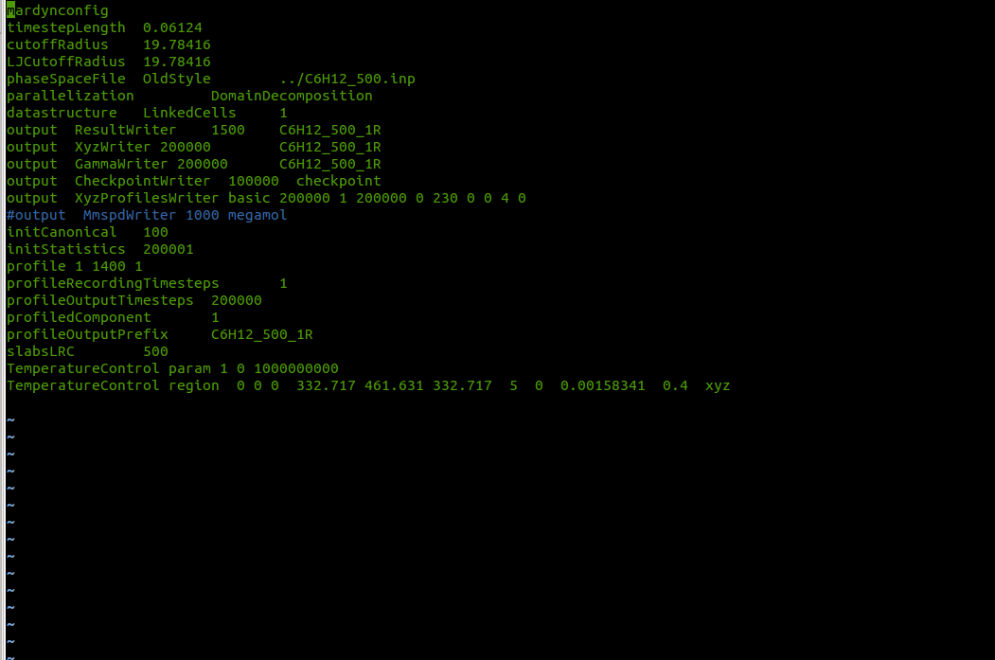
thermostating region
number of slabs the region is divided into
controlled component
0: all components
target temperature
moderation constant
thermostated directions
control frequency 1: every timestep
begin thermostating from timestep
end thermostating with timestep
lower left corner
upper right corner

