《操作系统》实验报告

年级、专业、班级 |  | 17级计科卓越班 |  |  | 姓名 | 宋春霖
 |  |  |  |  | 学号 | 20165025
实验题目 | 进程间通信
实验时间 | 2019/11/6 |  | 实验地点 | A主414
实验成绩 |  |  | 实验性质 | □综合性 □验证性□设计性
教师评价：
□算法/实验过程正确；
□源程序/实验内容提交
□程序结构/实验步骤合理；
□实验结果正确；
□语法、语义正确；
□报告规范；
其他：

评价教师签名：
- 实验目的

1.了解操作系统中常见的进程调度算法
2. 了解在Linux系统中利用多线程模拟实现FCFS、RR、SJF调度的过程
3. 了解进程同步的特点，掌握利用信号量实现进程同步的方法
4.了解Linux系统下创建多线程的原理及使用方法，模拟哲学家问题的实现

二、实验项目内容
在Linux环境下用C语言编写程序，模拟FCFS、RR、SJF等进程调度算法，以及利用信号量等方法解决哲学家就餐问题。
1.在主进程中，创建20个子线程，分别模拟进程调度算法FCFS、RR、SJF的实现，并分析子线程调度顺序是否正确。
2.以哲学家就餐问题为依托，利用信号量等方式解决同步问题。
3.通过创建5个子线程以模拟哲学家，然后设置5个互斥区，以模拟筷子
4.利用哲学家就餐问题的解决算法，模拟哲学家就餐问题的求解过程。
5.最后对程序运行结果进行分析，判断是否解决问题；并总结分析实验过程遇到的问题以及解决方法。
三.试验过程及算法
进程调度算法：
虚拟PCB的设计：设定进程的运行时间、到达时间，并记录开始、结束、到达、被时间片中断和周转时间。
虚拟PCB链表节点：包含一个虚拟PCB和一个虚拟PCB指针指向下一节点。
初始化函数：初始化多个进程，并且将PCB以链表的形式组织起来。
FCFS算法:将链表按照到达时间排序，从链表头依次处理每个进程，并且更新当前时间。
SJF算法:将链表按照到达时间排序，在到达时间小于当前时间的区域内选择运行时间最短的进程。
RR算法:将链表按照到达时间排序，对于运行时间小于等于时间片长度的进程，直接等到运行结束，对于运行时间大于时间片长度的进程，则运行时间片长度时间，并在PCB中记录当前程序的中断位置，在下次获得CPU控制权时候，从中断位置继续执行。
哲学家就餐问题：
问题设计：使用信号量实现进程间的同步和互斥，使用一个信号量mutex保证在拿起刀叉和放下刀叉的时候只能有一个进程执行，保证其动作是互斥的，将其初始化为1；再使用五个信号量表示其哲学家的状态，将其初始化为0。每次哲学家在想要吃饭之前，要尝试拿起刀叉，如果自己很饿、并且左边和右边的人没在吃饭，那么就可以拿起刀叉，释放哲学家自己的信号量，结束尝试。等待自己的信号量允许使用后，使用自己的信号量。而当自己吃完后，将自己的状态置为思考，并且探查一下周围两个人的状态，同样的，若满足条件，则释放自己的信号量。
四 实验中遇到的问题

在用pthread线程库编程的过程中，不能各个线程的状态及时的输出出来，因此print出来的信息可能会出现歧义。但可以通过断点调试，查看主线程中的phi_state数组中的状态，来观察代码的运行是否存在资源不互斥的问题。

五 实验结果以及分析：
FCFS:
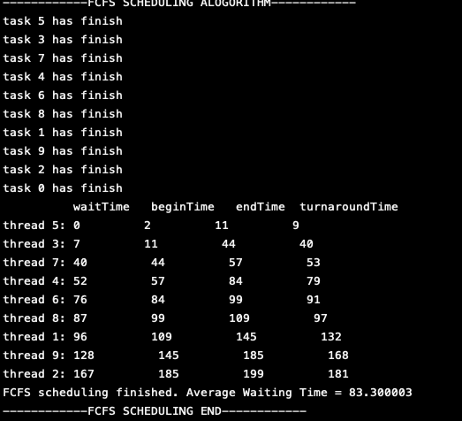
SJF:
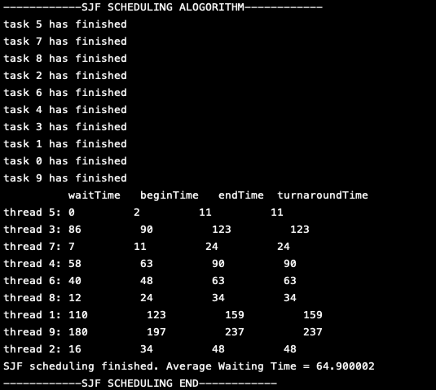

RR：
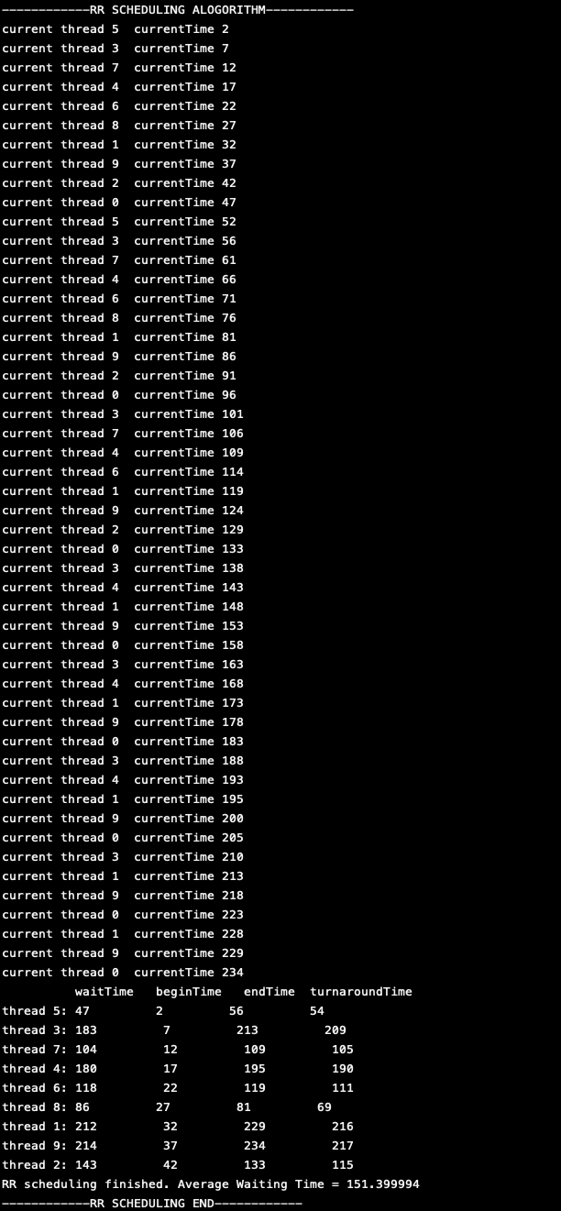

哲学家就餐问题：
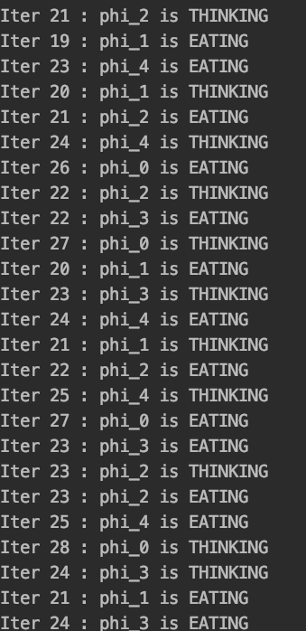

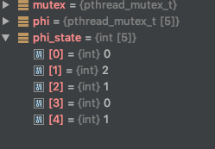
其中state==0为EATING状态，通过多次查看可知相邻编号的数字不会出现都为0的状态。
六 实验程序代码：

CPU调度部分代码：
#include <stdio.h>
#include <stdlib.h>
#include <sys/types.h>
#include <unistd.h>
#include <pthread.h>
#include <time.h>
#include <stdbool.h>
#define INT_MAX 2147483647
#define ThreadNum 10
#define Ready 0
#define Waiting 1
#define Finish 2

typedef struct VirtualPCB
{
int tid;
int waitTime;
int runTime;
int arriveTime;
int beginTime;
int interuptTime;
int endTime;
int turnaroundTime;
int state;
}VirtualPCB;

typedef struct VPCBnode
{
VirtualPCB PCB;
struct VPCBnode* next;
}VPCBnode;

struct VPCBnode* head;
struct VPCBnode* tail;

/*
init 10 SIMULATED threads
*/
void init()
{
int n;
srand(time(NULL));
head = malloc(sizeof(struct VPCBnode));
head->next = NULL;
tail = head;
for(n=0;n<ThreadNum;n++)
{
// insert every PCBNode to linked list tail
struct VPCBnode *node = malloc(sizeof(VPCBnode));
node->PCB.tid = n;
node->PCB.runTime = rand()%50;
node->PCB.waitTime = 0;
node->PCB.arriveTime = rand()%20;
node->PCB.beginTime = 0;
node->PCB.interuptTime = 0;
node->PCB.endTime = 0;
node->PCB.turnaroundTime = 0;
node->PCB.state = Ready;
tail->next = node;
tail = node;
printf("thread %d has created,runTime=%d,arriveTime=%d\n",n,node->PCB.runTime,node->PCB.arriveTime);
}

}

bool empty(){
return ThreadNum==0;
}
void swap(int* a,int* b){
int temp=*a;
*a=*b;
*b=temp;
}
void sortByArriveTime()
{
if(empty()||ThreadNum==1)
return;
VPCBnode temp;
VPCBnode* prev;
VPCBnode* cur;
for (int i = 0; i < ThreadNum-1; ++i)
{
prev = head->next;
cur = prev->next;
for (int j = 0; j < ThreadNum-i-1; ++j)
{
if(prev->PCB.arriveTime>cur->PCB.arriveTime)
{
swap(&(prev->PCB.tid),&(cur->PCB.tid));
swap(&(prev->PCB.waitTime),&(cur->PCB.waitTime));
swap(&(prev->PCB.runTime),&(cur->PCB.runTime));
swap(&(prev->PCB.arriveTime),&(cur->PCB.arriveTime));
swap(&(prev->PCB.beginTime),&(cur->PCB.beginTime));
swap(&(prev->PCB.interuptTime),&(cur->PCB.interuptTime));
swap(&(prev->PCB.endTime),&(cur->PCB.endTime));
swap(&(prev->PCB.turnaroundTime),&(cur->PCB.turnaroundTime));
swap(&(prev->PCB.state),&(cur->PCB.state));
}
prev = prev ->next;
cur = cur ->next;
}

}
}
void PCBstore(VPCBnode* source, VPCBnode * store)
{
VPCBnode * cur = source->next;
VPCBnode * temp = store;
for(int n=0;n<ThreadNum;n++)
{
// insert every PCBNode to linked list tail
struct VPCBnode *node = malloc(sizeof(VPCBnode));
memset(node,0,sizeof(VPCBnode));
node->PCB.tid = cur->PCB.tid;
node->PCB.runTime = cur->PCB.runTime;
node->PCB.waitTime = cur->PCB.waitTime;
node->PCB.arriveTime = cur->PCB.arriveTime;
node->PCB.beginTime = cur->PCB.beginTime;
node->PCB.interuptTime = cur->PCB.interuptTime;
node->PCB.endTime = cur->PCB.endTime;
node->PCB.turnaroundTime = cur->PCB.turnaroundTime;
node->PCB.state = cur->PCB.state;
temp->next = node;
temp = temp->next;
cur = cur->next;
}

}
void PCBrestore(VPCBnode* store,VPCBnode* restore)
{
VPCBnode * cur = store->next;
VPCBnode * temp = restore->next;
for(int n=0;n<ThreadNum;n++)
{
temp->PCB.tid = cur->PCB.tid;
temp->PCB.runTime = cur->PCB.runTime;
temp->PCB.waitTime = cur->PCB.waitTime;
temp->PCB.arriveTime = cur->PCB.arriveTime;
temp->PCB.beginTime = cur->PCB.beginTime;
temp->PCB.interuptTime = cur->PCB.interuptTime;
temp->PCB.endTime = cur->PCB.endTime;
temp->PCB.turnaroundTime = cur->PCB.turnaroundTime;
temp->PCB.state = cur->PCB.state;
temp = temp ->next;
cur = cur ->next;
}
}
void printScheduleInfo(VPCBnode* head)
{
VPCBnode * temp = head->next;
printf(" waitTime beginTime endTime turnaroundTime\n");
for(int i=0;i<ThreadNum-1;i++)
{
printf("thread %d: %d %d %d %d\n",temp->PCB.tid,temp->PCB.waitTime,temp->PCB.beginTime,temp->PCB.endTime,temp->PCB.turnaroundTime);
temp = temp -> next;
}
}
int FCFS()
{
printf("------------FCFS SCHEDULING ALOGORITHM------------\n");
sortByArriveTime();
int totalWaitingTime = 0;
int currentTime = head ->next->PCB.arriveTime;
if (empty())
{
printf("there is no task\n");
return -1;
}
VPCBnode * curr = head -> next;
while(1)
{
curr->PCB.beginTime = currentTime;
curr->PCB.endTime = currentTime + curr->PCB.runTime;
curr->PCB.waitTime = currentTime - curr->PCB.arriveTime;
curr->PCB.turnaroundTime = curr->PCB.waitTime + curr->PCB.runTime;
curr->PCB.state = Finish;
totalWaitingTime += curr->PCB.waitTime;
printf("task %d has finish\n",curr->PCB.tid);
// printf("curr->next:%x\n",curr->next);
currentTime += curr->PCB.runTime;
if (curr->next==NULL)
break;
curr = curr->next;
}
printScheduleInfo(head);
printf("FCFS scheduling finished. Average Waiting Time = %f\n",(float)totalWaitingTime/ThreadNum);
printf("------------FCFS SCHEDULING END------------\n");
return 0;
}
int SJF()
{
printf("------------SJF SCHEDULING ALOGORITHM------------\n");
sortByArriveTime();
VPCBnode * curr = head->next;
VPCBnode * shortest = head->next;
int currShortestPeriod = INT_MAX;
int currentTime = head->next->PCB.arriveTime;
int totalWaitingTime = 0;
int allFinish = 1;
while(1)
{
for (int i = 0; i < ThreadNum; ++i)
{
if(curr->PCB.runTime<=currShortestPeriod&&(curr->PCB.state!=Finish)&&curr->PCB.arriveTime<=currentTime)
{
shortest = curr;
currShortestPeriod = curr->PCB.runTime;
allFinish = 0;
}
curr = curr -> next;
}
// printf("current shortest is %d current time = %d\n",shortest->PCB.tid,currentTime);
// printf("isfinish: %d\n",allFinish);
if(!allFinish)
{
shortest->PCB.beginTime = currentTime;
shortest->PCB.endTime = currentTime + shortest->PCB.runTime;
shortest->PCB.waitTime = currentTime - shortest->PCB.arriveTime;
shortest->PCB.turnaroundTime = currentTime + shortest->PCB.runTime;
shortest->PCB.state = Finish;
totalWaitingTime +=shortest->PCB.waitTime;
printf("task %d has finished\n",shortest->PCB.tid);
currentTime+=shortest->PCB.runTime;
}

curr = head->next;
shortest = head->next;
currShortestPeriod = INT_MAX;
if (allFinish)
break;
allFinish =1;
}
printScheduleInfo(head);
printf("SJF scheduling finished. Average Waiting Time = %f\n",(float)totalWaitingTime/ThreadNum);
printf("------------SJF SCHEDULING END------------\n");

}
int RR(int slide)
{
printf("------------RR SCHEDULING ALOGORITHM------------\n");
sortByArriveTime();
int allFinish = 1;
int totalWaitingTime = 0;
int currentTime = head->next->PCB.arriveTime;
VPCBnode * curr = head->next;
while(1)
{
for (int i = 0; i < ThreadNum; ++i)
{
if (curr->PCB.state!=Finish&&curr->PCB.arriveTime<=currentTime)
{
printf("current thread %d currentTime %d\n",curr->PCB.tid,currentTime);
// execute current thread
if (curr->PCB.state==Ready)
{
// the first time to run this thread
curr->PCB.beginTime = currentTime;
curr->PCB.waitTime = currentTime - curr->PCB.arriveTime;
}
if (curr->PCB.runTime-curr->PCB.interuptTime<=slide)
{
// would not use up this slide OR just fit in slide
curr->PCB.waitTime += currentTime - curr->PCB.interuptTime;
currentTime += curr->PCB.runTime - curr->PCB.interuptTime;
curr->PCB.endTime = currentTime;
curr->PCB.state = Finish;
curr->PCB.turnaroundTime = currentTime - curr->PCB.arriveTime;
totalWaitingTime += curr->PCB.waitTime;

}
else
{
currentTime += slide;
curr->PCB.interuptTime +=slide;
curr->PCB.state = Waiting;
}
allFinish = 0;
}
curr = curr->next;
}
curr = head->next;
if (allFinish)
break;
allFinish = 1;
// Break Condition: all finish
}
printScheduleInfo(head);
printf("RR scheduling finished. Average Waiting Time = %f\n",(float)totalWaitingTime/ThreadNum);
printf("------------RR SCHEDULING END------------\n");
}
int main()
{

init();
VPCBnode* store = malloc(sizeof(VPCBnode));
PCBstore(head,store);
FCFS();
PCBrestore(store,head);
SJF();
PCBrestore(store,head);
RR(3);
PCBrestore(store,head);

}
消息队列部分代码：
#include<stdio.h>
#include<unistd.h>
#include<sys/msg.h>
#include<errno.h>
int infoqueue;
// char *s = "ok";
// char *a = "ok";
char s[10] = "ok";
char readbuffer[100];
typedef struct msg_u
{
long type;
char messageEntity[10];
//char* messageEntity;
}msg_u;
void childProcessFunction(int i);
int getqid()
{
key_t key = ftok(".",'t');
return msgget(key,0666|IPC_CREAT);

}
void sendMessage(int messageQueue, msg_u* msgObject)
{
int ret=msgsnd(messageQueue,msgObject,sizeof(msgObject->messageEntity),IPC_NOWAIT);

if(ret!=0)
{
printf("Message send failed\n");
printf("ret=%d\n",ret);
printf("messageQueue=%d\n",messageQueue);
printf("messageEntity:%s\n", msgObject->messageEntity);
printf("%s",strerror( errno ));
}
}
struct msg_u receiveMessage(int messageQueue)
{
msg_u msgObject;
int length = msgrcv(messageQueue,&msgObject,sizeof(msgObject.messageEntity),0,IPC_NOWAIT);
// printf("length=%d\n",length+2);
// printf("===========\n");
// printf("%s\n",msgObject.messageEntity);
// printf("==========\n");
// printf("afasdfasdfa\n");
// printf("fdasdfas\n");

return msgObject;
}
int main(int argc, char const *argv[])
{
infoqueue = getqid();
int pid;
pid = fork();
if(pid==0)
{ // the first child process
childProcessFunction(0);
}
else if(pid>0)
{
// main process
wait(NULL);
pid = fork();
if (pid==0)
{
// the second child process
childProcessFunction(1);
}
}
else
{
printf("process created error\n");
}
return 0;
}
void childProcessFunction(int i)
{
// char s[10] = "ok";

switch(i)
{
case 0:
printf("i am the first child process,i will write\n");
FILE *fp=NULL;
fp=fopen("2.txt","w");
fprintf(fp, "this is file's contents\n");
fclose(fp);
msg_u msgObject;
msgObject.type = 1;
//msgObject.messageEntity = s;
// printf("%s---------------\n",s);

strcpy(msgObject.messageEntity,s);
// printf("%s",msgObject.messageEntity);//
sendMessage(infoqueue,&msgObject);
break;
case 1:
printf("i am the second child process,i will read\n");
// printf("asdaas\n");
msg_u msgObject2 = receiveMessage(infoqueue);
// printf("%s",msgObject2.messageEntity);
int ret2 = strcmp(msgObject2.messageEntity,"ok");
if(!ret2)
{
FILE *fp2 =NULL;
fp2=fopen("2.txt","r");
fgets(readbuffer,sizeof(readbuffer),(FILE*)fp2);
printf("file's contents:%s",readbuffer);
fclose(fp);
}
break;
}
exit(0);
}

哲学家就餐问题部分代码：
#include<stdio.h>
#include<pthread.h>
#include<unistd.h>
#define N 5
#define EATING 0
#define THINKING 1
#define WAITING 2
#define LEFT (i-1+N)%N
#define RIGHT (i+1)%N
int phi_state[N] = {THINKING,THINKING,THINKING,THINKING,THINKING};
pthread_mutex_t mutex = PTHREAD_MUTEX_INITIALIZER;
pthread_mutex_t phi[N];
void* phi_sem_process(void *arg);
void phi_takeup_fork(int i);
void test(int i);
void phi_putdown_fork(int i);
int main()
{

pthread_t tid[N];
int argument[N];
for (int i = 0; i < N; ++i)
{
argument[i] = i;
}
// pthread_mutex_init(&mutex,0,1);
for (int i = 0; i < N; ++i)
{
pthread_mutex_init(&phi[i],NULL);
}
for(int i=0;i<N;i++)
{
pthread_create(&tid[i],NULL,phi_sem_process,&argument[i]);
}
for(int i=0;i<N;i++)
pthread_join(tid[i],NULL);
printf("all phi has quited\n");
return 0;
}
void* phi_sem_process(void *arg)
{
int i = *(int*)arg;

printf("phi_%d has been created\n", i);
for(int j=0;j<50;j++)
{

printf("Iter %d : phi_%d is THINKING \n",j,i);
sleep(3);
phi_takeup_fork(i); // take up the fork or waiting
// if the following can execute, then it should get the fork

printf("Iter %d : phi_%d is EATING\n",j,i);
sleep(5);
phi_putdown_fork(i);
}
printf("phi_%d has quited\n",i);
return NULL;
}

void phi_takeup_fork(int i)
{
pthread_mutex_lock(&mutex);
// sem_wait(&mutex);
phi_state[i] = WAITING;
test(i); // try to get two fork
// sem_post(&mutex);
pthread_mutex_unlock(&mutex);
// sem_wait(&phi[i]);
pthread_mutex_lock(&phi[i]);

}

void test(int i)
{
if(phi_state[i]==WAITING&&phi_state[LEFT]!=EATING&&phi_state[RIGHT]!=EATING)
{
phi_state[i] = EATING;
// sem_post(&phi[i]);
pthread_mutex_unlock(&phi[i]);
}
}
void phi_putdown_fork(int i)
{
// sem_wait(&mutex);
pthread_mutex_lock(&mutex);
phi_state[i] = THINKING;
test(LEFT);
test(RIGHT);
// sem_post(&mutex);
pthread_mutex_unlock(&mutex);
}
哲学家就餐部分代码：
#include<stdio.h>
#include<pthread.h>
#include<unistd.h>
#define N 5
#define EATING 0
#define THINKING 1
#define WAITING 2
#define LEFT (i-1+N)%N
#define RIGHT (i+1)%N
int phi_state[N] = {THINKING,THINKING,THINKING,THINKING,THINKING};
pthread_mutex_t mutex = PTHREAD_MUTEX_INITIALIZER;
pthread_mutex_t phi[N];
void* phi_sem_process(void *arg);
void phi_takeup_fork(int i);
void test(int i);
void phi_putdown_fork(int i);
int main()
{

pthread_t tid[N];
int argument[N];
for (int i = 0; i < N; ++i)
{
argument[i] = i;
}
// pthread_mutex_init(&mutex,0,1);
for (int i = 0; i < N; ++i)
{
pthread_mutex_init(&phi[i],NULL);
}
for(int i=0;i<N;i++)
{
pthread_create(&tid[i],NULL,phi_sem_process,&argument[i]);
}
for(int i=0;i<N;i++)
pthread_join(tid[i],NULL);
printf("all phi has quited\n");
return 0;
}
void* phi_sem_process(void *arg)
{
int i = *(int*)arg;

printf("phi_%d has been created\n", i);
for(int j=0;j<50;j++)
{

printf("Iter %d : phi_%d is THINKING \n",j,i);
sleep(3);
phi_takeup_fork(i); // take up the fork or waiting
// if the following can execute, then it should get the fork

printf("Iter %d : phi_%d is EATING\n",j,i);
sleep(5);
phi_putdown_fork(i);
}
printf("phi_%d has quited\n",i);
return NULL;
}

void phi_takeup_fork(int i)
{
pthread_mutex_lock(&mutex);
// sem_wait(&mutex);
phi_state[i] = WAITING;
test(i); // try to get two fork
// sem_post(&mutex);
pthread_mutex_unlock(&mutex);
// sem_wait(&phi[i]);
pthread_mutex_lock(&phi[i]);

}

void test(int i)
{
if(phi_state[i]==WAITING&&phi_state[LEFT]!=EATING&&phi_state[RIGHT]!=EATING)
{
phi_state[i] = EATING;
// sem_post(&phi[i]);
pthread_mutex_unlock(&phi[i]);
}
}
void phi_putdown_fork(int i)
{
// sem_wait(&mutex);
pthread_mutex_lock(&mutex);
phi_state[i] = THINKING;
test(LEFT);
test(RIGHT);
// sem_post(&mutex);
pthread_mutex_unlock(&mutex);
}

七 实验心得（实验结果及分析和（或）源程序调试过程（包含程序使用方法、程序运行截图），实验过程中遇到的问题分析与心得体会。（实验报告中最重要的部分，应尽量详细，重点描述自己遇到的问题以及解决方法））

关于CPU调度问题：
调度CPU中，SJF具有很好的等待优越性，使得大家等待的时间很短，但是从公平性的角度来讲，他并不公平，会使得长进程一直处于饥饿的状态得不到执行。反而RR时间片轮转的方式，比较公平，但是等待时间不优。可见，公平和效率很难同时达到。
关于哲学家就餐问题：
这是一道经典的同步互斥问题，通过信号量可以解决，用一个信号量解决其拿筷子互斥的问题，用多个信号解决哲学家之间的同步问题。

