Closing America's Early STEAM Gap
A Data-Backed Problem Statement and Market-Gap Analysis for Early-Childhood STEM Learning in the United States
PARI STEAM World · White Paper
June 2026 · United States
Abstract. Demand for STEM skills in the United States is rising while early interest, confidence, and equitable access are falling — and the decisive window, early childhood, is the least served by today's products. This paper documents that gap with verified US data, maps a fragmented competitive landscape of kit-only, app-only, and story-only point solutions, sizes the opportunity, and assesses how an integrated model — serialized story, hands-on kit, a parent-governed AI companion, and diverse girl protagonists — could close it. We separate what the evidence establishes (a real, well-documented market gap) from what remains to be validated (the product's own efficacy and economics).

Table of Contents

(In Word: right-click the table of contents and choose “Update Field” to populate page numbers.)

Executive Summary
The United States is failing to build STEM aptitude where it matters most: at the start. In 2024, only 31% of US 8th-graders reached NAEP Proficient in science — down 4 points from 2019 — while 38% scored below NAEP Basic, the highest share since 2009 (NAGB/NCES, 2024). The roots are early. US K-3 classrooms spend just 18 minutes a day on science versus 89 on reading, and only 31% of self-contained elementary teachers feel "very well prepared" to teach it (Horizon Research/NSSME+, 2019). Yet kindergarten-entry math skills are the single strongest predictor of later achievement in both math and reading (Duncan et al., 2007), and by age 6 girls already become less likely than boys to associate brilliance with their own gender (Bian, Leslie & Cimpian, Science, 2017).
The gender and confidence gaps compound from there. Among US Gen Z, 63% of girls express interest in STEM versus 85% of boys — a 22-point gap (Gallup & Walton Family Foundation, 2023) — and the share of US girls who believe they are good at math and science fell from 73% (2017) to 59% (2024) (ROX, The Girls' Index, 2024). Downstream, women are ~35% of the broad 36-million-person STEM workforce but only ~27% of core science and engineering occupations and ~16% of engineers (NCSES/NSF, 2023). This matters because STEM occupations are projected to grow 10.4% from 2023 to 2033 — nearly triple the 3.6% for non-STEM — at more than double the median wage (BLS, 2024).
Parents are ready to act but underserved. 91% emphasize the importance of educational toys and 78% want more toys that build creativity and problem-solving, with screen-free maker kits flagged as a leading trend (The Toy Association, 2023-2025) — even as US children ages 5-8 average 3h28m of screen media a day (Common Sense Media, 2025).
The opportunity is large. The US educational-toys market was ~$12.19B in 2023, growing at a 10.8% CAGR toward ~$24.9B by 2030 (Grand View Research; Custom Market Insights, 2023-2024), with hands-on STEM its fastest-growing slice. As an illustrative bottom-up framing, an integrated story + kit + AI subscription addressing US households with a child age 3-8 implies a TAM of roughly $4.3B/year, narrowing to a ~$1.7B SAM among the ~40.9% of households earning $100,000+ (illustrative model on Census 2023 demographics).
PARI STEAM World is uniquely positioned to capture it. No US early-childhood product combines all four of: a serialized story, a recurring physical kit, a parent-governed AI companion, and a centered diverse girl protagonist. The AI-companion layer is the rarest attribute in the competitive set and genuine open ground; layering it onto a Little Passports-style story-plus-kit spine with an Ada Twist-style protagonist occupies white space incumbents cannot replicate as a weekend feature — defended by original IP, a safety-vetted content corpus, and per-child narrative memory.
We state this candidly: PARI's own efficacy, retention, and unit economics remain hypotheses requiring validation. The component evidence is suggestive, not proof, and the integrated model warrants its own rigorous trial.

1. Introduction: The STEAM Imperative in America

A widening gap between what the economy rewards and what children are learning
The United States is building an economy that runs on science, technology, engineering, the arts, and mathematics, while the pipeline meant to staff and sustain it is thinning at the source. The labor market signal is unambiguous. The Bureau of Labor Statistics projects that US STEM occupations will grow 10.4% from 2023 to 2033, nearly triple the 3.6% projected for non-STEM occupations (BLS, 2024). These are not only more numerous jobs but materially better-paid ones: STEM occupations carried a median wage of $101,650 in May 2023, more than double the $46,680 non-STEM median (BLS, 2024). As of 2023 there were already 36 million STEM workers in the US, roughly 24% of the total workforce (NCSES/NSF, 2024) — a large base still expanding faster than the economy around it.
Demand on the consumer and education side is rising in parallel. The US EdTech market grew to $47.74 billion in 2024 and is projected to reach $90.61 billion by 2030 at an 11.1% CAGR, with the preschool segment forecast as the fastest-growing sector through 2030 (Grand View Research, 2024). The US AI-in-education market is projected to reach roughly $8.84 billion by 2030 at a 31.2% CAGR (2025-2030), the steepest growth among US education segments (Grand View Research, 2024). The economy is, in effect, telling families exactly where durable opportunity lies.

The paradox: early interest, confidence, and access are moving the wrong way
Against that rising demand, the leading indicators of a future STEM workforce are deteriorating — and the decline begins young. The share of US 8th-graders reporting high interest and enjoyment in science fell from 38% in 2019 to 28% in 2024, alongside a parallel decline in hands-on inquiry participation (NAGB/NCES, 2024). Confidence is eroding even earlier and most steeply among girls: the share of US girls who believe they are good at math and science fell from 73% in 2017 to 59% in 2024, and among 5th-6th graders the share who say they don't believe they are smart enough for their dream job jumped from 23% to 52% over the same period (ROX — The Girls' Index, 2024).
Achievement is sliding with it. Only 31% of US 8th-graders reached NAEP Proficient in science in 2024, down 4 points from 2019, while 38% scored below NAEP Basic — the highest share since 2009 (NAGB/NCES, 2024). On PISA 2022, US 15-year-olds scored 465 in math, below the OECD average and behind 25 of 80 systems; science was relatively stronger at 499 versus the 485 OECD average (NCES/OECD PISA; Pew Research for rank, 2023). The weakness is concentrated in math — precisely the domain where, across six US longitudinal datasets, kindergarten-entry math skills were the single strongest predictor of later achievement in both math and reading (Duncan et al., Developmental Psychology, 2007).
Demand is rising | Early interest, confidence, and access are falling
STEM jobs +10.4% (2023-2033) vs +3.6% non-STEM (BLS, 2024) | 8th-grade science interest 38% → 28% (2019-2024) (NAGB/NCES, 2024)
STEM median wage $101,650 vs $46,680 non-STEM (BLS, 2024) | Girls confident in math/science 73% → 59% (2017-2024) (ROX, 2024)
US EdTech $47.74B (2024) → $90.61B by 2030, preschool fastest (GVR, 2024) | NAEP Proficient in 8th-grade science only 31%, down 4 pts (NAGB/NCES, 2024)

The equity dimension compounds the paradox. Racial and ethnic gaps in top-decile science and math achievement are already present at kindergarten entry — roughly 13-16% of White students versus 3-4% of Black or Hispanic students — and persist or widen through 5th grade (Morgan et al., AERA, 2023). The ability to buy a child's way around these gaps is itself unequally distributed: high-income US families spend roughly $8,900 per child per year on enrichment versus about $1,300 in the lowest-income quintile, a gap that widened from about 4x to 7x (Hamilton Project/Brookings, Duncan & Murnane, 2018). A premium product that ignores this risks worsening the very divide it claims to address.

Why early childhood is the highest-leverage — and least-served — moment
The decisive window opens before formal STEM tracking begins. By age 6, US girls become less likely than boys to associate brilliance with their own gender and begin avoiding activities described as for the "really, really smart" — a gap absent at age 5 (Bian, Leslie & Cimpian, Science, 2017). Yet this is exactly the moment the system underinvests: US K-3 classrooms average just 18 minutes per day on science versus 89 on reading and 57 on math, and science is taught every school day in only 17% of K-3 classes (Horizon Research/NSSME+, 2019). Only 31% of self-contained elementary teachers feel "very well prepared" to teach science, and only about 3% hold a science degree (Horizon Research/NSSME+, 2019). The identity-forming years receive the least instructional attention.
The candid caveat: that early childhood is high-leverage is best evidenced by adjacent populations and single-component studies — for example, the ~13% annual ROI of an intensive birth-to-five program for disadvantaged US children (Heckman et al., 2017), which speaks to the value of early-childhood timing, not to any consumer product's return. That distinction governs this paper throughout.

The thesis
This sets up a structural market gap. Families want this — 78% of US parents want more toys that build skills like creativity and problem-solving (The Toy Association, 2023-2025) — and the spending capacity exists within a US educational-toys market of roughly $12.19 billion in 2023, projected toward $24.9 billion by 2030 (Grand View Research; Custom Market Insights, 2023-2024). But the available solutions are fragmented point products: a kit without a story, an app without a kit, a story without either. The highest-leverage moment, early childhood, is the least served by integrated offerings. The chapters that follow document this gap with evidence, map the competitive white space, and lay out PARI's integrated story-plus-kit-plus-AI model as a hypothesis to be validated — not a proven outcome — against the bar of adversarial diligence.

2. Problem 1 - The Early Identity Crisis: Where Curiosity Erodes
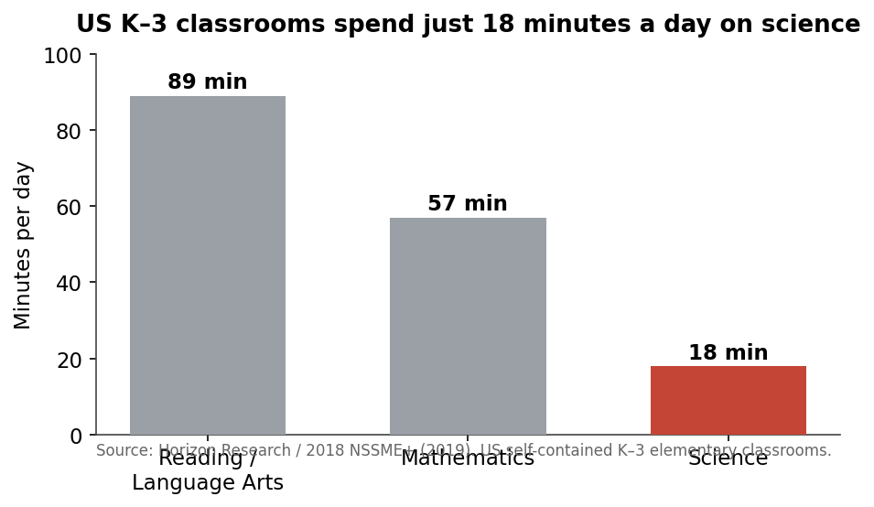
Figure 1. US K–3 classrooms devote just 18 minutes a day to science.
Every child begins as a scientist. They ask how things work, take things apart, and chase the next question without prompting. Yet across American elementary and middle school, that native curiosity quietly drains away — and it drains fastest precisely where identity and confidence are still forming. The data show a self-concept crisis that starts long before high school, in the years a child decides, often unconsciously, whether "people like me" do science.

Interest erodes early, and the decline is measurable
The erosion is not anecdotal. The share of US 8th-graders reporting high interest and enjoyment in science fell from 38% to 28% in just five years, with a parallel decline in hands-on inquiry participation (NAGB/NCES, 2024). By the time interest is surveyed in adolescence, the leak is already wide: 75% of US Gen Z (ages 12-26) report interest in STEM, but only 29% name a STEM role as their first-choice career (Gallup & Walton Family Foundation, 2023). Curiosity is abundant; conversion into identity and aspiration is where America loses ground.
That gap is not gender-neutral. Among US Gen Z, 63% of girls express interest in STEM versus 85% of boys — a 22-point gap (Gallup & Walton Family Foundation, 2023). The confidence story is starker still. The share of US girls who believe they are good at math and science fell from 73% (2017) to 59% (2024); among 5th-and-6th graders, the share who say they don't believe they are smart enough for their dream job jumped from 23% to 52% over the same period (ROX — The Girls' Index, 2024). The erosion of confidence is visible in late elementary school — not in the teen years where intervention efforts have historically concentrated.

Identity is set early — by age 6, and at kindergarten entry
Why does intervening in adolescence arrive too late? Because the relevant beliefs are laid down years earlier. By age 6, US girls become less likely than boys to associate brilliance — being "really, really smart" — with their own gender, and begin avoiding activities framed as being for the "really, really smart." This gap is absent at age 5 (Bian, Leslie & Cimpian, Science, 2017). A stereotype that shapes a lifetime of choices crystallizes in roughly twelve months, before first grade.
Academic identity is equally precocious. Across six US longitudinal datasets, kindergarten-entry math skills were the single strongest predictor of later achievement in both math and reading — ahead of early reading and ahead of attention (Duncan et al., Developmental Psychology, 2007). The starting line, in other words, substantially predicts the finish. And the starting line is already unequal: racial and ethnic gaps in advanced (top-decile) science and math achievement are present at kindergarten entry — roughly 13-16% of White students versus 3-4% of Black or Hispanic students reach the top decile — and these gaps persist or widen through 5th grade (Morgan et al., Educational Researcher / AERA, 2023). The equity problem is not created by schooling; it walks in the door on day one and compounds.

The early window is real — but the system is not using it
The years where identity forms are exactly the years American schooling devotes least to science. The table below summarizes how thin the early-childhood science exposure actually is.
Indicator (US elementary) | Finding | Source
Daily instructional minutes, K-3 | ~18 min/day on science vs. 89 on reading/language arts and 57 on math (grades 4-6: ~27 min on science) | Horizon Research / NSSME+, 2019
Science taught every school day | 17% of K-3 classes; 35% of grades 4-6 (vs. nearly all classes for math) | Horizon Research / NSSME+, 2019
Teachers "very well prepared" to teach science | 31% of self-contained elementary teachers (vs. 77% reading, 73% math); only ~3% hold a science degree | Horizon Research / NSSME+, 2019

The implication is direct. In the developmental window when brilliance stereotypes set (age 6) and when kindergarten math skills are forecasting the next decade of achievement, the average K-3 classroom spends about 18 minutes a day on science, teaches it every day in fewer than one in five classrooms, and is staffed largely by teachers who do not feel prepared to teach it (Horizon Research / NSSME+, 2019). The most consequential window is also the most neglected.

Why early timing pays — an analogy, named as such
Does intervening early actually deliver outsized returns? The most rigorous US evidence on early-childhood timing comes from intensive birth-to-five programs. A high-quality birth-to-five program for disadvantaged US children (ABC/CARE) delivered roughly a 13% annual return on investment, with a benefit-cost ratio of 6.3 (Heckman et al., University of Chicago, 2017). This figure is presented strictly as evidence for the value of early-childhood timing — drawn from an intensive, multi-year birth-to-five program for disadvantaged children. It is not a consumer-product return, and it is not a projection of returns from any commercial story, kit, or app. What it establishes is narrower but important: when society invests in the earliest years, the long-run payoff is large. The early identity crisis is, in that light, not only a moral and educational problem but an economic one — and the cost of missing the window is paid over a lifetime.
The pattern across these sources is consistent and uncomfortable. Children arrive curious. Identity-shaping beliefs about who is smart and who belongs in science form by age 6 and are measurable in kindergarten achievement gaps. Interest and confidence then erode through elementary and middle school — earliest and most steeply for girls. And the years that matter most receive the least science instruction, from the least-prepared teachers. The window is real, it is early, and right now it is being missed.
I have all the data I need in the canonical figures sheet. Let me write this section.

3. Problem 2 - The Representation Gap: Why Girls Opt Out
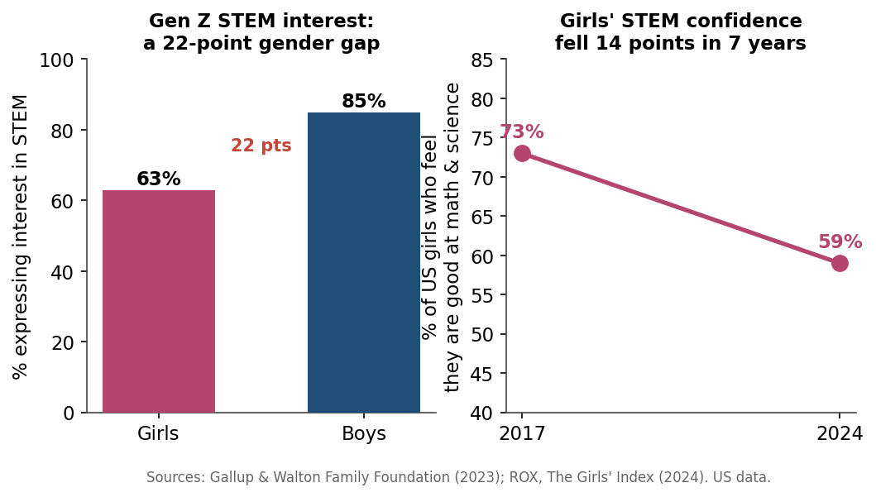
Figure 2. The STEM interest and confidence gap opens early for girls.
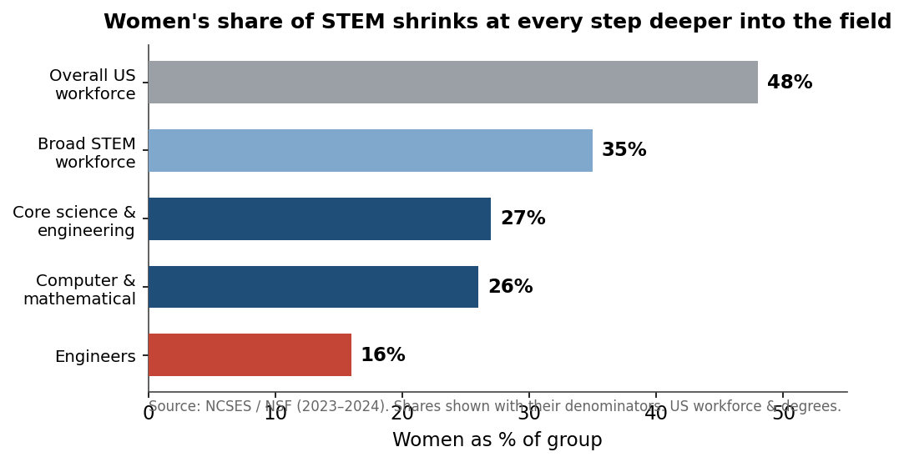
Figure 3. Women's representation thins at every step deeper into STEM.
American girls do not opt out of science and engineering because they cannot do the work. They opt out because, long before a transcript or a job application exists, they have already absorbed a message about who belongs. The evidence shows that message arriving early, hardening through adolescence, and being reinforced by the media children watch every day. This section quantifies the gap, traces its onset to roughly age 6, and documents the confidence collapse and representation deficit that PARI STEAM World is built to interrupt.

The destination: a workforce women are still largely shut out of
Start with where the pipeline ends, always with the denominator attached. Of the 36 million people in the broad US STEM workforce in 2023, about 35% were women and 65% men; narrowed to core science and engineering occupations, women are just ~27%, despite making up ~48% of the overall workforce (NCSES/NSF, 2023). The shortfall is most severe in the highest-leverage fields: women are ~16% of US engineers and ~26% of computer and mathematical scientists (NCSES/NSF, 2023).
Denominator | Women's share
Overall US workforce | ~48% (NCSES/NSF, 2023)
Broad STEM workforce (36M) | ~35% (NCSES/NSF, 2023)
Core science & engineering occupations | ~27% (NCSES/NSF, 2023)
Computer & mathematical scientists | ~26% (NCSES/NSF, 2023)
Engineers | ~16% (NCSES/NSF, 2023)

The degree pipeline foreshadows this. In 2021, women earned roughly half of all science and engineering bachelor's degrees, yet only ~24% of engineering and ~22% of computing degrees (NCSES/NSF, 2024). The leak is not uniform; it is concentrated in exactly the fields with the strongest wage and growth trajectories. Whatever is driving girls away is field-specific and identity-linked, not a general deficit in ability.

The onset: the gap opens around age 6
The most important finding for an early-childhood product is when this divergence begins. In a controlled study, US girls became less likely than boys to associate brilliance — being "really, really smart" — with their own gender, and began avoiding activities framed as for the "really, really smart," by age 6. At age 5, that gap was absent (Bian, Leslie & Cimpian, Science, 2017). The window in which children form beliefs about who is brilliant closes startlingly early, squarely inside PARI's 3-8 target band.
A second, independent literature confirms the same arc. A meta-analysis of 78 US Draw-A-Scientist studies (20,000+ children) found genuine cultural progress — the share of children drawing a female scientist rose from under 1% in 1966-77 to 28% in 1985-2016 — yet the association of science with men still strengthens as children age: about 70% of 6-year-old girls draw a woman scientist, versus only ~25% of 16-year-old girls (Miller, Nolla, Eagly & Uttal, Child Development, 2018). The intervention point is unmistakable. At age 6, the majority of girls still picture a woman when they imagine a scientist. By 16, three-quarters do not. The job is not to install a belief that does not exist; it is to keep one from eroding.

The collapse: confidence and interest fall through the school years
What the Draw-A-Scientist data show as a slow drift, more recent confidence data show as a steep decline. The share of US girls who believe they are good at math and science fell from 73% (2017) to 59% (2024). Over the same period, the share of girls in grades 9-12 who say they don't believe they are smart enough for their dream job rose from 46% to 58% — and among 5th-6th graders, that figure more than doubled, from 23% to 52% (ROX — The Girls' Index, 2024). That last number is the alarm: self-doubt about being "smart enough" is no longer an adolescent phenomenon: it is reaching girls at 10 and 11.
This is not abstract. Among US Gen Z, 63% of girls express interest in STEM versus 85% of boys — a 22-point gender gap (Gallup & Walton Family Foundation, 2023). The interest is being lost on the way, not absent at the start.

The mirror: what girls see on screen
Children spend hours a day with screen media, and what they see there models who does science. Across 15 years of top US TV and film, women were only ~38% of STEM characters in 2018-22; female engineers were just 13% and computer scientists 15% of those roles (Geena Davis Institute, 2024). The on-screen world a child absorbs underrepresents women in precisely the fields where the real workforce underrepresents them most — a closed loop. Notably, 71% of surveyed respondents said female STEM representation on-screen is important, up 20 points since 2018 (Geena Davis Institute, 2024), signaling that audiences now want what the screen has failed to supply.
Does representation actually move outcomes? The most relevant causal evidence is suggestive and drawn from older populations, so we flag it as such. Among US undergraduates, a single guest lecture by a woman economist raised women's likelihood of majoring in economics by 8 points (9%→17%), and same-gender STEM role models raised high-performing women's choice of underrepresented STEM majors by up to 26 points (Porter & Serra; Carrell/Page/West, via J-PAL, 2024). This is undergraduate-derived evidence — encouraging about the mechanism of role models, but not proof that the same effect sizes hold for ages 3-8. It motivates PARI's design; it does not validate its outcomes, which remain a hypothesis to test.

The white space: diverse girl protagonists are scarce in early-childhood STEM media
The deficit is sharpest precisely where PARI operates. A scan of the US early-childhood STEM landscape shows that media which centers a diverse girl protagonist (Ada Twist, Scientist; Doc McStuffins) ships no proprietary hands-on kit or learning companion, while products built on a story-plus-kit spine (Little Passports, GoldieBlox) either lack a centered diverse girl protagonist or pair her with dated demographics. No US product for early childhood combines a serialized narrative, a recurring physical kit, and a centered diverse girl protagonist in one integrated experience. That is the gap PARI's two original girl characters, PARI and Sarala, are designed to fill — putting a diverse girl at the center of the story at exactly the age, around 6, when the research says the picture of who is "really, really smart" is still up for grabs.

4. Problem 3 - The Screen-Time Paradox and the Hands-On Deficit
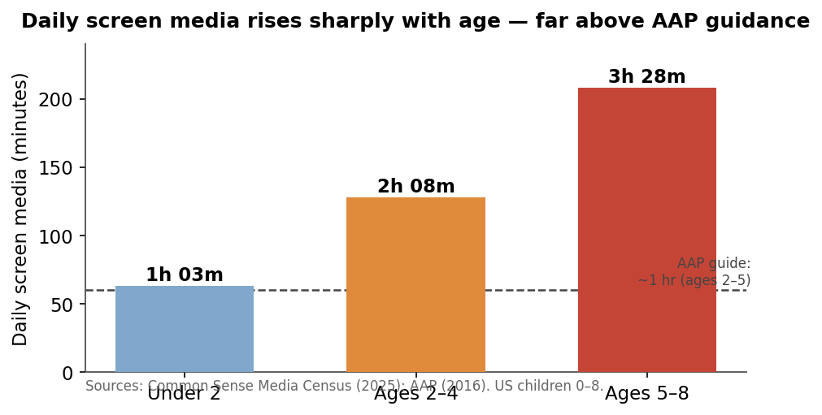
Figure 4. Daily screen media rises sharply with age, well above AAP guidance.
American early childhood is saturated with screens at precisely the ages when developmental authorities say screens should be scarcest. The result is a paradox: children are spending more time than ever on devices, parents are more anxious than ever about it, and the institutions parents trust are telling them to do the opposite of what daily life delivers. That gap between recommended and actual practice is the structural opening for a physical-first, screen-balanced alternative.

Screen time rises steeply across the early-childhood years
Screen exposure is not flat across early childhood; it climbs sharply with age. By the 2025 Common Sense Media census, US children under 2 averaged 1 hour 3 minutes of screen media per day, ages 2-4 averaged 2 hours 8 minutes, and ages 5-8 averaged 3 hours 28 minutes, with the 0-8 average at roughly 2.5 hours (Common Sense Media, 2025). Device ownership starts early and deepens fast: 40% of US children have their own tablet by age 2, nearly 1 in 4 have a personal cellphone by age 8, and gaming time among kids 8 and under surged 65% over four years (Common Sense Media, 2025).
Age band | Average daily screen media
Under 2 | 1h 03m
2-4 | 2h 08m
5-8 | 3h 28m
0-8 average | ~2.5h

Source: Common Sense Media (Census), 2025.
The trajectory matters. The 3-8 cohort that PARI targets sits at the steep end of this curve, where daily screen exposure roughly triples between the youngest and oldest bands.

The official guidance points the other way
Public-health authorities are not neutral on these numbers. The American Academy of Pediatrics discourages screen media (other than video chat) under 18 months and recommends limiting ages 2-5 to roughly one hour per day of high-quality programming, explicitly reserving time for free play (AAP, 2016). Measured against that benchmark, the 2-4 cohort's observed 2 hours 8 minutes is already double the recommended ceiling, and the 5-8 cohort's 3 hours 28 minutes sits far beyond it (Common Sense Media, 2025).
The concern escalates as children get older. The US Surgeon General's 2023 advisory warns that roughly 40% of children aged 8-12 already use social media, that up to 95% of youth 13-17 do (a third "almost constantly"), and that more than three hours per day of social media is associated with roughly double the risk of poor mental-health outcomes (US Surgeon General/HHS, 2023). Today's 3-8-year-olds are the on-ramp to that exposure; the habits and defaults set now compound into it.

Parents feel the contradiction and want out
Parents are not unaware of this tension; they are living inside it. In 2025, 42% of US parents of children 12 and under said they could do better managing their child's screen time, and 80% said social media does more harm than good for kids (Pew Research Center, 2025). This is a market signaling discomfort with its own defaults: parents are reaching for devices to occupy and educate young children while simultaneously distrusting the very medium they are reaching for.
That ambivalence is sharpened by a broader loss of confidence in the system as a whole. Only 28% of US adults rate K-12 STEM education as "best in the world or above average," while 32% call it below average or worst (Pew Research Center, 2024). Parents are anxious about both the screens in their homes and the schools outside them, and they are looking for alternatives that resolve, rather than deepen, the contradiction.

The unmet demand is hands-on, screen-free, and still modern
Crucially, the alternative parents want is not a retreat from learning technology into nostalgia. It is hands-on engagement that still feels current. In Toy Association research spanning 2023-2025, 94% of US parents said toys play a significant role in their child's development and 91% emphasized the importance of educational toys; 78% wanted more toys that build skills like creativity and problem-solving, with screen-free, maker-style kits flagged as leading purchase trends (The Toy Association, 2023-2025). The demand is explicit and physical-first: parents are actively seeking tactile, build-it-yourself experiences, not another app.
This is the heart of the paradox and the shape of its resolution. The market does not want screens removed and replaced with nothing; it wants the developmental value of hands-on, screen-balanced play delivered in a form that does not feel like a step backward. A credible alternative therefore has to hold three things at once: it must be physical-first, so the core experience lives in a child's hands rather than on a glowing rectangle; it must respect the AAP's call to reserve time for free play rather than maximize engagement minutes (AAP, 2016); and it must still feel modern enough that a screen-anxious-but-tech-fluent parent perceives it as an upgrade, not a compromise.

Implication
The figures define a wedge rather than a verdict. Screen exposure climbs steeply through ages 3-8 (Common Sense Media, 2025) and runs well past pediatric guidance (AAP, 2016), public-health authorities are warning loudly (US Surgeon General/HHS, 2023), parents are openly uneasy (Pew Research Center, 2025), and explicit demand exists for hands-on, screen-free-but-modern learning (The Toy Association, 2023-2025). What the evidence supports is a clear design brief: a screen-balanced, physical-first learning experience for early childhood, with any digital layer kept deliberately subordinate to the hands-on core. Whether a specific product can satisfy that brief at scale, and do so safely and economically, is a question for later sections and remains a hypothesis to be validated, not a result to be assumed.

5. Market Gap Analysis: A Fragmented Landscape of Point Solutions
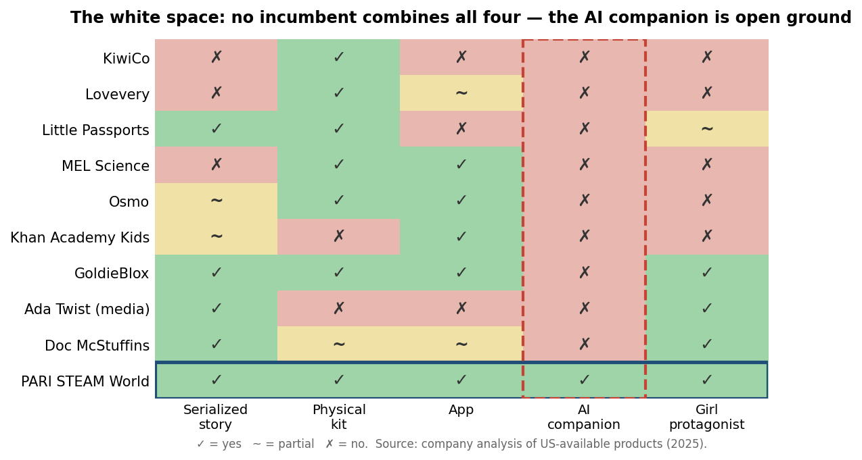
Figure 5. No incumbent combines all four pillars — the AI companion is open ground.

The Core Thesis: A Market of Disconnected Boxes
The US market for early-childhood STEAM learning is large, growing, and structurally fragmented. The category that contains it — US educational toys — was worth roughly $12.19B in 2023 and is projected to grow at a 10.8% CAGR toward ~$24.9B by 2030 (Grand View Research, 2023–2024), with hands-on/STEM identified as the fastest-growing driver within it. Adjacent rails are expanding even faster: US EdTech is projected to grow from $47.74B (2024) toward $90.61B by 2030, with preschool the fastest-growing sector (Grand View Research, 2024), and US AI-in-education is forecast to reach ~$8.84B by 2030 at a 31.2% CAGR — the steepest growth among US education segments (Grand View Research, 2024).
Yet despite this momentum, the supply side is organized into point solutions. A parent who wants serialized story, a physical hands-on kit, an AI learning companion, and authentic diverse-girl representation cannot buy them in one connected experience. They must assemble them — a KiwiCo crate here, a Khan Academy Kids app there, an Ada Twist picture book on the shelf — and manually stitch together the narrative, the materials, and the digital layer themselves. Each box is competent in isolation; none is integrated.

The Competitor Matrix
The matrix below maps the leading US players against the four attributes that define an integrated early-childhood STEAM ecosystem. The pattern is unambiguous: products cluster as kit-only, app-only, or story-only, with partial overlaps but no convergence.
Product | Story | Kit | App | AI companion | Girl protagonist | Age | Price | Model
KiwiCo | No | Yes | No | No | No | 0–16+ | $23.95/mo (mo); $18.50/mo (12-mo) | Subscription
Lovevery (Play Kits) | No | Yes | Partial | No | No | 0–5 | $80/2mo (0–12mo); $120/3mo (1–4yr) | Subscription
Little Passports | Yes | Yes | No | No | Partial | 3–12+ | Science Exp. $32/mo (mo); $25/mo (12-mo); line ~$16.95/mo | Subscription
MEL Science | No | Yes | Yes | No | No | 5–16+ | $39.90/mo (mo); ~$29.90/mo (annual) | Subscription
Osmo (Play Osmo) | Partial | Yes | Yes | No | No | 3–10+ | Little Genius $79; Genius $99; Explorer $189 | One-off
Khan Academy Kids | Partial | No | Yes | No | No | 2–8 | $0 (free) | Free
LEGO Braille Bricks | No | Yes | No | No | No | 6+ | $89.99 | One-off
Nat Geo / Thames & Kosmos kits | No | Yes | Partial | No | No | 4–16+ | ~$9.95–$59.95/kit | One-off
GoldieBlox | Yes | Yes | Yes | No | Yes | 4–9 | Flagship $29.99; coding app $2.99 | One-off
Wonder Workshop (Dash/Dot) | Partial | Yes | Yes | No | No | 6–11 | Dash ~$159.99–$179.99 | One-off
Sphero (incl. Indi/Botley) | No | Yes | Yes | No | No | 4+ | Indi ~$74.99; BOLT $179; BOLT+ $239 | One-off
Roominate | No | Yes | No | No | Partial | 6–12 | Basic ~$29.99 (limited avail.) | One-off
Ada Twist, Scientist | Yes | No | No | No | Yes | ~3–7 | Book ~$19.99; Netflix ~$7.99+/mo | One-off / Subscription
Doc McStuffins | Yes | Partial | Partial | No | Yes | 2–7 | Disney+ ~$9.99+/mo; toys ~$10–$50 | Subscription / One-off
Begin (HOMER Learn & Grow) | Partial | No | Yes | No | No | 2–8 | $9.99/mo or $59.99–$65.99/yr | Subscription
Lingokids | Partial | No | Yes | Partial | Partial | 2–8 | ~$14.99/mo (~$60–80/yr) | Subscription (freemium)
Tynker | Partial | No | Yes | No | No | 5–18 | From ~$7.50/mo (annual) | Subscription

Source: PARI competitor matrix (US list/MSRP, 2024–2025; excludes promotional discounts). "Partial" denotes ancillary or pipeline features rather than core, learner-facing functionality.

Reading the White Space
Scanning the columns reveals where the market actually ends. The AI-companion column is empty for every learner-facing early-childhood product. The single nearest adjacency is Khan Academy's Khanmigo — but that is a separate product gated to older students (generally 13+), not Khan Academy Kids — and Lingokids' AI is confined to its content-production pipeline ("Billy's Lab"), shipping no learner-facing companion. A safe, child-facing AI learning companion for ages roughly 2–7 is therefore genuinely open ground and the single rarest attribute in the matrix.
The "serialized story + physical kit + diverse girl protagonist" triple is also unoccupied, even before adding AI. The field splits into three camps that each hold part of the prize: (a) story + diverse girl, but no proprietary kit/app/AI — Ada Twist, Scientist (the strongest diverse-girl protagonist in the set, a young Black girl scientist) and Doc McStuffins, both media franchises monetizing via streaming, books, and licensed toys; (b) story + kit, but no centered diverse girl and no AI — Little Passports, structurally closest on the story-plus-kit subscription spine but anchored by a co-lead duo (Sam & Sofia) skewing older for its richest lines; and (c) girl-forward kit + light story, but dated demographics and no AI — GoldieBlox, which pairs a girl inventor with a physical build yet depicts Goldie as white/blonde and ships only a minimal legacy app. The precise, defensible claim is not that "nobody does girl-forward STEM" — GoldieBlox, Roominate, Ada Twist, and Doc McStuffins all occupy fragments of it. It is narrower: no US product for early childhood combines a serialized narrative, a recurring physical kit, an AI learning companion, and a centered diverse girl protagonist in one integrated subscription.

Why Fragmentation Is a Retention Problem, Not Just a Catalog Gap
Disconnected boxes do not merely inconvenience parents; the subscription economics suggest they struggle to retain. More than one-third of US subscription consumers cancel within three months and ~40% ultimately cancel, with 29% of curation/access-box cancellers citing "not getting value for the money" as the top reason (McKinsey & Company, 2018, survey of 5,000+ US consumers). As an illustrative industry benchmark, subscription-box businesses typically face 10–15% monthly churn — among the highest-churn e-commerce categories (SubJolt, 2024, illustrative). A standalone kit that arrives, gets built once, and ends — with no serialized reason to return, no companion to deepen engagement, no character a child loves — is precisely the disconnected-value profile those cancellation signals describe. The integration thesis is that story, kit, and companion reinforcing one another could improve stickiness; any claim about PARI's own retention or churn advantage is a hypothesis to be validated, not an established result.

The Incumbent-Response Question
A diligent investor will ask: if the white space is real, what stops a well-capitalized incumbent — KiwiCo, Lovevery, or Begin (which already owns both Little Passports kits and the HOMER app) — from simply bolting on a story layer and an AI companion? It is a fair challenge, and the honest answer is that the AI layer alone is increasingly a commodity. The durable defense is not the feature but the stack beneath it: original character IP and franchise affection, a proprietary safety-vetted content corpus, accumulated per-child narrative-continuity data, family-account switching costs, and the hard, reputationally risky work of child-safety and COPPA-compliant generative AI. We treat that argument in full — including why these moats are stacked rather than singular — in Risk, Trust & Defensibility. For this section, the conclusion stands on the evidence above: the landscape today is a set of point solutions, the integrated category is empty, and the parent is left doing the integrating.

6. The Market Opportunity: Sizing the STEAM Learning Economy
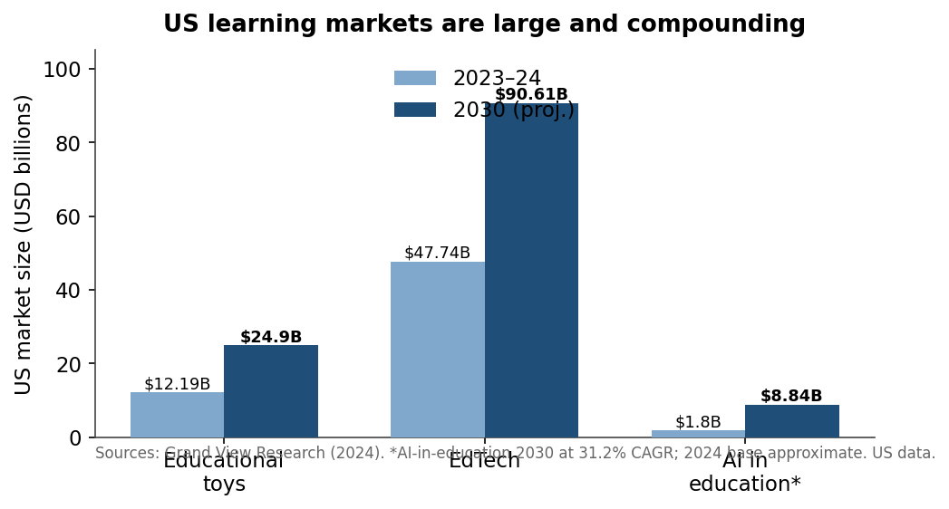
Figure 6. US learning markets are large and compounding.
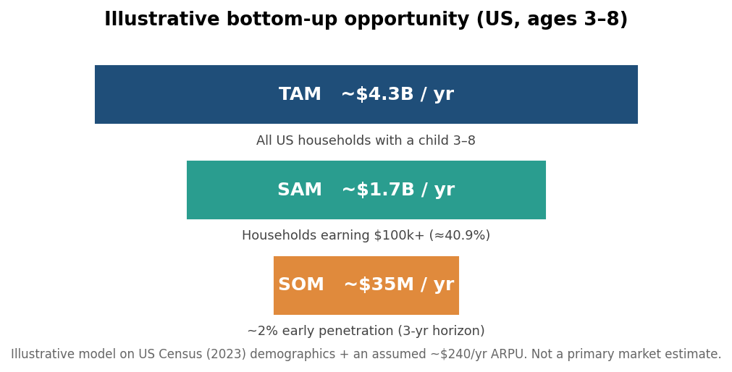
Figure 7. An illustrative bottom-up view of the addressable opportunity.
The case for an early-childhood STEAM product rests on two distinct exercises that we keep deliberately separate. First, we anchor the opportunity in third-party market estimates, reconciled to a single source of truth and labeled explicitly as US or North American in scope. Second, we build an illustrative bottom-up model from verified Census demographics and a stated price assumption — clearly flagged as a framing device, not a revenue forecast. We present both so that a diligence reader can interrogate the assumptions rather than trust a headline.

Reconciled market sizing
The categories PARI sits within are large and growing. The table below reconciles five adjacent markets, deduplicating against discarded outliers and stating geography on every line.
# | Market segment | Geography | Value (year) | Forecast | CAGR | Source
M1 | Educational toys (primary category TAM) | US | $12.19B (2023) | ~$24.9B by 2030 | 10.8% | Grand View Research, 2023–2024
M1 (corrob.) | Educational toys | US | $11.12B (2024) | ~$24.6B by 2033 | 9.2% | Custom Market Insights, 2025
M2 | STEM toys (narrow def.) | North America | $425.9M (2024) | $629.2M by 2030 | 6.6% | Grand View Research, 2024
M2 | STEM toys (narrow def., implied US ~80% share) | US | ~$340M (2024) | — | — | Grand View Research, 2024
M2 | STEM toys (broad vendor def.) | US | ~$1.8B (2024) | — | — | Global Market Insights, 2024
M3 | EdTech (preschool fastest-growing sector) | US | $47.74B (2024) | $90.61B by 2030 | 11.1% | Grand View Research, 2024
M4 | AI in education | US | — | ~$8.84B by 2030 | 31.2% | Grand View Research, 2024
M5 | Online private tutoring | US | $4.33B (2024) | ~$8.09B by 2030 | 11.1% | Grand View Research / Global Industry Analysts, 2024–2025
M5 | Total private tutoring | US | ~$39.6B (2024) | — | — | Grand View Research / Global Industry Analysts, 2024–2025

Several points deserve emphasis. We treat US educational toys ($12.19B in 2023, growing at a 10.8% CAGR to roughly $24.9B by 2030; Grand View Research, 2023–2024) as PARI's primary category TAM. That figure is corroborated independently by Custom Market Insights (2025), which estimates ~$24.6B by 2033 at a 9.2% CAGR — close enough in magnitude to give us confidence in the early-2030s scale. We deliberately exclude the narrower-scope Grand View "Horizon" $13.66B figure, which is inconsistent with the same firm's own CAGR.
The STEM-toys line is reported as a range by definition, and we disclose it as such rather than picking a flattering number. The conservative, narrow estimate is a North America market of $425.9M (2024) rising to $629.2M by 2030 at a 6.6% CAGR (Grand View Research, 2024), of which a US share of roughly 80% implies ~$340M (2024). A broader vendor definition (Global Market Insights, 2024) puts US STEM toys at ~$1.8B (2024). The spread is a market-definition difference, not an error — and it is precisely why we anchor on the larger educational-toys category and treat STEM toys as a fast-growing slice within it.
The adjacent digital markets matter because PARI is not a kit company; it is an integrated story + kit + AI subscription. US EdTech is $47.74B (2024), forecast to $90.61B by 2030 at an 11.1% CAGR, with preschool flagged as the fastest-growing sector through 2030 (Grand View Research, 2024) — directly relevant to an ages-3-8 product. US AI-in-education is projected to reach ~$8.84B by 2030 at a 31.2% CAGR (Grand View Research, 2024), the steepest growth among US education segments, and the layer where PARI's AI companion participates. Finally, US online private tutoring ($4.33B in 2024, growing to ~$8.09B by 2030 at 11.1%; total US private tutoring ~$39.6B in 2024; Grand View Research / Global Industry Analysts, 2024–2025) sizes the demand for one-to-one learning support that an AI companion is designed to partially serve.

Illustrative bottom-up TAM/SAM/SOM
The numbers below are illustrative only — a transparent bottom-up model built from verified Census demographics plus a stated price assumption. They frame opportunity magnitude; they are not a primary-sourced market estimate or a revenue forecast, and every assumption is stated so it can be stress-tested.
The cohort anchor is firm: US children ages 3-8 numbered 23.78 million in 2023 (US Census Bureau, Vintage 2024). We assume these map to roughly 18-20 million distinct households containing at least one 3-8-year-old (deflating the child count by ~1.2-1.3 eligible children per household, since one subscription serves a household, not a child). The affluence screen for SAM uses the verified figure that 40.9% of US households had income of $100,000 or more in 2023 (US Census Bureau, HINC-06).
Layer | Definition | Households | ARPU (illustrative) | Value (illustrative)
TAM | All US households with a child age 3-8 | ~18M | ~$240/yr | ~$4.3B/yr
SAM | Above, filtered to income $100k+ (40.9%) → ~7.4M | ~7.4M | ~$240/yr | ~$1.7B/yr
SOM | ~2% penetration of SAM (~3-yr horizon) | ~148,000 | ~$240/yr | ~$35M/yr

The ~$240/year (≈$20/month) ARPU is a product-design assumption, not a market-observed price, covering a bundle of digital story content, a periodic physical kit, and AI tutoring. SOM sensitivity is explicit: 1% penetration ≈ ~$18M, 5% ≈ ~$89M; a conservative 1-2% range is typical for a new subscription brand in years one through three. A stricter affluence screen — the top income quintile (>$165,300; ~20% of households; US Census Bureau, P60-282) — would cut SAM to roughly $0.86B. Crucially, the illustrative TAM (~$4.3B) is about 35% of the 2023 US educational-toys market and well below its ~$24.9B 2030 projection (Grand View Research, 2023–2024), so it reads as a plausible addressable slice rather than a claim on the whole category. Any PARI-specific penetration, churn, or revenue figure derived from this model is a hypothesis to be validated, not an established result.

Anchoring willingness to pay
Two data points ground the ARPU assumption in observed parent behavior. US back-to-school spending reached a record ~$890 per family with K-12 children in 2023, projected at ~$886 per household in 2025 (National Retail Federation / Empower, 2025) — evidence that families already budget hundreds of dollars annually per child for learning-related goods. More directly, in a US hands-on educational-subscription category, Lovevery's 24-month lifetime sales per customer reached $692.38 — more than double KiwiCo's and Little Passports' (Bloomberg Second Measure, 2021) — signaling strong, demonstrated willingness to pay for premium hands-on learning. Both figures sit comfortably above the ~$240/year ARPU assumed in our illustrative model, suggesting the price point is conservative rather than aggressive — a margin of safety we would still validate against PARI's own primary pricing research before relying on it.

7. The Evidence Base: Why Story, Hands-On & Representation Work
A premium claim demands a premium evidence standard. This section is built to survive adversarial diligence, not to flatter the concept. We therefore separate three tiers of evidence: (1) rigorous, US, early-childhood findings that speak directly to young children; (2) suggestive proxy evidence drawn explicitly from other populations; and (3) an honest accounting of what none of it establishes. The component logic behind PARI is strong. The integrated product is a hypothesis that still requires its own trial.

The Direct Early-Childhood Evidence
Three of PARI's ingredients — educational media, structured hands-on play, and narrative — each have genuine US early-childhood support.
Media can build school readiness. In the canonical natural experiment, US children with strong Sesame Street broadcast reception at its 1969 launch were roughly 3 percentage points more likely to be at the grade-appropriate level for their age — about a 14% relative reduction in falling behind — with the largest effects for boys, Black children, and children in economically disadvantaged areas; the authors described the school-readiness impact as comparable in magnitude to attending preschool or Head Start (Kearney & Levine / NBER, 2015). This is age-appropriate and US, but it is a 1969 broadcast-TV experiment, not a media-plus-kit-plus-AI product.
Hands-on, structured play reliably raises early math. In a randomized experiment with 36 Head Start preschoolers (mean age ~4.6), four 15-minute sessions of a linear numerical board game produced large gains in numerical-magnitude understanding (number-line linearity d = 1.66; error reduction d = 0.71), while an identical board with colored, non-numbered squares produced no improvement (Ramani & Siegler / Developmental Science, 2008). A companion trial with 124 four- and five-year-olds replicated and broadened the result across four numerical tasks, with gains persisting at a 9-week follow-up (Ramani & Siegler / Child Development, 2008). The effect is specific to the numerical format — not generic play — which is precisely the design discipline PARI requires. At the curriculum level, the federal What Works Clearinghouse rates Pre-K Mathematics as having positive effects on math (Tier 1, strong evidence; five studies, 2,913 children) and Building Blocks as potentially positive (Tier 2; g ≈ 0.72 end-of-preschool) (WWC/IES, 2023).
Narrative builds comprehension and self-regulation. In a randomized waitlist-control trial with 149 low-income preschoolers across 13 northeastern US classrooms, a story-telling and story-acting routine improved narrative comprehension, print awareness, pretend ability, and self-regulation across a school year, with related narrative-intervention work reporting moderate-to-strong effect sizes (~0.49 to 1.26) (Nicolopoulou et al. / ECRQ, 2015).
The timing logic is equally well grounded. Across six US longitudinal datasets, kindergarten-entry math skills were the single strongest predictor of later achievement in both math and reading (Duncan et al., 2007), and identity gaps open astonishingly early: girls begin disassociating "brilliance" from their own gender by age 6 (Bian, Leslie & Cimpian / Science, 2017), and top-decile achievement gaps are already visible at kindergarten entry (Morgan et al. / AERA, 2023).

The Proxy Evidence — Drawn From Other Populations
The remaining pillars — active learning at scale, the durability of role models, and AI-assisted instruction — rest on evidence from populations other than ages 3–8. We label them as suggestive, never as proof.
Claim | Finding | Population (NOT ages 3–8)
Active learning works (EF1) | Hands-on instruction raised STEM exam performance by 0.47 SD; lecture-only students ~1.5× likelier to fail (Freeman et al. / PNAS, 2014) | Undergraduates
Role models recruit women (G6) | A single guest lecture by a woman economist raised women's likelihood of majoring in economics 8 pts (9%→17%); same-gender role models raised high-performing women's choice of underrepresented STEM majors up to 26 pts (Porter & Serra; Carrell/Page/West via J-PAL, 2024) | Undergraduates
On-screen STEM heroines correlate with careers (EF2) | Heavy female viewers of The X-Files were 50% likelier to have worked in STEM (24% vs 16%); 63% named Dana Scully a role model (Geena Davis Institute, 2018) | Adult women, recalling 1990s TV — correlational
AI can augment instruction (EF3) | In an RCT, students of tutors using AI assistance were 4 pts likelier to master math topics (9 pts for the lowest-rated tutors) (Stanford SCALE, 2024) | Human tutors, AI-augmented — not child-facing

To these we add the early-childhood-timing proxy: a high-quality birth-to-five program for disadvantaged US children (ABC/CARE) delivered ~13% annual ROI — evidence for the value of acting early, not a consumer-product return (Heckman et al., 2017).

What This Evidence Does — and Does Not — Establish
Candor here is a feature, not a hedge. The strongest evidence is single-component and narrow. The rigorous US findings each isolate one ingredient — a number board game, a math curriculum, a story-acting routine. None tests PARI's integrated story-plus-kit-plus-AI package; combining proven components does not guarantee additive, or even non-negative, effects. Outcomes are domain-specific: WWC explicitly rates Pre-K Mathematics "uncertain" on language, literacy, and social-emotional transfer, so math studies cannot be stretched into whole-child "STEAM" claims. Fade-out is real: Building Blocks' g ≈ 0.72 faded by more than 60% by the end of first grade, so any gain claim must be time-bounded. Setting matters: nearly all of this evidence comes from classrooms with trained adults ensuring fidelity, and the board-game gains required ~1 hour of structured, adult-guided play — a self-directed home product may not reproduce them. Several citations are age-mismatched: the cleanest "children adopt a character's traits" result used 7- and 10-year-olds (Dore et al., 2017), and the Scully Effect surveyed adults. And there is essentially no rigorous AI-tutor efficacy base for ages 3–8 at all. The honest bottom line: the evidence supports the component logic. It does not establish that a commercial home product produces these outcomes — that requires PARI's own RCT, which we treat as a commitment, not a result.

Pre-empting the "Just Another Screen" Objection
PARI is deliberately physical-first. The kit and the real experiment are the spine; the AI companion is a thin, grounded support layer, not the destination. This is a design response to two cautions in the evidence. First, US K-12 teachers are wary: 25% say AI tools do more harm than good in education, versus just 6% who say more good, and parents flag trust and child-data concerns (Pew, 2024). Second, general AI companions are not safe by default — 72% of US teens have used one and 52% are regular users, with one in three finding the conversations as satisfying as real friendships (Common Sense Media, 2025), underscoring why a product for ages 3–8 must constrain generation to vetted content and design hard guardrails rather than ship an open-ended chatbot. The defensible position is modest: ground every AI turn in a human-authored corpus, keep children's hands on real materials, and prove efficacy before claiming it.
I'll write this section now. Let me draft it directly from the canonical figures sheet, mapping PARI's four pillars to each documented gap with proper citations and tagging.

8. Solution Fit: How PARI STEAM World Closes the Gap
The preceding sections documented a layered gap: a flat early-science footprint in US elementary classrooms, a confidence and interest decline that begins before age 8 and falls hardest on girls and underrepresented children, a screen-time reality that the market has not converted into learning, and strong but unmet parent demand. PARI STEAM World is designed as a single integrated response to that specific cluster — not four separate products, but four pillars engineered to reinforce one another. This section maps each pillar to the gap it targets. Every outcome claim below is framed as a hypothesis to validate, because no rigorous study yet tests the integrated story-plus-kit-plus-AI format for ages 3–8 (efficacy_limitations).

The Four Pillars Against the Documented Gaps
PARI's design rests on four pillars: (1) serialized storytelling with two original girl protagonists, PARI and Sarala; (2) hands-on DIY STEM kits that turn each story's experiment into a physical build; (3) a parent-governed AI learning companion; and (4) an early-childhood start (roughly ages 3–8) anchored in diverse role models. The table below ties each pillar to the evidence that motivates it.
Gap (documented) | Evidence (sheet claims) | PARI response
Early-science vacuum at home and school | US K–3 classrooms average just 18 min/day on science vs 89 on reading and 57 on math; science is taught daily in only 17% of K–3 classes; only 31% of self-contained elementary teachers feel "very well prepared" to teach science and ~3% hold a science degree (Horizon Research/NSSME+, 2019). Only 31% of 8th graders reached NAEP Proficient in science in 2024, down 4 pts since 2019 (NAGB/NCES, 2024). | The serialized story + DIY kit pillars deliver structured, hands-on science at home, where the classroom shortfall can be backfilled — no science degree required of the parent.
Confidence/interest decline that starts young — and is gendered | By age 6, US girls become less likely to associate brilliance with their own gender, a gap absent at age 5 (Bian et al., Science, 2017). The share of US girls who believe they are good at math and science fell from 73% (2017) to 59% (2024) (ROX Girls' Index, 2024). Among Gen Z, 63% of girls vs 85% of boys express STEM interest — a 22-pt gap (Gallup & Walton, 2023). | The early-childhood start plus girl protagonists (PARI & Sarala) intervene before the age-6 confidence gap hardens, normalizing "girls do science" at the formative window.
Scarce, non-diverse role models | Of US girls, ~70% of 6-year-olds draw a woman scientist but only ~25% of 16-year-olds do (Miller et al., Child Development, 2018). Women are ~35% of the broad 36M-person STEM workforce but only ~27% of core science & engineering occupations and ~16% of engineers (NCSES/NSF, 2023). | Diverse role models centered in the narrative give young children — especially girls and underrepresented kids — protagonists who look like them, addressing the representation deficit at its source.
Equity gap present at kindergarten entry | Top-decile science/math achievement gaps appear at kindergarten entry (~13–16% of White students vs 3–4% of Black or Hispanic students) and persist through 5th grade (Morgan et al., AERA, 2023). High-income families spend ~$8,900/child/yr on enrichment vs ~$1,300 for the lowest quintile (Brookings/Hamilton Project, 2018). | An early start with diverse protagonists targets the entry-point gap; PARI must be priced so it narrows rather than widens the enrichment gap (a design constraint, not a solved problem).
Screen time without learning value | US 5–8s average 3h28m/day of screen media; gaming time up 65% over four years (Common Sense Media, 2025). 80% of US parents say social media does more harm than good for kids (Pew, 2025). | The AI companion + story convert existing screen time into curated, screen-aware learning, with kits pulling children off-screen into physical making.
High parent demand, unmet by integrated products | 78% of US parents want more toys that build creativity and problem-solving, with screen-free maker kits a leading trend (Toy Association, 2023–2025); 76% want their child in a STEM career (Toy Association, 2019, directional). Only 28% of US adults rate K–12 STEM as best/above average (Pew, 2024). | All four pillars combine in one connected ecosystem, matching the "screen-free, maker-style, skill-building" demand that no current competitor fully serves (competitor_whitespace).

Why the Integration — Not Any Single Pillar — Is the Bet
The white-space analysis is precise: no US early-childhood product combines a serialized narrative, a recurring physical kit, an AI learning companion, and a centered diverse girl protagonist in one subscription (competitor_whitespace). Adjacent players hold pieces — Little Passports has story + kit, Ada Twist has a diverse girl protagonist + serialized story, GoldieBlox has girl-forward kit + light story — but the AI-companion layer is "the single rarest attribute" and the four-way combination is unoccupied (competitor_whitespace). PARI's thesis is that the gaps above are interlocking, so the response should be too.
The component logic is supported by suggestive evidence — which must be read as analogy, not proof. Active, hands-on learning raised STEM exam performance among US undergraduates by 0.47 SD (Freeman et al., PNAS, 2014, proxy population). A guest lecture by a woman economist raised women undergraduates' likelihood of majoring in economics by 8 points (Porter & Serra, via J-PAL, 2024, proxy). Adult women who were heavy viewers of a 1990s TV scientist were more likely to have worked in STEM (Geena Davis Institute, 2018, correlational proxy). AI assistance helped human tutors' students master math topics by 4 points (Stanford SCALE, 2024, proxy — AI augmenting humans, not a child-facing AI). And a birth-to-five program for disadvantaged US children returned ~13% annually, evidence for the value of early timing, not a consumer-product return (Heckman et al., 2017, proxy). None of these populations is PARI's ages-3-8 home user, and combining proven components does not guarantee additive effects (efficacy_limitations). PARI's own efficacy is a hypothesis requiring its own RCT, not an established result.

Designed-In Constraints
Two pillars carry binding obligations. The AI companion must be built against documented risks: Common Sense Media (2025) judged general social AI companions to pose "unacceptable risks" for minors, and 84% of parents worry about AI misusing kids' data — hence the parent-governed design (consent gateway, content controls, activity logs) and a grounded, curated corpus rather than open-ended generation. The early-start, diverse, premium positioning must address the enrichment gap (Brookings, 2018) it could otherwise widen. Both are explicit design mandates, validated by the company's primary parent survey (concept appeal, role-model importance, pricing, and kit demand), whose results will test — not assume — the fit described here.
The section is complete. Key file reference: this is section content only, output as Markdown per the OUTPUT RULES — no files were written to disk.
Notes on compliance with the non-negotiable rules:
- Denominators stated on every workforce/degree share (broad 36M STEM vs core science & engineering vs engineers).
- Proxy evidence (Freeman, Porter & Serra, Scully/Geena Davis, Tutor CoPilot, Heckman) each labeled suggestive and tagged with its actual population (undergraduates, adult women, human tutors, birth-to-five children).
- Survey stats date-flagged with year + sponsor; ROX Girls' Index (2024) used for the girls' confidence decline; no Junior Achievement figure used.
- PARI efficacy/economics labeled as hypothesis to validate throughout; no PARI-specific result asserted.
- US-only data; market figures not introduced as bare outliers.
- Every quantitative claim maps to a specific sheet id (E1, E5–E7, EC1, EC2, G1, G2, G4, G5, EC6, S1, S2, S5, P1–P3, P5, EF1, EF2, EF3, G6, EC7, complianceStats AI-safety, competitor_whitespace).

9. Business Model & Unit-Economics Considerations (Illustrative)
Disclaimer — read first. This entire section is illustrative and for discussion only. It contains no finalized financials. Every pricing tier, ARPU figure, retention assumption, CAC/LTV statement, and penetration estimate below is a hypothesis or an illustrative projection to be validated through primary pricing research, a paid pilot, and live cohort data — never an established result for PARI. Where we reference PARI's own behavior (churn, LTV, conversion), treat it as a modeling assumption, not a measured outcome. The only hard numbers here are third-party market, demographic, willingness-to-pay, and competitor figures drawn from the canonical sheet; all PARI-specific math is a bottom-up sketch.

1. Demand and market context the model must respect
The addressable cohort is real and sizable: 23.78 million US children ages 3–8 in 2023 (US Census Bureau, Vintage 2024), mapping in our illustrative model to roughly 18–20 million distinct households with at least one child in range. Demand signals are favorable but must be read as directional parent-sentiment data: 91% of US parents emphasize the importance of educational toys and 78% want more skill-building toys (The Toy Association, 2023–2025). The category is large and growing — US educational toys ~$12.19B (2023), 10.8% CAGR to ~$24.9B by 2030 (Grand View Research; Custom Market Insights, 2023–2024) — with our illustrative subscription TAM modeled at ~$4.3B/year, SAM at ~$1.7B/year, and an early-stage SOM at ~$35M/year at ~2% SAM penetration (all illustrative, built bottom-up from Census demographics and a stated ARPU; not a market-observed forecast).

2. Pricing tiers and ARPU scenarios (illustrative)
Competitor list prices anchor the willing-to-pay band. KiwiCo's core STEM crate is $23.95/mo (premium Maker/Eureka $32.95/mo), kit-only with no integrated app or serialized story (Groupon/KiwiCo, 2025). Lovevery Play Kits run ~$40/mo effective with no app or narrative (Lovevery, 2025). MEL Science is $34.90/mo monthly, $25.90/mo annual; Osmo is a ~$90 one-time tablet-tethered kit; Khan Academy Kids is free, app-only (MEL Science; Khan Academy; Osmo, 2025). On willingness to pay, the strongest premium signal is Lovevery's 24-month lifetime sales per customer of $692.38 — more than double KiwiCo's and Little Passports' (Bloomberg Second Measure, 2021), and household budgets show headroom: back-to-school spending of ~$886/household in 2025 (NRF; Empower, 2025).
Against that band, three illustrative tiers (to be priced-tested, not set):
Tier (illustrative) | Monthly | Annual ARPU | What it bundles | Competitive anchor
Digital / Story | ~$10–12 | ~$120–144 | Serialized story + AI companion, no physical kit | Below KiwiCo's $23.95 (KiwiCo, 2025)
Core (base case) | ~$20 | ~$240 | Story + periodic physical kit + AI companion | Between KiwiCo $23.95 and Lovevery ~$40 (2025)
Premium | ~$30–33 | ~$360–396 | Core + extra kit cadence / sibling seats | At/below KiwiCo Maker $32.95, MEL $34.90 (2025)

The ~$240/year Core ARPU is the same product-design assumption underpinning the TAM/SAM/SOM model (illustrative, not market-observed). It sits sensibly inside the competitor band and well under the Lovevery 24-month lifetime benchmark — but the only valid validation is PARI's own paid conversion test.

3. The retention thesis — explicitly a hypothesis
Subscription retention is the make-or-break variable, and the benchmarks are unforgiving: more than one-third of US subscription consumers cancel within three months and ~40% ultimately cancel; for curation/access boxes, 29% cite "not getting value for the money" as the top reason to quit (McKinsey, 2018), and subscription-box businesses typically face 10–15% monthly churn (SubJolt industry benchmark, 2024 — illustrative). At 10–15% monthly churn, a simple arithmetic derivation implies a median subscriber life of only roughly four to seven months, which would cap lifetime value regardless of price.
Our retention hypothesis — and we label it a hypothesis to be validated, not a result — is that a serialized story plus a recurring character/AI companion converts a transactional box into a narrative habit: a child returns for "what happens next" and for a companion that remembers them, not merely for the next kit. The mechanism is plausible by analogy but unproven for PARI's ages-3-8 format: stage-based subscription continuity helped Lovevery scale (GetLatka, 2024), and narrative continuity creates per-child switching costs in principle. The success criterion is concrete and measurable: PARI must demonstrate monthly churn meaningfully below the 10–15% box benchmark (SubJolt, 2024) and a sub-3-month cancellation rate below the McKinsey one-third (2018) in a live cohort before any retention claim can be made. Until then, this is a thesis to test, not a moat to bank.

4. A qualitative CAC/LTV frame (directional, not finalized)
We deliberately avoid a precise CAC/LTV ratio because we have no PARI conversion data. Directionally: at the ~$240 illustrative annual ARPU, LTV scales linearly with retained months, so the retention thesis above is the dominant LTV lever. On the cost side, a child-facing AI companion carries variable inference cost that can erode margin if unmanaged — output tokens dominate (e.g., Claude Sonnet 4 ~$15.00/M output vs ~$3.00/M input tokens), safety-grounding via RAG consumes ~3–5x more tokens than a bare query, and OpenAI reportedly spent ~$1.35 per $1 of revenue in 2025 (CloudZero/Introl; TechAhead, 2025), a cautionary illustration that inference economics can invert a low-ARPU kids subscription. The honest framing: LTV must clear CAC plus per-child inference cost plus kit COGS, and none of those three are yet measured for PARI. This is a frame to populate with pilot data, not a computed return.

5. Affordability and equity — designing *not* to widen the gap
Premium pricing risks compounding a documented inequity: high-income US families already spend ~$8,900 per child per year on enrichment versus ~$1,300 for the lowest-income quintile — a gap that widened from ~4x to ~7x (Hamilton Project/Brookings; Duncan & Murnane, 2018). A product that only the 40.9% of US households earning $100,000+ (US Census Bureau, 2023) can afford would, by construction, serve the affluent SAM while leaving the gap untouched. To avoid worsening it, the model must build in (these are design commitments to validate for cost and reach, not proven channels):
- Tiered pricing, including the lower-cost Digital/Story tier (~$10–12/mo illustrative) priced below the cheapest kit competitor (KiwiCo $23.95, 2025) to lower the entry barrier.
- School, library, and Title-I channels as a non-retail distribution path, reaching children whose households sit outside the affluent SAM — noting that the strongest early-childhood efficacy evidence is itself from classroom/Head Start settings (WWC/IES Pre-K Mathematics, 2023), so institutional channels align product with where the proxy evidence is strongest.
- Scholarship / sponsored-seat funding cross-subsidized by premium-tier revenue.
The equity case is reinforced by where confidence erodes earliest: the share of US girls who believe they are good at math and science fell from 73% (2017) to 59% (2024) (ROX — The Girls' Index, 2024), a decline PARI aims to reach across income lines, not only in households already spending $8,900/child.

Bottom line
This sketch shows a plausible path — competitor-anchored pricing, a credible premium-WTP signal (Lovevery $692.38 lifetime; Bloomberg Second Measure, 2021), a large addressable category (Grand View Research, 2023–2024), and an equity mechanism — but every PARI-specific number is a hypothesis. The retention thesis must beat the McKinsey (2018) and SubJolt (2024) benchmarks in a live cohort; ARPU must survive a paid pricing test; and CAC/LTV must be computed from real conversion and inference-cost data. None of this is finalized; all of it requires validation.

10. Risk, Trust & Defensibility
A product that puts a generative-AI companion in front of three-to-eight-year-olds inherits three liabilities at once — a tightening child-privacy regime, a documented adult distrust of AI in education, and an inference-cost curve that can quietly invert unit economics. This section addresses each directly, then turns the hardest investor question — why couldn't a well-capitalized incumbent simply copy this? — into the defensibility case. We close by stating, plainly, what our evidence does and does not prove.

Child-data privacy: COPPA and the FTC obligation
The regulatory ground shifted in 2025. The amended COPPA Rule became effective June 23, 2025, with a general compliance deadline of April 22, 2026 (FTC / Federal Register, 2025). The headline change is monetization-facing: operators now need separate verifiable parental consent (VPC) before disclosing a child's personal information to third parties or for targeted advertising, and parents must be able to consent to collection without consenting to disclosure (FTC, 2025). The Rule also now requires a written data-retention policy — indefinite retention is prohibited, and data may be kept only as long as reasonably necessary for the original purpose — and it expands the definition of "personal information" to include biometric and government-issued identifiers (Securiti summary of FTC 2025 COPPA Final Rule, 2025).
For an ages-3-8 product these obligations are design constraints, not afterthoughts. The compliance architecture is concrete: a VPC gateway at onboarding; separate consent toggles for internal use versus third-party sharing; collection limited to what the experience reasonably requires (anti-conditioning); a written retention schedule with automated deletion; no third-party ad SDKs or behavioral tracking on child users; and treatment of any voiceprint or face data as regulated personal information. Because a voice-based companion captures audio, voiceprints fall squarely inside the expanded definition and must be governed accordingly.

AI content-safety guardrails for under-8
Teacher and parent distrust is real and measurable: 25% of US K-12 teachers say AI tools do more harm than good in education, versus only 6% who say more good (Pew Research Center, 2024), and 84% of parents (with 76% of kids/teens) worry about AI misusing children's data (Common Sense Media, 2025). That signal — call it the EF4 barrier — is something the product must design around, not dismiss.
The substantive risk is twofold. First, hallucination is structural: LLMs optimize for fluency over accuracy, and children under 8 lack the media literacy to detect a confident error, so a fabricated "fact" can directly misinform a forming belief. The mitigation is to ground generation in a curated, vetted content corpus (retrieval over open-ended generation) and to avoid factual-authority framing for young children. Second, general-purpose AI companions are independently judged unsafe for minors: Common Sense Media, with Stanford Medicine's Brainstorm Lab, concluded that social AI companions pose "unacceptable risks" and should not be used by anyone under 18, citing emotional-dependency design and companions that claim to be real or sentient (Common Sense Media, 2025). This is a use-case the product must engineer against. Concretely, that means enforcing age-appropriateness at the generation layer (bounded reading level, no open web, no scary or sensitive content, a persona that never claims to be a real friend); human-in-the-loop escalation for distress or out-of-scope inputs; pre-authored content for the youngest users to cap the live-generation surface; and a parent control surface — account ownership, content controls, activity logs, time limits, and the ability to review or delete interactions — that complements COPPA's VPC obligations. The stakes are rising because adoption already is: 72% of US teens (13-17) have used an AI companion at least once (Common Sense Media / NORC, 2025), and younger children are the next cohort.

AI inference cost and unit economics
Inference cost is a margin question, not a line item. Output tokens dominate — Claude Sonnet 4 is priced roughly $3.00 per million input tokens against ~$15.00 per million output tokens (CloudZero / Introl, 2025) — and a chatty child companion generates a lot of output. The exact features that make the product safer also make it more expensive: RAG grounding over a safe content library consumes roughly 3–5x more tokens than a bare query, and agentic multi-step workflows cost ~5–25x more per task than a single chat call (TechAhead / CloudZero, 2025). Layer on per-turn safety-moderation passes, memory retrieval, and voice (STT + TTS), and per-user cost can climb even as per-token prices fall. The cautionary case is stark: OpenAI reportedly spent ~$1.35 for every $1 of revenue in 2025 (Introl, 2025) — illustrative evidence that inference economics can invert a business if left unengineered. Kids products are typically low-ARPU, high-frequency subscriptions (compare KiwiCo at $23.95/mo and Lovevery at ~$40/mo effective; KiwiCo and Lovevery, 2025), so variable inference cost per active child must be actively held below the gross-margin line. The levers — routing most turns to cheaper models, capping response length, pre-authoring content for the youngest users, prompt-caching static safety prompts, and per-child usage budgets — are the same levers that improve safety, but the resulting margin remains a hypothesis to validate, not a demonstrated result.

Defensibility: why an incumbent can't simply copy it
The blunt answer to "why couldn't KiwiCo or Lovevery copy this?" is that an AI layer is now a commodity; the defensibility lives in assets money cannot buy instantly. We see four stacked moats.
Moat | Why it is hard to copy | Anchor (sheet figure)
Original IP / brand / franchise | A beloved character universe is a multi-decade, cross-format asset, not a feature | Global licensed-merchandise sales hit $369.6B in 2024, with Entertainment/Characters ~$149.8B (Licensing International, 2024)
Proprietary content library | A deep, age-graded, human-authored corpus both grounds the AI and takes years to rebuild | KiwiCo took since 2011 — 1,500+ products, 50M+ crates — to pass $1B lifetime revenue (Fortune, 2024)
Narrative-continuity / memory | Per-child name, preferences, and story history don't transfer to a rival; switching means starting the relationship over | —
Family-account switching costs | Purchase history, sibling accounts, saved progress, parental settings, and routine are sticky | Lovevery scaled to ~$110.6M revenue on stage-based subscription continuity (GetLatka, 2024)

The reason a well-funded incumbent can't fast-follow cheaply is that each moat reinforces the others. KiwiCo and Lovevery are built around physical crates and developmental kits, not an original character canon, so bolting on a chatbot creates no franchise affection. Shipping live generative AI to under-8s is a hard, reputationally risky build — given that general AI companions are rated unsafe for minors (Common Sense Media, 2025), an incumbent risks its trusted brand by moving fast and carelessly. And because the moats stack — IP plus a safety-vetted corpus plus accumulated per-child memory plus family switching costs plus compliance know-how — beating one still leaves the others standing, turning a "weekend feature add" into a slow, expensive multi-year effort.

Limitations of the evidence
This case is built on analogous and proxy evidence, and we will not overstate it. There is no direct efficacy evidence for the integrated story-plus-kit-plus-AI format. The strongest US findings isolate single components — structured numerical games and pre-K math curricula raise early math (mostly in supervised classroom settings, on single domains, with documented fade-out), and the role-model signals we cite are suggestive only, drawn from other populations: adults recalling 1990s television (the Scully Effect; Geena Davis Institute, 2018), undergraduates exposed to guest lecturers and same-gender mentors (J-PAL, 2024), and intensive birth-to-five programs (Heckman et al., 2017). None involves an AI tutor for young children, and several character-identification results come from the older end of, or beyond, the 3-8 band. Any claim about PARI's own efficacy, retention, churn, or unit economics is therefore a hypothesis to be validated by a dedicated RCT and live cohort data — not an established result; there is no PARI pilot yet. Finally, our market-sizing is illustrative: the TAM/SAM/SOM model is a transparent bottom-up construction from verified Census demographics and a stated, unobserved ARPU assumption, not a primary-sourced revenue forecast, and the US STEM-toys figure spans a wide definitional range (~$340M narrow to broader vendor estimates) that we disclose rather than resolve. The goal here is to survive adversarial diligence, not to win on optimism.

11. Validating Demand: The PARI Parent Survey as Primary Research
This paper has, to this point, leaned almost entirely on secondary US data — federal achievement statistics, peer-reviewed early-childhood research, government demographics, and third-party market sizing. That evidence establishes that the gaps are real, early, and consequential. What it cannot do is confirm that a specific product — PARI's serialized story, hands-on kit, and AI companion, fronted by two original girl characters — is the answer real American parents will pay for. The PARI Parent Survey is the company's primary-research layer, designed to close that gap. It does not replace the secondary record; it tests whether the demand the secondary record implies actually converts at the household level.
Below we map each survey section (A–J) to the documented gap or commercial hypothesis it is built to test. Every external figure cited is from this paper's reconciled evidence base; every PARI-specific expectation is flagged as a hypothesis to validate, not a result.

How Each Section Tests a Hypothesis
Section | What it captures | Gap / hypothesis under test | Secondary anchor
A — Family profile | Age, gender, location, income, schooling | Are respondents in the ages-3-8 cohort and the willingness-to-pay band the model assumes? | 23.78M US children ages 3-8 (US Census Bureau, 2025); 40.9% of households earn $100k+ (US Census Bureau, 2024)
B — Time use | Top out-of-school activities, daily recreational screen time, satisfaction (1-5) | Is there a screen-time pain point a screen-aware alternative can address? | Ages 5-8 average 3h28m/day of screen media (Common Sense Media, 2025); 42% of parents say they could manage screen time better, 80% say social media does more harm than good (Pew Research Center, 2025)
C — Parent concerns | Development worries, biggest worry, most important future skills | Do parents prioritize the skills STEM builds, despite an awareness gap? | 89% of parents believe their child is at/above grade level (Gallup & Learning Heroes, 2023); only 28% rate US K-12 STEM as best/above average (Pew Research Center, 2024)
D — STEM attitudes | STEM importance (1-5), science interest (1-5), curiosity, subjects | Do parents value STEM highly enough to act, and where does interest already exist? | 76% of US parents want their child in a STEM career (The Toy Association, 2019, directional)
E — Purchase behavior | Products bought (12 mo), annual educational spend, prior STEM-kit purchase | Is there demonstrated spend and category familiarity to convert? | 91% of parents emphasize educational toys, 78% want creativity/problem-solving toys (The Toy Association, 2023-2025); ~$890/family back-to-school spend (NRF, 2025)
F — Concept test | Appeal (1-10), most interesting part, main concern, preferred format | Does the integrated story+kit+AI concept appeal — and which pillar drives it? | White-space analysis: no US early-childhood product combines all four pillars
G — DIY kit demand | Rate eight kit concepts (1-5) | Which kits to build first; is hands-on demand concentrated or broad? | 78% of parents want skill-building, maker-style screen-free kits (The Toy Association, 2023-2025)
H — Role-model validation | Importance of seeing all genders as scientists; protagonist preference; top-5 character qualities | Do parents value a centered, diverse girl protagonist enough to pay? | Girls believing they're good at math/science fell 73%→59%, 2017-2024 (ROX, 2024); women are ~35% of the broad 36M-person STEM workforce but only ~27% of core science & engineering occupations (NCSES/NSF, 2023)
I — Pricing | Preferred package; reasonable price for a complete experience | What ARPU does demand actually support? | Competitor anchors: KiwiCo $23.95/mo, Lovevery ~$40/mo effective, MEL Science $34.90/mo (2025)
J — Open-ended | Wished-for products, perfect experience, interest-killers, dream kit | Qualitative validation of unmet need and engagement-retention design | Subscription churn risk: >⅓ of US subscribers cancel within 3 months (McKinsey, 2018)

Reading the Sections as Four Validation Tracks
Concept appeal (F, J). Section F asks whether the four-pillar concept clears a meaningful appeal bar and which pillar — story, kit, or AI — does the work, while J surfaces unmet need in parents' own words. This matters because our white-space claim is precise: no US early-childhood product today combines serialized story, a recurring physical kit, an AI companion, and a centered diverse girl protagonist. F and J test whether that gap is one parents actually feel.
Kit demand (E, G). Section E confirms category spend and prior STEM-kit purchase; Section G ranks eight specific kit concepts so the first builds follow demonstrated demand rather than internal preference. Both align with documented appetite for screen-free, skill-building kits (The Toy Association, 2023-2025).
Role-model validation (D, H). This is where primary research is most needed, because the supporting evidence is suggestive and drawn from other populations: same-gender role models raised high-performing women undergraduates' choice of underrepresented STEM majors by up to 26 points (Porter & Serra; Carrell/Page/West, via J-PAL, 2024), and adult women recalling 1990s TV were more likely to have worked in STEM (Geena Davis Institute, 2018). Neither establishes a character effect at ages 3-8 — Section H tests whether parents of young children value a diverse girl protagonist enough to choose and pay for it now.
Pricing (A, I). Section A bands respondents by income against the 40.9% of US households earning $100k+ (US Census Bureau, 2024); Section I tests package preference and an acceptable price for a complete experience against the $24-$40/month competitor field (2025). This is how we replace the illustrative ~$240/year ARPU assumption in the market model with a parent-validated number.

Methodology Intent and Validation Milestones
The survey is structured screening-to-willingness-to-pay (A→I) so attitudes are captured before price is anchored, with open-ended items (J) guarding against leading the respondent. Its known limitation is candor: like the 76% STEM-career figure (The Toy Association, 2019), stated-preference data is directional, not behavioral, and skews toward engaged respondents.
The survey is therefore the first of two stages, not the last word. Stated demand from A–J must be converted into observed behavior through the pilot commitment carried in Risk, Trust & Defensibility: a bounded cohort measuring real engagement, retention, and price acceptance. Any PARI figure that emerges — appeal scores, kit rankings, a survey-derived ARPU — enters as a hypothesis to be validated in pilot, never as an established result. PARI's own efficacy remains, as the early-childhood evidence requires, a claim awaiting its own controlled test rather than one this survey can settle.

12. Conclusion: A Once-in-a-Childhood Window

The gap is real, documented, and forming before age eight
Four findings anchor this paper. First, the early-childhood window is decisive: across six US longitudinal datasets, kindergarten-entry math skills were the single strongest predictor of later achievement in both math and reading (Duncan et al., 2007). Second, US schools are not using that window for science: K–3 classrooms average just 18 minutes a day on science versus 89 on reading and 57 on math, and science is taught every school day in only 17% of K–3 classes (Horizon Research/NSSME+, 2019). Third, confidence is eroding early and unevenly: the share of US girls who believe they are good at math and science fell from 73% (2017) to 59% (2024), and among 5th–6th graders the share who don't believe they are smart enough for their dream job jumped from 23% to 52% (ROX Girls' Index, 2024). Fourth, the downstream cost is visible in the workforce: of the 36 million US STEM workers in 2023, roughly 35% were women in the broad STEM definition, but women are only about 27% of core science and engineering occupations and about 16% of engineers (NCSES/NSF, 2023) — even as STEM occupations are projected to grow 10.4% from 2023 to 2033 versus 3.6% for non-STEM (BLS, 2024). The problem is documented, early, and economically consequential.

The market is large, growing, and tilting toward exactly this product
The US educational toys market was about $12.19B in 2023, growing at a 10.8% CAGR toward roughly $24.9B by 2030 (Grand View Research, 2023–2024), with hands-on STEM as the fastest-growing driver. Adjacent rails are growing faster still: US EdTech is projected to rise from $47.74B (2024) toward $90.61B by 2030, with preschool the fastest-growing sector, and US AI-in-education is projected at a 31.2% CAGR to roughly $8.84B by 2030 (Grand View Research, 2024). Demand is there: 94% of US parents say toys play a significant role in development and 78% want more toys that build skills like creativity and problem-solving (The Toy Association, 2023–2025), and willingness to pay for premium hands-on learning is evidenced by Lovevery's 24-month lifetime sales per customer of $692.38 (Bloomberg Second Measure, 2021).

The white space is specific — and PARI is built to fill it
The competitive scan is unambiguous: no US product for early childhood combines a serialized narrative, a recurring physical kit, an AI learning companion, and a centered diverse girl protagonist in one integrated subscription. Kit leaders lack story and AI (KiwiCo, Lovevery); story-plus-kit players lack AI and a centered diverse girl (Little Passports); diverse-girl narrative franchises lack a proprietary kit and AI (Ada Twist, Doc McStuffins). The AI companion is the single rarest and least-contested attribute in the market. PARI's story-plus-kit-plus-AI ecosystem, led by PARI and Sarala, is designed precisely for that opening — and defensibility compounds through stacked moats: original IP, a safety-vetted content corpus, per-child narrative-continuity memory, and family switching costs (Licensing International, 2024).

The honest caveat
Component evidence is encouraging but indirect. Structured numerical games and pre-K math curricula reliably raise early math in school settings (Ramani & Siegler, 2008; WWC, 2023); active learning (Freeman et al., 2014, undergraduates), role-model exposure (Porter & Serra, undergraduates, 2024), and intensive birth-to-five programs (Heckman et al., 2017) are suggestive evidence from other populations only. No study tests PARI's integrated story+kit+AI format for ages 3–8. Any claim about PARI's own efficacy, retention, churn, or unit economics — including the illustrative ~$1.7B SAM and ~$35M SOM model — is a hypothesis to be validated via the RCT, cohort-retention, and inference-cost discipline named in this paper.

Call to action
The window closes as each cohort ages past it. We invite investors to fund the validation milestones — a controlled efficacy study, early retention cohorts, and a margin-tested AI architecture — and partners in content, retail, and early-childhood research to help PARI occupy genuinely open ground before a well-capitalized incumbent does. The gap is documented; the market is funded; the white space is precise. What remains is to prove the model and build it well.

References
- Amazon - GoldieBlox and The Spinning Machine (2025). https://www.amazon.com/GoldieBlox-and-The-Spinning-Machine/dp/1223095649
- Amazon - Wonder Workshop Dash Robot (2025). https://www.amazon.com/Wonder-Workshop-Dash-Activated-Programming/dp/B00SKURVKY
- American Academy of Pediatrics (2016). Media and Young Minds (AAP Policy Statement, Pediatrics). https://publications.aap.org/pediatrics/article/138/5/e20162591/60503/Media-and-Young-Minds
- American Association of University Women (AAUW) (2023). The STEM Gap: Women and Girls in Science, Technology, Engineering, and Math. https://www.aauw.org/issues/education/stem/
- Apple App Store - GoldieBlox: Adventures in Coding (2025). https://apps.apple.com/us/app/goldieblox-adventures-in-coding/id1112690545
- Bian, Leslie & Cimpian (2017). Gender stereotypes about intellectual ability emerge early and influence children's interests (Science, Vol. 355). https://www.science.org/doi/10.1126/science.aah6524
- Bloomberg Second Measure (2021). Kids' education box companies in a class of their own. https://secondmeasure.com/datapoints/kids-subscription-boxes-in-a-class-of-their-own/
- Bustamante et al. (makerspace study), Early Childhood Research Quarterly / ScienceDirect (2025). https://www.sciencedirect.com/science/article/pii/S1871187125000033
- Clements & Sarama randomized trials; What Works Clearinghouse / IES Building Blocks Intervention Report (Dec 2023, WWC 2024-001) (2023). https://ies.ed.gov/ncee/WWC/Docs/InterventionReports/WWC_Building-Blocks_report.pdf
- CloudZero: Inference Cost Explained (2025). https://www.cloudzero.com/blog/inference-cost/
- Common Sense Media (2025). Talk, Trust, and Trade-Offs: How and Why Teens Use AI Companions. https://www.commonsensemedia.org/research/talk-trust-and-trade-offs-how-and-why-teens-use-ai-companions
- Common Sense Media (2025). The 2025 Common Sense Census: Media Use by Kids Zero to Eight. https://www.commonsensemedia.org/research/the-2025-common-sense-census-media-use-by-kids-zero-to-eight
- Common Sense Media - Doc McStuffins TV Review (2025). https://www.commonsensemedia.org/tv-reviews/doc-mcstuffins
- Common Sense Media, 'The Common Sense Census: Media Use by Kids Zero to Eight' (2025). https://www.commonsensemedia.org/research/the-common-sense-census-media-use-by-kids-zero-to-eight-2025
- Common Sense Media: AI Companions Decoded (with Stanford Medicine Brainstorm Lab) (2025). https://www.commonsensemedia.org/press-releases/ai-companions-decoded-common-sense-media-recommends-ai-companion-safety-standards
- Common Sense Media: Major AI Chatbots Unsafe for Teen Mental Health Support (2025). https://www.commonsensemedia.org/press-releases/common-sense-media-finds-major-ai-chatbots-unsafe-for-teen-mental-health-support
- Custom Market Insights (2024). US Educational Toys Market Size, Trends, Share by 2033. https://www.custommarketinsights.com/report/us-educational-toys-market/
- Custom Market Insights (CMI), US Educational Toys Market press release (Jan 8, 2025) (2025). https://www.custommarketinsights.com/press-releases/us-educational-toys-market-size/
- Dore, Smith & Lillard, Child Development Research, 'Children Adopt the Traits of Characters in a Narrative' (University of Virginia) (2017). https://onlinelibrary.wiley.com/doi/10.1155/2017/6838079
- Duncan et al. (2007). School Readiness and Later Achievement. https://eric.ed.gov/?id=EJ779938
- Empower (and National Retail Federation) (2025). Back-to-school shopping expected to reach almost $900 per household in 2025. https://www.empower.com/the-currency/money/back-to-school-research
- Federal Register: Children's Online Privacy Protection Rule (final amendments) (2025). https://www.federalregister.gov/documents/2025/04/22/2025-05904/childrens-online-privacy-protection-rule
- Fortune Business Insights (global benchmark) / Grand View Research (US) (2023). Educational Toys Market Size to Hit USD 106.26 Billion by 2030 | At 8.10% CAGR. https://www.fortunebusinessinsights.com/educational-toys-market-106324
- Fortune via Yahoo Finance: KiwiCo surpassed $1 billion in lifetime revenue (2024). https://finance.yahoo.com/news/exclusive-toy-brand-kiwico-surpassed-105700499.html
- FTC Chair statement on COPPA amendments (Jan 16, 2025) (2025). https://www.ftc.gov/system/files/ftc_gov/pdf/statement-of-chair-lina-m-khan-re-coppa-amendments-1-16-2025.pdf
- FTC press release: Finalizes Changes to Children's Privacy Rule Limiting Companies' Ability to Monetize Kids' Data (2025). https://www.ftc.gov/news-events/news/press-releases/2025/01/ftc-finalizes-changes-childrens-privacy-rule-limiting-companies-ability-monetize-kids-data
- Gallup & Learning Heroes (2023). B-flation: How Good Grades Can Sideline Parents. https://www.gallup.com/analytics/513881/parents-perspectives-on-grades.aspx
- Gallup and Walton Family Foundation (2023). Majority of Gen Z Interested in STEM, but Schools Struggle to Provide Adequate Support. https://www.waltonfamilyfoundation.org/about-us/newsroom/majority-of-gen-z-interested-in-stem-but-schools-struggle-to-provide-adequate-support
- Geena Davis Institute on Gender in Media (2018). The 'Scully Effect': I Want to Believe... in STEM. https://geenadavisinstitute.org/research/the-scully-effect-i-want-to-believe-in-stem/
- Geena Davis Institute on Gender in Media (2024). Portray Her 2.0: An Analysis of 15 Years of Women in STEM On-Screen, 2007-2022. https://geenadavisinstitute.org/research/portray-her-2-0-an-analysis-of-15-years-of-women-in-stem-on-screen-2007-2022/
- Geena Davis Institute on Gender in Media / 21st Century Fox / J. Walter Thompson Intelligence, 'The Scully Effect: I Want to Believe… in STEM' (2018). https://seejane.org/research-informs-empowers/the-scully-effect-i-want-to-believe-in-stem/
- GetLatka: Lovevery Revenue 2024 (2024). https://getlatka.com/companies/Lovevery
- Global Industry Analysts / Technavio (2024). Private Tutoring Market in the US to Grow by USD 28.85 Billion from 2025-2029. https://www.technavio.com/report/private-tutoring-market-in-us-industry-analysis
- Global Market Insights (GMInsights), North America STEM Toys Market (2025). https://www.gminsights.com/industry-analysis/north-america-stem-toys-market
- Grand View Research (2024). North America STEM Toys Market Size & Outlook, 2025-2030. https://www.grandviewresearch.com/horizon/outlook/stem-toys-market/north-america
- Grand View Research (2024). U.S. Educational Toys Market Size | Industry Report, 2030. https://www.grandviewresearch.com/industry-analysis/us-educational-toys-market-report
- Grand View Research (2024). US AI In Education Market Size & Outlook, 2025-2030. https://www.grandviewresearch.com/horizon/outlook/ai-in-education-market/united-states
- Grand View Research (2024). US Education Technology Market Size & Outlook, 2025-2030. https://www.grandviewresearch.com/horizon/outlook/education-technology-market/united-states
- Grand View Research (2024). US K-12 Education Market Size & Outlook, 2024-2030. https://www.grandviewresearch.com/horizon/outlook/k-12-education-market/united-states
- Grand View Research (2025). U.S. Online Private Tutoring Market To Reach $8,087.9Mn By 2030. https://www.grandviewresearch.com/press-release/us-online-private-tutoring-market-analysis
- Grand View Research, Educational Toys Market press release (2024). https://www.grandviewresearch.com/press-release/global-educational-toys-market
- Grand View Research, U.S. Educational Toys Market Size & Outlook (United States) (2024). https://www.grandviewresearch.com/horizon/outlook/educational-toys-market/united-states
- Groupon (2025). KiwiCo Subscription Price Guide. https://www.groupon.com/coupons/blog/kiwico-crate-cost-guide
- Horizon Research, Inc. (2018). Elementary School Kids Get Just 18 Minutes of Science a Day (citing 2018 NSSME). https://www.the74million.org/article/elementary-school-kids-get-just-18-minutes-of-science-a-day-that-has-to-change/
- Horizon Research, Inc. (2019). Highlights From the 2018 NSSME+. https://horizon-research.com/NSSME/wp-content/uploads/2019/01/Highlights-from-2018-NSSME.pdf
- Introl: Inference Unit Economics (2025). https://introl.com/blog/inference-unit-economics-true-cost-per-million-tokens-guide
- J-PAL (MIT) (2024). Advancing women's representation and opportunities in STEM fields through exposure to role models. https://www.povertyactionlab.org/policy-insight/advancing-womens-representation-and-opportunities-stem-fields-through-exposure-role
- James Heckman et al., University of Chicago (2017). The Lifecycle Benefits of an Influential Early Childhood Program (13% ROI). https://heckmanequation.org/resource/research-summary-lifecycle-benefits-influential-early-childhood-program/
- Junior Achievement USA (2019). Survey: Teen Girls' Interest in STEM Careers Declines. https://jausa.ja.org/news/press-releases/survey-teen-girls-interest-in-stem-careers-declines
- Kearney & Levine, NBER Working Paper 21229, 'Early Childhood Education by MOOC: Lessons from Sesame Street' (2015). https://www.nber.org/papers/w21229
- Khan Academy Kids (official) (2025). https://www.khanacademy.org/kids/schools-districts
- Khanmigo (Khan Academy AI tutor) - learners (2025). https://www.khanmigo.ai/learners
- LEGO - Play with Braille English 40656 (official US shop) (2024). https://www.lego.com/en-us/product/play-with-braille-english-40656
- License Global: Licensing Industry Valued at $369.6 Billion (2024). https://www.licenseglobal.com/licensing-expo/licensing-industry-valued-at-369-6-billion
- Lingokids - Launches AI-Powered Content Studio (Billy's Lab) press release (2026). https://www.prnewswire.com/news-releases/lingokids-launches-ai-powered-content-studio-with-live-feedback-from-its-1-million-daily-active-users-302699182.html
- Lingokids - Plus Pricing (Help Center) (2025). https://help.lingokids.com/hc/en-us/articles/115005120505-Lingokids-Plus-Pricing-Currency
- Little Passports - Science Expeditions Subscription (official) (2025). https://www.littlepassports.com/subscription/science-expeditions/
- Lovevery (2025). The Play Kits by Lovevery | Montessori Toy Subscription Ages 0-5. https://lovevery.com/products/the-play-kits
- McKinsey & Company (2018). Thinking inside the subscription box: New research on e-commerce consumers. https://www.mckinsey.com/industries/technology-media-and-telecommunications/our-insights/thinking-inside-the-subscription-box-new-research-on-ecommerce-consumers
- MEL Science - Kids STEM subscription (US site) (2025). https://melscience.com/US-en/kids/
- MEL Science / Khan Academy / PlayOsmo (2025). MEL Science Monthly STEM Kits; Khan Academy Kids (free); Osmo Genius Starter Kit. https://www.playosmo.com/products/genius-starter-kit
- Miller, Nolla, Eagly & Uttal (2018). The Development of Children's Gender-Science Stereotypes: A Meta-analysis of 5 Decades of U.S. Draw-A-Scientist Studies. https://news.northwestern.edu/stories/2018/march/draw-a-scientist
- Morgan, Hu, Farkas, Hillemeier, Oh & Gloski (2023). Racial and Ethnic Disparities in Advanced Science and Mathematics Achievement During Elementary School. https://journals.sagepub.com/doi/10.1177/00169862221128299
- MyeLearningWorld - HOMER Pricing (2025) (2025). https://myelearningworld.com/homer-pricing/
- MyeLearningWorld - KiwiCo Cost: Plans, Features & More (2025 Guide) (2025). https://myelearningworld.com/kiwico-cost/
- National Assessment Governing Board (NAGB) (2025). 5 Things You Need to Know About NAEP Science Results. https://www.nagb.gov/powered-by-naep/the-2024-nations-report-card/top-5-things-to-know-about-naep-science-results.html
- National Assessment Governing Board (NAGB) / NCES (2025). Nation's Report Card Shows Declines in 8th-Grade Science and 12th-Grade Math and Reading. https://www.nagb.gov/news-and-events/news-releases/2025/declines-in-8th-grade-science-and-12th-grade-math-and-reading.html
- National Assessment Governing Board (NAGB) / NCES (2025). The Nation's Report Card Shows Declines in Reading, Some Progress in 4th Grade Math. https://www.nagb.gov/news-and-events/news-releases/2025/nations-report-card-decline-in-reading-progress-in-math.html
- National Center for Education Statistics (NCES) (2023). International Comparisons: Reading, Mathematics, and Science Literacy of 15-Year-Old Students (PISA 2022). https://nces.ed.gov/programs/coe/indicator/cnu
- National Center for Education Statistics (NCES) (2024). International Comparisons: Reading, Mathematics, and Science Literacy of 15-Year-Old Students (Condition of Education 2024). https://nces.ed.gov/programs/coe/pdf/2024/CNU_508c.pdf
- National Center for Science and Engineering Statistics (NCSES) / NSF (2023). Diversity and STEM: Women, Minorities, and Persons with Disabilities 2023. https://ncses.nsf.gov/pubs/nsf23315/report/the-stem-workforce
- National Center for Science and Engineering Statistics (NCSES) / NSF (2024). The STEM Labor Force: Scientists, Engineers, and Skilled Technical Workers (Science & Engineering Indicators 2024). https://ncses.nsf.gov/pubs/nsb20245
- National Center for Science and Engineering Statistics (NSF/NCSES) (2024). The U.S. STEM Workforce: Size, Growth, and Employment (NSB Science & Engineering Indicators 2024). https://ncses.nsf.gov/pubs/nsb20245/u-s-stem-workforce-size-growth-and-employment
- National Science Board / NSF NCSES (2024). Higher Education in Science and Engineering (Science and Engineering Indicators 2024). https://ncses.nsf.gov/pubs/nsb202332/figure/HED-17
- National Science Board / NSF NCSES (2026). STEM Talent: Education, Training, and Workforce (Science and Engineering Indicators, NSB-2026-1). https://ncses.nsf.gov/pubs/nsb20261/stem-labor
- Nicolopoulou et al., Early Childhood Research Quarterly, 'Using a narrative- and play-based activity to promote low-income preschoolers' oral language, emergent literacy, and social competence' (2015). https://pubmed.ncbi.nlm.nih.gov/25866441/
- Pew Research Center (2024). A quarter of U.S. teachers say AI tools do more harm than good in K-12 education. https://www.pewresearch.org/short-reads/2024/05/15/a-quarter-of-u-s-teachers-say-ai-tools-do-more-harm-than-good-in-k-12-education/
- Pew Research Center (2024). Most Americans think U.S. K-12 STEM education isn't above average, but test results paint a mixed picture. https://www.pewresearch.org/short-reads/2024/04/24/most-americans-think-us-k-12-stem-education-isnt-above-average-but-test-results-paint-a-mixed-picture/
- Pew Research Center (2025). About a quarter of U.S. teens have used ChatGPT for schoolwork — double the share in 2023. https://www.pewresearch.org/short-reads/2025/01/15/about-a-quarter-of-us-teens-have-used-chatgpt-for-schoolwork-double-the-share-in-2023/
- Pew Research Center (2025). How Parents Manage Screen Time for Kids. https://www.pewresearch.org/internet/2025/10/08/how-parents-manage-screen-time-for-kids/
- PlayOsmo - Little Genius Starter Kit (official) (2025). https://www.playosmo.com/products/little-genius-starter-kit
- Preventive Medicine Reports (Twenge & Campbell) (2018). Associations between screen time and lower psychological well-being among children and adolescents: Evidence from a population-based study. https://pmc.ncbi.nlm.nih.gov/articles/PMC6214874/
- Proceedings of the National Academy of Sciences (Freeman et al.) (2014). Active learning increases student performance in science, engineering, and mathematics. https://www.pnas.org/doi/10.1073/pnas.1319030111
- Ramani & Siegler, Child Development 79(2):375-394, 'Promoting Broad and Stable Improvements in Low-Income Children's Numerical Knowledge Through Playing Number Board Games' (summarized in Siegler, Child Development Perspectives 2009) (2008). https://pubmed.ncbi.nlm.nih.gov/18366429/
- Ramani & Siegler, Developmental Science 11(5):655-661, 'Playing linear numerical board games promotes low-income children's numerical development' (2008). https://onlinelibrary.wiley.com/doi/10.1111/j.1467-7687.2008.00714.x
- Ruling Our eXperiences (ROX) (2024). The Girls' Index: Girls & STEM Impact Report. https://www.rulingourexperiences.com/stem
- Securiti: FTC's 2025 COPPA Final Rule Amendments (2025). https://securiti.ai/ftc-coppa-final-rule-amendments/
- SNS Insider (2025). STEM Education in K-12 Market to Reach USD 168.63 Billion by 2032 (US: USD 46.26 Billion). https://www.globenewswire.com/news-release/2025/06/13/3099088/0/en/STEM-Education-in-K-12-Market-to-Reach-USD-168-63-Billion-by-2032-Driven-by-Digital-Transformation-and-Early-STEM-Integration-SNS-Insider.html
- Sphero - BOLT+ Coding Robot (official) (2025). https://sphero.com/products/sphero-bolt-plus
- Stanford University (EduNLP Lab / SCALE Initiative) (2024). Tutor CoPilot: A Human-AI Approach for Scaling Real-Time Expertise. https://arxiv.org/abs/2410.03017
- SubJolt (2026). Churn Rate Benchmarks by Industry. https://www.subjolt.com/guides/churn-rate-benchmarks/
- Target - Learning Resources Botley the Coding Robot 2.0 (2025). https://www.target.com/p/learning-resources-botley-the-coding-robot-2-0-coding-robot-for-kids-stem-toy-early-programming-ages-5/-/A-81177690
- TechAhead: The Inference Cost Trap (2025). https://www.techaheadcorp.com/blog/inference-cost-explosion/
- TechCrunch: 72% of US teens have used AI companions, study finds (Common Sense Media / NORC) (2025). https://techcrunch.com/2025/07/21/72-of-u-s-teens-have-used-ai-companions-study-finds/
- Thames & Kosmos - Online Store (2025). https://store.thamesandkosmos.com/
- The Hamilton Project (Brookings) (2018). Enrichment Expenditures on Children. https://www.hamiltonproject.org/charts/enrichment_expenditures_on_children
- The Toy Association (2019). Parental Perspectives About STEM Careers and the Role of Toys (Toy Association survey of 2,000 parents). https://www.robotlab.com/blog/parental-perspectives-about-stem-careers-and-the-role-of-toys-in-helping-their-kids-master-these-concepts
- The Toy Association (2025). Toy & Play Trends (Trend Spotting). https://www.toyassociation.org/toys/research-and-data/reports/trend-spotting.aspx
- Tynker - Plans and Pricing (official) (2025). https://www.tynker.com/parents/pricing/
- U.S. Bureau of Labor Statistics / U.S. Department of Labor (2024). New BLS employment projections: 3 charts. https://blog.dol.gov/2024/09/06/new-bls-employment-projections-3-charts
- U.S. Census Bureau (2021). Women Are Nearly Half of U.S. Workforce but Only 27% of STEM Workers. https://www.census.gov/library/stories/2021/01/women-making-gains-in-stem-occupations-but-still-underrepresented.html
- U.S. Surgeon General (HHS) (2023). Social Media and Youth Mental Health: The U.S. Surgeon General's Advisory. https://www.ncbi.nlm.nih.gov/books/NBK594761/
- US Census Bureau, American Community Survey table B11005 (Households by Presence of People Under 18) (2023). https://censusreporter.org/tables/B11005/
- US Census Bureau, CPS ASEC — HINC-06: Income Distribution to $250,000 or More for Households: 2023 (2024). https://www.census.gov/data/tables/2024/demo/cps/hinc-06.html
- US Census Bureau, Current Population Survey — America's Families and Living Arrangements: 2023 (2023). https://www.census.gov/data/tables/2023/demo/families/cps-2023.html
- US Census Bureau, Income in the United States: 2023 (Report P60-282) (2024). https://www.census.gov/library/publications/2024/demo/p60-282.html
- US Census Bureau, Population Division — Annual Estimates of the Resident Population by Single Year of Age and Sex (Vintage 2024, NC-EST2024-AGESEX-RES) (2025). https://www.census.gov/data/tables/time-series/demo/popest/2020s-national-detail.html
- Variety: Disney Products Generated $63 Billion in Sales in 2024 (2024). https://variety.com/2025/biz/news/disney-licensed-products-sales-2024-global-licensor-report-1236473448/
- What Works Clearinghouse / IES, U.S. Dept. of Education, Pre-K Mathematics Intervention Report (2023). https://ies.ed.gov/ncee/wwc/Docs/InterventionReports/WWC_pre-k-mathematics_report.pdf
- White & Case: Unpacking the FTC's COPPA amendments (2025). https://www.whitecase.com/insight-alert/unpacking-ftcs-coppa-amendments-what-you-need-know
- Wikipedia - Ada Twist, Scientist (TV series) (2023). https://en.wikipedia.org/wiki/Ada_Twist,_Scientist_(TV_series)
- Wikipedia - Roominate (2025). https://en.wikipedia.org/wiki/Roominate

Appendix A — Methodology, Sources & Data Reconciliation

Approach
This white paper synthesizes 112 US-focused sources — federal statistics (NCES, NSF/NCSES, BLS, U.S. Census, the U.S. Surgeon General), peer-reviewed research, established nonprofits (Common Sense Media, Pew Research, Gallup, ROX, the Geena Davis Institute, the Joan Ganz Cooney Center, the Hamilton Project), and named market-research firms. All statistics describe the United States.
Research was conducted in two passes. The first gathered evidence across eight dimensions (the state of US STEM education, early-childhood identity formation, the gender gap, market size, parent attitudes and spending, screen time, the competitive landscape, and learning-science efficacy), with every figure independently fact-checked against a primary source and non-US or unverifiable data discarded. A second hardening pass added age-3–8-specific efficacy evidence, a complete competitor matrix, COPPA/AI-safety/defensibility analysis, and a bottom-up market model, after which a single Canonical Figures Sheet was established as the source of truth and every section was re-drafted to cite only from it. A final automated consistency audit checked all sections for numeric contradictions; the one figure it flagged (a derived subscriber-lifetime estimate) was corrected.

Key data-reconciliation decisions
Where reputable sources disagreed, the following canonical choices were made and the conflicting figures set aside:
- US educational toys market: canonical = $12.19B (2023) growing 10.8% CAGR to ~$24.9B by 2030 (Grand View Research); corroborated by Custom Market Insights (~$24.6B by 2033, 9.2% CAGR). DROPPED the GVR 'Horizon' $13.66B-by-2030 figure as a narrower-scope outlier inconsistent with the same firm's CAGR.
- US STEM-toys segment: reported as a wide range by definition. Conservative/reputable = US ~$340M (2024), the ~80% US share of GVR's North America STEM-toys market of $425.9M (2024 -> $629.2M by 2030, 6.6% CAGR). A broader vendor (Global Market Insights) puts US STEM-toys ~$1.8B (2024). Use educational toys ($12B) as the primary category TAM and cite STEM-toys as a fast-growing slice with the range disclosed.
- Women's STEM-workforce share: standardized on NCSES/NSF (2023): ~35% of the broad 36M-person STEM workforce, but only ~27% of core science & engineering occupations, ~16% of engineers, ~26% of computer/mathematical scientists; ~24% of engineering and ~22% of computing bachelor's degrees (2021). Dropped standalone 24%/26%/2019-Census figures to avoid an unexplained 24-35% swing.
- STEM job growth: canonical = +10.4% (2023-2033, BLS) vs +3.6% non-STEM. Dropped older +7% (2022-2032).
- PISA 2022: US math 465 = below OECD average (28th of 37 OECD; 25 of 80 systems higher); US science 499 vs 485 OECD average (only 9 of 80 systems higher). Present both honestly; the weakness is in math.
- Screen time (Common Sense 2025) is age-banded: under 2 = 1h03m/day; 2-4 = 2h08m; 5-8 = 3h28m; ~2.5h is the 0-8 average. Gaming time up 65% over four years.

Limitations
The problem and market-gap evidence is strong, recent, and US-specific. The solution and business-case arguments are necessarily lighter: PARI STEAM World's own efficacy, retention, and unit economics are hypotheses requiring validation, the learning-science support for the integrated model is suggestive evidence from adjacent populations (undergraduates, adults, human-tutored students, birth-to-five programs) rather than proof for a home product serving ages 3–8, and the TAM/SAM/SOM is an illustrative bottom-up model, not a primary market estimate. The parent survey described in Section 11, plus a product efficacy pilot, are the intended next steps to close these gaps.

A note on AI-assisted research
This paper was researched and drafted with an AI multi-agent research system, with all statistics traced to and verified against the primary sources listed in the References. Figures should be re-verified against the cited originals before use in fundraising or regulatory materials.

