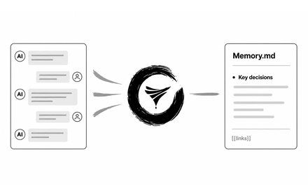
Chat Distiller is a Chrome Manifest V3 extension that asks the AI in your current chat to distill the conversation, validates the structured response, and saves it as Markdown to a directory you explicitly authorize.
There is no developer-controlled backend, analytics service, or cloud storage. It works independently with any local Markdown directory (Obsidian, Git repos, or local folders), and can also companion with Aikito.

