**Crear los wsdl y xsd**

1. Svcutil Service.dll

Te crea:

* 1. *schemas.microsoft.com.2003.10.Serialization.xsd*
  2. Namespase.xsd
  3. Namespase.wsdl

1. Svcutil MSMC_WCF_Service.dll /out:MyProxy.cs /config:app.config
   1. Te crea el proxy y el config par aponer en el cliente.

Otra forma:

1. Levantando en ie esta URL : <http://localhost:8000/ServiceModelSample> podemos hacer
2. Ejecutar
   1. svcutil.exe <http://localhost:8000/ServiceModelSamples/service?wsdl> /out:MyProxy.cs /config:app.config

**Crear el proxy y config del cliente**

svcutil *.xsd *.wsdl language:C#

Forma standar:

1. Open a visual studio command prompt, and change to the directory that contains the WCF service
2. Run the following command line: svcutil <YOUR_SERVICE.exe>
3. This will list a few files, namely *\*.wsdl*, and *\*.xsd*, and a *schemas.microsoft.com.2003.10.Serialization.xsd* file
4. Next you need to run the following command line: svcutil *.wsdl *.xsd /language:C# /out:MyProxy.cs /config:app.config
5. You now have 2 new client files, *MyProxy.cs* and *app.config,* so you can copy these to your client application

Para synchronous delegates

svcutil *.wsdl *.xsd /a /language:C# /out:MyProxy.cs /config:app.confi

**Configure service definition file**

Agregat un archivo txt .

Renombrar con .svc

Ponerle este codiguete**:**

<%@ServiceHost Service="Hello.HelloService" %>

<%@Assembly Name="HelloServiceApplication" %>

**Test the service using VS2008 tools ( wcftestclient.exe )**

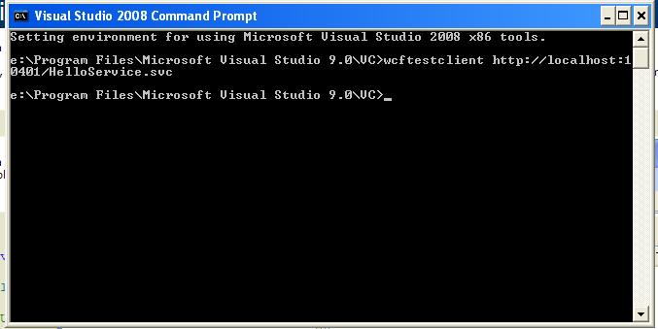

**wcftestclient.exe** <http://localhost:8000/ServiceModelSamples/service/mex>