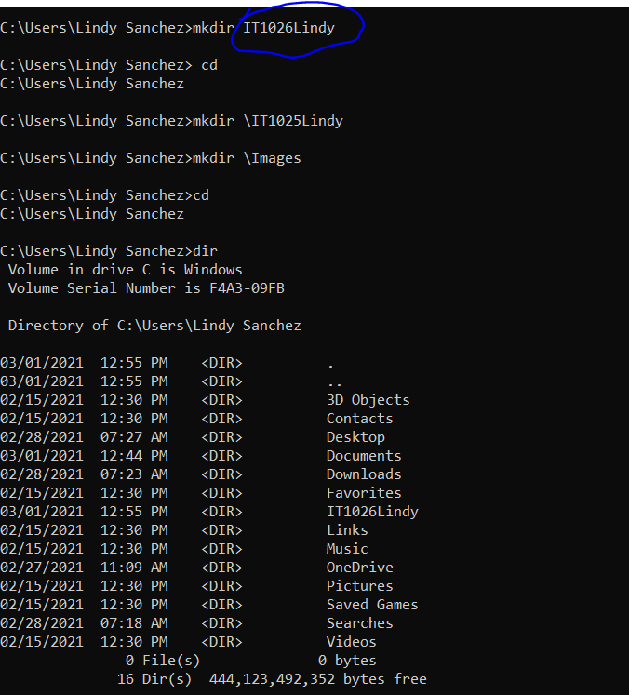

The circled was a type….but not sure why it’s showing that one in my list of directories, but the correct ones in the actual folders:

