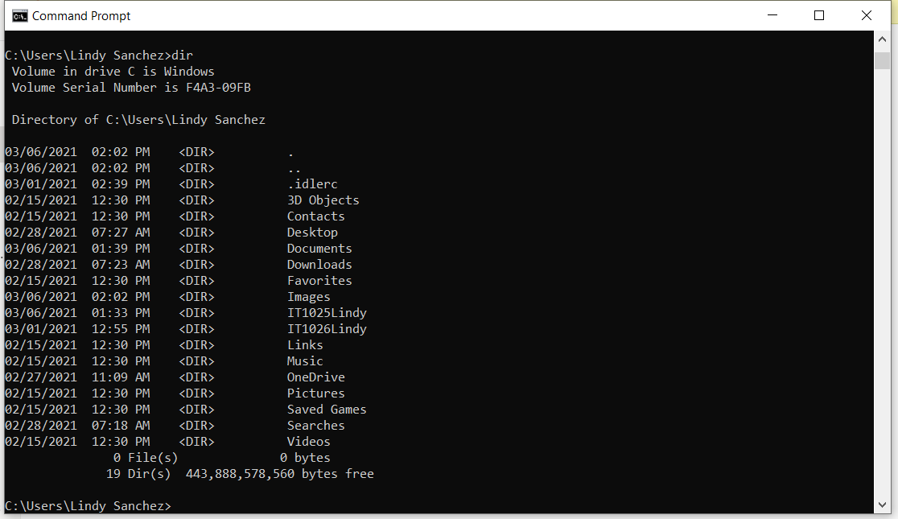

IT1026Lindy was a mistake..

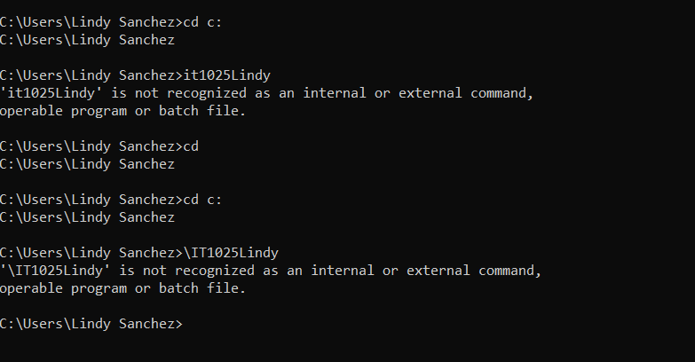

I don’t know what I’m doing wrong here. I couldn’t get it to look like the example. But, the file is in that folder:

