Cost to set up:

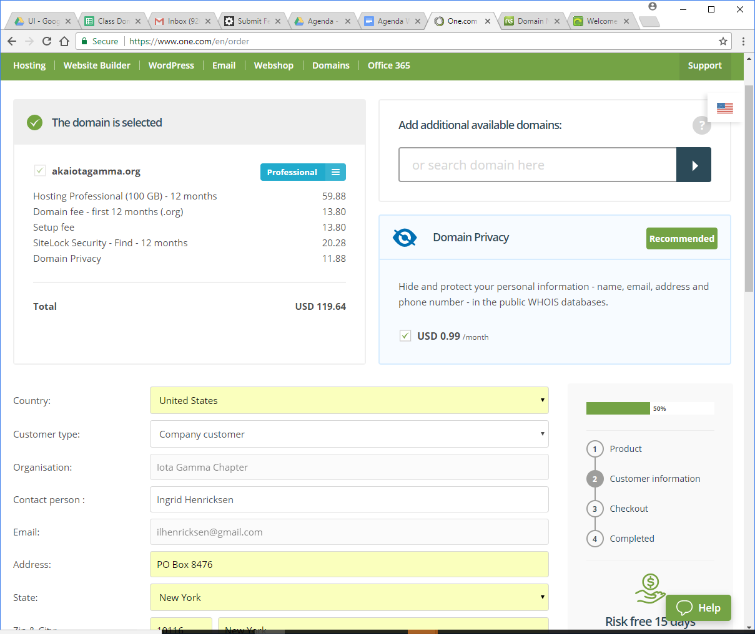

The difference between the professional site and the free one is SSH

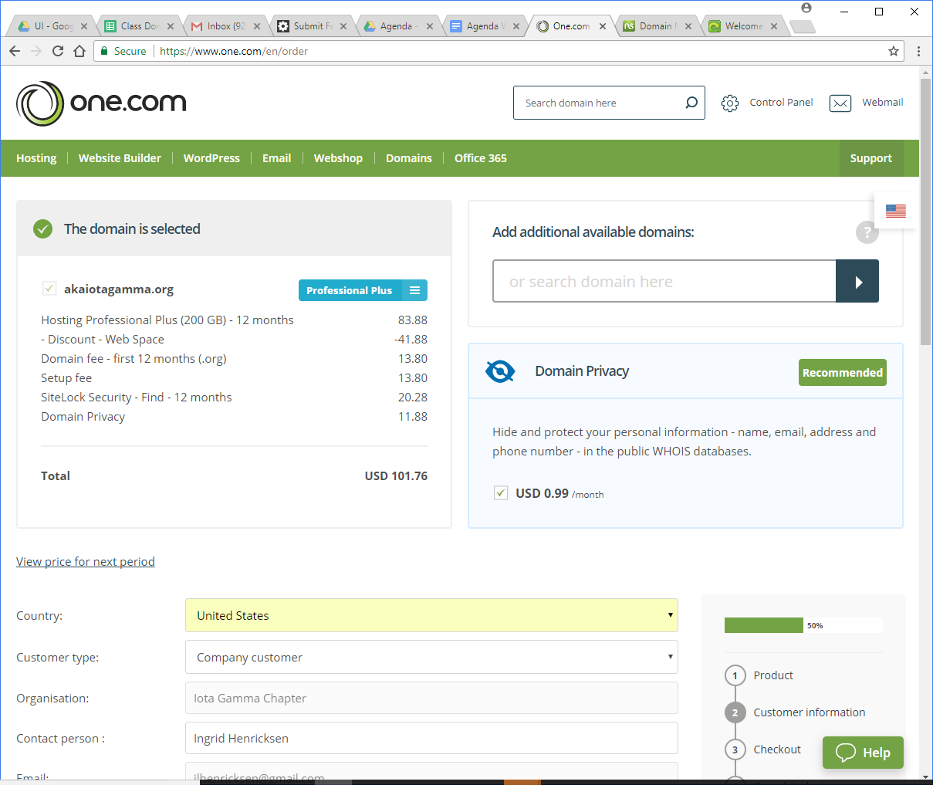and this is professional plus which includes backup and restore. That is one of the features we said our database would provide. It is available at a discount for a year.