**Appendix – Big Data Project**

A.1 – Goodman-Bacon Decomposition

Ein Bild, das Text, Screenshot, Reihe, Diagramm enthält.

Cohorts represents the forbidden comparison between early and late treated observations. Since almost no weight is assigned to it (due to the shortness of our panel) we can infer that the estimates are robust with regards to this concern. The decomposition corresponds to the following model:

$$Sentiment_{i, c,s,t}=a_{i}+β_{c}+γ_{s}+θ_{t}+δDis.Exposure_{i\left(c\right),t }+e_{i,t}$$

The model is slightly different from the one we estimate because here we use Year Fixed Effects rather than a linear time trend.

A2. – Additional Specifications: Regression Analysis

All Baseline Estimates without control

|  |  |  |  |  |
| --- | --- | --- | --- | --- |
|  | Affected t-1 | Affected t-1  (County) | Affected t | Affected t-1  (County) |
| treated | 0.322 |  |  |  |
|  | (0.94) |  |  |  |
|  |  |  |  |  |
| treated_county |  | 0.157 |  |  |
|  |  | (0.42) |  |  |
|  |  |  |  |  |
| treat |  |  | 0.460 |  |
|  |  |  | (1.24) |  |
|  |  |  |  |  |
| treat_county |  |  |  | 0.468 |
|  |  |  |  | (1.04) |
|  |  |  |  |  |
| _cons | -1.562*** | -1.274*** | -1.550*** | -1.418*** |
|  | (-18.87) | (-15.27) | (-14.90) | (-20.95) |
| *N* | 87 | 120 | 93 | 120 |
| *R*2 | 0.80 | 0.82 | 0.79 | 0.78 |

*t* statistics in parentheses

* *p* < 0.10, ** *p* < 0.05, *** *p* < 0.01

Including Linear Time Trends

|  |  |  |  |  |  |  |  |  |  |
| --- | --- | --- | --- | --- | --- | --- | --- | --- | --- |
|  | | Affected t-1 | | Affected t-1  (County) | | Affected t | | Affected t-1  (County) | |
| treated | | 0.348 | |  | |  | |  | |
|  | | (1.11) | |  | |  | |  | |
|  | |  | |  | |  | |  | |
| treated_county | |  | | 0.0249 | |  | |  | |
|  | |  | | (0.09) | |  | |  | |
|  | |  | |  | |  | |  | |
| treat | |  | |  | | 0.616* | |  | |
|  | |  | |  | | (1.98) | |  | |
|  | |  | |  | |  | |  | |
| treat_county | |  | |  | |  | | 0.470 | |
|  | |  | |  | |  | | (1.56) | |
|  | |  | |  | |  | |  | |
| _cons | | -1.533*** | | -1.421*** | | -1.386*** | | -1.416*** | |
|  | | (-5.98) | | (-6.54) | | (-5.99) | | (-6.44) | |
|  | |  | |  | |  | |  | |
| Time Trend | | Yes | | Yes | | Yes | | Yes | |
| *N* | | 87 | | 120 | | 93 | | 120 | |
| *R*2 | | 0.800 | | 0.818 | | 0.794 | | 0.776 | |
|  | |  | |  | |  | |  | |

*t* statistics in parentheses

* *p* < 0.10, ** *p* < 0.05, *** *p* < 0.01

Including County Specific Time Trends

|  |  |  |  |  |
| --- | --- | --- | --- | --- |
|  | Affected t-1 | Affected t-1  (County) | Affected t | Affected t (County) |
| treated | -0.462 |  |  |  |
|  | (-0.85) |  |  |  |
|  |  |  |  |  |
| treated_county |  | -0.387 |  |  |
|  |  | (-0.91) |  |  |
|  |  |  |  |  |
| treat |  |  | 0.204 |  |
|  |  |  | (0.41) |  |
|  |  |  |  |  |
| treat_county |  |  |  | 0.374 |
|  |  |  |  | (0.85) |
| *N* | 87 | 120 | 93 | 120 |
| *R*2 | 0.899 | 0.905 | 0.868 | 0.848 |

*t* statistics in parentheses

* *p* < 0.10, ** *p* < 0.05, *** *p* < 0.01

Including Year Fixed Effects instead of linear time trend

|  |  |  |  |  |
| --- | --- | --- | --- | --- |
|  | Affected t-1 | Affected t-1 (County) | Affected t | Affected t  (County) |
| treated | 0.348 |  |  |  |
|  | (1.11) |  |  |  |
|  |  |  |  |  |
| treated_county |  | 0.0249 |  |  |
|  |  | (0.09) |  |  |
|  |  |  |  |  |
| treat |  |  | 0.616* |  |
|  |  |  | (1.98) |  |
|  |  |  |  |  |
| treat_county |  |  |  | 0.470 |
|  |  |  |  | (1.56) |
|  |  |  |  |  |
| _cons | -1.533*** | -1.421*** | -1.386*** | -1.416*** |
|  | (-5.98) | (-6.54) | (-5.99) | (-6.44) |
|  |  |  |  |  |
| Time FE | Yes | Yes | Yes | Yes |
| *N* | 87 | 120 | 93 | 120 |
| *R*2 | 0.800 | 0.818 | 0.794 | 0.776 |

*t* statistics in parentheses

* *p* < 0.10, ** *p* < 0.05, *** *p* < 0.01

Controlling for Beliefs

|  |  |  |  |  |
| --- | --- | --- | --- | --- |
|  | Affected t-1 | Affected t-1 | Affected t-1 | Affected t-1 |
| treated | 0.369 |  |  |  |
|  | (1.19) |  |  |  |
|  |  |  |  |  |
| beliefs | 0.127 | 0.110 |  |  |
|  | (1.62) | (1.66) |  |  |
|  |  |  |  |  |
| treated_county |  | 0.0146 |  |  |
|  |  | (0.05) |  |  |
|  |  |  |  |  |
| treat |  |  | 0.515* |  |
|  |  |  | (1.98) |  |
|  |  |  |  |  |
| believer |  |  | -0.170** | -0.233*** |
|  |  |  | (-2.30) | (0.07) |
|  |  |  |  |  |
| treat_county |  |  |  | 0.289 |
|  |  |  |  | (0.289) |
|  |  |  |  |  |
|  |  |  |  |  |
| _cons | -10.34* | -9.125* | 10.15* | 19.87*** |
|  | (-1.88) | (-1.95) | (2.00) | (3.24) |
|  |  |  |  |  |
| Time Trend | Yes | Yes | Yes | Yes |
| *N* | 87 | 120 | 93 | 120 |
| *R*2 | 0.810 | 0.825 | 0.813 | 0.805 |
|  |  |  |  |  |
|  |  |  |  |  |

*t* statistics in parentheses

* *p* < 0.10, ** *p* < 0.05, *** *p* < 0.01

Heterogenous Treatment Effects (Interaction Treatment dummy and climate beliefs)

|  |  |  |  |  |
| --- | --- | --- | --- | --- |
|  | Affected t-1 | Affected t-1 (County) | Affected t | Affected t  (County) |
| 1.treated | 7.537** |  |  |  |
|  | (2.37) |  |  |  |
|  |  |  |  |  |
| t | 0.108 | 0.208 | -0.223 | -0.155 |
|  | (0.69) | (1.57) | (-1.53) | (-1.34) |
|  |  |  |  |  |
| 1.treated_county |  | 1.517 |  |  |
|  |  | (0.77) |  |  |
|  |  |  |  |  |
| 1.treat |  |  | -0.484 |  |
|  |  |  | (-0.24) |  |
|  |  |  |  |  |
| 1.treat_county |  |  |  | 2.563 |
|  |  |  |  | (1.01) |
| *N* | 87 | 120 | 93 | 120 |
| *R*2 | 0.818 | 0.826 | 0.813 | 0.805 |
|  |  |  |  |  |

*t* statistics in parentheses

* *p* < 0.10, ** *p* < 0.05, *** *p* < 0.01

Heterogenous Treatment Effects 2 (Interaction Treatment dummy and Number of press articles in State)

|  |  |  |  |  |
| --- | --- | --- | --- | --- |
|  | Affected t-1 | Affected t-1 (County) | Affected t | Affected t  (County) |
| 1.treated | 0.489 |  |  |  |
|  | (1.36) |  |  |  |
|  |  |  |  |  |
| nb_articles_state | 0.101 | 0.0413 | 0.269 | 0.310 |
|  | (0.42) | (0.21) | (0.96) | (1.36) |
|  |  |  |  |  |
| t | -0.0506 | 0.0713 | -0.167 | -0.0581 |
|  | (-0.35) | (0.63) | (-1.19) | (-0.53) |
|  |  |  |  |  |
| 1.treated_county |  | 0.123 |  |  |
|  |  | (0.43) |  |  |
|  |  |  |  |  |
| 1.treat |  |  | 0.724** |  |
|  |  |  | (2.28) |  |
|  |  |  |  |  |
| 1.treat_county |  |  |  | 0.613** |
|  |  |  |  | (2.22) |
| *N* | 87 | 120 | 93 | 120 |
| *R*2 | 0.801 | 0.819 | 0.800 | 0.784 |
|  |  |  |  |  |

*t* statistics in parentheses

* *p* < 0.10, ** *p* < 0.05, *** *p* < 0.01

A3. – Additional Graphs: Time Trends

Ein Bild, das Text, Screenshot, Reihe, Diagramm enthält.
Ein Bild, das Text, Screenshot, Reihe, Diagramm enthält.
Ein Bild, das Text, Reihe, Screenshot, Diagramm enthält.
Ein Bild, das Text, Reihe, Diagramm, Screenshot enthält.
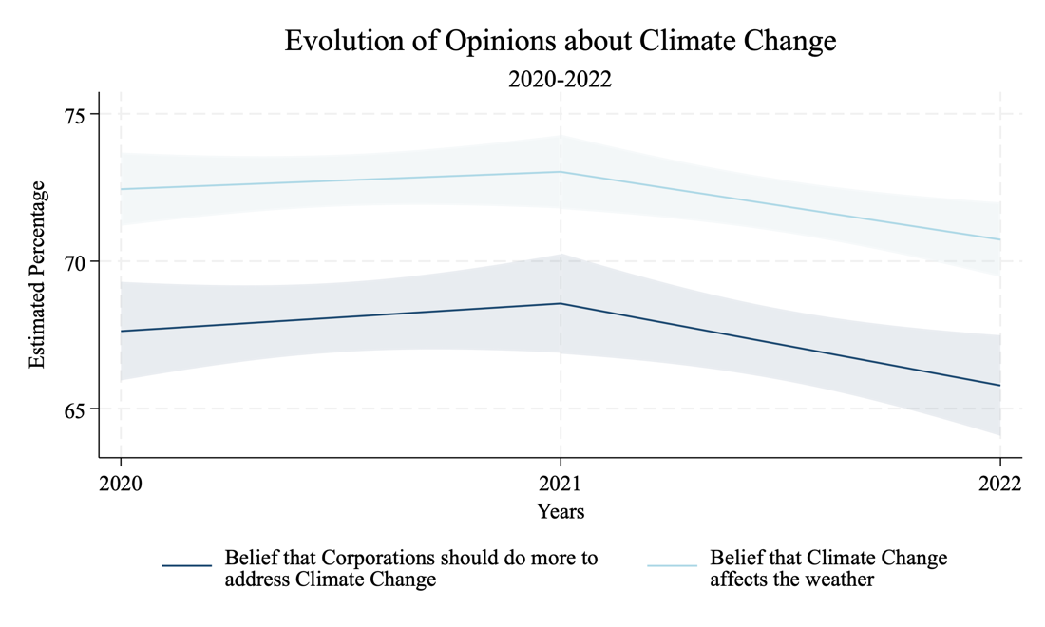

A4. – Additional Graphs: ESG Sentiment and Climate Beliefs

Ein Bild, das Text, Quittung, Reihe, Diagramm enthält.
