Documentation and Installation for CBSE exercise SS 13

uMeet by Stefan Beyer, Ronny Marx, Manuel Oddoy, Lars Schütze

Deploy the umeet-ear-archive to a JBoss 7.1.1 server. It should work with the standalone standard configuration. Alternatively add a subsystem with following properties to your configuration, so the persistence can connect to the database.
<subsystem xmlns="urn:jboss:domain:datasources:1.0>
<datasources>
<datasource jndi-name="java:jboss/datasources/ExampleDS" pool-name="ExampleDS" enabled="true" use-java-context="true>
<connection-url>jdbc:h2:mem:test;DB_CLOSE_DELAY=-1</connection-url>
<driver>h2</driver>
<security>
<user-name>sa</user-name>
<password>sa</password>
</security>
</datasource>
<drivers>
<driver name="h2" module="com.h2database.h2">
<xa-datasource-class>org.h2.jdbcx.JdbcDataSource</xa-datasource-class>
</driver>
</drivers>
</datasources>
</subsystem>

Insert some test credentials or register a new user. Possible test users are:
E-Mail | Password
uebung@cbse.st | test
master@cbse.st | test

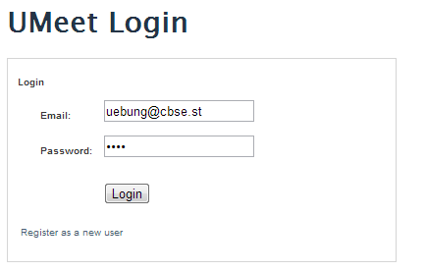Illustration 1: Login
Alternatively register a new user with the link at the bottom of Illustration 1: Login.

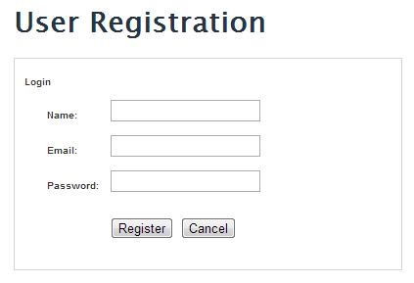Illustration 2: Register
The E-Mail has to be unique and all fields have to be filled, also the E-Mail has to be well formed.

When logged into the system you see your appointments for the current date. After first start there isn't any appointment, in the Illustration 3: Appointments of the Day is already an appointment created.

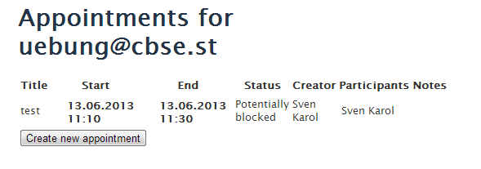Illustration 3: Appointments of the Day

To create a new appointment click on Create new appointment.
Now you have to fill the form for a new appointment. When trying to create a new conflicting appointment there is a conflict shown, see Illustration 4: Create conflicting appointment. The system checks for conﬂicts like specified in the requirements:
If there are no conﬂicts, it should add the appointment to both users’ calendars.
Otherwise, it should inform the user of the conﬂict, and, if the conﬂicting appointment is not private, inform the user of the conﬂicting appointment. Two appointments are in conﬂict, if they overlap in time, and none of the two appointments is of type Free.
When there is a private conflicting appointment, then the conflicting user is shown and the other fields are left blank. All other conflicts are like in Illustration 4: Create conflicting appointment.

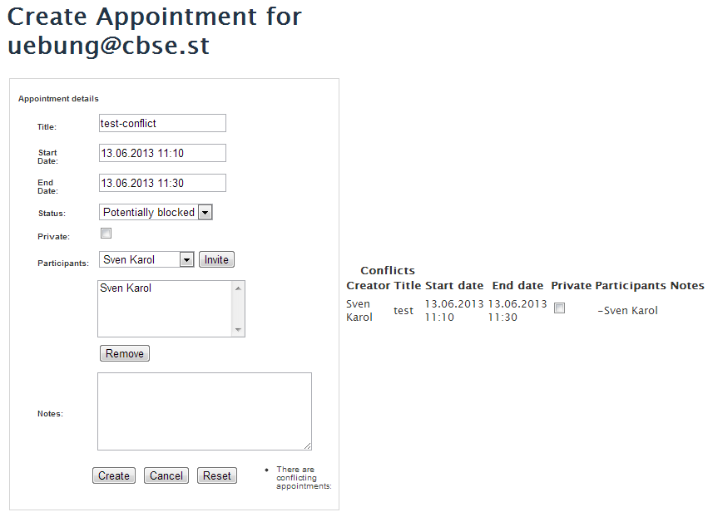Illustration 4: Create conflicting appointment

