Plots - Lithic analysis Ramioul

Lisa Schunk

2021-02-05

# Goal of the script

This script reads the xlsx file (derived data) containing all the information gained through a lithic analysis.  
The script will:

1. Read the xlsx file
2. Plot all relevant variables in various combinations
3. Save the plot as PDFs

dir_in <- "analysis/Ramioul/derived_data/"  
dir_out <- "analysis/Ramioul/plots/"

Raw data must be located in “analysis/Ramioul/derived_data/”.  
Formatted data will be saved in “analysis/Ramioul/plots/”. The knit directory for this script is the project directory.

# Load packages

library(openxlsx)

Warning: package 'openxlsx' was built under R version 4.0.3

library(readxl)  
library(R.utils)  
library(tools)  
library(chron)  
library(ggplot2)

Warning: package 'ggplot2' was built under R version 4.0.3

library(wesanderson)  
library(dplyr)

Warning: package 'dplyr' was built under R version 4.0.3

library(ggsci)

# Get name, path and information of the file

data_file <- list.files(dir_in, pattern = "\\.xlsx$", full.names = TRUE)  
md5_in <- md5sum(data_file)  
info_in <- data.frame(files = basename(names(md5_in)), checksum = md5_in,   
 row.names = NULL)

The checksum (MD5 hashes) of the imported files are:

files checksum  
1 Ramioul_lithic_analysis.xlsx 6dcfbbc95a1a28ab6f0b32ff043da7ca

# Load data into R object

imp_data <- read.xlsx(xlsxFile = data_file, sheet = 1, startRow = 1, colNames = TRUE,  
 rowNames = FALSE, skipEmptyRows = FALSE)

# Data analsysis - plots

## Histogram

### Histogram dimensions - Keilmesser

# Load data sheet Keilmesser   
KM_dim <- read.xlsx(xlsxFile = data_file, sheet = 3)   
  
# Keilmesser length   
# Calculates the mean value for the plot and ascribes the N value   
mean_length <- mean(KM_dim$length, na.rm = TRUE)  
n <- doBy::summaryBy(length ~ artefact.state, data = KM_dim, FUN = length)  
tag <- gsub(pattern = "_", replacement = " ", paste0(n[[1]], " (n = ", n[[2]], ")"))  
  
# Histogram Keilmesser length  
KM.length <- ggplot(KM_dim, aes(x = length, fill = artefact.state)) +   
 geom_histogram(binwidth = 1) +  
 labs(x = "length [mm]", y = "n", title = "", fill = "artefact state",   
 size = 12) +  
 theme_classic() +  
 geom_vline(aes(xintercept = mean_length), linetype = "dashed", size = 1) +  
 geom_text(aes(y = mean_length, x = 65, label = round(mean_length, 1)),  
 nudge_y = -70.24) +  
 scale_fill_manual(values = wes_palette(n = 1, name = "FantasticFox1"),   
 labels = tag)   
  
print(KM.length)

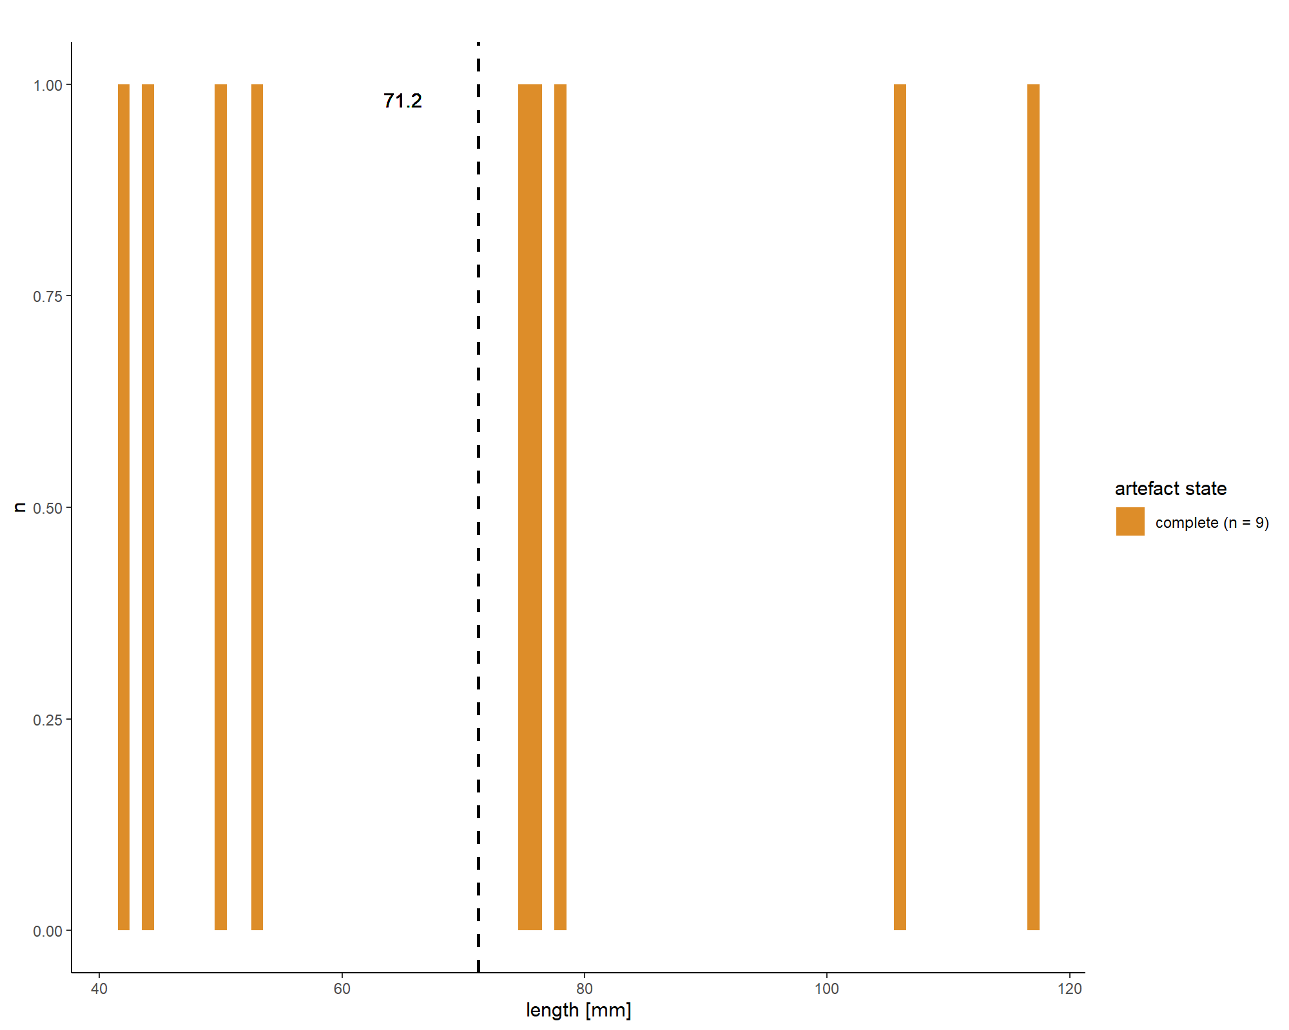

file_out <- paste0(file_path_sans_ext(info_in[["file"]]), "KM.length", ".pdf")  
ggsave(filename = file_out, plot = KM.length, path = dir_out, device = "pdf",   
 width = 170, height = 250, units = "mm")  
  
  
# Keilmesser width  
# Calculates the mean value for the plot and ascribes the N value   
mean_width <- mean(KM_dim$width, na.rm = TRUE)  
n <- doBy::summaryBy(width ~ artefact.state, data = KM_dim, FUN = length)  
tag <- gsub(pattern = "_", replacement = " ", paste0(n[[1]], " (n = ", n[[2]], ")"))  
  
# Histogram Keilmesser width  
KM.width <- ggplot(KM_dim, aes(x = width, fill = artefact.state)) +   
 geom_histogram(binwidth = 0.5) +  
 labs(x = "width [mm]", y = "n", title = "", fill = "artefact state",   
 size = 12) +  
 theme_classic() +  
 geom_vline(aes(xintercept = mean_width), linetype = "dashed", size = 1) +  
 geom_text(aes(y = mean_length, x = 41, label = round(mean_width, 2)),   
 nudge_y = -69.25) +  
 scale_fill_manual(values = wes_palette(n = 1, name = "FantasticFox1"),   
 labels = tag)   
  
print(KM.width)

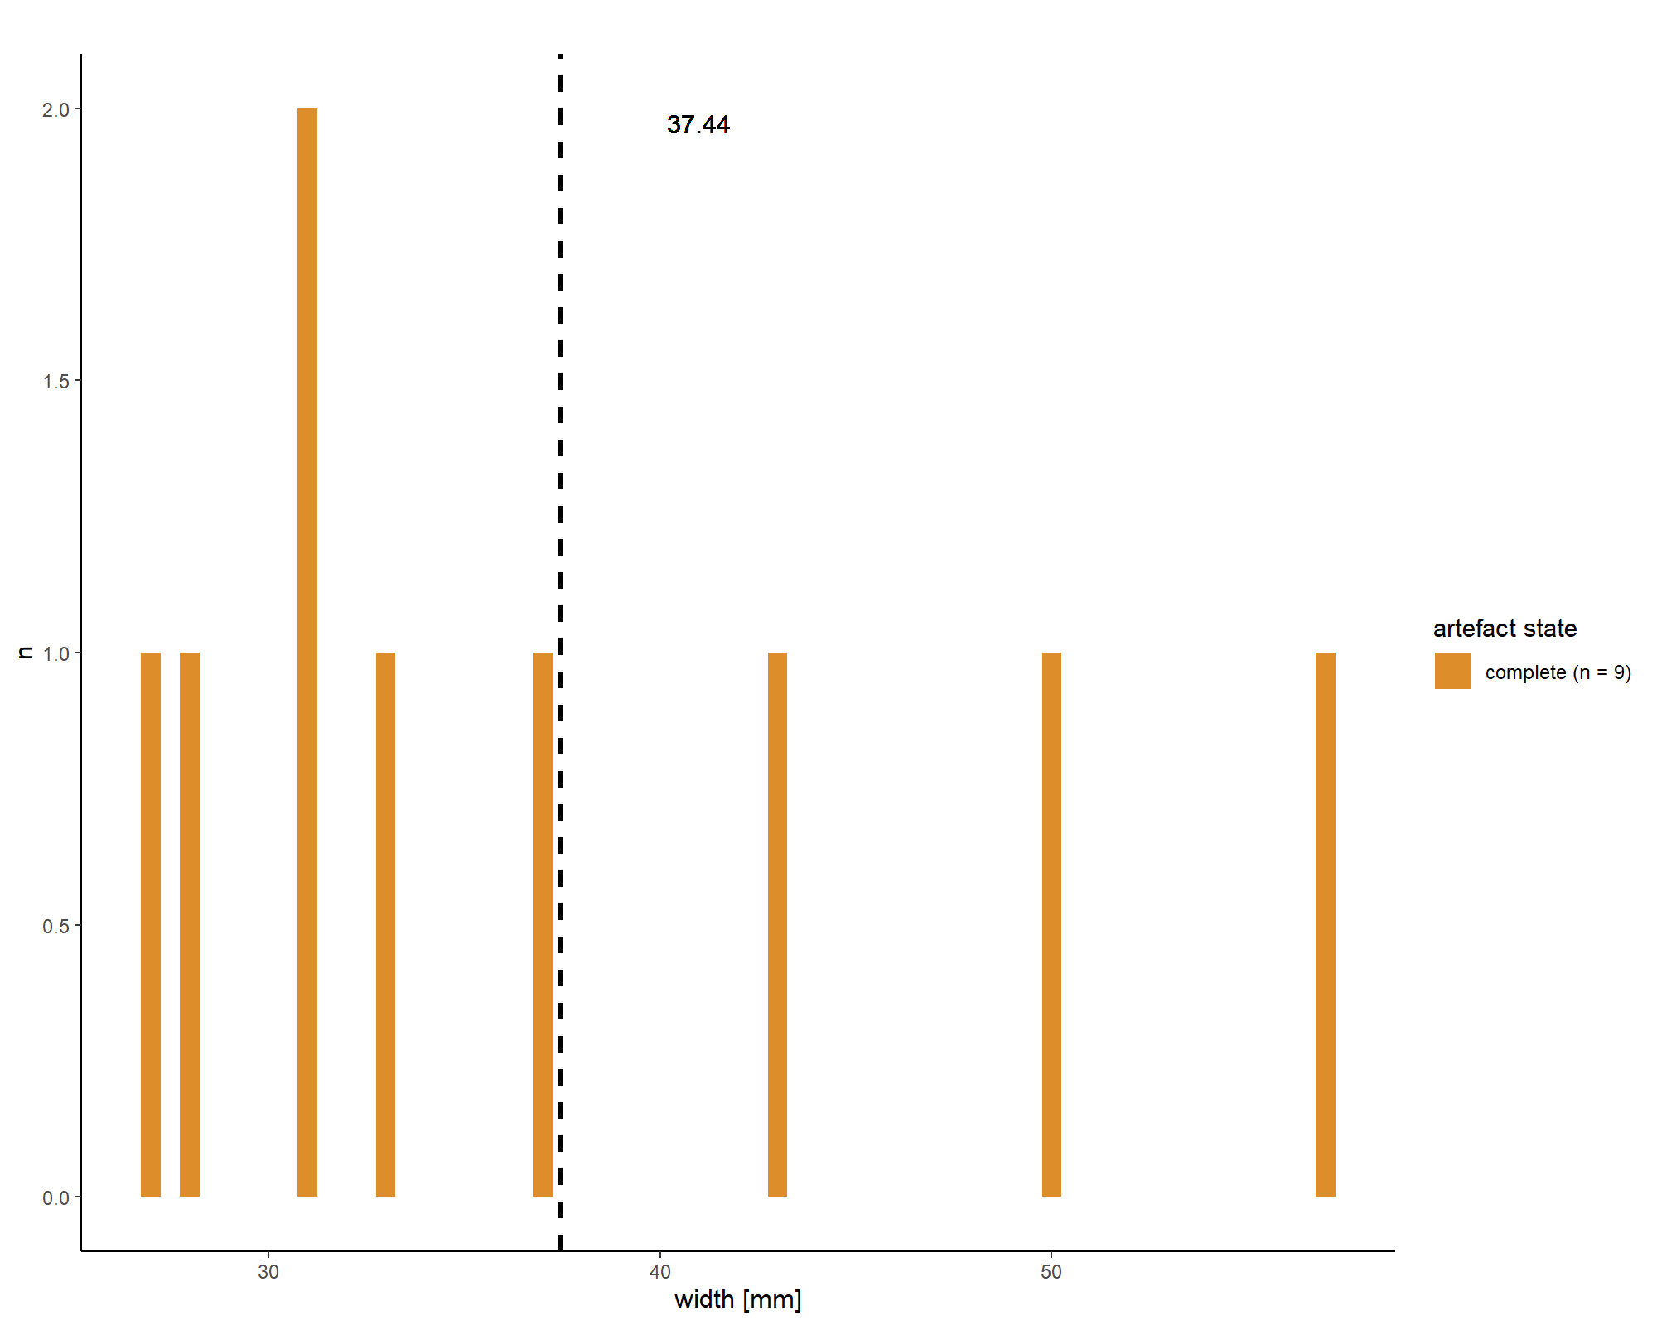

file_out <- paste0(file_path_sans_ext(info_in[["file"]]), "KM.width", ".pdf")  
ggsave(filename = file_out, plot = KM.width, path = dir_out, device = "pdf",   
 width = 170, height = 250, units = "mm")  
  
  
# Keilmesser thickness  
# Calculates the mean value for the plot and ascribes the N value   
mean_thickness <- mean(KM_dim$thickness, na.rm = TRUE)  
n <- doBy::summaryBy(thickness ~ artefact.state, data = KM_dim, FUN = length)  
tag <- gsub(pattern = "_", replacement = " ", paste0(n[[1]], " (n = ", n[[2]], ")"))  
  
# Histogram Keilmesser thickness   
KM.thickness <- ggplot(KM_dim, aes(y = thickness, fill = artefact.state)) +   
 geom_histogram(binwidth = 1) +  
 labs(y = "thickness [mm]", x = "n", title = "", fill = "artefact state",  
 size = 12) +  
 theme_classic() +  
 geom_hline(aes(yintercept = mean_thickness), linetype = "dashed",   
 size = 1) +  
 geom_text(aes(y = mean_thickness, x = 1.9, label = round(mean_thickness,  
 1)), nudge_y = 0.5) +  
 scale_fill_manual(values = wes_palette(n = 1, name = "FantasticFox1"),  
 labels = tag)   
  
print(KM.thickness)

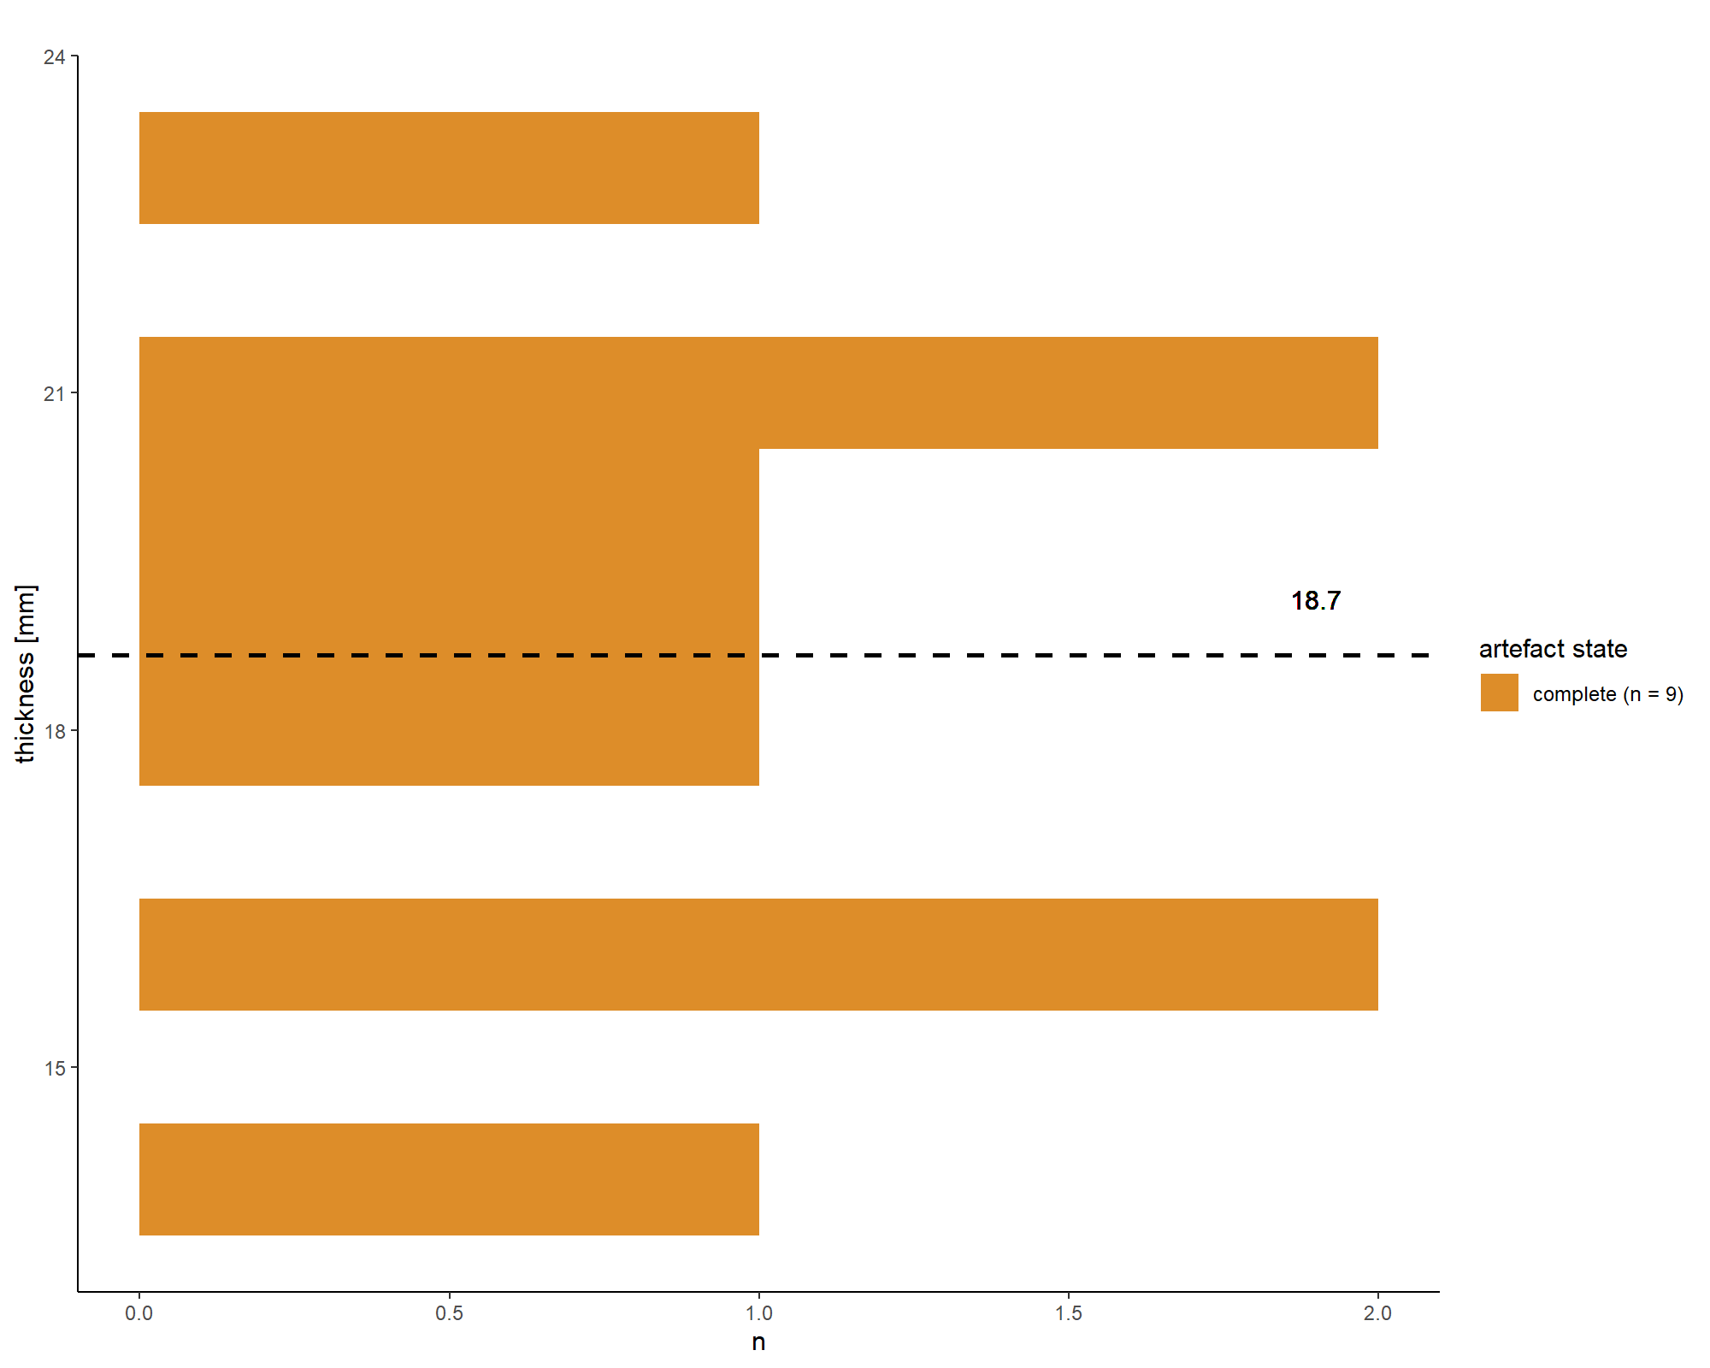

file_out <- paste0(file_path_sans_ext(info_in[["file"]]), "KM.thickness", ".pdf")  
ggsave(filename = file_out, plot = KM.thickness, path = dir_out, device = "pdf",   
 width = 250, height = 170, units = "mm")  
  
  
  
# Keilmesser Back   
# Load data sheet Keilmesser thickness back   
KM_back <- read.xlsx(xlsxFile = data_file, sheet = 19)   
  
# Calculates the mean value for the plot and ascribes the N value   
mean_KM_back <- mean(KM_back$thickness.back, na.rm = TRUE)  
n <- doBy::summaryBy(thickness.back ~ artefact.state, data = KM_back, FUN = length)  
tag <- gsub(pattern = "_", replacement = " ", paste0(n[[1]], " (n = ", n[[2]], ")"))  
  
# Histogram Keilmesser thickness back   
KM.back <- ggplot(KM_back, aes(y = thickness.back, fill = artefact.state)) +   
 geom_histogram(binwidth = 0.6) +  
 labs(x = "thickness [mm]", y = "n", title = "", fill = "artefact state",  
 size = 12) +  
 theme_classic() +  
 geom_hline(aes(yintercept = mean_KM_back), linetype = "dashed",   
 size = 1) +  
 geom_text(aes(y = mean_KM_back, x = 1.95, label = round(mean_KM_back,  
 1)), nudge_y = 0.7) +  
 scale_fill_manual(values = wes_palette(n = 1, name = "FantasticFox1"),  
 labels = tag)   
  
print(KM.back)

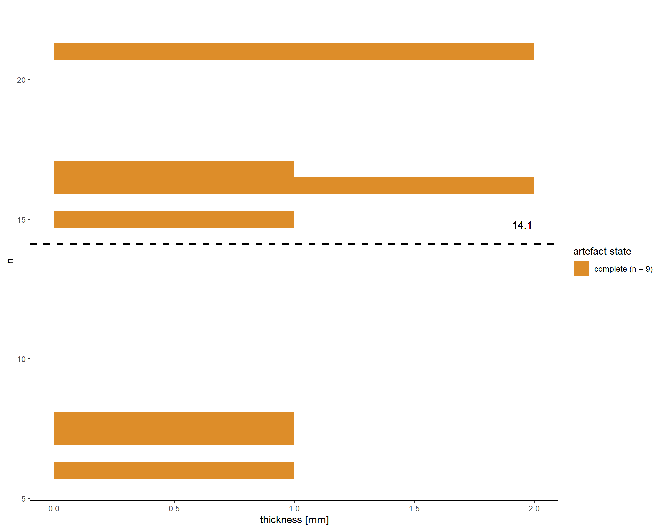

file_out <- paste0(file_path_sans_ext(info_in[["file"]]), "KM.back", ".pdf")  
ggsave(filename = file_out, plot = KM.back, path = dir_out, device = "pdf", width = 250,  
 height = 170, units = "mm")

### Histogram dimensions - Pradnik scraper

# Load data sheet Pradnik scraper   
PS_dim <- read.xlsx(xlsxFile = data_file, sheet = 4)   
  
# Pradnik scraper length   
# Calculates the mean value for the plot and ascribes the N value   
mean_PS_length <- mean(PS_dim$length, na.rm = TRUE)  
n <- doBy::summaryBy(length ~ artefact.state, data = PS_dim, FUN = length)  
tag <- gsub(pattern = "_", replacement = " ", paste0(n[[1]], " (n = ", n[[2]], ")"))  
  
# Histogram Pradnik scraper length  
PS.length <- ggplot(PS_dim, aes(x = length, fill = artefact.state)) +   
 geom_histogram(binwidth = 0.1) +  
 labs(x = "length [mm]", y = "n", title = "", fill = "artefact state",   
 size = 12) +  
 theme_classic() +  
 geom_vline(aes(xintercept = mean_PS_length), linetype = "dashed", size = 1) +  
 geom_text(aes(y = mean_PS_length, x = 49, label = round(mean_PS_length, 1)),  
 nudge_y = -47.35) +  
 scale_fill_manual(values = wes_palette(n = 1, name = "Chevalier1"),   
 labels = tag)   
  
print(PS.length)

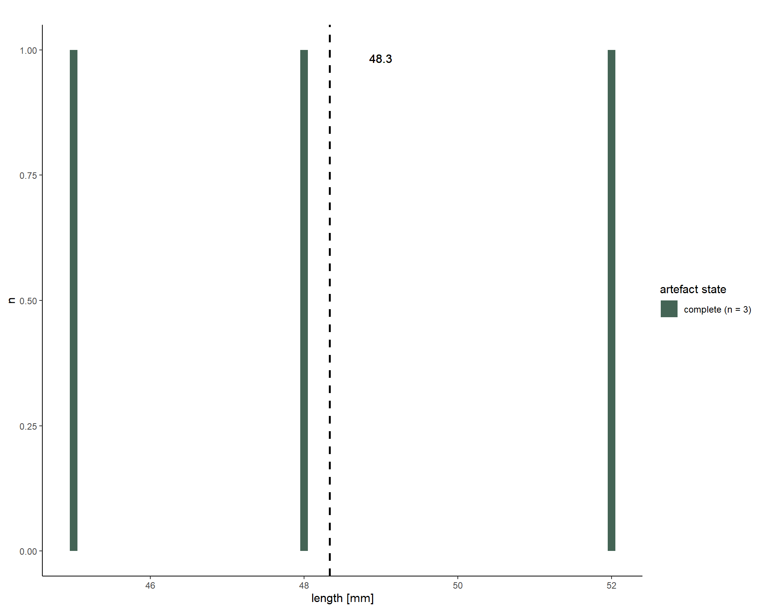

file_out <- paste0(file_path_sans_ext(info_in[["file"]]), "PS.length", ".pdf")  
ggsave(filename = file_out, plot = PS.length, path = dir_out, device = "pdf",   
 width = 170, height = 250, units = "mm")  
  
  
# Pradnik scraper width   
# Calculates the mean value for the plot and ascribes the N value   
mean_PS_width <- mean(PS_dim$width, na.rm = TRUE)  
n <- doBy::summaryBy(width ~ artefact.state, data = PS_dim, FUN = length)  
tag <- gsub(pattern = "_", replacement = " ", paste0(n[[1]], " (n = ", n[[2]], ")"))  
  
# Histogram Pradnik scraper width  
PS.width <- ggplot(PS_dim, aes(x = width, fill = artefact.state)) +   
 geom_histogram(binwidth = 0.1) +  
 labs(x = "width [mm]", y = "n", title = "", fill = "artefact state",   
 size = 12) +  
 theme_classic() +  
 geom_vline(aes(xintercept = mean_PS_width), linetype="dashed", size = 1) +  
 geom_text(aes(y = mean_PS_width, x = 36, label = round(mean_PS_width, 1)),  
 nudge_y = -33.7) +  
 scale_fill_manual(values = wes_palette(n = 1, name = "Chevalier1"),   
 labels = tag)   
   
print(PS.width)

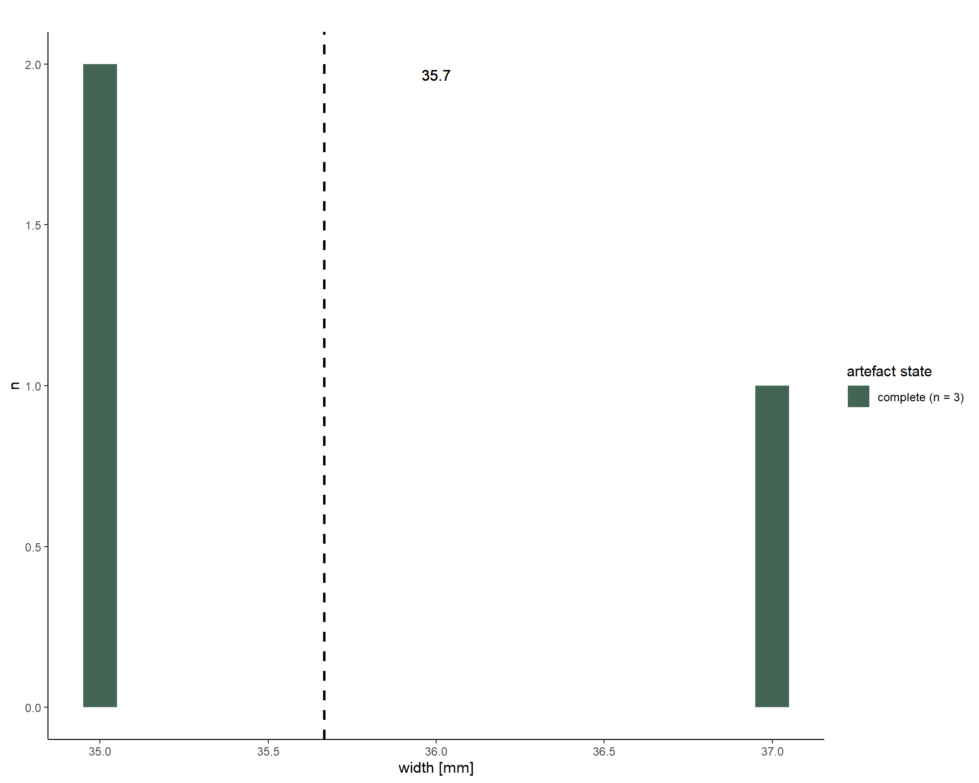

file_out <- paste0(file_path_sans_ext(info_in[["file"]]), "PS.width", ".pdf")  
ggsave(filename = file_out, plot = PS.width, path = dir_out, device = "pdf",   
 width = 170, height = 250, units = "mm")  
  
  
# Pradnik scraper thickness  
# Calculates the mean value for the plot and ascribes the N value   
mean_PS_thickness <- mean(PS_dim$thickness, na.rm = TRUE)  
n <- doBy::summaryBy(thickness ~ artefact.state, data = PS_dim, FUN = length)  
tag <- gsub(pattern = "_", replacement = " ", paste0(n[[1]], " (n = ", n[[2]], ")"))  
  
# Histogram Pradnik scraper thickness   
PS.thickness <- ggplot(PS_dim, aes(y = thickness, fill = artefact.state)) +   
 geom_histogram(binwidth = 0.2) +  
 labs(y = "thickness [mm]", x = "n", title = "", fill = "artefact state",  
 size = 12) +  
 theme_classic() +  
 geom_hline(aes(yintercept = mean_PS_thickness), linetype = "dashed",   
 size = 1) +  
 geom_text(aes(y = mean_PS_thickness, x = 1.9, label =  
 round(mean_PS_thickness, 1)), nudge_y = 0.2) +  
 scale_fill_manual(values = wes_palette(n = 1, name = "Chevalier1"),   
 labels = tag)   
  
print(PS.thickness)

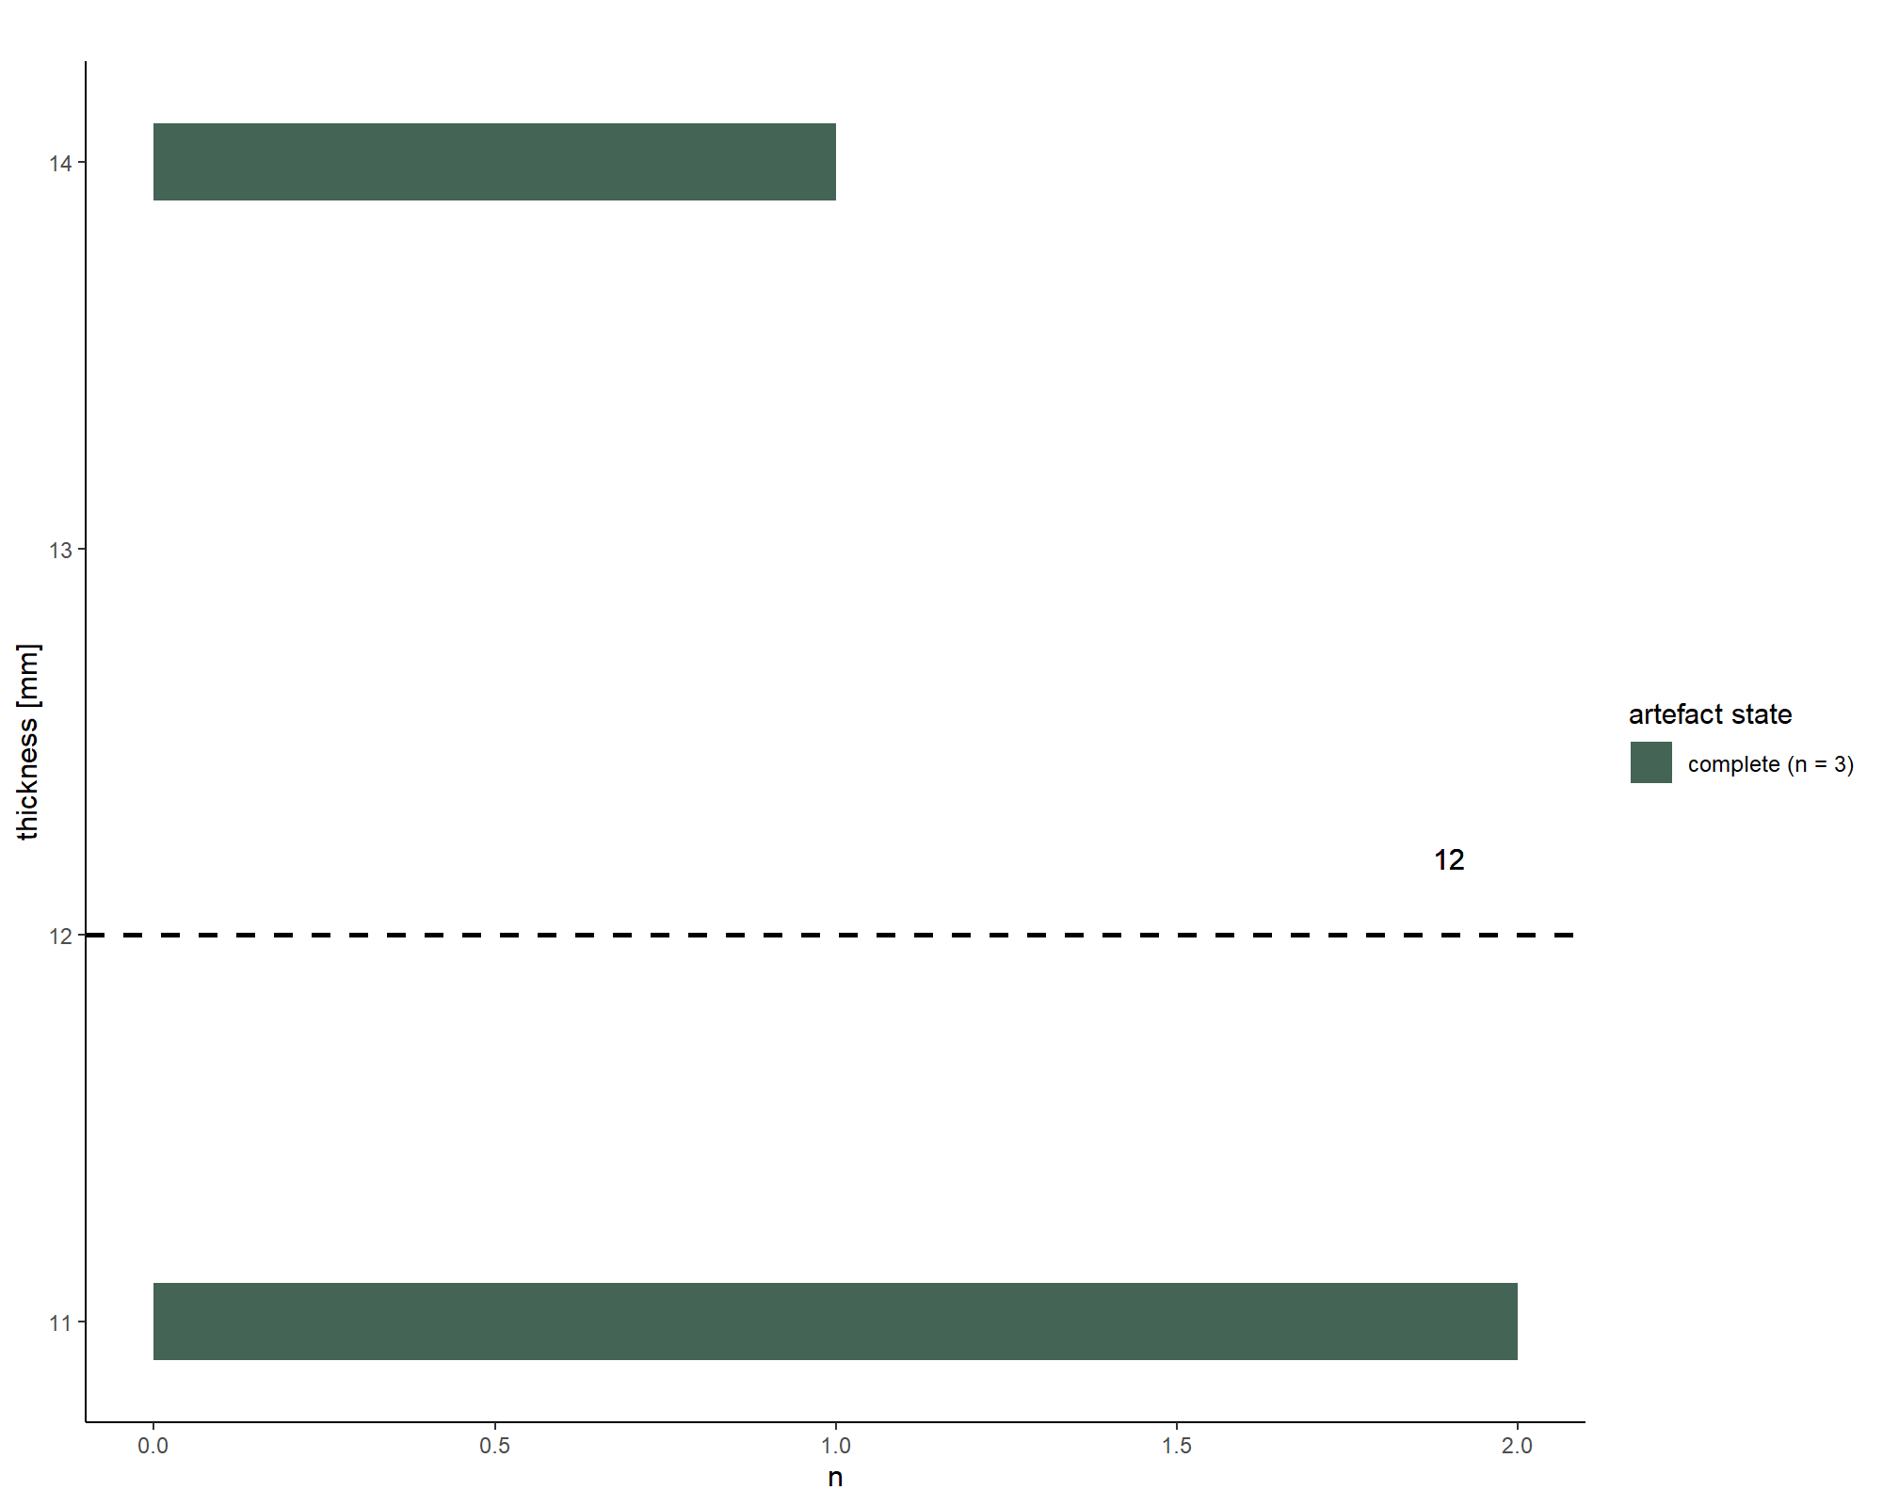

file_out <- paste0(file_path_sans_ext(info_in[["file"]]), "PS.thickness", ".pdf")  
ggsave(filename = file_out, plot = PS.thickness, path = dir_out, device = "pdf",   
 width = 250, height = 170, units = "mm")  
  
  
  
# Back Pradnik scraper thickness  
# Load data sheet Pradnik scraper thickness back   
PS_back <- read.xlsx(xlsxFile = data_file, sheet = 20)   
  
# Calculates the mean value for the plot and ascribes the N value   
mean_PS_back <- mean(PS_back$thickness.back, na.rm = TRUE)  
n <- doBy::summaryBy(thickness.back ~ artefact.state, data = PS_back, FUN = length)  
tag <- gsub(pattern = "_", replacement = " ", paste0(n[[1]], " (n = ", n[[2]], ")"))  
  
# Histogram Pradnik scraper thickness back   
PS.back <- ggplot(PS_back, aes(y = thickness.back, fill = artefact.state)) +   
 geom_histogram(binwidth = 0.05) +  
 labs(y = "thickness [mm]", x = "n", title = "", fill = "artefact state",  
 size = 12) +  
 theme_classic() +  
 geom_hline(aes(yintercept = mean_PS_back), linetype = "dashed",   
 size = 1) +  
 geom_text(aes(y = mean_PS_back, x = 1.9, label = round(mean_PS_back, 1)),  
 nudge_y = -0.1) +  
 scale_fill_manual(values = wes_palette(n = 1, name = "Chevalier1"),  
 labels = tag)   
  
print(PS.back)

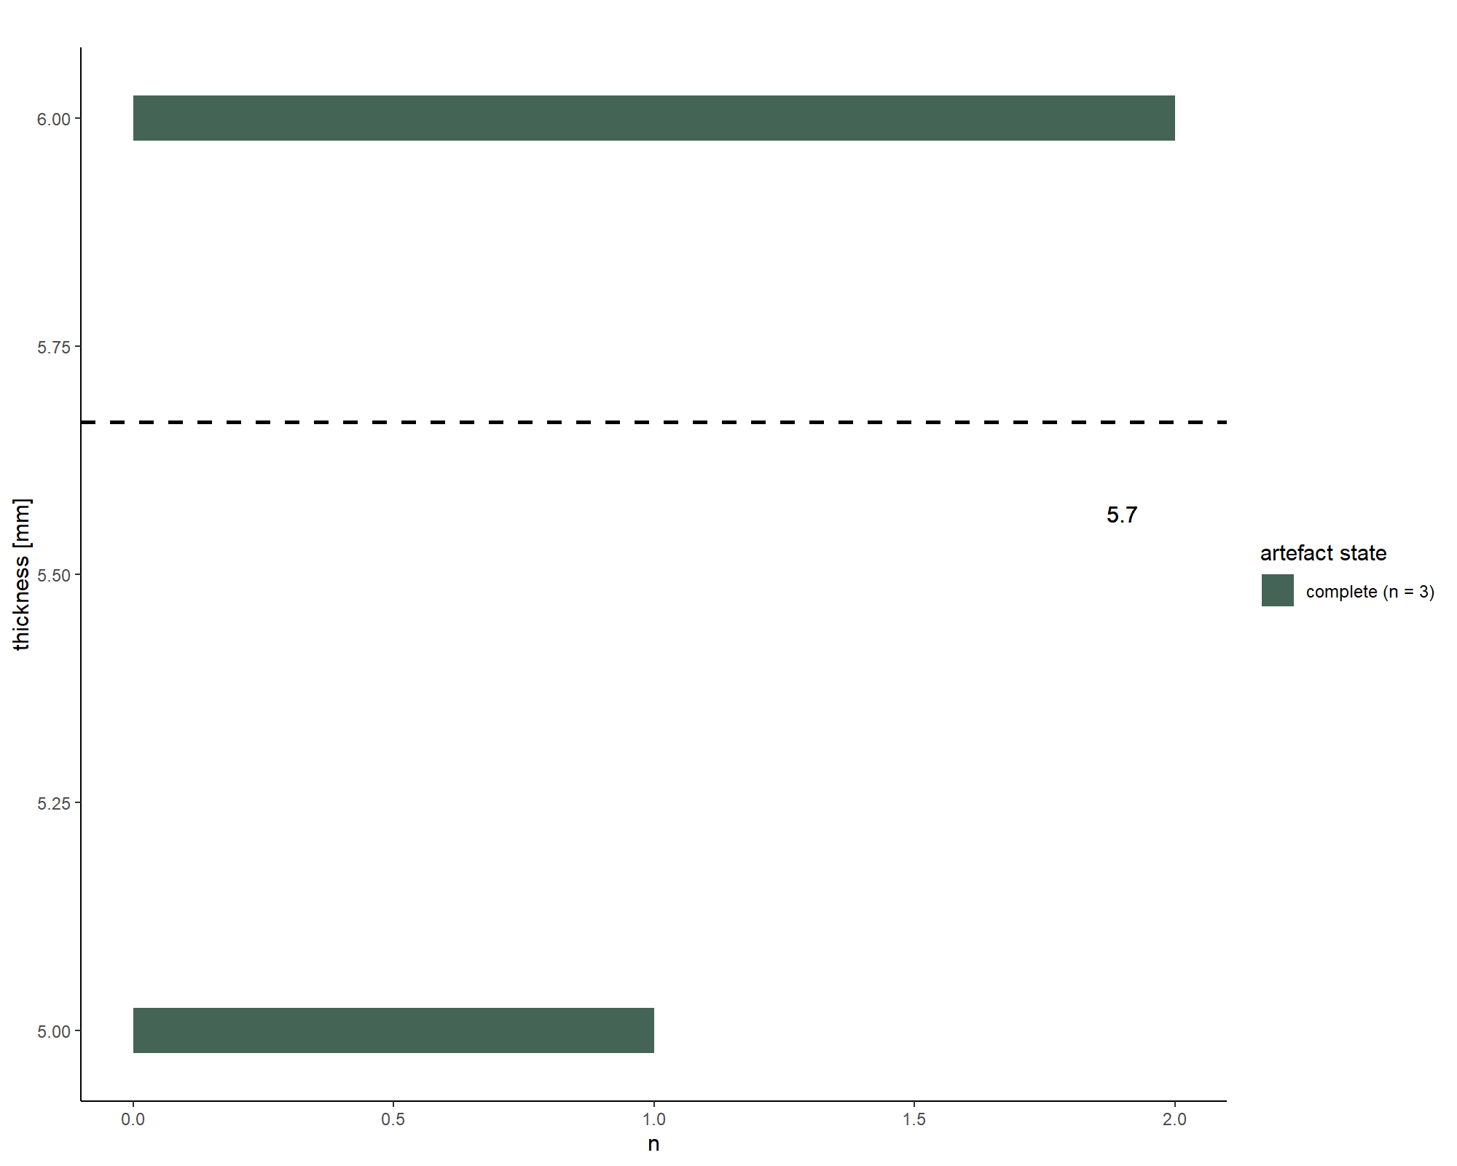

file_out <- paste0(file_path_sans_ext(info_in[["file"]]), "PS.back", ".pdf")  
ggsave(filename = file_out, plot = PS.back, path = dir_out, device = "pdf",   
 width = 250, height = 170, units = "mm")

## Scatterplot

### Length-width ratio

# Load data sheet Keilmesser   
KM_dim <- read.xlsx(xlsxFile = data_file, sheet = 3)   
  
# Keilmesser length VS width   
# Ascribes the N value   
n <- doBy::summaryBy(length + width ~ artefact.state, data = KM_dim, FUN = length)  
tag <- gsub(pattern = "_", replacement = " ", paste0(n[[1]], " (n = ", n[[2]], ")"))  
  
# Scatterplot Keilmesser (complete + point) length VS width   
KM.length_width <- ggplot(KM_dim, aes(y = length, x = width, fill = artefact.state)) +  
 geom_point(size = 3, shape = 21) +  
 labs(y = "length [mm]", x = "width [mm]", title = "",   
 fill = "artefact state", size = 12) +  
 xlim(0, 70) + ylim(0, 120) +  
 theme_classic() +  
 scale_fill_manual(values = wes_palette(n = 1, name = "FantasticFox1"),  
 labels = tag)   
  
print(KM.length_width)

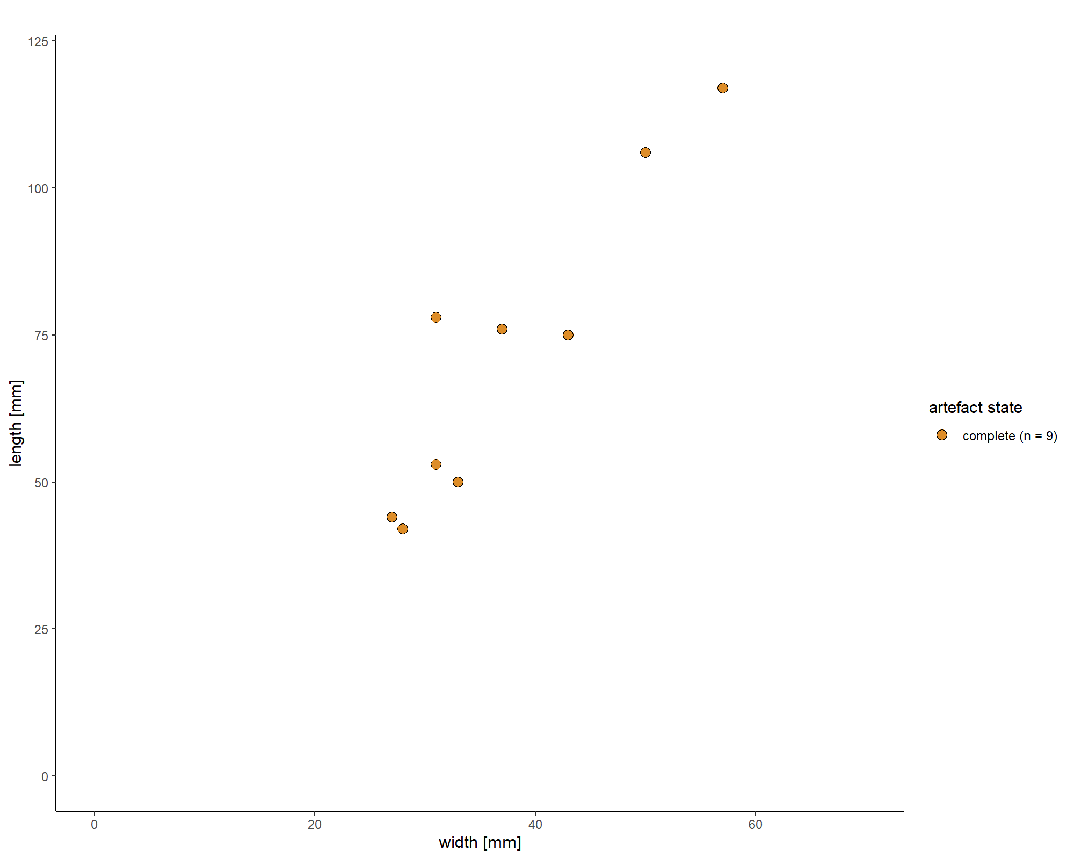

file_out <- paste0(file_path_sans_ext(info_in[["file"]]), "KM.length_width", ".pdf")  
ggsave(filename = file_out, plot = KM.length_width, path = dir_out, device = "pdf",   
 width = 200, height = 290, units = "mm")  
  
  
# Pradnik scraper length VS width   
# Ascribes the N value   
n <- doBy::summaryBy(length + width ~ artefact.state, data = PS_dim, FUN = length)  
tag <- gsub(pattern = "_", replacement = " ", paste0(n[[1]], " (n = ", n[[2]], ")"))  
  
# Scatterplot Pradnik scraper length VS width   
PS.length_width <- ggplot(PS_dim, aes(y = length, x = width, fill = artefact.state)) +  
 geom_point(size = 3, shape = 21) +  
 labs(y = "length [mm]", x = "width [mm]", title = "",  
 fill = "artefact state", size = 12) +  
 xlim(0, 45) + ylim(0, 55) +  
 theme_classic() +  
 scale_fill_manual(values = wes_palette(n = 6, name = "Chevalier1",   
 type = "continuous"), labels = tag)   
  
print(PS.length_width)

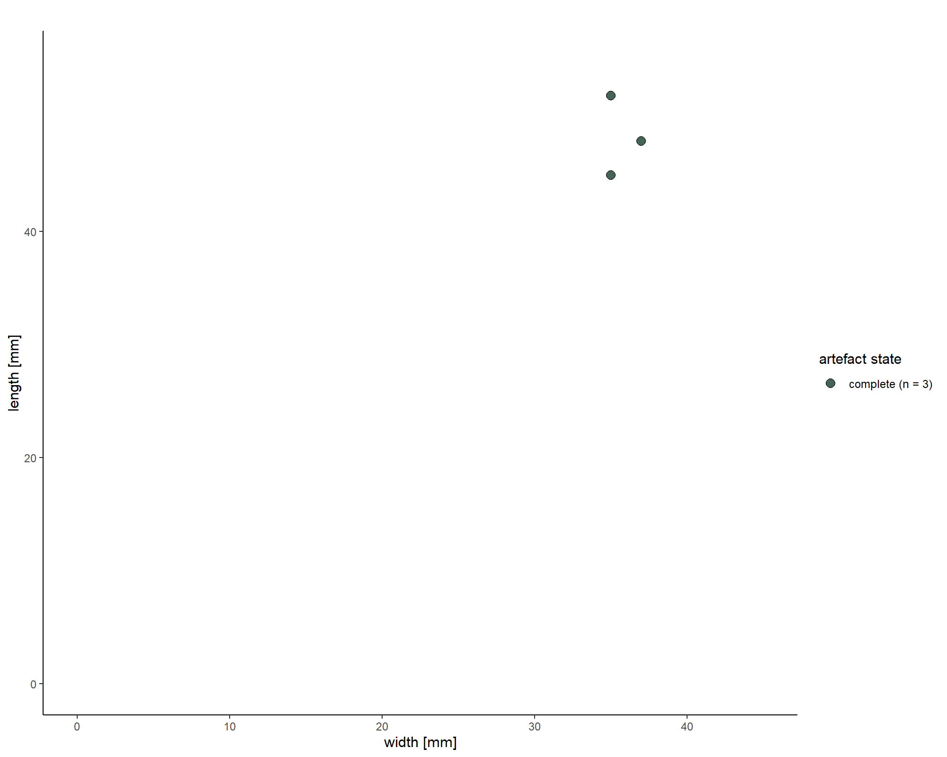

file_out <- paste0(file_path_sans_ext(info_in[["file"]]), "PS.length_width", ".pdf")  
ggsave(filename = file_out, plot = PS.length_width, path = dir_out, device = "pdf")  
  
  
# Keilmesser (complete) + Pradnik scraper length VS width  
# Load data sheet dimensions   
dim <- read.xlsx(xlsxFile = data_file, sheet = 2)   
# Defines only the relevant rows   
KM.PS_dim <- dim[c(3:11, 12:14), ]   
  
# Keilmesser (complete) + Pradnik scraper length VS width   
# Ascribes the N value   
n <- doBy::summaryBy(length + width ~ technological.class, data = KM.PS_dim, FUN = length)  
tag <- gsub(pattern = "_", replacement = " ", paste0(n[[1]], " (n = ", n[[2]], ")"))  
  
# Scatterplot Keilmesser (complete) + Pradnik scraper length VS width  
KM.PS.length_width <- ggplot(KM.PS_dim, aes(y = length, x = width,   
 fill = technological.class)) +  
 geom_point(size = 3, shape = 21) +  
 labs(y = "length [mm]", x = "width [mm]", title = "",  
 fill = "artefact category", size = 12) +  
 xlim(0, 80) + ylim(0, 120) +  
 theme_classic() +  
 scale_fill_manual(values = wes_palette(n = 3, name =  
 "GrandBudapest1", type = "continuous"), labels = tag)   
  
print(KM.PS.length_width)

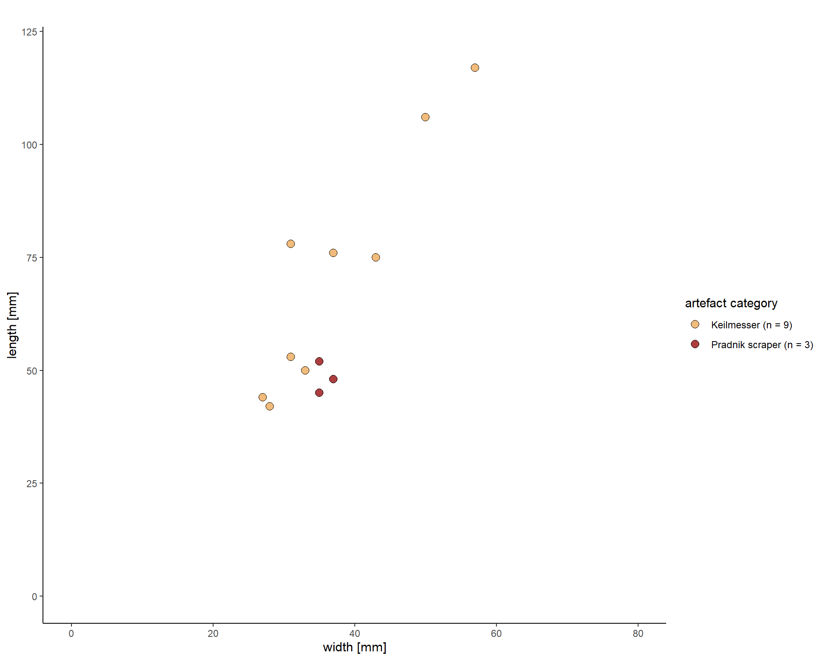

file_out <- paste0(file_path_sans_ext(info_in[["file"]]), "KM.PS.length_width", ".pdf")  
ggsave(filename = file_out, plot = KM.PS.length_width, path = dir_out, device = "pdf",  
 width = 170, height = 250, units = "mm")  
   
  
# Keilmesser (complete): length-width combined with morpho type  
# Load data sheet Keilmesser morpho type   
KM_morpho.type <- read.xlsx(xlsxFile = data_file, sheet = 25)   
  
# Ascribes the N value   
n <- doBy::summaryBy(length + width ~ morpho.type, data = KM_morpho.type, FUN = length)  
tag <- gsub(pattern = "_", replacement = " ", paste0(n[[1]], " (n = ", n[[2]], ")"))  
  
  
# Scatterplot Keilmesser (complete): length-width combined with morpho type   
KM.width_length_morpho <- ggplot(KM_morpho.type, aes(y = length, x = width,   
 fill = morpho.type)) +  
 geom_point(size = 2, shape = 21) +  
 labs(y = "length [mm]", x = "width [mm]", title = "",   
 fill = "Keilmesser shape", size = 12) +  
 xlim(0, 80) + ylim(00, 120) +  
 theme_classic() +  
 scale_fill_manual(values = wes_palette(n = 3, name =   
 "FantasticFox1", type = "continuous"), labels = tag)   
   
print(KM.width_length_morpho)

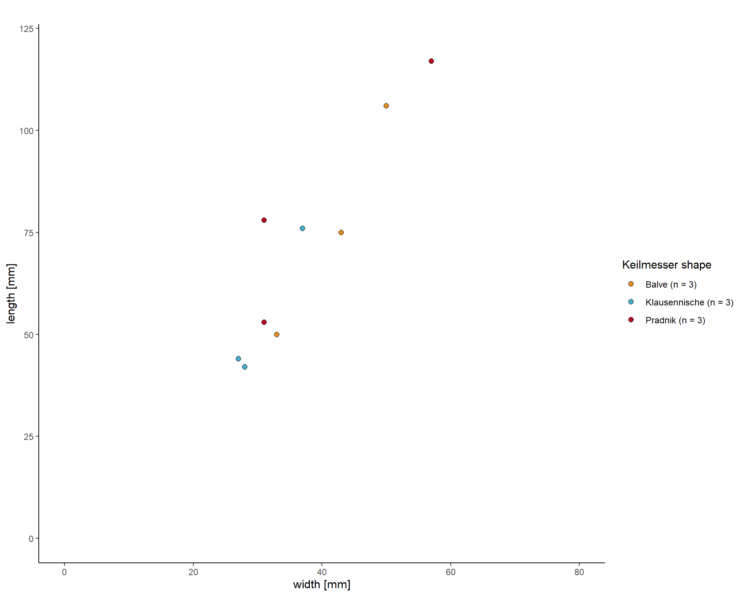

file_out <- paste0(file_path_sans_ext(info_in[["file"]]),   
 "KM.width_length_morpho", ".pdf")  
ggsave(filename = file_out, plot = KM.width_length_morpho, path = dir_out,   
 device = "pdf", width = 170, height = 250, units = "mm")

## Barplot

### Morphotype

# Keilmesser morpho type   
# Load data sheet Keilmesser morpho type   
KM_morpho.type <- read.xlsx(xlsxFile = data_file, sheet = 25)   
  
# Barplot Keilmesser morpho type   
KM.morpho.type <- ggplot(data = KM_morpho.type) + aes(x = morpho.type,   
 fill = morpho.type) +   
 geom_bar(stat = "count", width = 0.3, fill = c("#899DA4", "#D76848",  
 "#E8B37B")) +  
 theme_classic() +  
 theme(legend.position = "none") +   
 labs(x = " ", y = "n")   
   
print(KM.morpho.type)

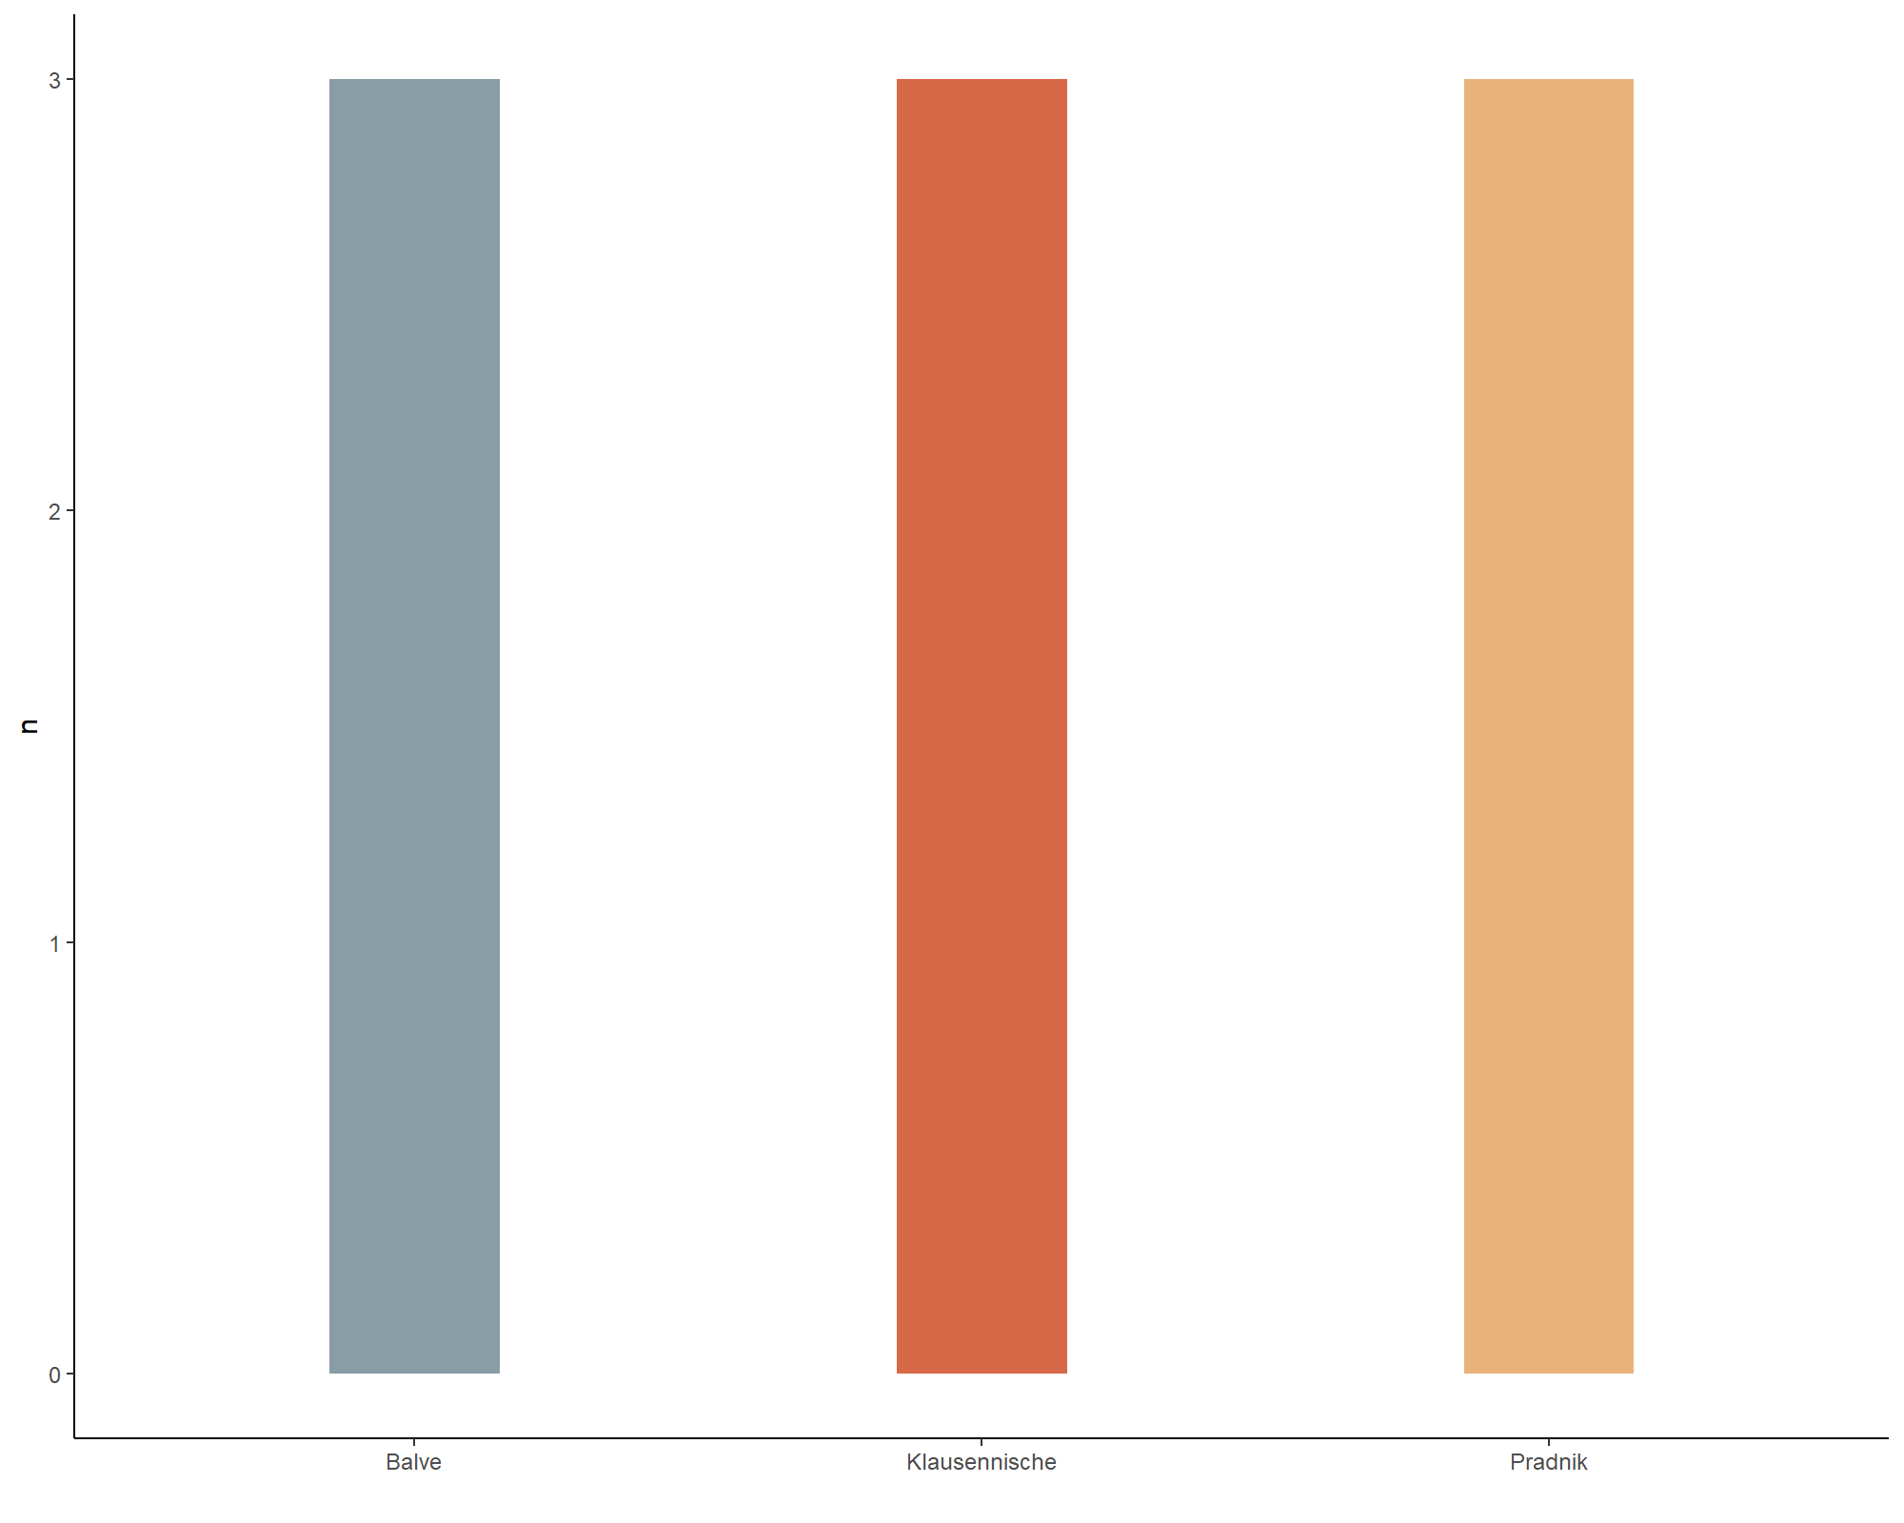

file_out <- paste0(file_path_sans_ext(info_in[["file"]]), "KM.morpho.type", ".pdf")  
ggsave(filename = file_out, plot = KM.morpho.type, path = dir_out, device = "pdf",   
 width = 170, height = 200, units = "mm")

## Barplot

### Edge retouch

# Keilmesser edge retouch   
# Load data sheet Keilmesser edge retouch   
KM_edge <- read.xlsx(xlsxFile = data_file, sheet = 21)   
  
# Barplot Keilmesser edge retouch   
KM.edge <- ggplot(data = KM_edge) + aes(x = retouch.type.edge, fill = retouch.type.edge) + geom_bar(stat = "count", width = 0.5, fill = c ("#798E87", "#972D15",  
 "#29211F")) +  
 theme_classic() +  
 theme(legend.position = "none") +   
 labs(x = " ", y = "n")   
   
print(KM.edge)

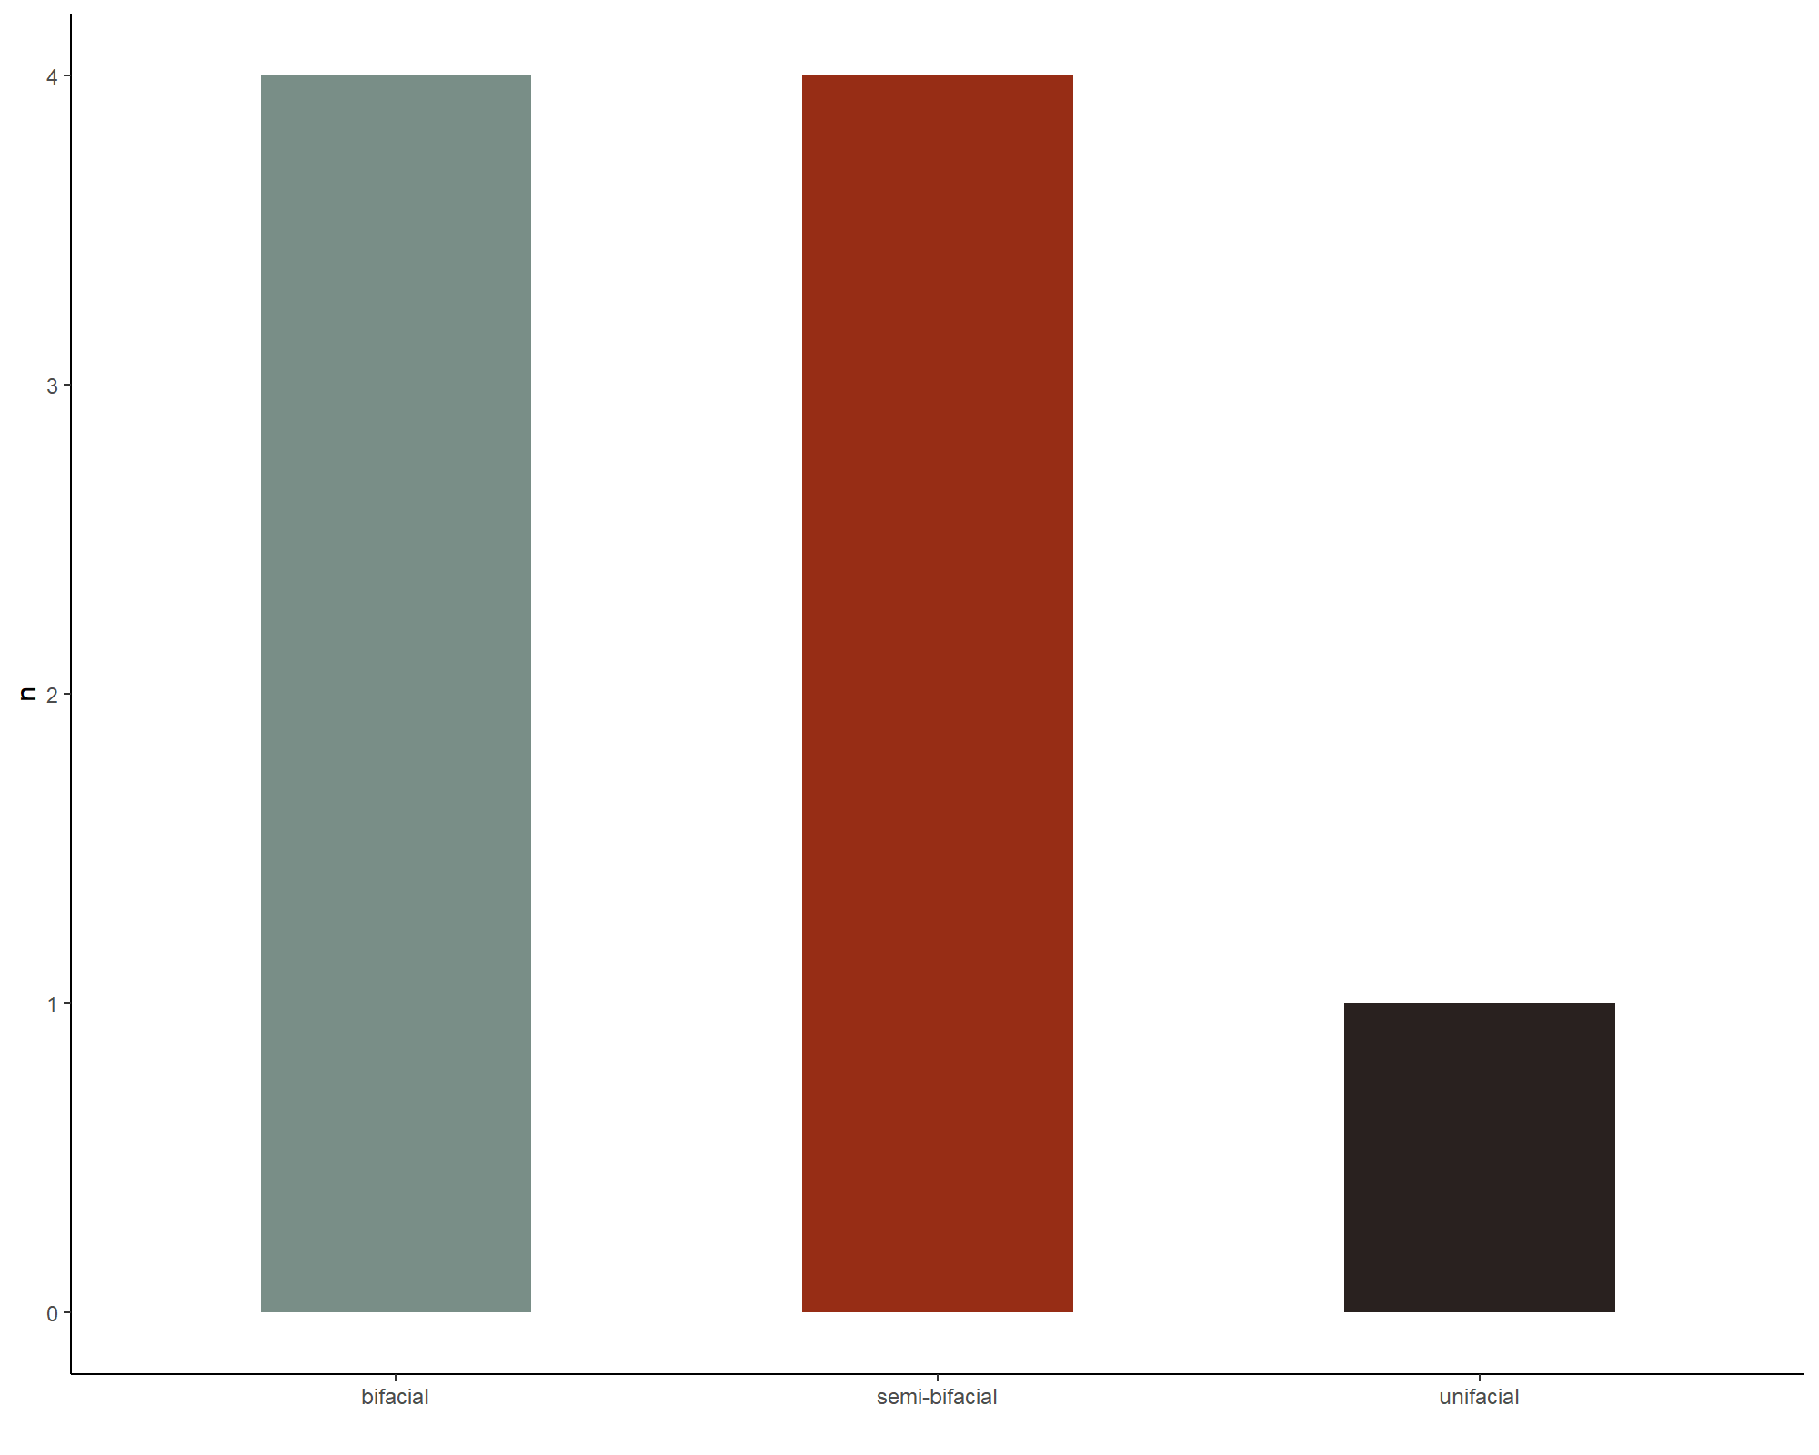

file_out <- paste0(file_path_sans_ext(info_in[["file"]]), "KM.edge", ".pdf")  
ggsave(filename = file_out, plot = KM.edge, path = dir_out, device = "pdf",   
 width = 170, height = 200, units = "mm")  
  
  
  
# Pradnik scraper edge retouch   
# Load data sheet Pradnik scraper edge retouch   
PS_edge <- read.xlsx(xlsxFile = data_file, sheet = 22)   
  
# Barplot Pradnik scraper edge retouch   
PS.edge <- ggplot(data = PS_edge) + aes(x = retouch.type.edge, fill = retouch.type.edge) +  
 geom_bar(stat = "count", width = 0.5, fill = c ("#972D15", "#29211F")) +  
 theme_classic() +  
 theme(legend.position = "none") +   
 labs(x = " ", y = "n")   
   
print(PS.edge)

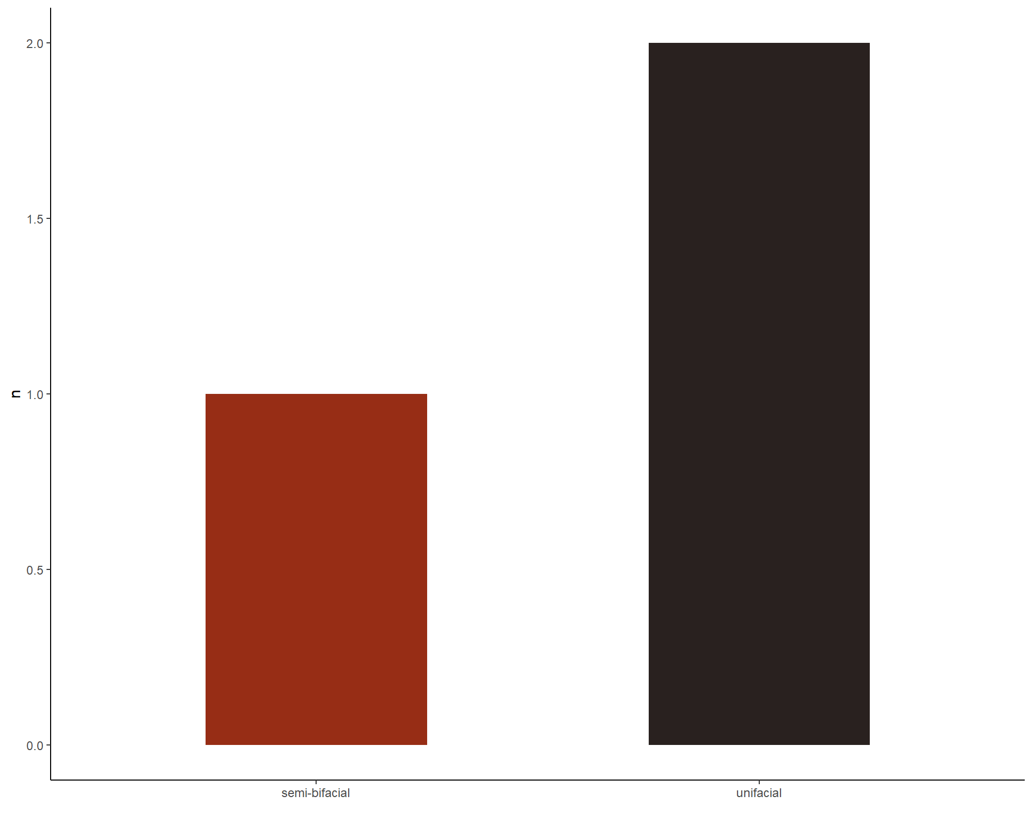

file_out <- paste0(file_path_sans_ext(info_in[["file"]]), "PS.edge", ".pdf")  
ggsave(filename = file_out, plot = PS.edge, path = dir_out, device = "pdf",   
 width = 170, height = 200, units = "mm")

## Barplot

### Raw material

# Keilmesser raw material  
# Load data sheet Keilmesser raw material  
KM_raw_material <- read.xlsx(xlsxFile = data_file, sheet = 13)   
  
# Barplot Keilmesser raw material   
KM.raw_material <- ggplot(data = KM_raw_material) + aes(x = raw.material,   
 fill = raw.material) +   
 geom_bar(stat = "count", width = 0.15, fill = c("#D69C4E",   
 "#046C9A")) +  
 theme_classic() +  
 theme(legend.position = "none") +   
 labs(x = " ", y = "n") +   
 scale_x_discrete(labels=c("flint", "silicified schist"))   
   
print(KM.raw_material)

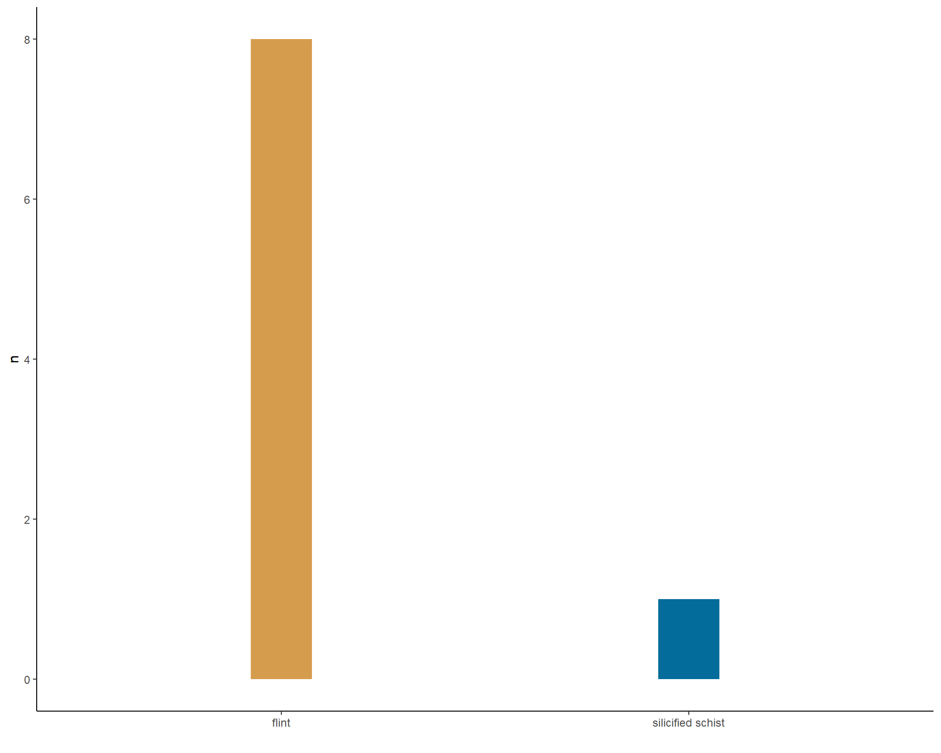

file_out <- paste0(file_path_sans_ext(info_in[["file"]]), "KM.raw_material", ".pdf")  
ggsave(filename = file_out, plot = KM.raw_material, path = dir_out,   
 device = "pdf", width = 250, height = 170, units = "mm")  
  
  
# Pradnik scraper raw material  
# Load data sheet Pradnik scraper raw material  
PS_raw_material <- read.xlsx(xlsxFile = data_file, sheet = 14)   
  
# Barplot Pradnik scraper raw material   
PS.raw_material <- ggplot(data = PS_raw_material) + aes(x = raw.material,   
 fill = raw.material) +   
 geom_bar(stat = "count", width = 0.08, fill = c("#D69C4E")) +  
 theme_classic() +  
 theme(legend.position = "none") +   
 labs(x = " ", y = "n") +   
 scale_x_discrete(labels= "flint")   
  
print(PS.raw_material)

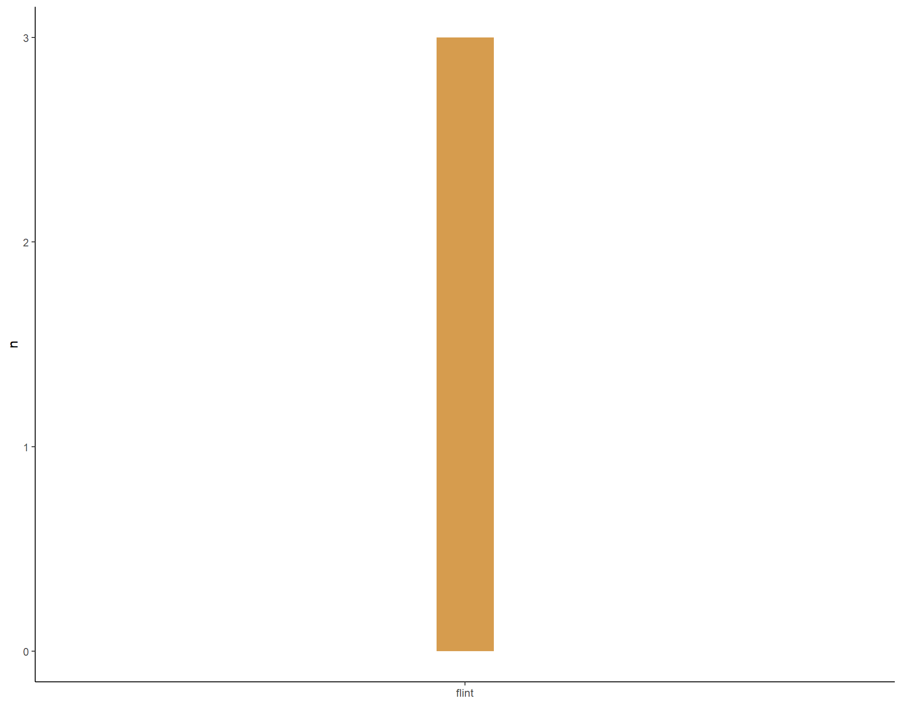

file_out <- paste0(file_path_sans_ext(info_in[["file"]]), "PS.raw_material", ".pdf")  
ggsave(filename = file_out, plot = PS.raw_material, path = dir_out, device = "pdf",   
 width = 250, height = 170, units = "mm")  
  
  
# All tool types raw material  
# Load data sheet all tool types raw material  
all_raw_material <- read.xlsx(xlsxFile = data_file, sheet = 1)   
  
# Barplot Pradnik scraper raw material   
all.raw_material <- ggplot(data = all_raw_material) + aes(x = raw.material,   
 fill = raw.material) +   
 geom_bar(stat = "count", width = 0.15, fill = c("#D69C4E",   
 "#046C9A")) +  
 theme_classic() +  
 theme(legend.position = "none") +   
 labs(x = " ", y = "n") +   
 scale_x_discrete(labels=c("flint", "silicified schist"))   
   
print(all.raw_material)

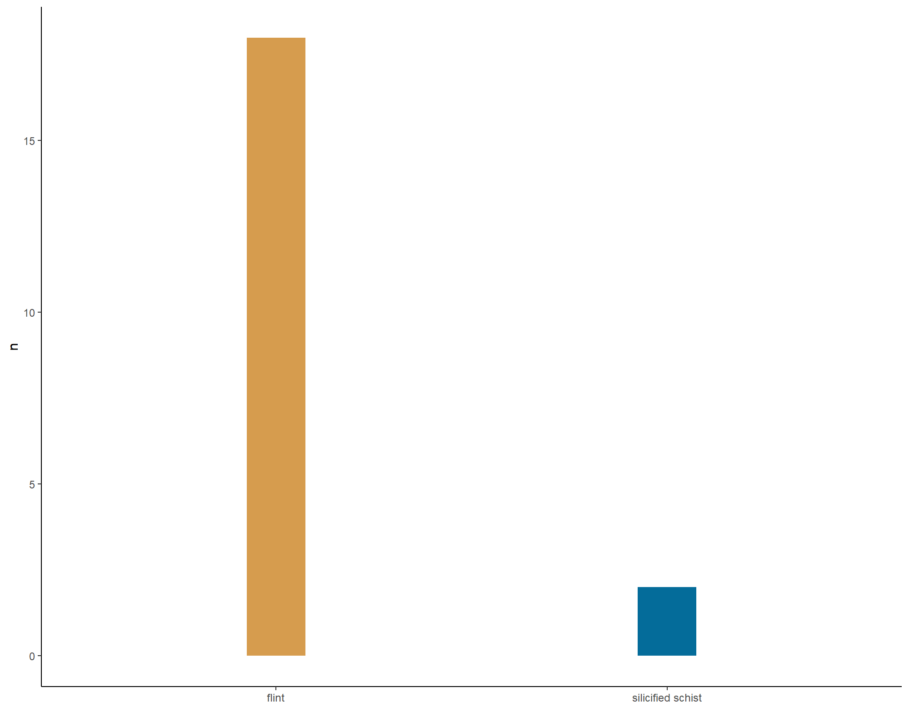

file_out <- paste0(file_path_sans_ext(info_in[["file"]]), "all.raw_material", ".pdf")  
ggsave(filename = file_out, plot = all.raw_material, path = dir_out, device = "pdf",   
 width = 250, height = 170, units = "mm")

## Barplot

### Morphology back

# Keilmesser morphology back   
# Load data sheet Keilmesser morphology back   
KM_back <- read.xlsx(xlsxFile = data_file, sheet = 19)   
  
# colour code   
# Darjeeling2 = c("#ECCBAE", "#046C9A", "#D69C4E", "#ABDDDE", "#000000"),  
  
# Barplot Keilmesser morphology back   
KM.back_morpho <- ggplot(data = KM_back) + aes(x = morphology.back,   
 fill = morphology.back) +   
 geom_bar(stat = "count", width = 0.25, fill = c("#518BA0", "#518BA0", "#B9C7AD")) +  
 theme_classic() +  
 theme(legend.position = "none") +   
 labs(x = " ", y = "n") +   
 scale_x_discrete(labels=c("cortex + partly retouched",  
 "cortex/unworked", "retouched"))   
   
print(KM.back_morpho)

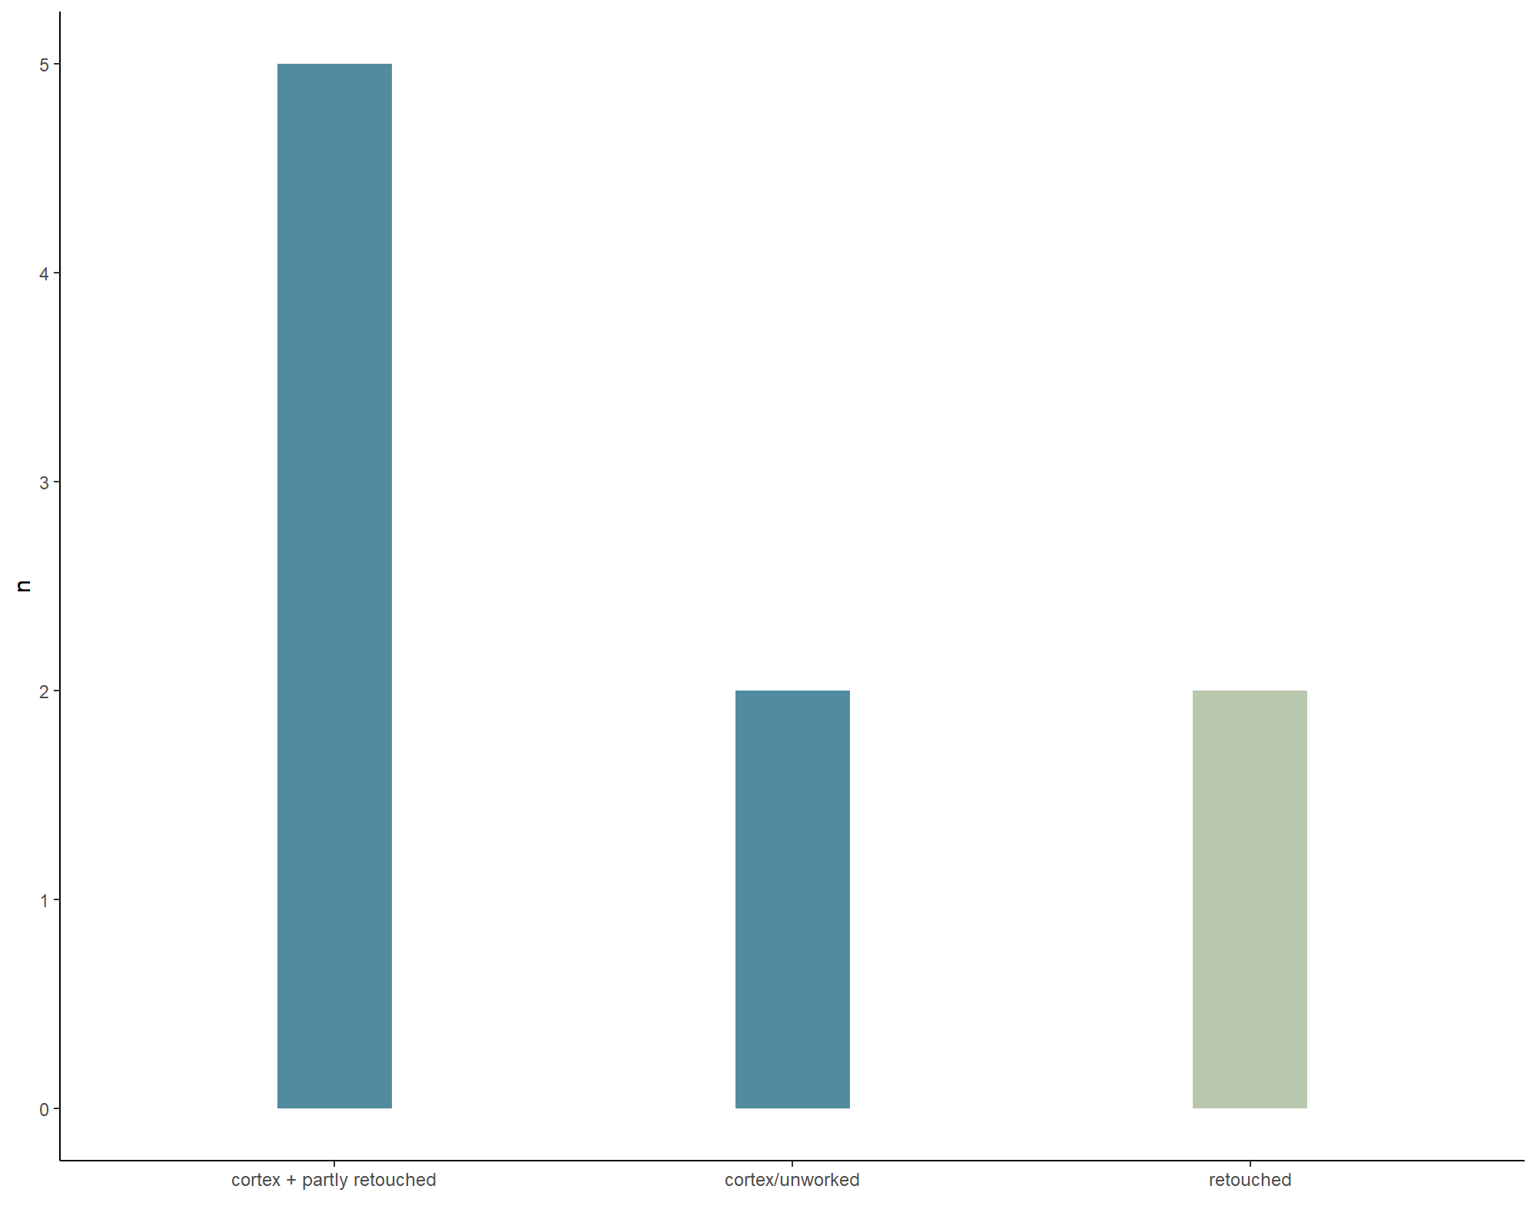

file_out <- paste0(file_path_sans_ext(info_in[["file"]]), "KM.back_morpho", ".pdf")  
ggsave(filename = file_out, plot = KM.back_morpho, path = dir_out, device = "pdf",   
 width = 250, height = 170, units = "mm")  
  
  
  
# Pradnik scraper morphology back   
# Load data sheet Pradnik scraper morphology back   
PS_back <- read.xlsx(xlsxFile = data_file, sheet = 20)   
  
# Barplot Pradnik scraper morphology back   
PS.back_morpho <- ggplot(data = PS_back) + aes(x = morphology.back,   
 fill = morphology.back) +   
 geom_bar(stat = "count", width = 0.22, fill = "#B9C7AD") +  
 theme_classic() +  
 theme(legend.position = "none") +   
 labs(x = " ", y = "n") +   
 scale_x_discrete()   
   
print(PS.back_morpho)

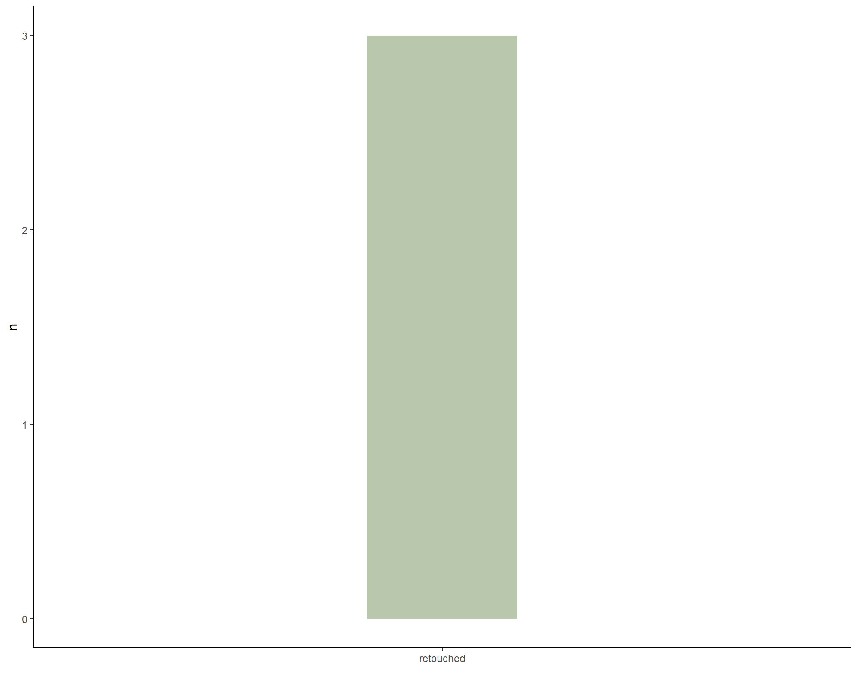

file_out <- paste0(file_path_sans_ext(info_in[["file"]]), "PS.back_morpho", ".pdf")  
ggsave(filename = file_out, plot = PS.back_morpho, path = dir_out, device = "pdf",   
 width = 250, height = 170, units = "mm")  
  
  
# Keilmesser blanks  
# Load data sheet Keilmesser blanks   
KM_cortex_blanks <- read.xlsx(xlsxFile = data_file, sheet = 17)   
  
# Ascribes the N value   
n <- doBy::summaryBy(blank ~ cortex, data = KM_cortex_blanks, FUN = length)  
tag <- gsub(pattern = "_", replacement = " ", paste0(n[[1]], " (n = ", n[[2]], ")"))  
  
# Barplot Keilmesser blanks   
KM.cortex_blanks <- ggplot(data = KM_cortex_blanks) + aes(x = blank, fill = cortex) +   
 geom_bar(stat = "count", width = 0.38) +  
 theme_classic() +  
 labs(x = " ", y = "n") +   
 scale_x_discrete(labels=c("core", "flake", "N/A")) +  
 scale_fill_manual(values = wes_palette(n = 7, name = "Darjeeling2",  
 type = "continuous"), labels = tag)   
   
print(KM.cortex_blanks)

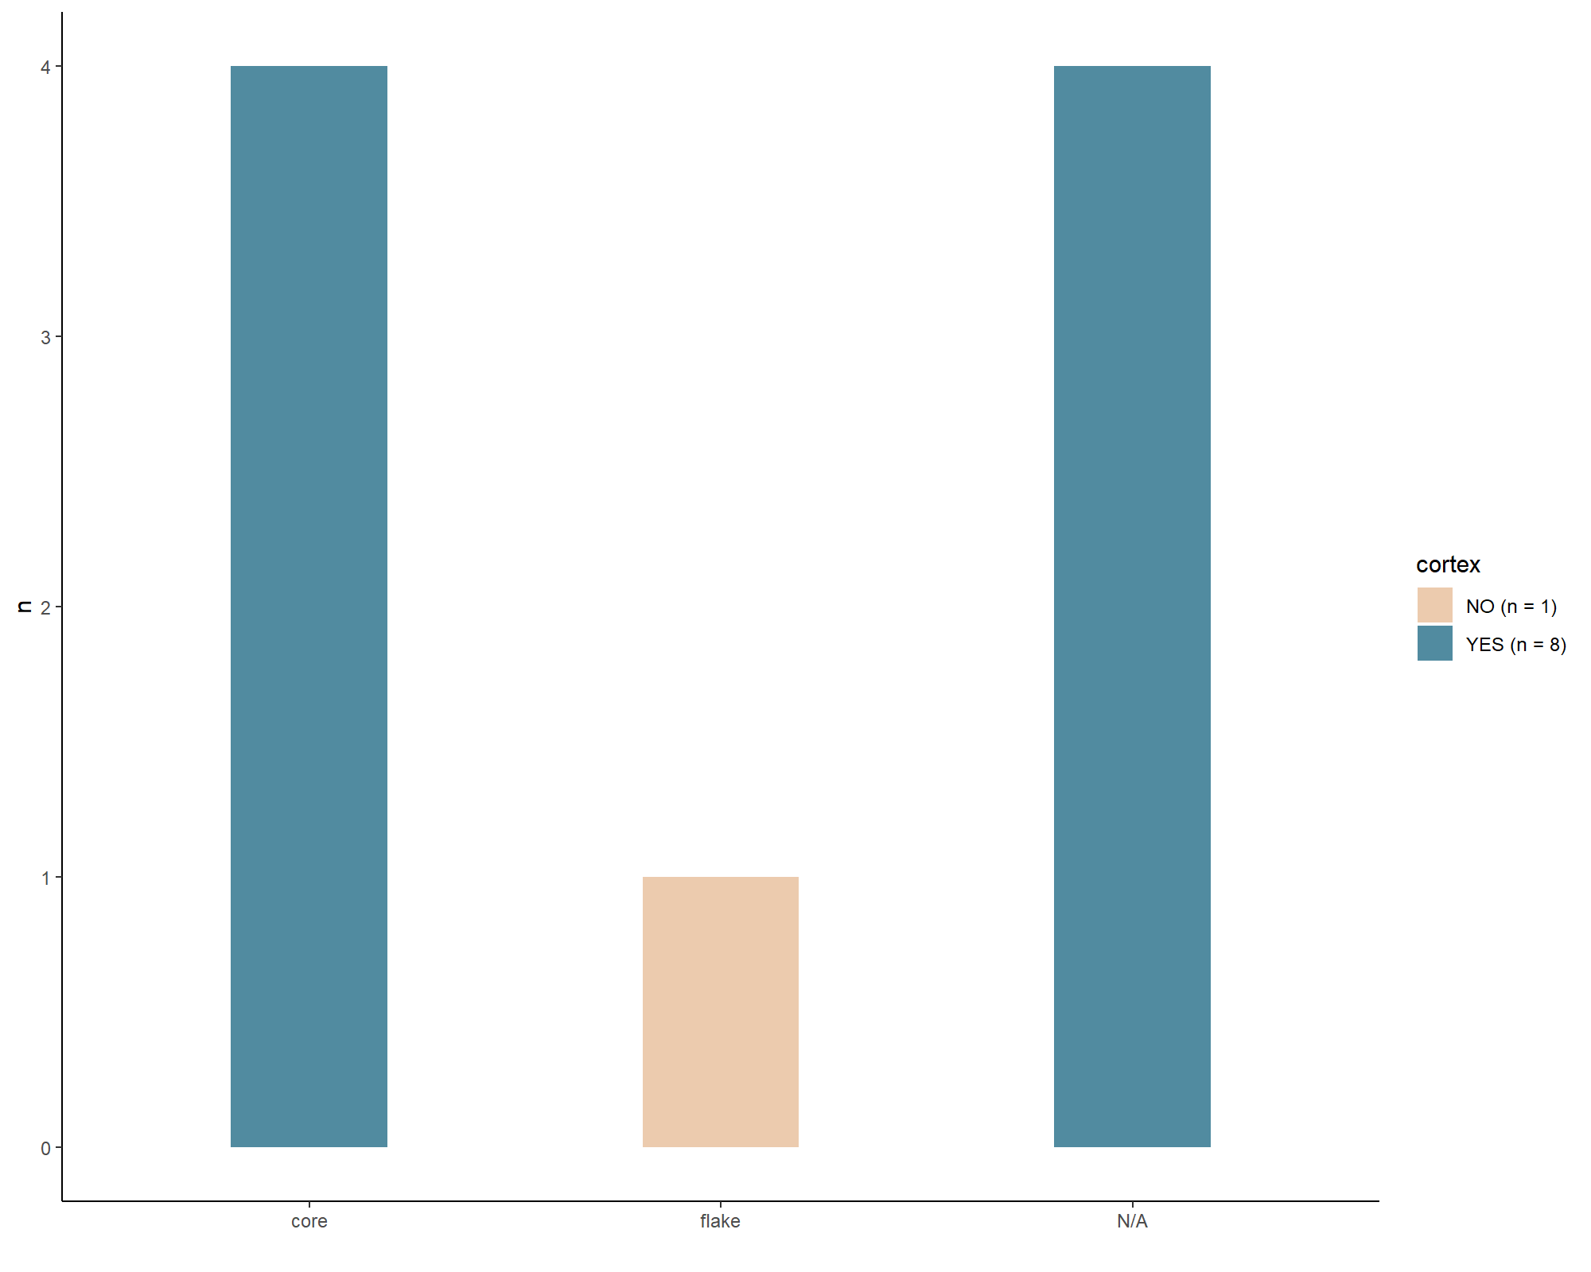

file_out <- paste0(file_path_sans_ext(info_in[["file"]]), "KM.cortex_blanks", ".pdf")  
ggsave(filename = file_out, plot = KM.cortex_blanks, path = dir_out, device = "pdf",   
 width = 250, height = 170, units = "mm")  
  
  
# Pradnik scraper blanks  
# Load data sheet Pradnik scraper blanks   
PS_cortex_blanks <- read.xlsx(xlsxFile = data_file, sheet = 18)   
  
# Ascribes the N value   
n <- doBy::summaryBy(blank ~ cortex, data = PS_cortex_blanks, FUN = length)  
tag <- gsub(pattern = "_", replacement = " ", paste0(n[[1]], " (n = ", n[[2]], ")"))  
  
# Barplot Pradnik scraper blanks   
PS.cortex_blanks <- ggplot(data = PS_cortex_blanks) + aes(x = blank, fill = cortex) +   
 geom_bar(stat = "count", width = 0.15) +  
 theme_classic() +  
 labs(x = " ", y = "n") +   
 scale_x_discrete(labels= "flake") +  
 scale_fill_manual(values = wes_palette(n = 7, name = "Darjeeling2",  
 type = "continuous"), labels = tag)   
   
print(PS.cortex_blanks)

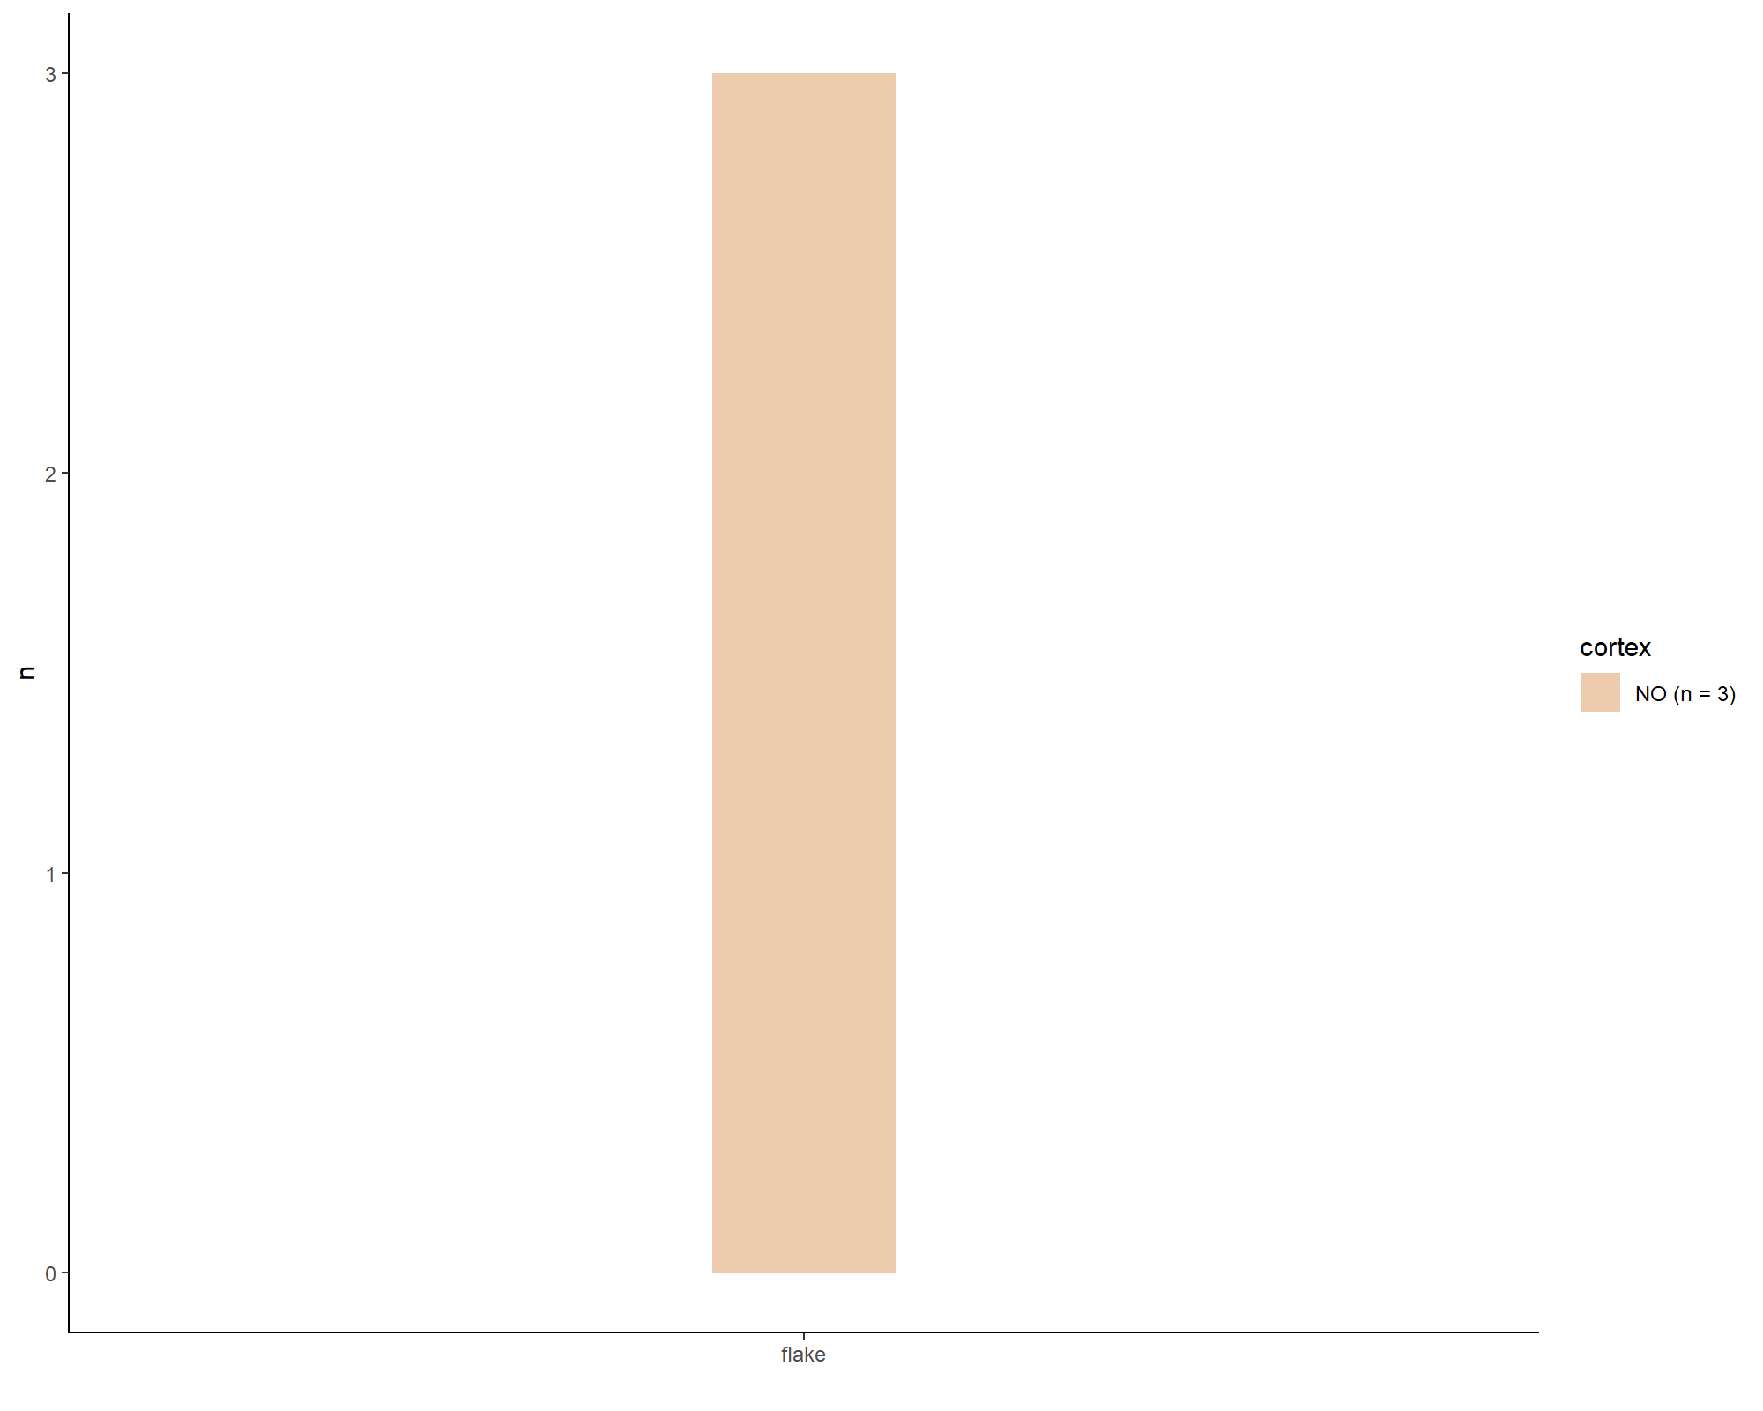

file_out <- paste0(file_path_sans_ext(info_in[["file"]]), "PS.cortex_blanks", ".pdf")  
ggsave(filename = file_out, plot = PS.cortex_blanks, path = dir_out, device = "pdf",   
 width = 250, height = 170, units = "mm")

## Barplot

### Pradnik method

# Keilmesser application Pradnik method  
# Load data sheet Keilmesser Pradnik method  
KM_Pradnik.method <- read.xlsx(xlsxFile = data_file, sheet = 27)   
  
# Barplot Keilmesser Pradnik method   
KM.PM <- ggplot(data = KM_Pradnik.method) + aes(x = application.Pradnik.method,   
 fill = application.Pradnik.method) +   
 geom_bar(stat = "count", width = 0.2) +   
 theme_classic() +  
 labs(x = " ", y = "n") +   
 theme(legend.position = "none") +   
 scale_x_discrete(labels=c("no", "yes")) +  
 scale_fill_manual(values = wes_palette(n = 3, name = "GrandBudapest1",   
 type = "continuous"))   
   
print(KM.PM)

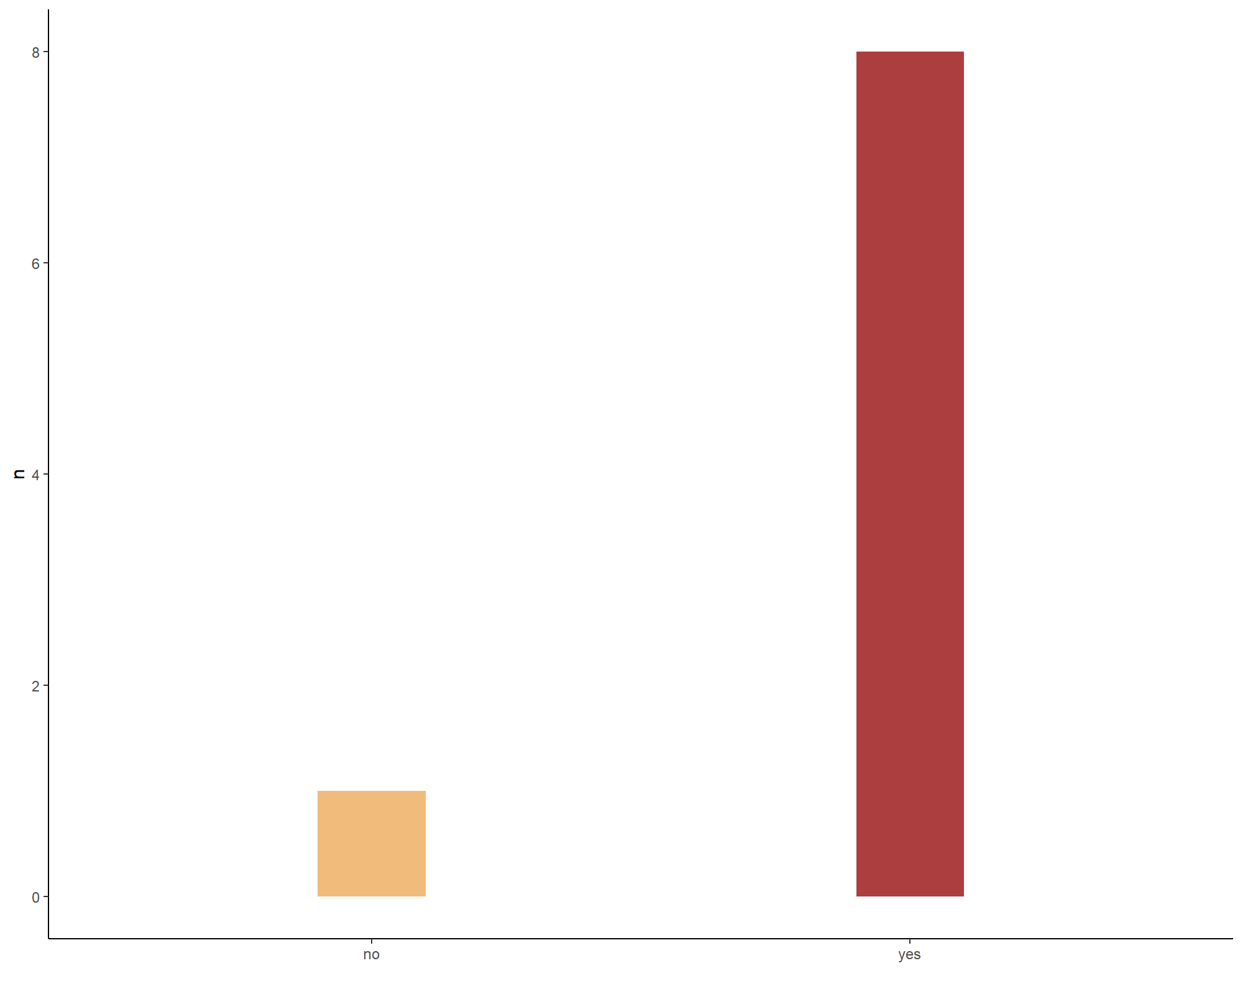

file_out <- paste0(file_path_sans_ext(info_in[["file"]]), "KM.PM", ".pdf")  
ggsave(filename = file_out, plot = KM.PM, path = dir_out, device = "pdf",   
 width = 250, height = 170, units = "mm")

## Barplot

### Lateralisation

# Keilmesser lateralisation  
# Load data sheet Keilmesser lateralisation  
KM_lateralisation <- read.xlsx(xlsxFile = data_file, sheet = 29)   
  
# Barplot Keilmesser lateralisation  
KM.lat <- ggplot(data = KM_lateralisation) + aes(x = tool.lateralisation,   
 fill = tool.lateralisation) +   
 geom_bar(stat = "count", width = 0.2) +   
 theme_classic() +  
 labs(x = " ", y = "n") +   
 theme(legend.position = "none") +  
 scale_fill_manual(values = wes_palette(n = 9, name = "Royal1",   
 type = "continuous"))   
  
print(KM.lat)

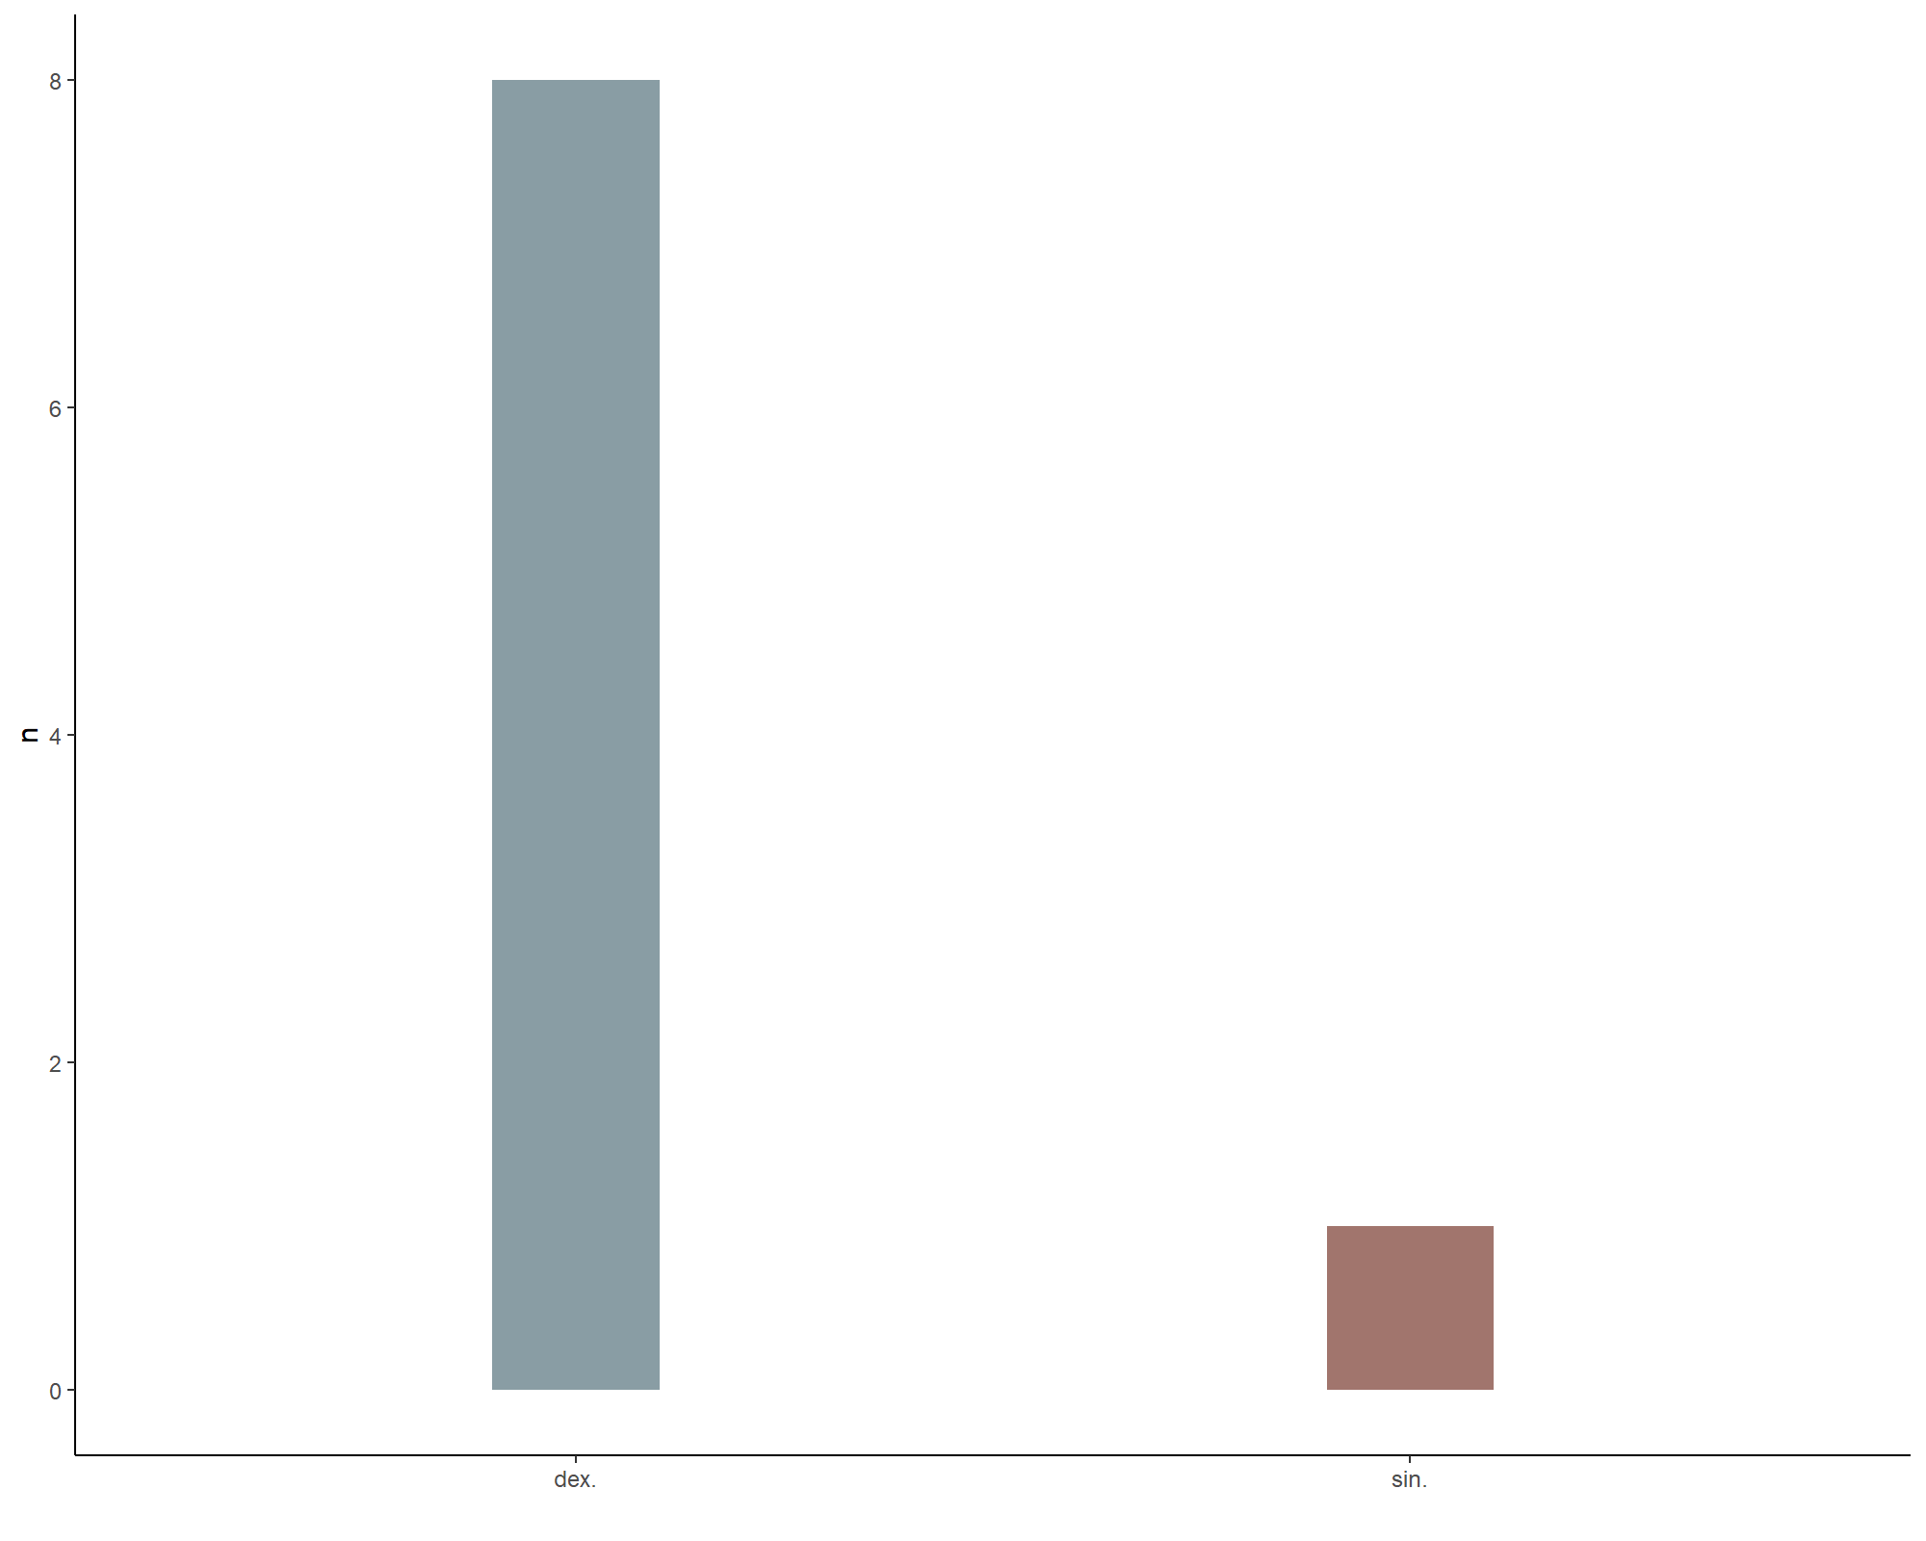

file_out <- paste0(file_path_sans_ext(info_in[["file"]]), "KM.lat", ".pdf")  
ggsave(filename = file_out, plot = KM.lat, path = dir_out, device = "pdf")  
  
  
# Pradnik scraper lateralisation  
# Load data sheet Pradnik scraper lateralisation  
PS_lateralisation <- read.xlsx(xlsxFile = data_file, sheet = 30)   
  
# Barplot Keilmesser lateralisation  
PS.lat <- ggplot(data = PS_lateralisation) + aes(x = tool.lateralisation,   
 fill = tool.lateralisation) +   
 geom_bar(stat = "count", width = 0.2) +   
 theme_classic() +  
 labs(x = " ", y = "n") +   
 theme(legend.position = "none") +  
 scale_fill_manual(values = wes_palette(n = 9, name = "Royal1",   
 type = "continuous"))   
  
print(PS.lat)

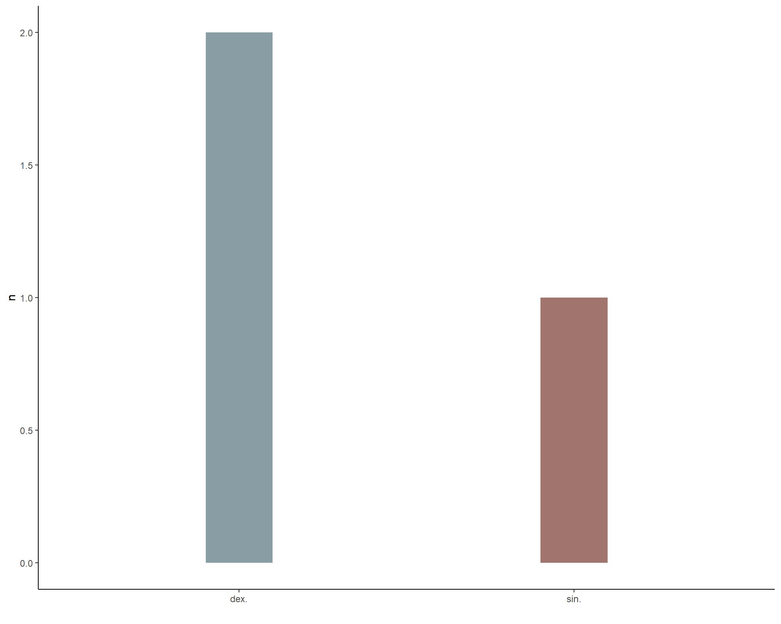

file_out <- paste0(file_path_sans_ext(info_in[["file"]]), "PS.lat", ".pdf")  
ggsave(filename = file_out, plot = PS.lat, path = dir_out, device = "pdf")

## Ternary plot

### Perimeter

library(ggtern)  
# Perimeter Keilmesser   
# Load data sheet Keilmesser perimeter  
KM_perimeter <- read.xlsx(xlsxFile = data_file, sheet = 7)   
  
# Ternary diagram Keilmesser perimeter  
KM.perimeter <- ggtern(data = KM_perimeter, aes(x = perimeter.distal.posterior.part,   
 y = perimeter.active.edge, z = perimeter.basis.back)) +  
 geom_point(aes(colour = morpho.type)) +  
 theme_bw() +  
 scale_colour_startrek() +  
 theme_hidetitles() +  
 theme_showarrows() +  
 xlab("distal posterior part")+   
 ylab("active edge")+  
 zlab("basis + back")+   
 labs(colour = "Keilmesser shape") +  
 tern_limits(labels=c(0, 20, 40, 60, 80, 100)) +  
 theme_rotate(degrees = 330)  
   
  
print(KM.perimeter)

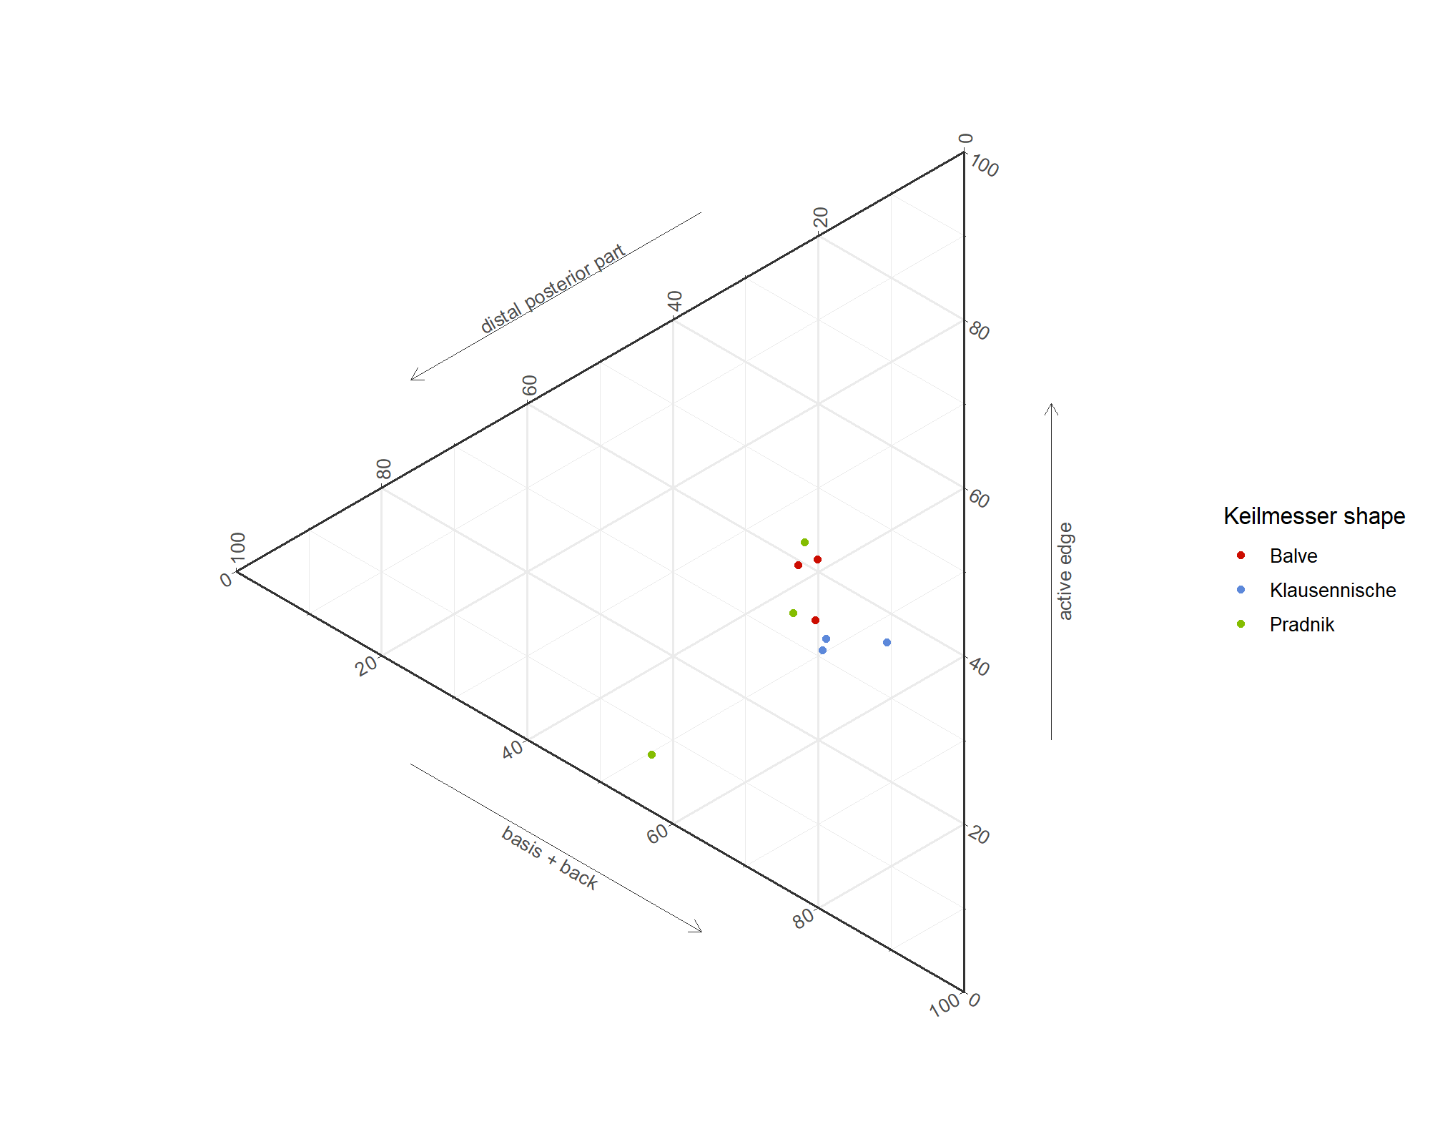

file_out <- paste0(file_path_sans_ext(info_in[["file"]]), "KM.perimeter", ".pdf")  
ggsave(filename = file_out, plot = KM.perimeter, path = dir_out, device = "pdf",   
 width = 250, height = 170, units = "mm")

# sessionInfo() and RStudio version

sessionInfo()

R version 4.0.2 (2020-06-22)  
Platform: x86_64-w64-mingw32/x64 (64-bit)  
Running under: Windows 10 x64 (build 19041)  
  
Matrix products: default  
  
locale:  
[1] LC_COLLATE=German_Germany.1252 LC_CTYPE=German_Germany.1252   
[3] LC_MONETARY=German_Germany.1252 LC_NUMERIC=C   
[5] LC_TIME=German_Germany.1252   
  
attached base packages:  
[1] tools stats graphics grDevices utils datasets methods   
[8] base   
  
other attached packages:  
 [1] ggtern_3.3.0 ggsci_2.9 dplyr_1.0.3 wesanderson_0.3.6  
 [5] ggplot2_3.3.3 chron_2.3-56 R.utils_2.10.1 R.oo_1.24.0   
 [9] R.methodsS3_1.8.1 readxl_1.3.1 openxlsx_4.2.3   
  
loaded via a namespace (and not attached):  
 [1] tidyselect_1.1.0 xfun_0.20 purrr_0.3.4 lattice_0.20-41   
 [5] latex2exp_0.4.0 colorspace_2.0-0 vctrs_0.3.6 generics_0.1.0   
 [9] doBy_4.6.8 htmltools_0.5.1.1 compositions_2.0-1 yaml_2.2.1   
[13] rlang_0.4.10 pillar_1.4.7 glue_1.4.2 withr_2.4.1   
[17] DBI_1.1.1 plyr_1.8.6 lifecycle_0.2.0 robustbase_0.93-7   
[21] stringr_1.4.0 munsell_0.5.0 gtable_0.3.0 cellranger_1.1.0   
[25] zip_2.1.1 evaluate_0.14 labeling_0.4.2 knitr_1.31   
[29] DEoptimR_1.0-8 highr_0.8 proto_1.0.0 broom_0.7.4   
[33] Rcpp_1.0.6 scales_1.1.1 backports_1.2.0 farver_2.0.3   
[37] gridExtra_2.3 Deriv_4.1.2 tensorA_0.36.2 digest_0.6.27   
[41] stringi_1.5.3 grid_4.0.2 magrittr_2.0.1 tibble_3.0.5   
[45] crayon_1.4.0 tidyr_1.1.2 pkgconfig_2.0.3 bayesm_3.1-4   
[49] ellipsis_0.3.1 MASS_7.3-53 Matrix_1.2-18 assertthat_0.2.1   
[53] rmarkdown_2.6 R6_2.5.0 compiler_4.0.2

RStudio version 1.3.1056.

END OF SCRIPT