Plot - Edge angle analysis - experimental data

Lisa Schunk

2021-02-04 16:36:40

# Goal of the script

This script plots all edge angle values. The three experiments will be treated separately.

dir_in <- "analysis/derived_data/"  
dir_out <- "analysis/plots"

Raw data must be located in ~/analysis/derived_data/.  
Formatted data will be saved in ~/analysis/plots.

## The knit directory for this script is the project directory.

# Load packages

library(openxlsx)

Warning: package 'openxlsx' was built under R version 4.0.3

library(readxl)  
library(R.utils)  
library(ggplot2)

Warning: package 'ggplot2' was built under R version 4.0.3

library(tools)  
library(tidyverse)

Warning: package 'readr' was built under R version 4.0.3

Warning: package 'dplyr' was built under R version 4.0.3

Warning: package 'forcats' was built under R version 4.0.3

library(patchwork)

Warning: package 'patchwork' was built under R version 4.0.3

library(ggsci)  
library(ggfortify)

Warning: package 'ggfortify' was built under R version 4.0.3

library(wesanderson)

Warning: package 'wesanderson' was built under R version 4.0.3

library(doBy)

Warning: package 'doBy' was built under R version 4.0.3

library(ggfortify)

# Get name, path and information of the file

data_file <- list.files(dir_in, pattern = "\\.xlsx$", full.names = TRUE)  
md5_in <- md5sum(data_file)  
info_in <- data.frame(file = basename(names(md5_in)), checksum = md5_in, row.names = NULL)

The checksum (MD5 hashes) of the imported file is:

file checksum  
1 EdgeAngle_experiment.xlsx ed7878fcffd202c8e363d138621a7ce7

# Load data into R object

imp_data <- read.xlsx(xlsxFile = data_file, sheet = 1, startRow = 1, colNames = TRUE,  
 rowNames = FALSE, skipEmptyRows = FALSE)   
str(imp_data)

'data.frame': 29933 obs. of 16 variables:  
 $ section : chr "FLT4-10-1000strokes_E1_RE_SEC-01_local" "FLT4-10-1000strokes_E1_RE_SEC-01_local" "FLT4-10-1000strokes_E1_RE_SEC-01_local" "FLT4-10-1000strokes_E1_RE_SEC-01_local" ...  
 $ experiment : chr "'aVSn'-experiment" "'aVSn'-experiment" "'aVSn'-experiment" "'aVSn'-experiment" ...  
 $ ID : chr "FLT4-10" "FLT4-10" "FLT4-10" "FLT4-10" ...  
 $ strokes : chr "1000strokes" "1000strokes" "1000strokes" "1000strokes" ...  
 $ edge : chr "E1" "E1" "E1" "E1" ...  
 $ sec : chr "SEC-01" "SEC-01" "SEC-01" "SEC-01" ...  
 $ Raw.material : chr "flint" "flint" "flint" "flint" ...  
 $ Contact.material: chr "bone plate" "bone plate" "bone plate" "bone plate" ...  
 $ Task : chr "cutting" "cutting" "cutting" "cutting" ...  
 $ Edge.angle : chr "60°" "60°" "60°" "60°" ...  
 $ Angle_number : num 1 2 3 4 5 6 7 8 9 10 ...  
 $ Distance_origin : num 1 2 3 4 5 6 7 8 9 10 ...  
 $ Segment : num 2 2 2 2 2 2 2 2 2 2 ...  
 $ Three_point : num 75.2 67 63.5 61.9 60.9 60.3 59.9 59.4 59.2 59 ...  
 $ Two_lines : num 68.1 58 57.1 56.9 57.2 57.7 56.7 56.7 57.1 57.2 ...  
 $ Best_fit : num 69.7 58.3 57 57 57.3 57 57.1 57.1 56.6 57.6 ...

The imported file is: “~/analysis/derived_data/EdgeAngle_experiment.xlsx”

# Prepare variables

## Define numeric variables

num.var <- 14:length(imp_data)

The following variables will be used:

[14] Three_point  
[15] Two_lines  
[16] Best_fit

# Facet wrap to plot each experiment individually

## Artfifical VS natural experiment

# selects only the data from the aVSn experiment   
aVSn <- filter(imp_data, experiment == "'aVSn'-experiment")  
aVSn <- filter(aVSn, Angle_number == "3" | Angle_number == "4" | Angle_number == "5" |  
 Angle_number == "6")  
aVSn <- filter(aVSn, sec == "SEC-02" | sec == "SEC-03" | sec == "SEC-04" | sec == "SEC-05" |  
 sec == "SEC-06" | sec == "SEC-07" | sec == "SEC-08")  
  
# adds a column that combines sample and location  
aVSn_data <- unite(aVSn, ID_cycle, c(ID, strokes), remove = FALSE)  
  
# computes the mean per sample   
aVSn_mean <- summaryBy(. ~ ID_cycle+ID+strokes+Contact.material+Raw.material+Edge.angle, data = aVSn_data, FUN = mean)  
  
# gets new order   
aVSn_mean$strokes <- factor(aVSn_mean$strokes, levels=c("before", "50strokes", "250strokes",  
 "1000strokes", "2000strokes"))  
aVSn_mean$ID <- factor(aVSn_mean$ID, levels=c("FLT4-5", "FLT4-7", "FLT4-10", "FLT4-6",  
 "FLT4-14", "FLT4-15","FLT4-11", "FLT4-12",  
 "FLT4-13", "FLT4-4", "FLT4-8", "FLT4-9",  
 "LYDIT4-2", "LYDIT4-3", "LYDIT4-8","LYDIT4-5",  
 "LYDIT4-7", "LYDIT4-12", "LYDIT4-9",  
 "LYDIT4-10", "LYDIT4-11", "LYDIT4-1",  
 "LYDIT4-4", "LYDIT4-6"))   
  
# gets the min/max range of the data set   
range_var <- range(aVSn_mean[["Three_point.mean"]])   
  
# plots   
# plots first the lydit samples  
p_lydite <- ggplot(data = aVSn_mean[grep("LYDIT", aVSn_mean[["ID_cycle"]]), ],   
 aes(x = strokes, y = Three_point.mean, colour = Edge.angle)) +   
 geom_point(size = 2) +  
 geom_line(aes(group = ID)) +  
 facet_wrap(ID ~ Contact.material, nrow = 4)+  
 theme_classic()+  
 xlab("strokes") + ylab(NULL) +  
 labs(colour = "Edge angle") +  
 coord_cartesian(ylim = range_var) +   
 scale_colour_manual(values = "#CB2314") +  
 scale_x_discrete(breaks = c("before", "50strokes", "250strokes" , "1000strokes",  
 "2000strokes"), labels = c("0", "50", "250", "1000",  
 "2000"))  
  
  
# plots the flint samples   
p_flint <- ggplot(data = aVSn_mean[grep("FLT", aVSn_mean[["ID_cycle"]]), ],   
 aes(x = strokes, y = Three_point.mean, colour = Edge.angle)) +   
 geom_point(size = 2) +  
 geom_line(aes(group = ID)) +  
 facet_wrap(ID ~ Contact.material, nrow = 4)+  
 theme_classic()+  
 xlab("strokes") + ylab(NULL) +  
 labs(colour = "Edge angle") +  
 coord_cartesian(ylim = range_var) +  
 scale_colour_manual(values = "#CB2314") +  
 scale_x_discrete(breaks = c("before", "50strokes", "250strokes" , "1000strokes",  
 "2000strokes"), labels = c("0", "50", "250", "1000",  
 "2000"))  
  
print(p_flint)

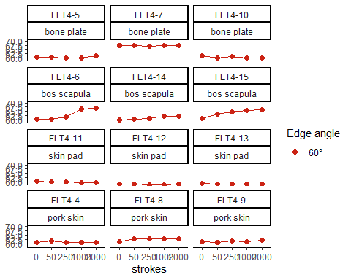

# combines the flint and the lydite plots   
p <- p_flint + p_lydite + plot_layout(guides = 'collect')   
   
print(p)

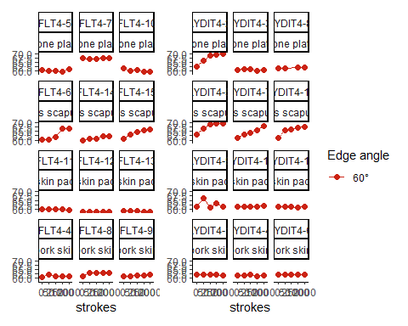

#save to PDF  
file_out <- paste0(file_path_sans_ext(info_in[["file"]]), "_aVSn_EA_plot", ".pdf")  
ggsave(filename = file_out, plot = p, path = dir_out, device = "pdf",   
 width = 370, height = 280, units = "mm")

## Tool function experiment

# selects only the data from the TFE experiment and the 'Three-point' method   
#TFE <- imp_data[7460:20629,1:14]  
TFE <- filter(imp_data, experiment == "tool_function-experiment_cutting" |   
 experiment == "tool_function-experiment_carving")  
TFE <- filter(TFE, Angle_number == "3" | Angle_number == "4" | Angle_number == "5" |  
 Angle_number == "6")  
TFE <- filter(TFE, sec == "SEC-02" | sec == "SEC-03" | sec == "SEC-04" | sec == "SEC-05" |  
 sec == "SEC-06" | sec == "SEC-07" | sec == "SEC-8")  
  
# adds a column that combines sample and location  
TFE_data <- unite(TFE, ID_cycle, c(ID, strokes), remove = FALSE)  
TFE_mean <- summaryBy(. ~ ID_cycle + ID + strokes + Contact.material +   
 Raw.material + Edge.angle + Task, data = TFE_data, FUN = mean)  
  
# computes the mean per sample   
TFE_final <- TFE_mean[c(0:49, 51:80, 83:122),]  
# removes the test sample LYDIT5-14 (carving)   
  
# gets new order   
TFE_final$strokes <- factor(TFE_final$strokes, levels=c("before", "50strokes", "250strokes",  
 "1000strokes", "2000strokes"))  
  
  
# plots   
# plots first the lydite samples  
p_lydite2 <- ggplot(data = TFE_final[grep("LYDIT", TFE_final[["ID_cycle"]]), ],   
 aes(x = strokes, y = Three_point.mean, colour = Edge.angle)) +   
 geom_point(size = 2) +  
 geom_line(aes(group = ID)) +  
 facet_wrap(ID ~ Contact.material+Task, nrow = 3)+  
 theme_classic()+  
 xlab("strokes") + ylab(NULL) +  
 labs(colour = "Edge angle") +  
 ylim(30, 110) +   
 scale_colour_manual(values = c("#046C9A", "#FAD510")) +  
 scale_x_discrete(breaks = c("before", "50strokes", "250strokes" ,  
 "1000strokes", "2000strokes"), labels =   
 c("0", "50", "250", "1000", "2000"))  
  
  
# plots the flint samples   
p_flint2 <- ggplot(data = TFE_final[grep("FLT", TFE_final[["ID_cycle"]]), ],   
 aes(x = strokes, y = Three_point.mean, colour = Edge.angle)) +   
 geom_point(size = 2) +  
 geom_line(aes(group = ID)) +  
 facet_wrap(ID ~ Contact.material+Task, nrow = 3)+  
 theme_classic()+  
 xlab("strokes") + ylab(NULL) +  
 labs(colour = "Edge angle") +  
 ylim(30, 110) +   
 #coord_cartesian(ylim = range_var) +  
 scale_colour_manual(values = c("#046C9A", "#FAD510")) +  
 scale_x_discrete(breaks = c("before", "50strokes", "250strokes" , "1000strokes",  
 "2000strokes"), labels = c("0", "50", "250", "1000",  
 "2000"))  
  
   
# combines the flint and the lydite plots   
p2 <- p_flint2 + p_lydite2 + plot_layout(guides = 'collect')   
   
print(p2)

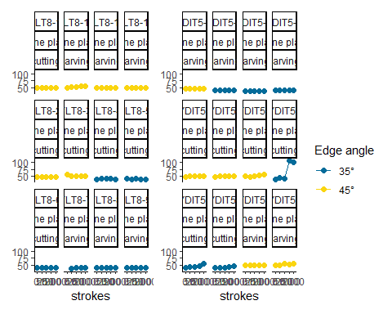

#save to PDF  
 file_out <- paste0(file_path_sans_ext(info_in[["file"]]), "_TFE_EA_plot", ".pdf")  
 ggsave(filename = file_out, plot = p2, path = dir_out, device = "pdf", width = 370,   
 height = 280, units = "mm")

## Initial experiment

# selects only the data from the initial experiment   
IE <- filter(imp_data, experiment == "initial_experiment")  
# filters the first two and the two last sections out   
IE <- filter(IE, Angle_number == "3" | Angle_number == "4" | Angle_number == "5" |  
 Angle_number == "6")  
IE <- filter(IE, sec == "SEC-02" | sec == "SEC-03" | sec == "SEC-04" | sec == "SEC-05" |   
 sec == "SEC-06" | sec == "SEC-07" | sec == "SEC-8")  
  
  
# adds a column that combines sample and location  
IE_data <- unite(IE, ID_cycle, c(ID, strokes), remove = FALSE)  
  
# computes the mean per sample   
IE_mean <- summaryBy(. ~ ID_cycle + ID + strokes + Contact.material +  
 Raw.material + Edge.angle + Task, data = IE_data, FUN = mean)  
  
# gets new order   
IE_mean$strokes <- factor(IE_mean$strokes, levels=c("before", "50strokes", "250strokes",  
 "1000strokes", "2000strokes"))  
  
  
# plots   
# plots the lydite and flint samples  
p3 <- ggplot(data = IE_mean, aes(x = strokes, y = Three_point.mean, colour = Edge.angle)) +   
 geom_point(size = 2) +  
 geom_line(aes(group = ID)) +  
 facet_wrap(ID ~ Contact.material+Task, ncol = 4)+  
 theme_classic()+  
 xlab("strokes") + ylab(NULL) +  
 labs(colour = "Edge angle") +  
 ylim(35, 130) +   
 scale_colour_manual(values = c("#354823", "#CB2314")) +  
 scale_x_discrete(breaks = c("before", "50strokes", "250strokes" , "1000strokes",  
 "2000strokes"), labels = c("0", "50", "250", "1000",  
 "2000"))  
  
  
print(p3)

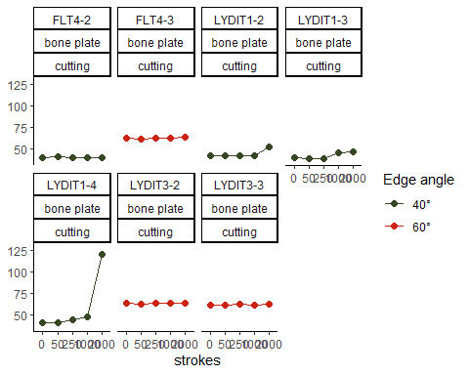

#save to PDF  
file_out <- paste0(file_path_sans_ext(info_in[["file"]]), "_IE_EA_plot", ".pdf")  
ggsave(filename = file_out, plot = p3, path = dir_out, device = "pdf",width = 250,   
 height = 170, units = "mm")

## Show files information

files_out <- c(paste0(dir_out, file_out, ".xlsx"), paste0(dir_out, file_out, ".Rbin"))  
md5_out <- md5sum(files_out)  
info_out <- data.frame(files = basename(names(md5_out)), checksum = md5_out,   
 row.names = NULL)

The checksum (MD5 hashes) of the exported files are:

files checksum  
1 plotsEdgeAngle_experiment_IE_EA_plot.pdf.xlsx <NA>  
2 plotsEdgeAngle_experiment_IE_EA_plot.pdf.Rbin <NA>

# sessionInfo() and RStudio version

sessionInfo()

R version 4.0.2 (2020-06-22)  
Platform: x86_64-w64-mingw32/x64 (64-bit)  
Running under: Windows 10 x64 (build 19041)  
  
Matrix products: default  
  
locale:  
[1] LC_COLLATE=German_Germany.1252 LC_CTYPE=German_Germany.1252   
[3] LC_MONETARY=German_Germany.1252 LC_NUMERIC=C   
[5] LC_TIME=German_Germany.1252   
  
attached base packages:  
[1] tools stats graphics grDevices utils datasets methods   
[8] base   
  
other attached packages:  
 [1] doBy_4.6.8 wesanderson_0.3.6 ggfortify_0.4.11 ggsci_2.9   
 [5] patchwork_1.1.1 forcats_0.5.1 stringr_1.4.0 dplyr_1.0.3   
 [9] purrr_0.3.4 readr_1.4.0 tidyr_1.1.2 tibble_3.0.6   
[13] tidyverse_1.3.0 ggplot2_3.3.3 R.utils_2.10.1 R.oo_1.24.0   
[17] R.methodsS3_1.8.1 readxl_1.3.1 openxlsx_4.2.3   
  
loaded via a namespace (and not attached):  
 [1] Rcpp_1.0.6 lattice_0.20-41 lubridate_1.7.9.2 assertthat_0.2.1   
 [5] digest_0.6.27 R6_2.5.0 cellranger_1.1.0 backports_1.2.1   
 [9] reprex_1.0.0 evaluate_0.14 highr_0.8 httr_1.4.2   
[13] pillar_1.4.7 rlang_0.4.10 rstudioapi_0.13 Matrix_1.2-18   
[17] rmarkdown_2.6 labeling_0.4.2 munsell_0.5.0 broom_0.7.4   
[21] compiler_4.0.2 Deriv_4.1.2 modelr_0.1.8 xfun_0.20   
[25] pkgconfig_2.0.3 htmltools_0.5.1.1 tidyselect_1.1.0 gridExtra_2.3   
[29] crayon_1.4.0 dbplyr_2.0.0 withr_2.4.1 MASS_7.3-51.6   
[33] grid_4.0.2 jsonlite_1.7.2 gtable_0.3.0 lifecycle_0.2.0   
[37] DBI_1.1.1 magrittr_2.0.1 scales_1.1.1 zip_2.1.1   
[41] cli_2.3.0 stringi_1.5.3 farver_2.0.3 fs_1.5.0   
[45] xml2_1.3.2 ellipsis_0.3.1 generics_0.1.0 vctrs_0.3.6   
[49] glue_1.4.2 hms_1.0.0 yaml_2.2.1 colorspace_2.0-0   
[53] rvest_0.3.6 knitr_1.31 haven_2.3.1

RStudio version 1.3.1073.

END OF SCRIPT