Plots - use-wear archaeology & experiments

Lisa Schunk

2021-01-28 14:10:21

# Goal of the script

This script plots all variables to see which ones should be used for further analysis.  
Scatterplots of each variable will be plotted.

dir_in <- "analysis/derived_data/"  
dir_out <- "analysis/plots"

Raw data must be located in ~/analysis/derived_data/.  
Formatted data will be saved in ~/analysis/plots. The knit directory for this script is the project directory.

# Load packages

library(R.utils)  
library(ggplot2)  
library(tools)  
library(tidyverse)  
library(patchwork)  
library(doBy)

Warning: package 'doBy' was built under R version 4.0.3

library(ggrepel)  
library(openxlsx)  
library(wesanderson)

Warning: package 'wesanderson' was built under R version 4.0.3

library(ggfortify)

Warning: package 'ggfortify' was built under R version 4.0.3

# Get name, path and information of the file

data_file <- list.files(dir_in, pattern = "\\.Rbin$", full.names = TRUE)  
md5_in <- md5sum(data_file)  
info_in <- data.frame(file = basename(names(md5_in)), checksum = md5_in, row.names = NULL)

The checksum (MD5 hashes) of the imported file is:

file checksum  
1 Use-wear_all.Rbin 88e7180102c60afd659b1de1aab8c3ce

# Load data into R object

imp_data <- loadObject(data_file)  
str(imp_data)

'data.frame': 234 obs. of 60 variables:  
 $ Sample : chr "FLT4-12" "FLT4-12" "FLT4-12" "FLT4-12" ...  
 $ Site : Factor w/ 5 levels "aVSn","TFE","Balve",..: 1 1 1 1 1 1 1 1 1 1 ...  
 $ Tool.type : Factor w/ 5 levels "Standard sample",..: 1 1 1 1 1 1 1 1 1 1 ...  
 $ Raw.material : Factor w/ 2 levels "flint","lydite": 1 1 1 1 1 1 1 1 1 1 ...  
 $ Location : chr "B" "B" "B" "B" ...  
 $ Sublocation : chr "1" "1" "1" "1" ...  
 $ Area : chr "01" "01" "01" "01" ...  
 $ Spot : chr "a" "b" "c" "a" ...  
 $ Usewear.type : chr "before" "before" "before" "2000" ...  
 $ Contact.material : chr "skin pad" "skin pad" "skin pad" "skin pad" ...  
 $ Task : chr "cutting" "cutting" "cutting" "cutting" ...  
 $ Edge.angle : chr "60°" "60°" "60°" "60°" ...  
 $ Objective : chr "50x095" "50x095" "50x095" "50x095" ...  
 $ Analysis.date : Date, format: "2020-08-17" "2020-08-17" ...  
 $ Analysis.time : 'times' num 0.617 0.618 0.618 0.619 0.619 ...  
 ..- attr(*, "format")= chr "h:m:s"  
 $ Acquisition.date.time : chr "7/20/2020 2:39:46 PM" "7/20/2020 2:55:08 PM" "7/20/2020 3:12:51 PM" "7/20/2020 3:29:51 PM" ...  
 $ Axis.length.X : num 255 255 255 255 255 ...  
 $ Axis.size.X : num 1198 1198 1198 1198 1198 ...  
 $ Axis.spacing.X : num 0.213 0.213 0.213 0.213 0.213 ...  
 $ Axis.length.Y : num 255 255 255 255 255 ...  
 $ Axis.size.Y : num 1198 1198 1198 1198 1198 ...  
 $ Axis.spacing.Y : num 0.213 0.213 0.213 0.213 0.213 ...  
 $ Axis.length.Z : num 27287 27231 26655 13395 13291 ...  
 $ Axis.size.Z : num 63694 65201 63762 65466 65538 ...  
 $ Axis.spacing.Z : num 0.428 0.418 0.418 0.205 0.203 ...  
 $ NM.points.ratio.Z : num 0 0 0 0 0 0 0 0 0 0 ...  
 $ Sq : num 160 151 196 227 160 ...  
 $ Ssk : num -0.0199 4.1704 2.0253 2.2084 2.0238 ...  
 $ Sku : num 6.21 37.01 10.42 11.22 9.9 ...  
 $ Sp : num 1153 1693 1606 1740 1174 ...  
 $ Sv : num 716 594 406 473 321 ...  
 $ Sz : num 1870 2286 2013 2212 1496 ...  
 $ Sa : num 115.8 84.7 138.7 154.4 111.9 ...  
 $ Smr : num 12.722 0.832 1.59 1.645 10.656 ...  
 $ Smc : num 177 111 232 250 184 ...  
 $ Sxp : num 362 192 211 245 175 ...  
 $ Sal : num 5.94 7.73 8.18 12.2 8.71 ...  
 $ Str : num 0.0746 0.669 0.226 0.6994 0.1989 ...  
 $ Std : num 170 133 50.5 101 81.5 ...  
 $ Sdq : num 0.1019 0.0833 0.1177 0.1378 0.1048 ...  
 $ Sdr : num 0.513 0.337 0.68 0.916 0.54 ...  
 $ Vm : num 0.0103 0.0176 0.0206 0.0263 0.0175 ...  
 $ Vv : num 0.187 0.128 0.252 0.276 0.202 ...  
 $ Vmp : num 0.0103 0.0176 0.0206 0.0263 0.0175 ...  
 $ Vmc : num 0.119 0.073 0.133 0.143 0.106 ...  
 $ Vvc : num 0.164 0.115 0.241 0.262 0.192 ...  
 $ Vvv : num 0.0233 0.0128 0.0112 0.0138 0.0092 ...  
 $ Maximum.depth.of.furrows: num 905 865 814 881 640 ...  
 $ Mean.depth.of.furrows : num 257 174 386 409 311 ...  
 $ Mean.density.of.furrows : num 3081 3318 3101 3225 3191 ...  
 $ First.direction : num 1.69e+02 1.35e+02 8.76e-03 9.00e+01 9.00e+01 ...  
 $ Second.direction : num 180 90 135 135 45 ...  
 $ Third.direction : num 135 45 117 116 135 ...  
 $ Isotropy : num 6.16 66.63 52.93 77.77 55.86 ...  
 $ epLsar : num 0.00356 0.00393 0.00189 0.00195 0.00041 ...  
 $ NewEplsar : num 0.0187 0.0188 0.0179 0.0179 0.0175 ...  
 $ Asfc : num 1.145 0.703 1.494 2.067 1.207 ...  
 $ Smfc : num 3.08 3.3 2.88 2.52 2.52 ...  
 $ HAsfc9 : num 0.201 0.636 0.191 0.512 0.239 ...  
 $ HAsfc81 : num 0.264 0.939 0.388 0.722 0.386 ...

The imported file is: “~/analysis/derived_data/Use-wear_all.Rbin”

# Prepare variables

## Define numeric variables

num.var <- 27:length(imp_data)

The following variables will be used:

[27] Sq  
[28] Ssk  
[29] Sku  
[30] Sp  
[31] Sv  
[32] Sz  
[33] Sa  
[34] Smr  
[35] Smc  
[36] Sxp  
[37] Sal  
[38] Str  
[39] Std  
[40] Sdq  
[41] Sdr  
[42] Vm  
[43] Vv  
[44] Vmp  
[45] Vmc  
[46] Vvc  
[47] Vvv  
[48] Maximum.depth.of.furrows  
[49] Mean.depth.of.furrows  
[50] Mean.density.of.furrows  
[51] First.direction  
[52] Second.direction  
[53] Third.direction  
[54] Isotropy  
[55] epLsar  
[56] NewEplsar  
[57] Asfc  
[58] Smfc  
[59] HAsfc9  
[60] HAsfc81

# Plot each of the selected numeric variables

## Boxplot of all the variables combined with the tool type (without outliers)

# excludes the outliers   
# adds the indices as row numbers   
imp_data <- imp_data %>% mutate(id = row_number())  
imp_data2 <- imp_data[-c(19, 20, 55, 59, 62, 70), ]  
  
  
arch <- filter(imp_data2, Site == "Balve" | Site == "Buhlen" | Site == "Ramioul")   
exp <- filter(imp_data2, Site == "aVSn" | Site == "TFE")  
  
# converts the data into factor   
arch[["Tool.type"]] <- factor(arch[["Tool.type"]])  
exp[["Tool.type"]] <- factor(exp[["Tool.type"]])  
  
# colours archaeological data  
custom.col2 <- data.frame(type = levels(arch$Tool.typ),   
 col = c( "#0B775E", "#E1BD6D", "#35274A" ,"#F2300F"))   
arch$col <- custom.col2[arch$Tool.typ %in% levels(arch[["Tool.type"]]), "col"]  
  
# colours experimental data   
# Darjeeling1 = c("#FF0000", "#00A08A", "#F2AD00", "#F98400", "#5BBCD6")  
custom.col6 <- data.frame(type = levels(exp$Tool.typ), col = "#F98400")   
exp$col <- custom.col6[exp$Tool.typ %in% levels(exp[["Tool.type"]]), "col"]  
  
# gets new order   
exp$Usewear.type <- factor(exp$Usewear.type, levels=c("before", "2000"))  
  
  
# plot tool type   
for (i in num.var){  
   
 # gets the min/max range of the data set  
range_var <- range(imp_data2[[i]])   
  
   
 p_arch <- ggplot(data = arch, aes_string(x = "Usewear.type", y = names(imp_data)[i],  
 fill = "Tool.type")) +  
 geom_boxplot(outlier.size = 0.7, lwd = 0.2) +  
 theme_classic() +  
 coord_cartesian(ylim = range_var) +   
 labs( x = "Use-wear type", title = " ") +  
 labs(y = gsub("\\.", " ", names(imp_data)[i])) +  
 labs(fill = "Tool type") +   
 scale_fill_manual(values = arch$col)  
   
   
 p_exp <- ggplot(data = exp, aes_string(x = "Usewear.type", y = names(imp_data)[i],  
 fill = "Tool.type")) +  
 geom_boxplot(outlier.size = 0.7, lwd = 0.2) +  
 theme_classic() +  
 coord_cartesian(ylim = range_var) +   
 labs( x = "Use-wear type", title = " ") +  
 labs(y = gsub("\\.", " ", names(imp_data)[i])) +  
 labs(fill = "Tool type") +   
 scale_fill_manual(values = exp$col)  
   
  
 # combines the plots   
 p <- p_arch + p_exp + plot_layout(width = c(4, 1), guides = 'collect')  
   
 print(p)  
   
 # saves the plots   
 file_out <- paste0(file_path_sans_ext(info_in[["file"]]), "_boxplot_arch.exp_",   
 names(imp_data)[i], ".pdf")  
 ggsave(filename = file_out, plot = p, path = dir_out, device = "pdf", width = 250, height = 170, units = "mm")  
   
}

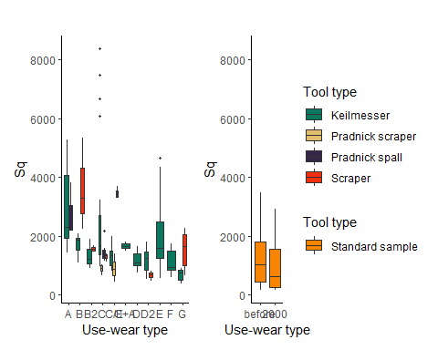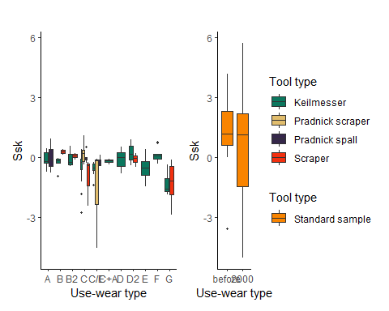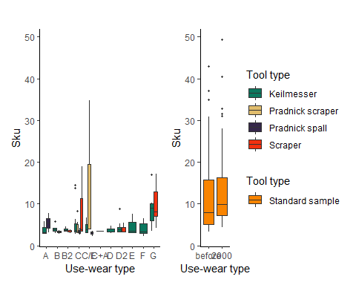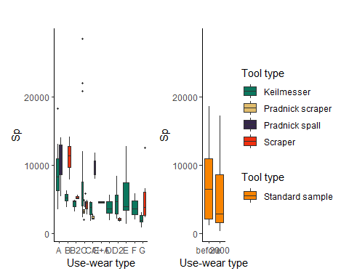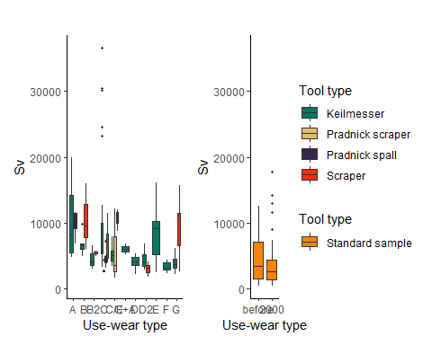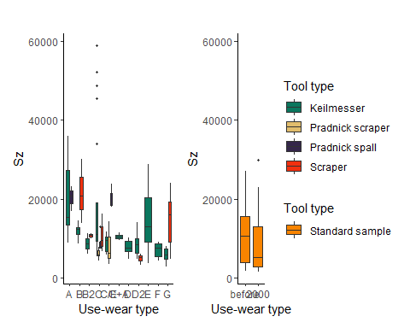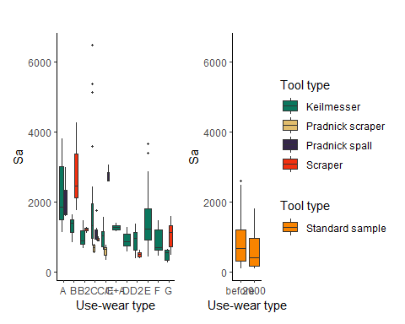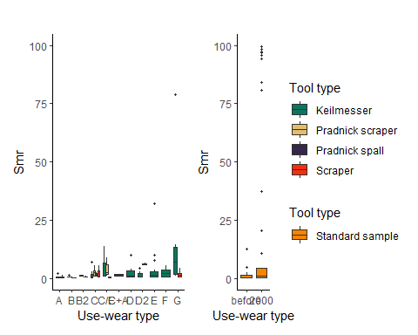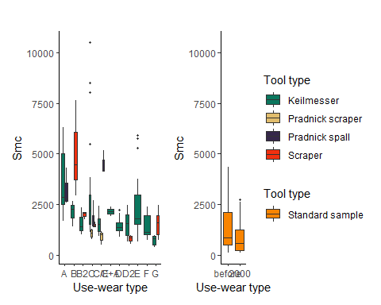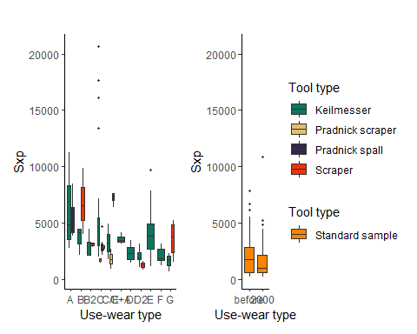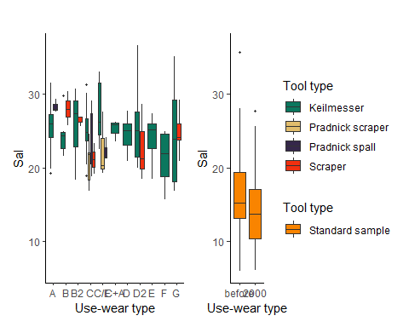

Warning: Removed 9 rows containing non-finite values (stat_boxplot).

Warning: Removed 8 rows containing non-finite values (stat_boxplot).

Warning: Removed 9 rows containing non-finite values (stat_boxplot).

Warning: Removed 8 rows containing non-finite values (stat_boxplot).

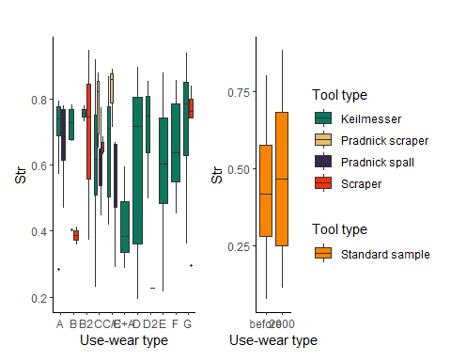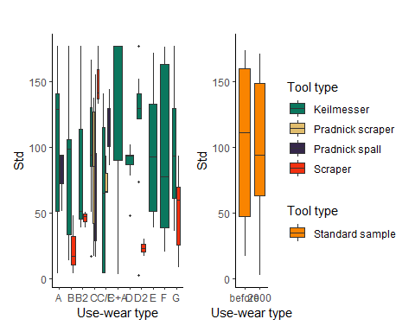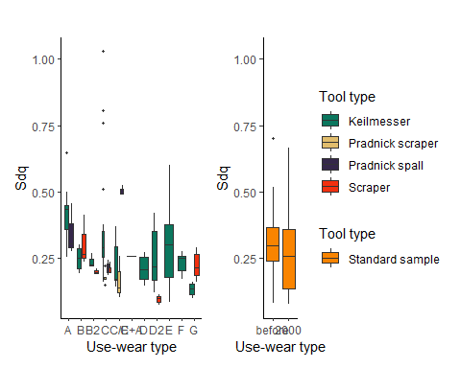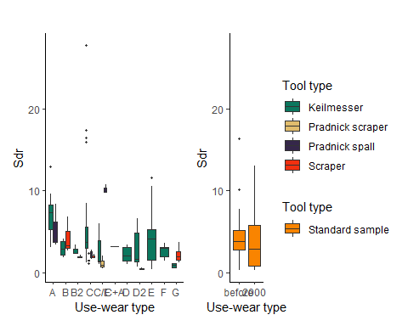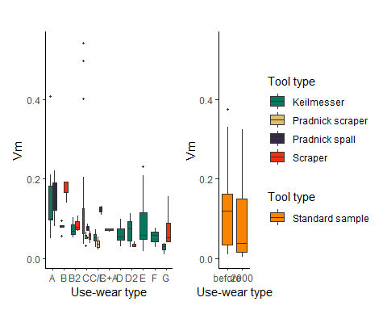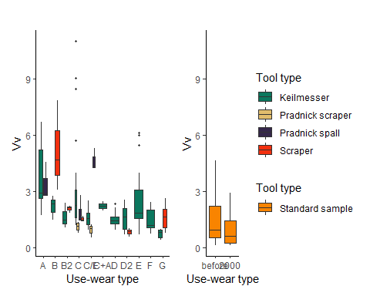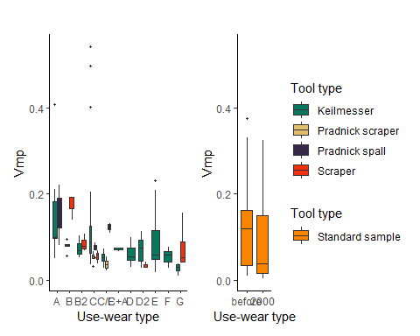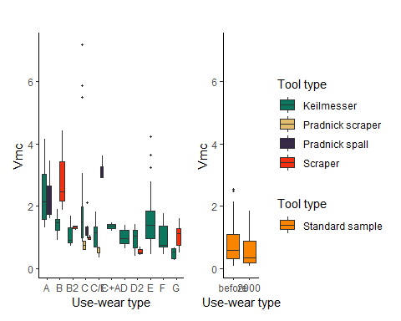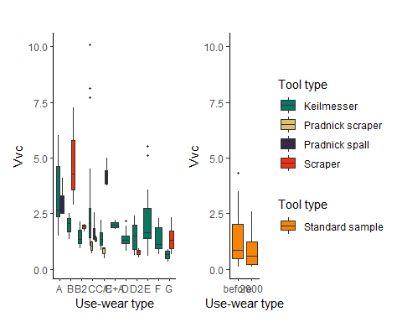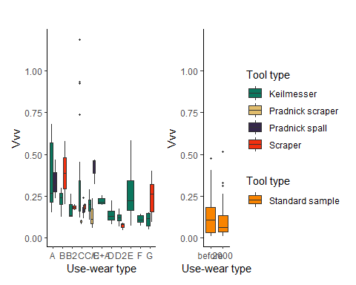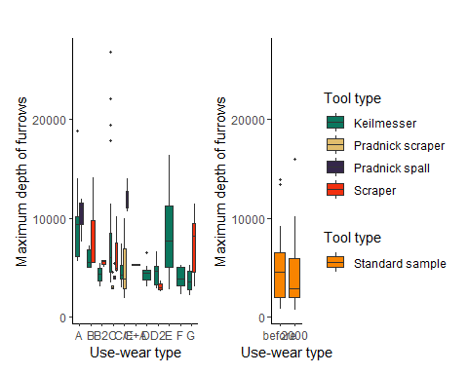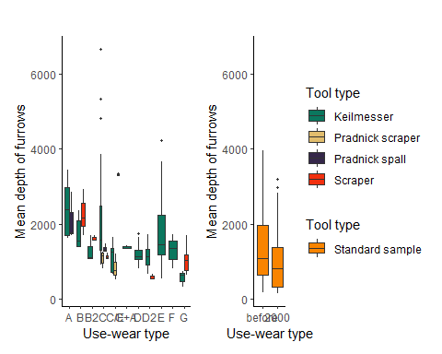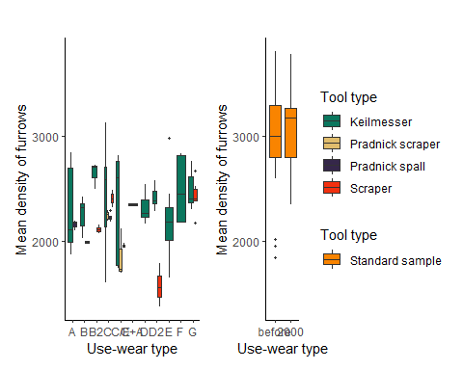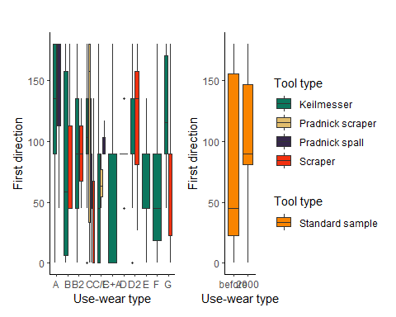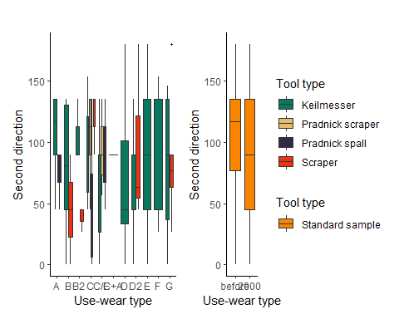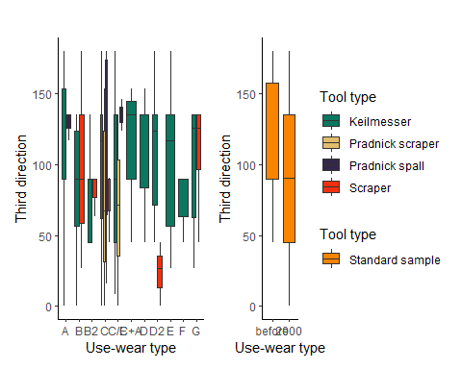

Warning: Removed 3 rows containing non-finite values (stat_boxplot).

Warning: Removed 3 rows containing non-finite values (stat_boxplot).

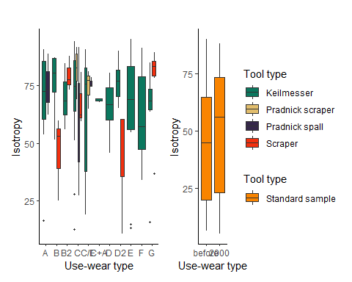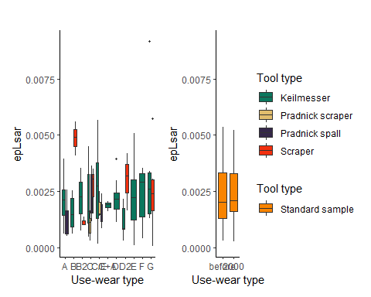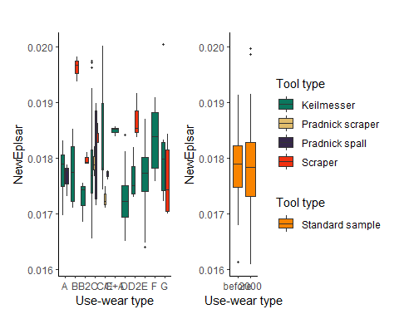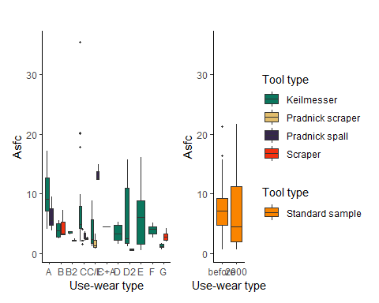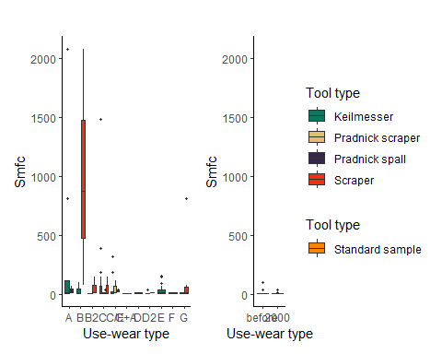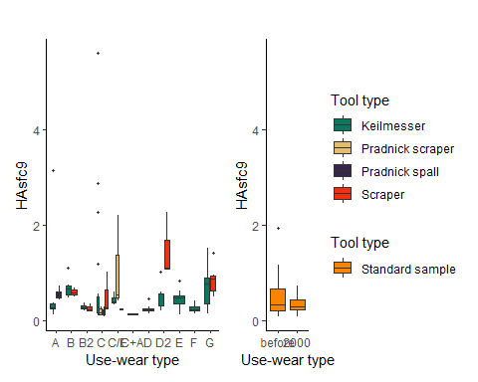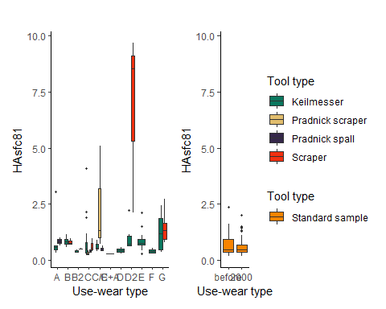

## Principal component analysis (without outliers)

# PCA use-wear types  
# removes rows with na values   
data_pca <- na.omit(imp_data2)  
# uses for the PCA only selected variables: Sq, SSK, Vmc, Isotropy, Mean density of furrows, Asfc, HAsfc9   
imp_data.pca <- prcomp(data_pca[, c(27:28, 45, 50, 54, 57, 59)], scale. = TRUE)   
# converts the data into factor   
data_pca[["Usewear.type"]] <- factor(data_pca[["Usewear.type"]])  
  
  
custom.col1 <- data.frame(type = levels(data_pca$Usewear.typ),   
 col = c("#FD6467", "#999999", "#52854c", "#c3d7a4", "#00A08A", "#487bb6", "#9a0f0f", "#fdbf6f",  
 "#d16103", "#ffdb6d", "#985633", "#134680", "#05100c"))   
data_pca$col <- custom.col1[data_pca$Usewear.typ, "col"]  
  
  
# Using ggfortify  
PCA<- autoplot(imp_data.pca, data = data_pca, colour = "Usewear.type", size = 2,  
 loadings = TRUE, loadings.colour = "black", loadings.label = TRUE, loadings.label.colour = "black",   
 loadings.label.size = 4, loadings.label.repel = TRUE,   
 frame = TRUE, frame.type = "convex", frame.colour = "Usewear.type", frame.alpha = 0) +   
 theme_classic() +  
 scale_colour_manual(values = custom.col$col)

Warning: `select_()` is deprecated as of dplyr 0.7.0.  
Please use `select()` instead.  
This warning is displayed once every 8 hours.  
Call `lifecycle::last_warnings()` to see where this warning was generated.

Warning: `group_by_()` is deprecated as of dplyr 0.7.0.  
Please use `group_by()` instead.  
See vignette('programming') for more help  
This warning is displayed once every 8 hours.  
Call `lifecycle::last_warnings()` to see where this warning was generated.

Error in is_missing(values): object 'custom.col' not found

print(PCA)

Error in print(PCA): object 'PCA' not found

# saves the plot  
file_out <- paste0(file_path_sans_ext(info_in[["file"]]), "_PCA_all.data", ".pdf")  
ggsave(filename = file_out, plot = PCA, path = dir_out, device = "pdf")

Error in grid.draw(plot): object 'PCA' not found

## (facet plot = 1 plot for flint, 1 plot for lydite)

# selects only the data from after 2000 strokes on the bone plate (experimental data)   
exp2000 <- filter(exp, Usewear.type == "2000" & Contact.material == "bone plate")  
  
for (i in num.var){  
 #plot  
 range_var <- range(exp2000[[i]]) # gets the min/max range of the data set   
   
 p <- ggplot(data = exp2000, aes_string(x="Task", y = names(exp2000)[i], colour="Edge.angle")) +   
 # avoids overplotting  
 scale_color_manual(values=c("#046C9A","#FAD510", "#CB2314")) +  
 geom_jitter(size = 3, position = position_jitter(width = 0.35, seed = 1)) +   
 coord_cartesian(ylim = range_var) +   
 theme_classic() +   
 # removes the "." between "Edge.angle" in the legend   
 labs(colour = gsub("\\.", " ", "Edge.angle")) +   
 # removes the "." between the variable names  
 labs(y = gsub("\\.", " ", names(exp2000)[i])) +   
 # combines the flint and the lydite plot into one   
 facet_wrap(~Raw.material)   
   
   
 print(p)  
  
  
 #save to PDF  
 file_out <- paste0(file_path_sans_ext(info_in[["file"]]), "_exp_2000_plot_",   
 names(imp_data)[i], ".pdf")  
 ggsave(filename = file_out, plot = p, path = dir_out, device = "pdf")  
}

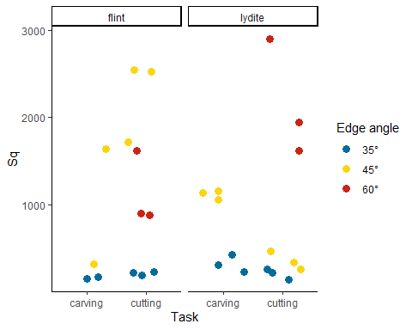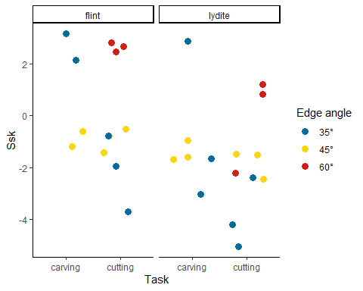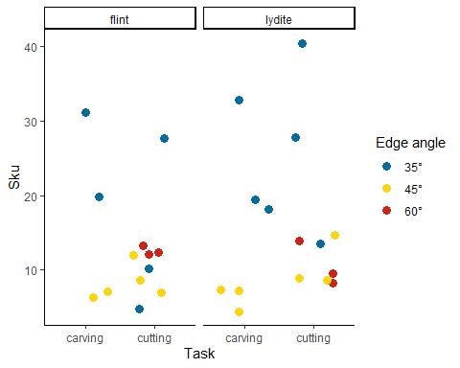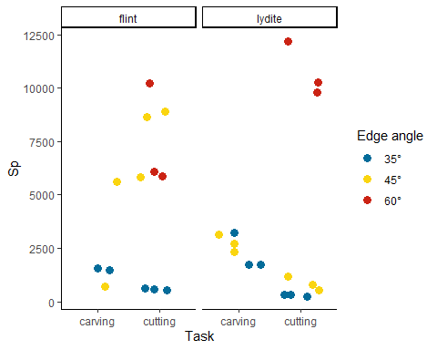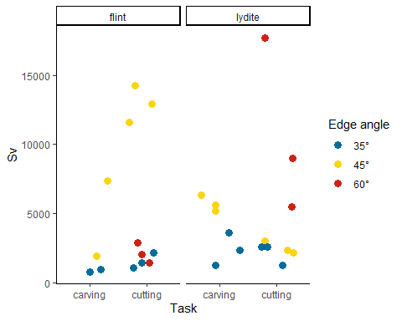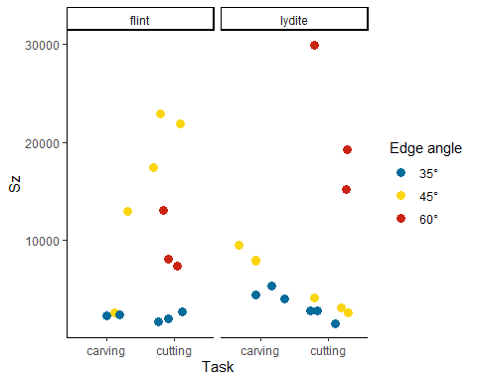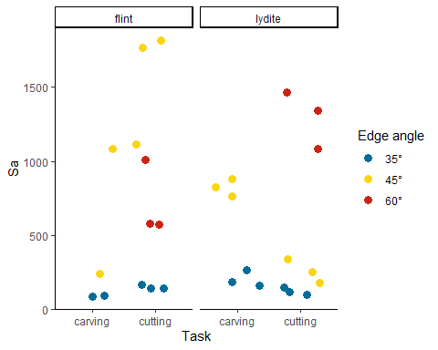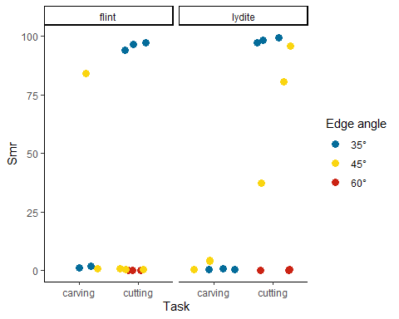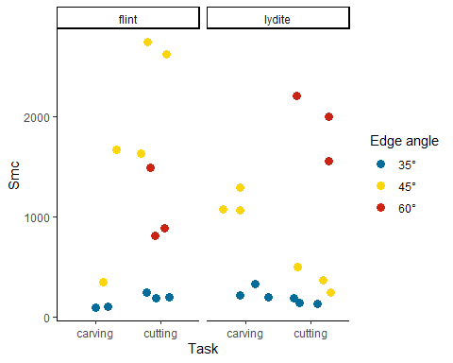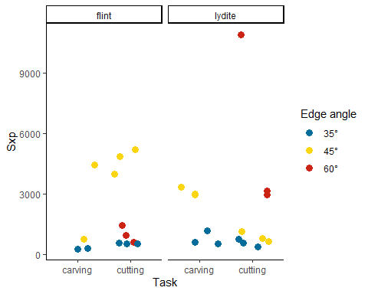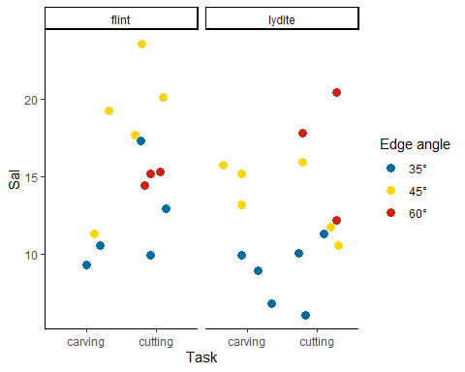

Warning: Removed 2 rows containing missing values (geom_point).  
  
Warning: Removed 2 rows containing missing values (geom_point).

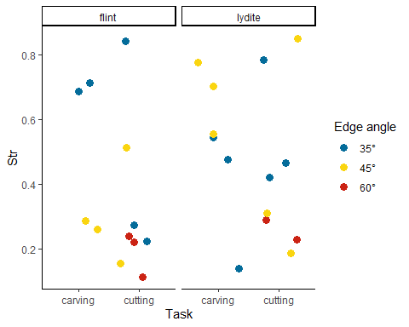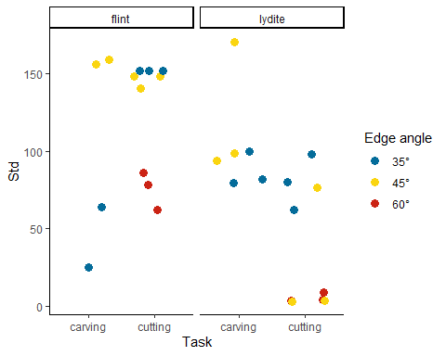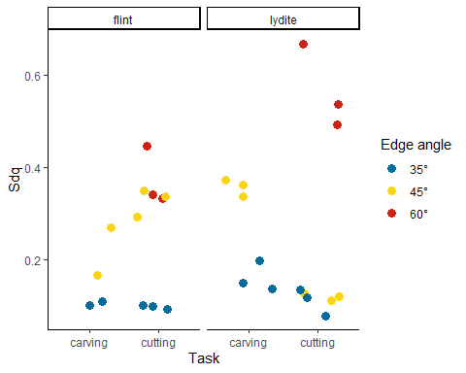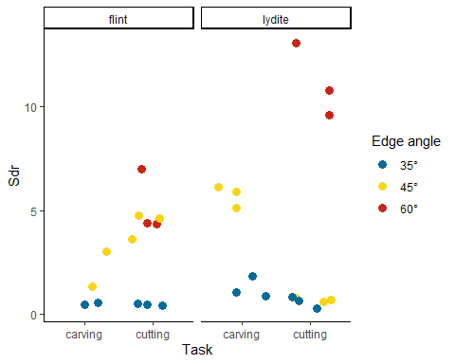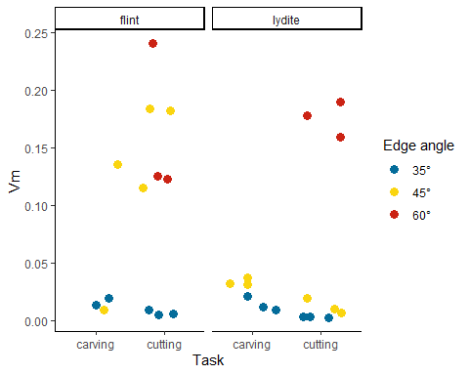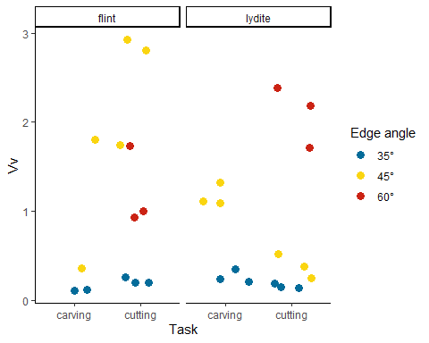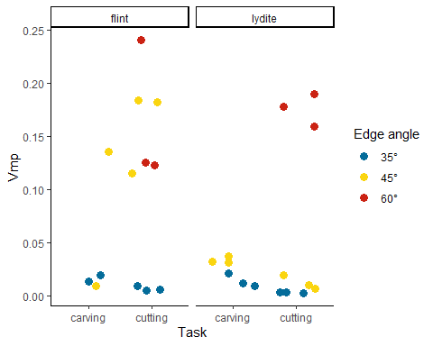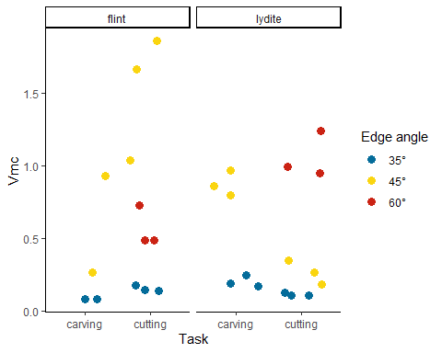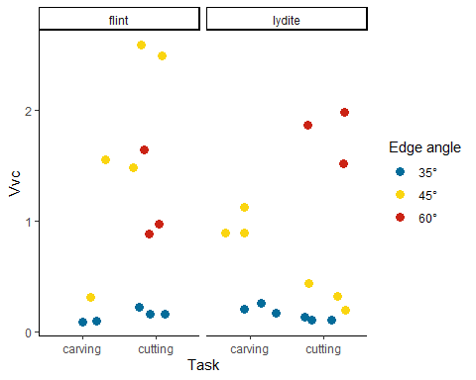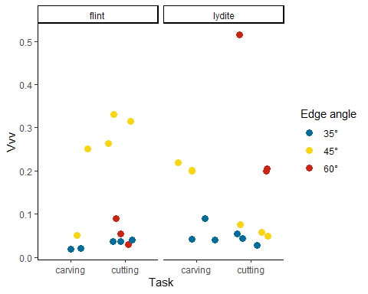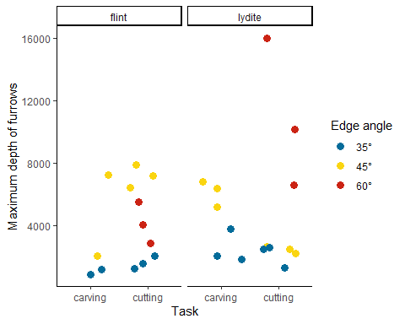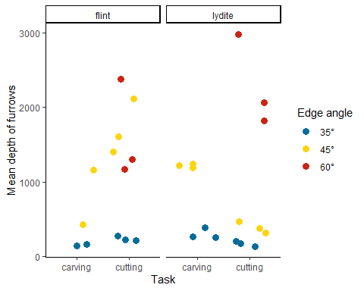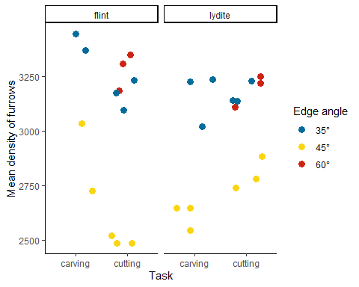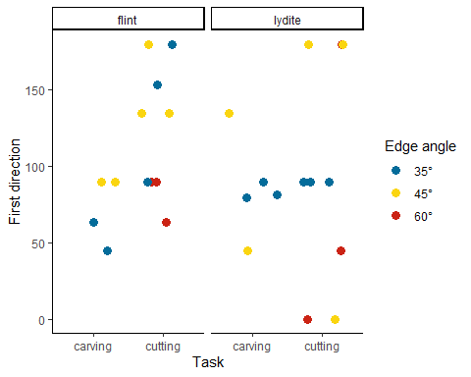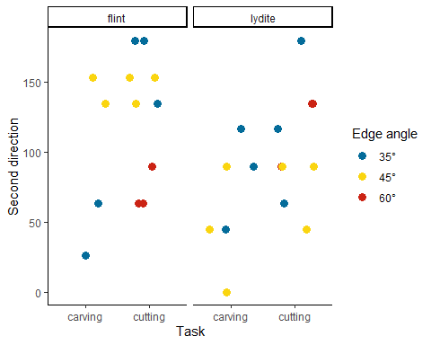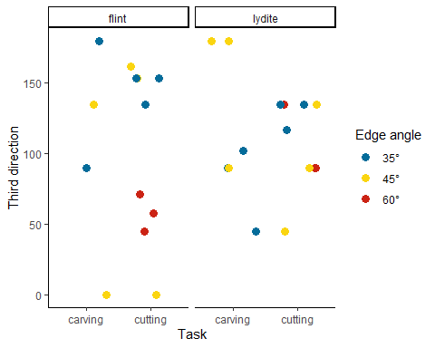

Warning: Removed 2 rows containing missing values (geom_point).  
  
Warning: Removed 2 rows containing missing values (geom_point).

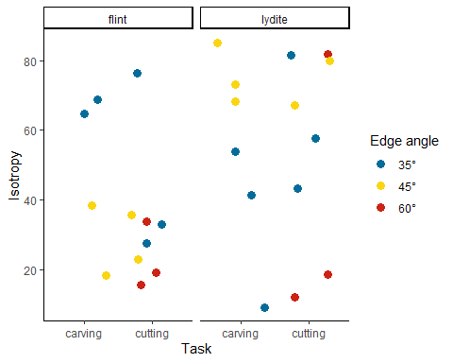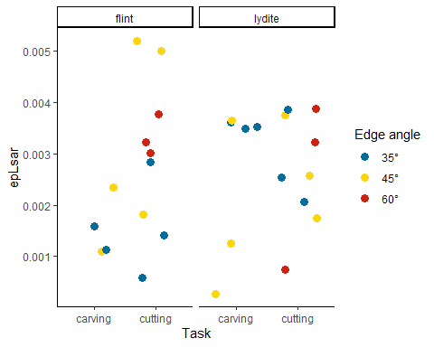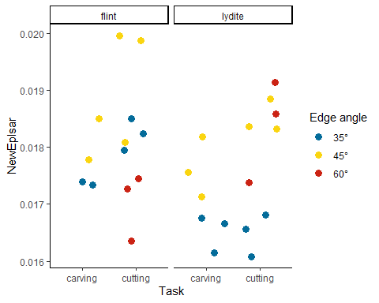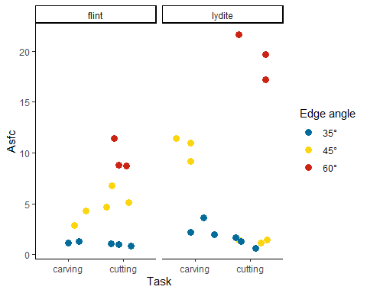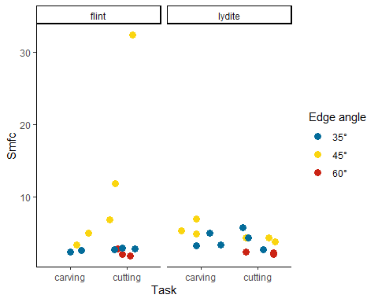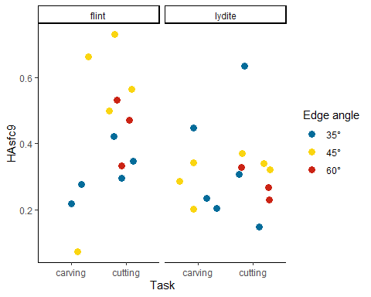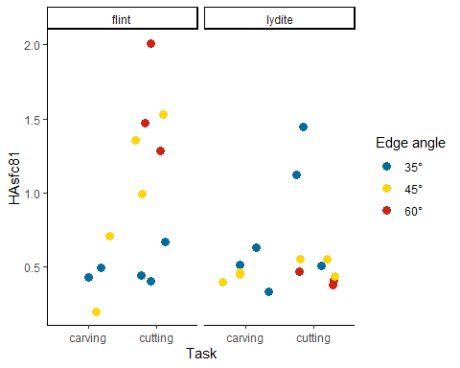

The files will be saved as “~/analysis/plots.[ext]”.

# Show plot files information

info_out <- list.files(path = dir_out, pattern = "\\.pdf$",   
 full.names = TRUE) %>%   
 md5sum()

The checksum (MD5 hashes) of the exported files are:

analysis/plots/Use-wear_all_boxplot_arch.exp_Asfc.pdf   
 "13b0754f6cc6c4107941efc86e19a619"   
 analysis/plots/Use-wear_all_boxplot_arch.exp_epLsar.pdf   
 "f3595db76923304997a13683e9b386a5"   
 analysis/plots/Use-wear_all_boxplot_arch.exp_First.direction.pdf   
 "8053167ddec3c59fa22111cfd8d020b6"   
 analysis/plots/Use-wear_all_boxplot_arch.exp_HAsfc81.pdf   
 "d62728acde392922a2d572acd284696b"   
 analysis/plots/Use-wear_all_boxplot_arch.exp_HAsfc9.pdf   
 "ab424350bf9ed15d0b894cbb22167045"   
 analysis/plots/Use-wear_all_boxplot_arch.exp_Isotropy.pdf   
 "226cb6025db9be6b99019d1e4a5f92f9"   
analysis/plots/Use-wear_all_boxplot_arch.exp_Maximum.depth.of.furrows.pdf   
 "85ad39c2d74d435c1f06622e9a2d817e"   
 analysis/plots/Use-wear_all_boxplot_arch.exp_Mean.density.of.furrows.pdf   
 "e832e5a1c65c477ff08541405b7d1721"   
 analysis/plots/Use-wear_all_boxplot_arch.exp_Mean.depth.of.furrows.pdf   
 "786efef9c4281a4ab19c876d531c560c"   
 analysis/plots/Use-wear_all_boxplot_arch.exp_NewEplsar.pdf   
 "e257afc4a335620882f407ce901e4a3f"   
 analysis/plots/Use-wear_all_boxplot_arch.exp_Sa.pdf   
 "5f88ab8355a5c6731752c92eb7571be8"   
 analysis/plots/Use-wear_all_boxplot_arch.exp_Sal.pdf   
 "f1770a657234ad00c8c9c315d5adf76b"   
 analysis/plots/Use-wear_all_boxplot_arch.exp_Sdq.pdf   
 "6c948234466adc306b4ffab8986e717c"   
 analysis/plots/Use-wear_all_boxplot_arch.exp_Sdr.pdf   
 "6aac73c810fb7c73c95cb3371467eeea"   
 analysis/plots/Use-wear_all_boxplot_arch.exp_Second.direction.pdf   
 "328839b10b7b2c7b053782e4386ed468"   
 analysis/plots/Use-wear_all_boxplot_arch.exp_Sku.pdf   
 "f8fcae1bdbe9948da3c420179189c9d9"   
 analysis/plots/Use-wear_all_boxplot_arch.exp_Smc.pdf   
 "f71ec8f74960c67e46c12042b95c8e6e"   
 analysis/plots/Use-wear_all_boxplot_arch.exp_Smfc.pdf   
 "37178fdd416951b0596eb36d29f3cae7"   
 analysis/plots/Use-wear_all_boxplot_arch.exp_Smr.pdf   
 "1dc470d66c1a7fdd7e0415086bb0e9b7"   
 analysis/plots/Use-wear_all_boxplot_arch.exp_Sp.pdf   
 "424d01f2a235f44f317806a0f1c88f40"   
 analysis/plots/Use-wear_all_boxplot_arch.exp_Sq.pdf   
 "47c34ee21ab1e1a432a843f2ab6c7fb7"   
 analysis/plots/Use-wear_all_boxplot_arch.exp_Ssk.pdf   
 "018df3150e788ddc92d193fc924d13e8"   
 analysis/plots/Use-wear_all_boxplot_arch.exp_Std.pdf   
 "944a0be63b40f1742c6418f49d7bd8ca"   
 analysis/plots/Use-wear_all_boxplot_arch.exp_Str.pdf   
 "5163b2cd6f0522d28e890f20581edf81"   
 analysis/plots/Use-wear_all_boxplot_arch.exp_Sv.pdf   
 "680d09dc7173297bd965e89e34d392b1"   
 analysis/plots/Use-wear_all_boxplot_arch.exp_Sxp.pdf   
 "425b818722871b7d3f846f50a3f8d972"   
 analysis/plots/Use-wear_all_boxplot_arch.exp_Sz.pdf   
 "d39b9fccbb09eaafc34313268ded42af"   
 analysis/plots/Use-wear_all_boxplot_arch.exp_Third.direction.pdf   
 "95846bb24336399712b8159d656a2ba3"   
 analysis/plots/Use-wear_all_boxplot_arch.exp_Vm.pdf   
 "b8cbadfc9d5e92ff3f858534c5980f40"   
 analysis/plots/Use-wear_all_boxplot_arch.exp_Vmc.pdf   
 "a4d40ef818cbfbcb168f58f07e590fd9"   
 analysis/plots/Use-wear_all_boxplot_arch.exp_Vmp.pdf   
 "cdfc7fcf8a7c2666b18aab4152635a3e"   
 analysis/plots/Use-wear_all_boxplot_arch.exp_Vv.pdf   
 "c5313406bc8fd062cef62a72e4c2504c"   
 analysis/plots/Use-wear_all_boxplot_arch.exp_Vvc.pdf   
 "00de190d686240d8946bcb5f9ed6a795"   
 analysis/plots/Use-wear_all_boxplot_arch.exp_Vvv.pdf   
 "09908b486ba645886ea9a99499a9108f"   
 analysis/plots/Use-wear_all_exp_2000_plot_Asfc.pdf   
 "8ffd979da5ad453aa0ae751ffe018b39"   
 analysis/plots/Use-wear_all_exp_2000_plot_epLsar.pdf   
 "ec2fb6fd2c38b7efdb56492e634cbea3"   
 analysis/plots/Use-wear_all_exp_2000_plot_First.direction.pdf   
 "4583ecbd24bbf082c79329e2d416f36a"   
 analysis/plots/Use-wear_all_exp_2000_plot_HAsfc81.pdf   
 "d9234dbdb482aa255a2231f43e1a8959"   
 analysis/plots/Use-wear_all_exp_2000_plot_HAsfc9.pdf   
 "4f65008abc72fc9305c3623c3eca82b0"   
 analysis/plots/Use-wear_all_exp_2000_plot_Isotropy.pdf   
 "58549c349009febcf5e8fb40364bd02e"   
 analysis/plots/Use-wear_all_exp_2000_plot_Maximum.depth.of.furrows.pdf   
 "3953194fe515ce3ada7f928b53d8a25e"   
 analysis/plots/Use-wear_all_exp_2000_plot_Mean.density.of.furrows.pdf   
 "f5cd0ce5e2edbedee62ea19bc81cdb5a"   
 analysis/plots/Use-wear_all_exp_2000_plot_Mean.depth.of.furrows.pdf   
 "3ce3f750651710ead38fa241c8780a99"   
 analysis/plots/Use-wear_all_exp_2000_plot_NewEplsar.pdf   
 "6acd8539d889c35b9524ee5303d357dc"   
 analysis/plots/Use-wear_all_exp_2000_plot_Sa.pdf   
 "907c3a7351a5c5329055c5b1f26740e3"   
 analysis/plots/Use-wear_all_exp_2000_plot_Sal.pdf   
 "07a532bf5ee6fbfd9f8d5c328c941745"   
 analysis/plots/Use-wear_all_exp_2000_plot_Sdq.pdf   
 "bfad035a8480386c6ca19c143bb337b5"   
 analysis/plots/Use-wear_all_exp_2000_plot_Sdr.pdf   
 "187625ef9d547a832785489f9dbb2e53"   
 analysis/plots/Use-wear_all_exp_2000_plot_Second.direction.pdf   
 "eb44a6fda69b8789e5c1db7195cf05a2"   
 analysis/plots/Use-wear_all_exp_2000_plot_Sku.pdf   
 "b51995c0bd5191b786cb706bce95d41c"   
 analysis/plots/Use-wear_all_exp_2000_plot_Smc.pdf   
 "0359191bbf4593486b696ba1884c5080"   
 analysis/plots/Use-wear_all_exp_2000_plot_Smfc.pdf   
 "08fc2600981007f02e51abe48d50c631"   
 analysis/plots/Use-wear_all_exp_2000_plot_Smr.pdf   
 "501be9711fbcff663d847c04306fb488"   
 analysis/plots/Use-wear_all_exp_2000_plot_Sp.pdf   
 "60eb0bb15957ad4599f7cd6916f20be0"   
 analysis/plots/Use-wear_all_exp_2000_plot_Sq.pdf   
 "60d0c20fa8f192e82a96436d171025d1"   
 analysis/plots/Use-wear_all_exp_2000_plot_Ssk.pdf   
 "12b53022b807dcd79041300c022ea06c"   
 analysis/plots/Use-wear_all_exp_2000_plot_Std.pdf   
 "758118fa5af8495c171009660f8f6dde"   
 analysis/plots/Use-wear_all_exp_2000_plot_Str.pdf   
 "0c0072c6431a03f6fe7501fcf3f71744"   
 analysis/plots/Use-wear_all_exp_2000_plot_Sv.pdf   
 "3337bba6588656d2eb4f01d42e9975bd"   
 analysis/plots/Use-wear_all_exp_2000_plot_Sxp.pdf   
 "2b25357ab881026e765511e65cc5c4f7"   
 analysis/plots/Use-wear_all_exp_2000_plot_Sz.pdf   
 "a94c2bd09ccb8a9c2d88cbfc1a797ec0"   
 analysis/plots/Use-wear_all_exp_2000_plot_Third.direction.pdf   
 "af2e3ca8d03defa8243b2ac68785bc84"   
 analysis/plots/Use-wear_all_exp_2000_plot_Vm.pdf   
 "784473144668d147fba83b0d939f3db7"   
 analysis/plots/Use-wear_all_exp_2000_plot_Vmc.pdf   
 "889bbaeab57dde5b43282e3970be4f9b"   
 analysis/plots/Use-wear_all_exp_2000_plot_Vmp.pdf   
 "cecf5e6853ef37c44e0ba89b2cbb7d53"   
 analysis/plots/Use-wear_all_exp_2000_plot_Vv.pdf   
 "d51aa10c68615e223f3e3e81e742cf9f"   
 analysis/plots/Use-wear_all_exp_2000_plot_Vvc.pdf   
 "50c03214501f9b61bc93b0c949e6d949"   
 analysis/plots/Use-wear_all_exp_2000_plot_Vvv.pdf   
 "e139b87f7dc28736a04c2f3b5cce0491"   
 analysis/plots/Use-wear_all_PCA_all.data.pdf   
 "6d1e5fa315133b09a2257d95603f6e55"

# sessionInfo() and RStudio version

sessionInfo()

R version 4.0.2 (2020-06-22)  
Platform: x86_64-w64-mingw32/x64 (64-bit)  
Running under: Windows 10 x64 (build 19041)  
  
Matrix products: default  
  
locale:  
[1] LC_COLLATE=German_Germany.1252 LC_CTYPE=German_Germany.1252   
[3] LC_MONETARY=German_Germany.1252 LC_NUMERIC=C   
[5] LC_TIME=German_Germany.1252   
  
attached base packages:  
[1] tools stats graphics grDevices utils datasets methods   
[8] base   
  
other attached packages:  
 [1] ggfortify_0.4.11 wesanderson_0.3.6 openxlsx_4.1.5 ggrepel_0.8.2   
 [5] doBy_4.6.7 patchwork_1.0.1 forcats_0.5.0 stringr_1.4.0   
 [9] dplyr_1.0.2 purrr_0.3.4 readr_1.3.1 tidyr_1.1.2   
[13] tibble_3.0.3 tidyverse_1.3.0 ggplot2_3.3.2 R.utils_2.10.1   
[17] R.oo_1.24.0 R.methodsS3_1.8.1  
  
loaded via a namespace (and not attached):  
 [1] Rcpp_1.0.5 lubridate_1.7.9 lattice_0.20-41 assertthat_0.2.1  
 [5] digest_0.6.25 R6_2.4.1 cellranger_1.1.0 backports_1.1.9   
 [9] reprex_0.3.0 evaluate_0.14 httr_1.4.2 pillar_1.4.6   
[13] rlang_0.4.7 readxl_1.3.1 rstudioapi_0.11 blob_1.2.1   
[17] Matrix_1.2-18 rmarkdown_2.3 labeling_0.3 munsell_0.5.0   
[21] broom_0.7.0 compiler_4.0.2 Deriv_4.0.1 modelr_0.1.8   
[25] xfun_0.16 pkgconfig_2.0.3 htmltools_0.5.0 tidyselect_1.1.0  
[29] gridExtra_2.3 fansi_0.4.1 crayon_1.3.4 dbplyr_1.4.4   
[33] withr_2.2.0 MASS_7.3-51.6 grid_4.0.2 jsonlite_1.7.1   
[37] gtable_0.3.0 lifecycle_0.2.0 DBI_1.1.0 magrittr_1.5   
[41] scales_1.1.1 zip_2.1.1 cli_2.0.2 stringi_1.5.3   
[45] farver_2.0.3 fs_1.5.0 xml2_1.3.2 ellipsis_0.3.1   
[49] generics_0.0.2 vctrs_0.3.4 glue_1.4.2 hms_0.5.3   
[53] yaml_2.2.1 colorspace_1.4-1 rvest_0.3.6 knitr_1.29   
[57] haven_2.3.1

RStudio version 1.3.1073.

END OF SCRIPT