Creation of arrays in numpy
Source code:
import numpy as ujwal
def create_arrays():
# Create a 1D array from a list
lis = [1, 23, 4, 5, 6, 7, 8]
ar = ujwal.array(lis)
print("Array from list:", ar)
# Create an array with 10 zeros
arr = ujwal.zeros(10)
print("Array of zeros:", arr)
# Create an array with 10 ones
ones_array = ujwal.ones(10)
print("Array of ones:", ones_array)
# Create a filled array of shape (4,) with the value 5
filled_array = ujwal.full((4), 5)
print("Filled array:", filled_array)
# Create a 2D array of zeros with shape (2, 3)
array_2d = ujwal.zeros((2, 3))
print("2D array of zeros:", array_2d)
# Create arrays using arange function
first = ujwal.arange(0, 5, 1)
print("First array with range:", first)
sec = ujwal.arange(1, 8, 2)
print("Second array with range:", sec)
Output:
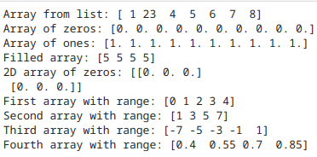
thi = ujwal.arange(-7, 2, 2)
print("Third array with range:", thi)
fou = ujwal.arange(0.4, 1, 0.15)
print("Fourth array with range:", fou)
if __name__ == "__main__":
create_arrays()

Generating Arrays with random values
Source code:
import numpy as ujwal
def random_arrays():
# Generate a random array of integers between 0 and 100 of size 10
random_array = ujwal.random.randint(0, 101, size=10)
print("Random array:", random_array)

# Sort the random array
sorted_array = ujwal.sort(random_array)
print("Sorted random array:", sorted_array)

# Generate another random array using linspace
linspace_array = ujwal.linspace(1, 10, 7)
print("Linspace array:", linspace_array)

# Generate a 3D random array
random_3d_array = ujwal.random.rand(2, 2, 2)
print("3D random array:", random_3d_array)

if __name__ == "__main__":
random_arrays()
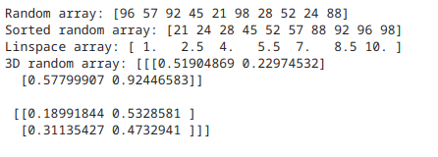
Output:

Properties of the array
Source code:

import numpy as ujwal
def array_properties():
# Generate a random 3D array for property checks
array_example = ujwal.random.rand(2, 2, 2)

# Print array properties
print("Number of dimensions:", array_example.ndim)
print("Size of the array:", array_example.size)
print("Data type of the array:", array_example.dtype)
print("Shape of the array:", array_example.shape)
print("Size of each item:", array_example.itemsize)

# Transpose the array and print
transposed_array = array_example.transpose()
print("Transposed array:", transposed_array)

if __name__ == "__main__":
array_properties()
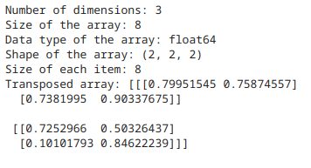
Output:

Manipulating arrays, indexing and slicing
Source code:
import numpy as ujwal
def array_manipulation():
# Create a 1D array
first = ujwal.arange(0, 5, 1)
# Iterate over the array using nditer
print("Iterating over array using nditer:")
for x in ujwal.nditer(first):
print(x)
# Create a random array and sort it
random_array = ujwal.random.randint(0, 101, size=10)
print("Random array:", random_array)
sorted_array = ujwal.sort(random_array)
print("Sorted random array:", sorted_array)
# Original word lists for lexical sorting
word = ["elderberry", "apple", "banana", "cherry", "date"]
word2 = ["honeydew", "fig", "grape", "kiwi", "lemon"]
# Convert lists to NumPy arrays
word_array = ujwal.array(word)
word2_array = ujwal.array(word2)
# Lexically sort the arrays using lexsort
sorted_indices_word = ujwal.lexsort([word_array])
sorted_indices_word2 = ujwal.lexsort([word2_array])
sorted_word = word_array[sorted_indices_word]
sorted_word2 = word2_array[sorted_indices_word2]
print("Sorted word array:", sorted_word)
print("Sorted word2 array:", sorted_word2)
# Generate a random array for median calculation
random_for_median = ujwal.random.randint(0, 101, size=10)
median_value = ujwal.median(random_for_median)
print("Median of random array:", median_value)
# Create a random 3x3 array for demonstration
ranarr = ujwal.random.randint(1, 100, size=(3, 3))
print("Random 3x3 array:", ranarr)
if __name__ == "__main__":
array_manipulation()
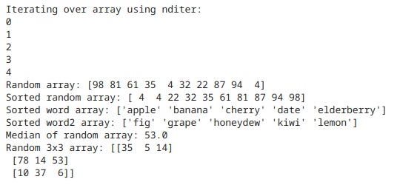
Output:

Element wise addition in numpy
Source code:
import numpy as ujwal

def elementwise_operations():
# Create two 1D arrays for element-wise addition
array1 = ujwal.array([1, 2, 3])
array2 = ujwal.array([[1], [2], [3]])

# Element-wise addition
summed = array1 + array2

# Print the result
print("Summed array:")
for x in summed:
print(x)

if __name__ == "__main__":
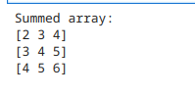
elementwise_operations()
Output:

Array broadcasting
Source code:
Output:
import numpy as ujwal
def elementwise_operations():
# Create two 1D arrays for element-wise addition
array1 = ujwal.array([1, 2, 3])
array2 = ujwal.array([[1], [2], [3]]) # 2D array with shape (3, 1)

# Element-wise addition
summed = array1 + array2

# Print the result of element-wise addition
print("Summed array (element-wise addition):")
for x in summed:
print(x)

# Example of array broadcasting
scalar_value = 10
broadcasted_result = array1 + scalar_value # Adding a scalar to the 1D array

# Print the result of broadcasting
print("Result of broadcasting (adding scalar to array):", broadcasted_result)
if __name__ == "__main__":
elementwise_operations()
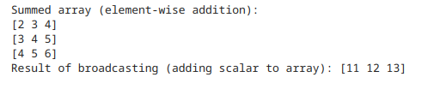

Creating a series in pandas
Source Code:
import numpy as np
import pandas as pd
np.random.seed(42)
this=np.random.randint(0, 101, size=10)
print(f"Numpy array is {this}")
that=pd.Series(this)
print(that)

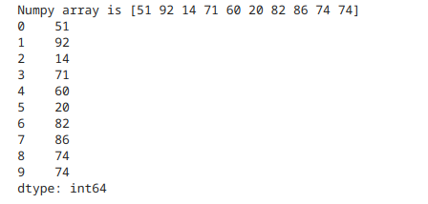
Output:

series using a list
Source Code:
import pandas as pd
ls=["Apple","Tesla","Persimmon","Adidas"]
l=pd.Series(ls)
print(l)
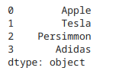
Output:

Slicing and Indexing series

Accessing data using built in index
Source Code:
import pandas as pd
ls=["Apple","Tesla","Persimmon","Adidas"]
x = pd.Series(ls, index = ["A", "B", "C","D"])
print(x.iloc[0:3])
Output:

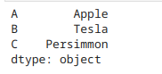

Accessing data using custom index
Source Code:
import pandas as pd
ls=["Apple","Tesla","Persimmon","Adidas"]
x = pd.Series(ls, index = ["A", "B", "C","D"])
print(x.loc["A"])
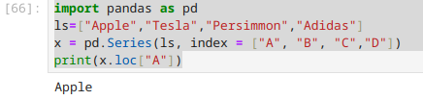
Output:

Dataframes

Creating dataframes
Source Code:
import pandas as ujwal
dat=[['Dikesh',12],['Ronish',31],['Ujwal',40]]
df=ujwal.DataFrame(dat,columns=['Name','Roll'])
df

Output:
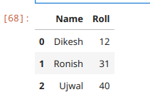

Creating Dataframes from excel files
Source Code:
import pandas as ujwal
fil="/home/nullproj/Documents/BIM-5th-semester/python/practice/pandas/FSI.xlsx"
df=ujwal.read_excel(fil)
df
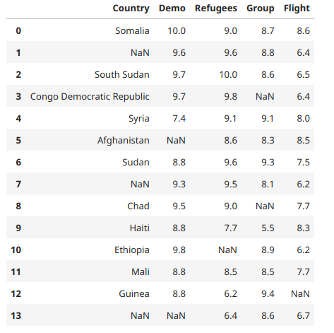
Output:

Creating Dataframes from CSV file
Source code:
import pandas as ujwal
name="/home/nullproj/Documents/BIM-5th-semester/python/practice/pandas/output.csv"
df=ujwal.read_csv(name,on_bad_lines="skip")
df
Output:
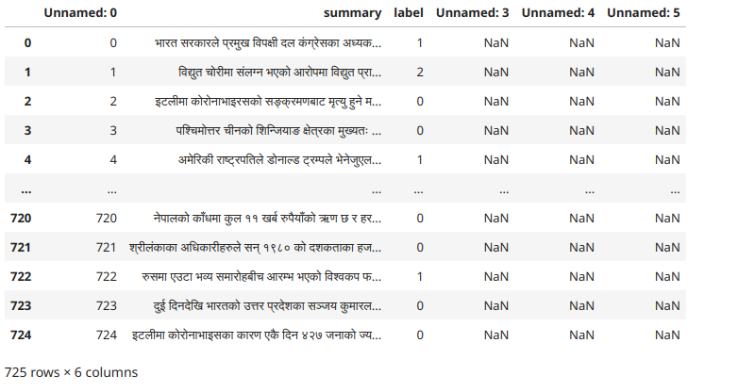

Dataframe Properties
df.head(): Display top 5 lines of the dataframe
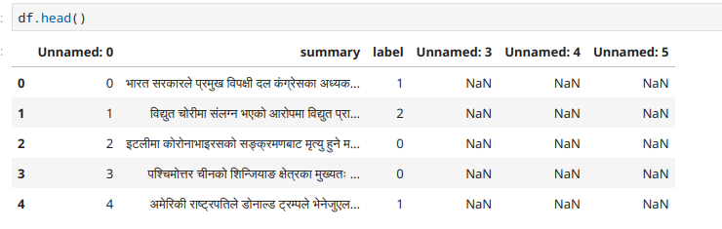
Output:
df.tail(): Display last 5 lines of the dataframe
df.shape(): Display the shape of the dataframe
df.index(): Display the index range of the dataframe
df.columns(): Display the columns of the dataframe
df.dtypes(): Display the data types of the dataframe
df.values(): Display the values of the dataframe
Output:
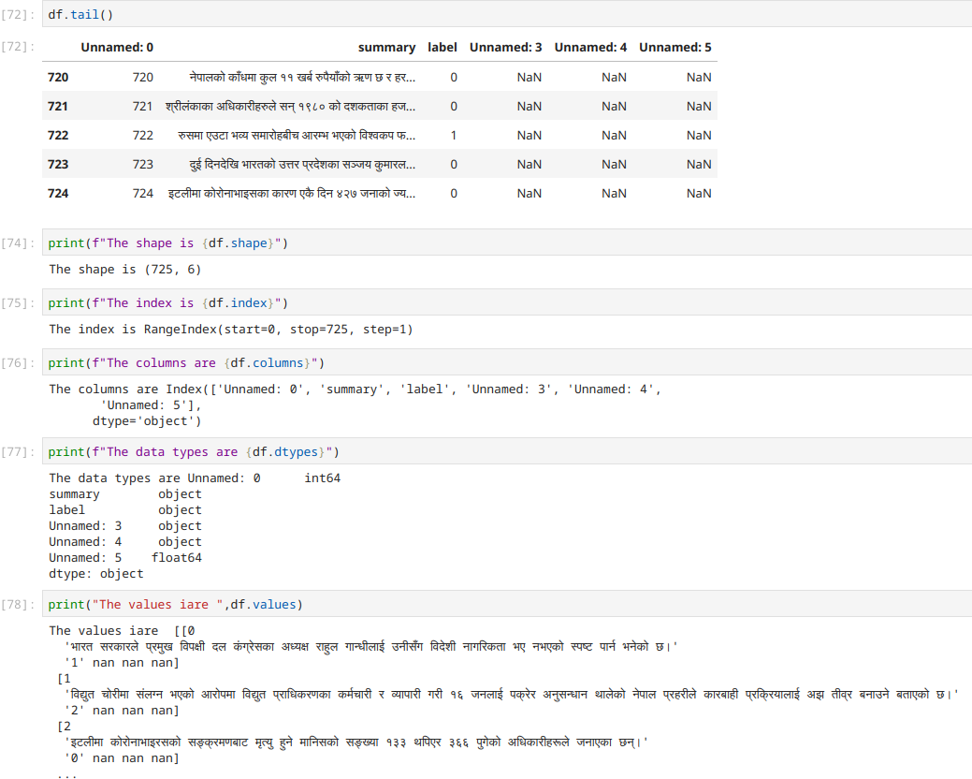
df.size(): Display the size of the dataframe
df.ndim(): Display the dimensions of the dataframe
df.empty(): check if the dataframe is empty
df.T(): Display the Transpose of the dataframe
Output:

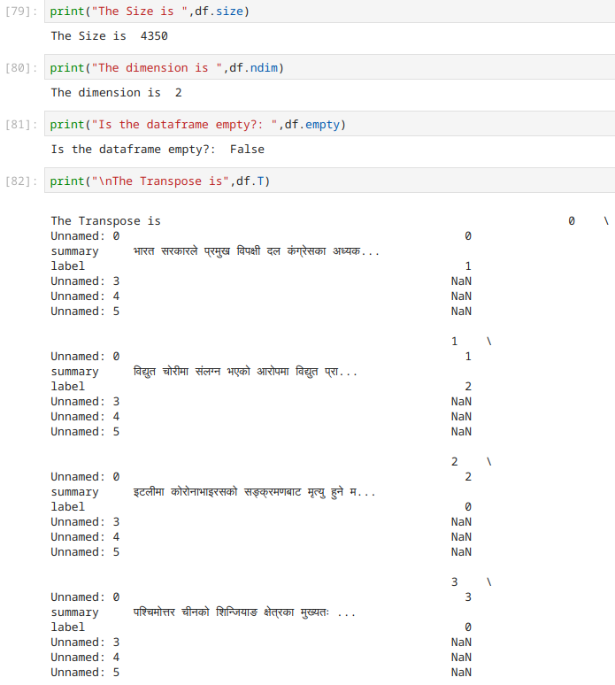
Full result of transpose is not possible to include because it’s too long

Checking Null values in a dataframe
Source Code:
import pandas as ujwal
filename="/home/nullproj/Documents/BIM-5th-semester/python/practice/pandas/FSINULL.xlsx"
fd=ujwal.read_excel(filename)
print(df.isnull())
Output:
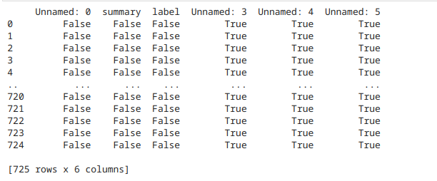
Continuing on the same file
Source code:
#to list the number of null values
totalnull=df.isnull().sum()
print("Total number of null values",totalnull)
Output:

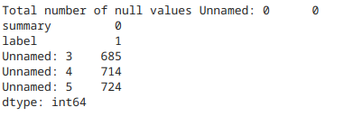

removing null values from a dataframe
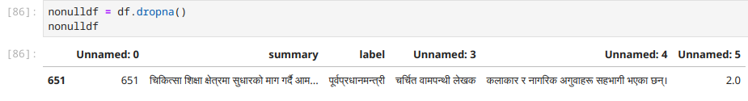

Filling the null values in the dataframe with mean of each
Source Code:
import pandas as pd
filename = "/home/nullproj/Documents/BIM-5th-semester/python/practice/pandas/FSINULL.xlsx"
df = pd.read_excel(filename)
print(df[df.isna().any(axis =1)])
#Filling the missing values with the mean valuesdf
df['Demo'].fillna(df['Demo'].mean(), inplace = True)
df['Refugees'].fillna(df['Refugees'].mean(), inplace = True)
df['Group'].fillna(df['Group'].mean(), inplace = True)
df['Flight'].fillna(df['Flight'].mean(), inplace = True)
df['Country'].fillna('No_Country', inplace = True)
df
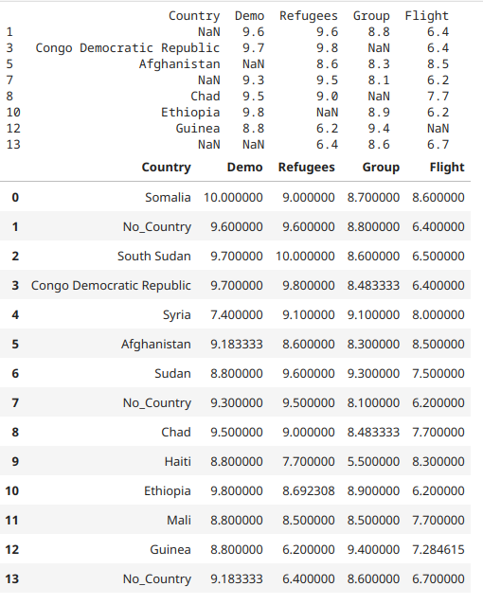
Output:
Continuing on the same file

displaying specific column
Source Code:
col1 = df['Country']
print(col1)
col2 = df[['Group','Flight']]
print(col2)
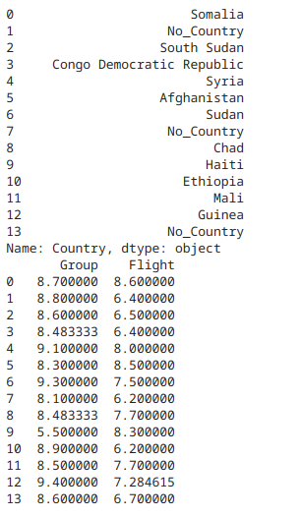
Output:

