# PIXEL SENSORS

A pixel sensor is an imaging sensor and was in early days limited to light applications. In later years pixel sensors have been developed to also detect energetic particles.

The smallest sensing unit of a pixel sensor is a pixel. A matrix of pixels forms a larger sensing area and together with the proper stimulus (light or ionizing particles) they generate an image. Image granularity (spatial resolution) is determined by the pixels size; a large pixel gives low granularity, few pixels fit in a matrix, and a small pixel gives high granularity, many pixels fit in a matrix. The sensitive mechanism of a pixel is a configuration of semiconductors which generate a pulse signal as a consequence of ionizing radiation traversing its sensing volume.

There are two types of pixel sensors, active and passive. The main difference between an Active Pixel Sensor (APS) and a Passive Pixel Sensor (PPS) is that the former incorporates one or more amplifying transistor (MOSFET transistors) while the latter does not. Pixels of PPS are read out without amplification. Transistors in an APS convert generated charge to voltage, amplify the voltage signal and remove noise. These characteristics make APS superior to PPS which has high noise and slow readout rates in comparison.

# MAPS

In the early 1990s, APS based on CMOS technology was proposed and at the end of the decade so was their application in particle physics [R.Turchetta ]. CMOS based APS implement a monolithic pixel architecture (Fig.??b). Monolithic designs include in-pixel circuitry and provide a compact sensor-electronics configuration. In contrast, **hybrid** **architecture** (Fig.?? a) comprise individually manufactured pixel and readout electronics coupled by the means of bump bonding. Monolithic APS (MAPS) architecture allows for pixel integrated circuitry, which avoids complexities brought by bump bonding and waste of pixel area due to extra material.

**Sensor Architecture**

CMOS 0.18 um technology -> deep pwell

**Detection Principles**

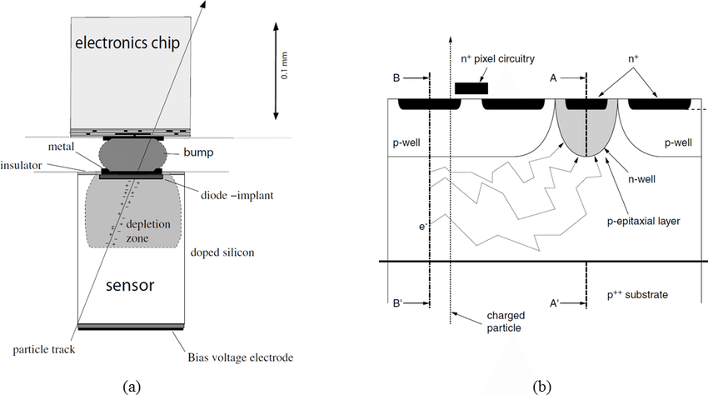

Small pixels, more functionality

MAPS also show significantly lower power consumption of , … (4mW/cm” ish) SOURCE??

while hybrids :few hundred mW/cm2[L.Maczewski].

?? Other great interests of MAPS are its low power consumption and low cost …

**Sources**

[L.Maczewski] MAPS (used by Viljar): https://arxiv.org/pdf/1005.3710.pdf

Sedra, A., & Smith, K. (n.d.). Microelectronic circuits (4th ed., The Oxford series in electrical engineering). New York: Oxford University Press.