
A 3D Interactive Animated Game with Tanks
Final Project Report

By:
Loren Segal  Kiran Ramaswamy  Nadim Haddad  Yifei Yan | 5442680  5168082  5929213  5086922

Concordia University
COMP 471 - Fall 2007
Table of Contents
1. Introduction 3
2. World Drawing and Quake 3 Map Files 4
2.1 Motivation 4
2.2 Map File Format 5
2.3 BSP Culling and Drawing Optimizations 5
2.4 Drawing Polygon Faces 6
2.5 Lighting 6
2.5.1 Ambient Lighting 6
2.5.2 World Lighting 6
2.5.3 Tank Lighting 6
3. Physics Engine 8
3.1 Completeness of Engine 8
3.2 Tank / World Collision 8
3.3 Tank / Tank Collision 9
4. Special Effects 10
4.1 Moving Sky 10
4.2 Motion Blur 10
4.3 Camera Effects 10
5. User Manual 11
5.1 Installation procedure 11
5.2 Game Logic and Rules 11
5.3 Player controls: 12
5.4 Special Controls 13
5.5 End of the game 13
5.6 Configuration File 14
5.6.1 map <mapname> [default: tankracer] 14
5.6.2 gravity <decimal> [default: 0.05] 14
5.6.3 maxplayers <integer> [default: 2] 14
5.6.4 maxlaps <integer> [default: 3] 14
5.6.5 timelimit <integer> [default: 240] 14
5.6.6 <playerNum> tank <integer> [default: 0] 14
5.6.7 <playerNum> <key> <left | right | forward | back> 14
6. References 15
7. Licensing Notes 15

Introduction
The goal of this project was to implement a game that involves the tanks created in previous assignments in the course. The game chosen was a racing game for two players, using tanks as the vehicles. The game idea was inspired mainly by the Super Nintendo™ racing title “Super Mario Kart”. In this, the goal was to create a 3D environment that had a very cartoon-like feel, rather than a completely realistic one. In addition to this, the team wanted to stay away from the unoriginal idea of a standard tank battle game and create something with more original value. Major points of concern in the design of the game were the physics and collision engine, which rely heavily on 3D vector math, and speed optimizations, which relied in the end on the use of BSP culling to optimize the rendering phase.

World Drawing and Quake 3 Map Files
The world refers to the 3D virtual environment that the tanks and players are put inside during the game. This section will explain the basic motivation behind the design choice of using Quake 3 map files to read pre-compiled environment information.

Motivation
The game requires the underlying engine to render the environment at least twice in each frame because it is two player game. Because the race track maps used could be rather complex and contain many polygons, the entire game design hinged on finding an efficient way to draw the environment around the tanks. In addition to the performance issue, the team needed to come up with a way to easily create and edit a potentially complex game environment. Objects like tunnels, mountains, trees and curved roads would be too time consuming to implement by hand, programmatically. Because of these reasons, a file format had to be chosen that could be modelled using a GUI toolkit and also help the engine find out which polygons needed to be drawn. File formats like those for 3D modelling tools like Lightwave or 3D Studio Max were briefly considered, but ignored because they were proprietary formats and not suitable for the project. The “.OBJ” format described briefly in course notes was also considered, but was too simplistic, did not provide any texture mapping information and had no known UI toolkits to create such files. Instead, the team looked to how the professionals do it, including such people as John Carmack of Id Software, a well known name in the gaming and 3D industry. Carmack, who pioneered the use of BSP trees to precompile environment information into maps with the game Doom, had set an industry standard with the “.bsp” file format. This file format is used in exceedingly many of the “First Person Shooter” games out today, including Half-Life, Unreal Tournament, and others.
This step led us to the choice of using the Quake 3 map file format, a derivative of the original “.bsp” file format used in many commercial games. Quake 3’s format was specifically chosen because it was the last game that Id Software had released to the public under LGPL, making it a non-proprietary solution. This file format also had plenty of GUI editors created for it, including the open source GtkRadient editor, which was used to create our tank racing map.

Map File Format
The “.bsp” file format [1] contains more information than was ultimately used. The “.bsp” files are compiled from “.map” source files which are edited in a map editor. The compilation step occurs in three steps: basic face compilation (or bsp step), BSP tree generation (or visibility step) and lightmap compilation (or light step). First all vertices are transformed into a list of faces which each contain a texture reference and UV mapping coordinates for the face. During the visibility step, the faces are divided so that a BSP tree can be generated into a set of leaves and clusters. Each cluster is a set of leaves visible from one another. A leaf in this case is a set of faces, not just one. Also note that a leaf is note a child node in this case, and that all nodes are leaves. This data will ultimately be used in figuring out which leaves need to be drawn and which can be ignored. The light step generates a lightmap texture, compiling all statically cast lights in the map onto a texture that will be overlaid on the faces, giving the effect of lighting and static cast shadows without the need for expensive OpenGL lighting calls. Light volume information is also generated to help illuminate dynamic objects (the tanks) given their position in the map. The map compilation step also generates “brush” information to help with the collision detection system, though another method was implemented for collision detection.

BSP Culling and Drawing Optimizations
Because the map files generate a BSP tree, we can use the BSP algorithm to traverse the leaves and find out which leaf our camera is positioned in. We then use the visibility cluster information to find out which leaves are visible from that leaf, and draw those as well. This cuts our drawing down from something around 1000 leaves to about 10 (depending on the map), for each rendered frame, which is a significant performance improvement. The algorithm uses the plane equations stored with each leaf to find out if the camera is in front or behind a leaf (See Figure 1). Starting from the root node, we recurse to the front child of each leaf until we hit a child node. This value is our camera leaf position.
Normal
Camera
Leaf 1
Leaf 2
Plane
Figure 1. Finding the Camera Leaf

Drawing Polygon Faces
After the camera’s leaf had been found, a set of faces could be generated. These faces are not unique to a leaf and are not in back to front order. A quicksort algorithm was used to implement a simple Painter’s Algorithm and quickly sort these faces from distance to the camera. This sorting was not necessary for most of the map, and could be left out. It should be noted that the only back to front drawing is when you deal with translucent/transparent polygons, which can only be drawn after everything behind it has been. The map used only contained opaque textures, but for the benefit of a complete implementation, sorting was added. The face is then rendered with the precompiled UV texture map, and texture applied. For lighting, the lightmap texture is applied on top using the ARB OpenGL multi-texturing extension and modulated to create a more exaggerated look.
It should be noted that the map specification allows for Bezier patches to be created, and the implementation in Tank Racer supports this, tessellating each patch into a mesh at load time. The archway on the last turn of the map uses a tessellated Bezier patch, for illustration. The algorithm for tessellating patches can be found in Morgan McGuire’s “Rendering Quake 3 Maps” article [2], which was modified from Paul Baker’s “Octagon Engine” [3].

Lighting

Ambient Lighting
The ambient light in the world is controlled by a base lighting value derived from a simple sine function over time. This is meant to emulate a day and night scenario for the map. Ambient light is modulated using glColor to set the colour of each face.

World Lighting
As mentioned before, all statically cast lightmap information was compiled into texture data to be rendered on top of each respective polygon face. This improves performance by not relying on OpenGL’s computationally expensive lighting calculations for most of the scene.

Tank Lighting
For the tanks, no static cast lighting information was available from the map, since the objects are not static. However, for each position in the map there is “light volume” information generated by the map that contains the brightness of the ambient light in that area and the direction to the overall light source and strength. To light the tank in a realistic manner, this information is used to briefly turn on OpenGL’s lighting and create a light using the parameters given with the light volume information. Basic trigonometric functions are used to convert the “light direction” into a radial position around the tank at a reasonable distance. In doing this, only the tanks are lit by OpenGL lighting. This makes for a crude but functional lighting system that yields reasonably accurate results.

Physics Engine

Completeness of Engine
The physics engine implemented in the game was not meant to be a complete model of the physical world. Naturally, this would be too time consuming to implement and computationally expensive for any game to process. Because of this, many physical models were either approximated, defined implicitly through other models or omitted altogether. For instance, acceleration is omitted in favour of dealing exclusively with force and velocity vectors. Frictional constants are also simplified and rotational friction is treated as regular friction. It is also important to note that, like the graphics, the physics engine was not meant to reflect real life but rather be realistic in the context of the cartoon environment generated by the game. Therefore, physical models like skidding have been slightly exaggerated for aesthetic purposes.

Tank / World Collision
Ray
θ
Polygon
Tank

To verify that a tank has collided with the world, the BSP tree information from the map file is used to traverse the leaves and find the leaf in which the intersection occurred. Then, using a modified algorithm originally described on Gamespp.com [4], the force direction vector is extended from the tank position and tested for intersection with each n-vertex polygon in the leaf. The algorithm sums the total angle between the point of the ray (force vector) in the plane of the polygon and each of the vertices of the polygon (See Figure 2). If the total angle sums to 360 degrees, then a collision has occurred, and the physics engine is set to respond with a force vector in the opposite direction, applying friction as well. This method is not perfect, however, and fails due to computational inaccuracies in using floating point values. Actual results have shown that such a collision system cannot accurately predict any arbitrary collision and fails on some extreme cases (See Figure 3).
Ray
Very flat polygon
Figure 2. Ray in Polygon Algorithm
Figure 3. Failed Collision Detection

Tank / Tank Collision
The basic method used to detect to tanks colliding used is hitbox detection. Essentially, the process involves marking specific points around the object’s cube perimeter to dictate its “hitbox”. The hitbox points are used to check if a collision has occurred by verifying if any point of one hitbox lies within the other (See Figure 4).
The number of points used for the hitbox is important; while technically any number of points can be used, having too few will result in missed detections of collisions, while having too many will have a performance cost. This is especially important when the number of objects is large, as is the case in the tank racing game. Initially eight points were chosen, located at the eight vertices of a cube which represented the object. After some thought, sixteen and 125 points were examined, however, after experimentation, it was decided that eight points would be used.
This was solved by testing whether one hitbox was within the other hitbox, as well as whether the other hitbox was within the first. This is still not a guaranteed method of detecting a collision; the current implementation, using this method, still misses collisions under edge cases (See Figure 5). It is, however, mostly sufficient; the trade-off to detect more collisions, as mentioned earlier, would require more points used for the hitboxes, and the reduced speed of the calculations is too great to merit using the extra points.
Tank 1
Tank 2
Hitbox Top-View
Tank 1
Points inside
Tank 2
Hitbox Top-View
Figure 4. Hitbox Collision Detection
Figure 5. Hitbox Collision Miss
After a collision, the physics engine would determine the correct amount of force to apply in the opposite direction of each tank, taking into account frictional forces.

Special Effects

Moving Sky
To create the effect of a moving sky, two spheres are drawn outside the map at a relative “infinite” distance, once slightly smaller than the other. The spheres are texture mapped with images of skies and clouds, the inner sphere using clouds. The inner sphere also uses alpha blending and modulates its own texture on the texture of the sphere behind it, giving the effect of shiny bright clouds during daylight.

Motion Blur
The Cowtank (the default tank of player two) implements motion blur when turning. This effect is generated using the accumulation buffer by re-rendering the scene after moving the tank slightly. This feature was implemented in assignment four. Due to its performance cost, the feature is disabled by default.

Camera Effects
A trailing camera effect was added to the player viewport so that when the tank turns, the camera would not immediately turn as well. Instead, the camera lags behind the players’ rotation by a number of 10 frames. This gives a trailing movement effect that allows the viewer to see the sides of the tank, rather than just the back.

User Manual

Installation procedure
- Extract the zip file to any directory.
- If you are running the game in Windows (recommended), double click on the file “tankracer.exe” located in the top-directory of the extracted files.
- After pressing any key in the intro menu, the game will begin. Notice that the countdown starts soon as the map loads. Players have 5 seconds to get ready but their tanks can’t move during that period.

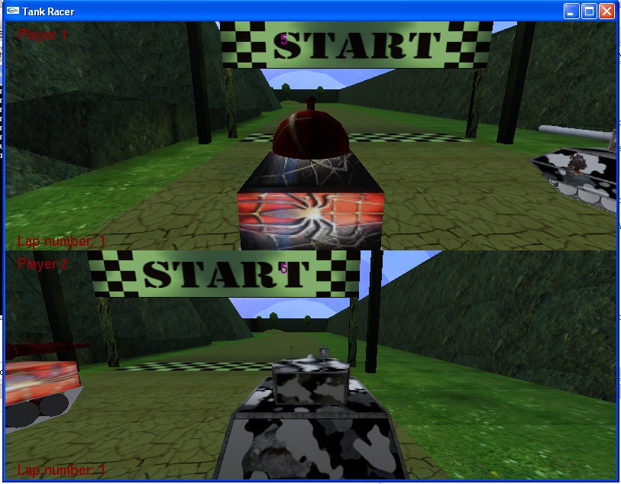
Figure 6. Countdown Timer

Game Logic and Rules
The winning condition for the players is to complete a certain number of laps. This value can be edited via a Configuration File (See Section 4.9). In order to detect when a lap has been completed, there are a number of checkpoints used. Before a lap can be completed, the tank must cross through each of these checkpoints at least once. After finishing a lap, the flag to check if a tank has crossed the checkpoints is reset. In this manner, the tanks must race through the entirety of the course, and cannot take “shortcuts” to avoid some of it.
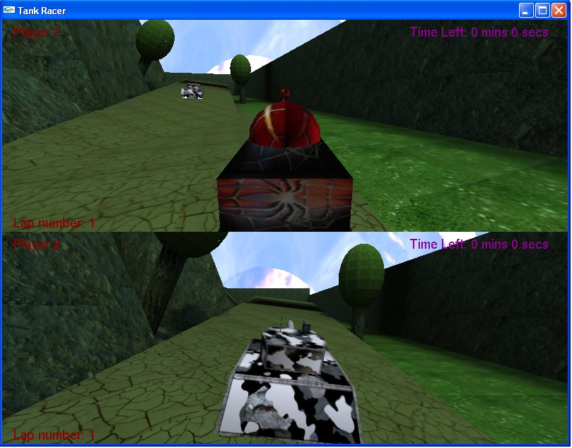
Figure 7. In-game view
The terrain of the world contains certain attributes which can affect the speed of the tanks. The speed is determined by the friction of the ground at the location of the tank. The race track itself has a relative friction of 1. The grass around the race track has a higher friction of 1.25, and the oil patches present near the end of the course have a friction of 0.2. Each tank has settings which adjust the speed they are capable of moving at, their acceleration, and their turning rate, so that the player’s selection of a tank has more than just aesthetic purpose.

Player controls:
Key | Action
* A, D, W, S | Turn left, turn right, move forward and backward keys for player one
* Arrow keys | Turn left, turn right, move forward and backward keys for player two
F1 | Restarts the game
P | Pauses the game
Esc | Quits the game
* Denotes default key mappings. Key mappings can be changed using the Configuration File.

Special Controls
The following controls are mainly used to debug the game.
Key | Action
F2 | Toggles drawing of textures on objects
F3 | Toggles drawing of hitboxes on tanks
F4 | Restarts ambient lighting from sunrise
F5 | Turns on motion blur for the "Cowtank”
F6 | Toggles “fly” mode allowing the player to fly through the map (debugging). Use ‘g’ and ‘b’ to fly up and down respectively in this mode.

End of the game
The game ends when a player completed designated number of laps within the time limit. If neither player finishes on time, then both players lose. The game can be restarted or quit at this point.
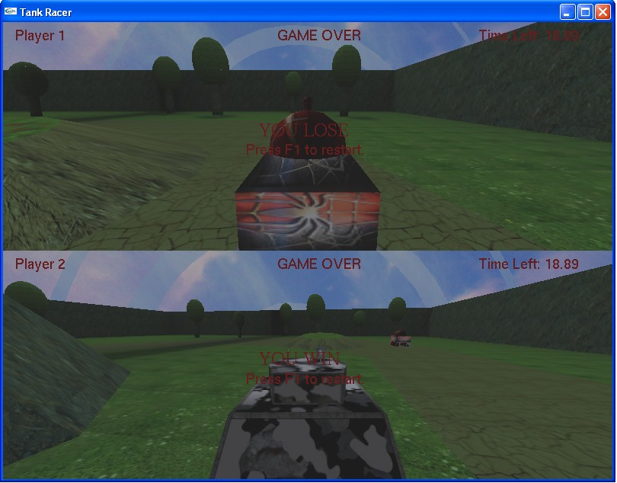
Figure 8. End of game

Configuration File
The configuration file is located in the top-level directory of the archive under the name “config.txt”. The file contains key-value pairs that can be edited to change game settings before loading the game. The following is a list of configuration keys and their possible and default values:

map <mapname> [default: tankracer]
Sets the map to load from the “maps\” sub-directory. The “.bsp” suffix is not included.

gravity <decimal> [default: 0.05]
Sets the gravity in the downward direction that the physics engine will use on the tanks.

maxplayers <integer> [default: 2]
Sets the number of players that are in the game. Currently only supports the values 1 or 2.

maxlaps <integer> [default: 3]
Sets the number of laps needed to finish the game.

timelimit <integer> [default: 240]
Sets the time limit in number of seconds.

<playerNum> tank <integer> [default: 0]
Sets the tank for playerNum (an integer from 0 to maxplayers – 1). A playerNum of 0 refers to player 1. The following are valid integer values for the tank along with their tank names:
0: Cowtank
1: Spidertank
2: NTank

<playerNum> <key> <left | right | forward | back>
Sets the key that controls the respective left, right, forward or back action for the tank’s movement for playerNum, the zero based index of the player number (0 refers to player #1). Valid key values are any single ASCII character, or any of the following symbolic key names representing arrow keys: left, right, up, down. Default keys for player 0 are: ‘a’ (left), ‘d’ (right), ‘s’ (back), ‘w’ (forward) and the arrow keys for player 1.

References
- “Unofficial Quake 3 Map Specs (Proudfoot, 2000)” http://graphics.stanford.edu/~kekoa/q3/.
- “Rendering Quake 3 Maps (Morgan McGuire, 2003)” http://graphics.cs.brown.edu/games/quake/quake3.html
- “The Octagon Engine” source code by Paul Baker (http://paulsprojects.net/opengl/octagon/octagon.html) was used as a general guide.
- Ray through triangle detection algorithm from http://www.gamespp.com/algorithms/CollisionDetectionTutorial.html was extrapolated to support n-vertex concave polygons.

Licensing Notes
- An implementation of the Targa file format (.tga) imaging library was borrowed from the BOINC codebase under the BSD license.
- The libjpeg 6b (http://www.ijg.org/) library compiled for Windows is packaged with the source. libjpeg is released under a “free” license.
- The Octagon Engine (http://paulsprojects.net/opengl/octagon/octagon.html) by Paul Baker is licensed under the New BSD License. Only ARB extension driver code for loading extensions on Windows was used from the project and used code is clearly marked as such.
- Quake 3 is a trademark of Id Software (http://www.idsoftware.com). The source code for Quake 3 is freely available under the LGPL license, though none of its source was used for the project.
- GtkRadient (http://www.qeradiant.com/) is licensed under three licenses, LGPL, GPL and BSD. None of the source from GtkRadient was used in this project.

