Twittle User Manual



Copyright © 2008 Loren Segal. All Rights Reserved.

Table of Contents

1 Introduction 1

2 Installing Twittle 1

3 Running Twittle for the First Time 1

4 The User Interface 1

5 Twittle Options 1

6 Uninstalling Twittle 1

7 Acknowledgements & Author 1

8 Licensing Information 1

# Introduction

*Twittle* is an application to let you use your [Twitter](http://twitter.com) account from your desktop. Using *Twittle*, you can follow what your friends are doing and even update them on your latest status yourself, all without ever opening your browser. *Twittle* also allows you to share images and links by integrating with services like [TwitPic](http://twitpic.com/) and [is.gd](http://is.gd).

# Installing Twittle

***Important note for Windows users:*** *Please make sure you have the* [*Microsoft Visual C++ 2005 SP1 Redistributable Package*](http://www.microsoft.com/downloads/details.aspx?FamilyID=200B2FD9-AE1A-4A14-984D-389C36F85647&displaylang=en) *before installing Twittle. It's a small (2.6mb) free download from Microsoft.  
http://www.microsoft.com/downloads/details.aspx?FamilyID=200B2FD9-AE1A-4A14-984D-389C36F85647*

*Twittle* is easily installed because it is only one file. Simply store the exe file **twittle.exe** somewhere safe and double click the icon to run it. It’s as simple as that!

***Note:*** *User account settings are stored on the local disk in your Application Data folder (under Windows XP), AppData (Windows Vista), Application Support (OS X) or ‘~/.twittle’ (UNIX/Linux). See the uninstalling section for more information.*

# Running Twittle for the First Time

*Twittle* needs to know your Twitter account settings **[*]** before going any further. If you don’t have a Twitter account yet, you can visit <http://www.twitter.com> to register for one. You might also want to add a few people to follow before moving on. That is, of course, the whole point of Twitter! You can find people to add from the Twitter website or simply ask your friends to join.

Once you have setup your account, simply enter the account details in the box as shown below:

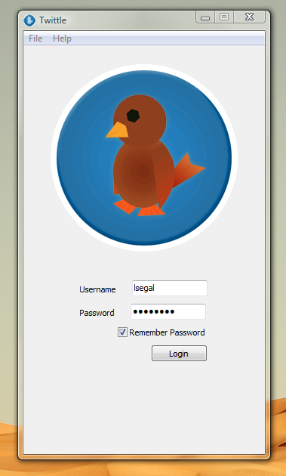

If everything worked out right, you will be greeted with your friends’ status updates. It should look a little like this:

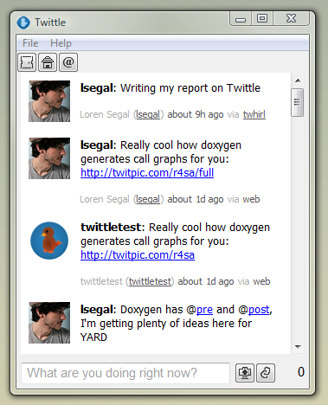

Now you can update your friends on what you’re doing. Simply type a message in the textbox at the bottom of the screen and hit return. Once it shows up with the other statuses, you can be sure your friends who are following you will soon get the message.

You may have noticed on the right there is a number that keeps counting up when you type. This is because Twitter has a length limit on their messages of 140 characters. This is to keep status updates short n’ sweet! If the number turns red it means your status will be cut off and your friends might not see all of what you wrote! Try rewriting your update to be more concise. If you’re inserting a URL for your friends, consider shortening it with the *Shorten URL* button (see below in *The User Interface* section).

***\* Note****: Twittle will never attempt to store your username, password, or any of your local data anywhere other than on your local machine. This notice does not apply to the use of the* [*TwitPic*](http://twitpic.com/) *service for image uploading (though they probably don’t store your data either). Please see their terms of service for a similar policy.*

# The User Interface

You might notice a few buttons on the top and a few more on the bottom. Let’s go over their functionality:

|  |  |  |
| --- | --- | --- |
|  | *View all public tweets* | This button allows you to see what everyone in the Twitter community is saying! Be careful though, things happen very fast in the outside world! |
|  | *View your friends’ tweets* | This button allows you to follow your friends’ tweets (status updates) only. This is probably what you want to be looking at most of the time. |
|  | *View replies directed to you* | Sometimes your friends will reply to you in a tweet. A “reply” is known in the Twitter world when someone types “*@yourusername*” before the message. You can click this button to conveniently find all the messages where people wrote directly to you. |
|  | *Upload an image* | This button uploads an image on your local machine to <http://twitpic.com> and puts the URL where you can find that image in your text box so you can quickly and easily share images with your friends! |
|  | *Shorten a URL* | This button takes a URL and shortens it with <http://is.gd>. Your new URL will look like <http://is.gd/something>, and it will be inserted into your text box. You can use this when you have a really long URL that you want to share with the world. |

You can also do things with your mouse:

**Right click on a status item** This will open a popup menu allowing you to copy the item as text or even as HTML.

**Drag an image onto the window** This will automatically bring up the image preview so  
that you can upload the image without clicking any buttons at all.

Now that you know what all the buttons do, let’s look at some of the key combinations you can use to make life faster:

**Ctrl+L** This is equivalent to hitting the *Shorten URL* button. If you already have text selected in your text box it will automatically use this as the URL to shorten.

**Ctrl+C** If you need to copy a tweet from a friend, you can highlight a status item and hit Ctrl+C, it will be as if you right clicked and pressed “Copy as Text”

**Ctrl+O\*** Brings up the options dialog (we’ll see this soon).

**Ctrl+Q\*** Quits Twittle. Bye Bye!

*\*\** ***Note****: Under Mac OS X, the options dialog is located at Command+, and quitting is done with Command+Q.*

That summarizes the user interface. Now let’s look at some of the options.

# Twittle Options

To access this menu, click *File -> Options* (*Ctrl+O*), or *Twittle -> Settings* (*Command+,*). You will see this:

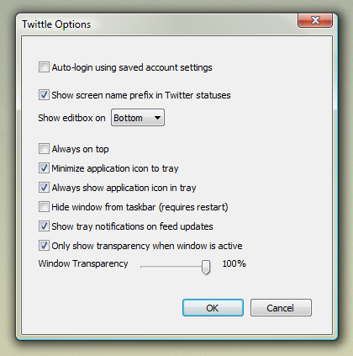

Let’s go over some of the options:

**Auto-login using saved account settings**:

This setting automatically logs you in with your last saved settings (if you clicked “Remember Me” in the login window).

**Show screen name prefix in Twitter statuses:**

Usually you will see updates as “**someusername:** I went to the store”. If you’d rather not see this prefix, you can disable it with this checkbox.

**Show editbox on [Top/Bottom]:**

You might want to customize your user experience by moving the text box on top if you prefer it there.

**Always on top:**

Shows the application window on top of all your other windows.

**Minimize application icon to tray:**

When you minimize Twittle you can have it hide from the taskbar and only show in your system tray.

**Always show application icon in tray:**

Make sure the application icon is always showing in your system tray.

**Hide window from taskbar:**

If you are always showing the application in your system tray, you may not want to ever want to see the window in the taskbar. You can remove it with this checkbox. Make sure you are showing the application in your system tray though!

**Show tray notifications on feed updates:**

Tray notifications are these little things:  
 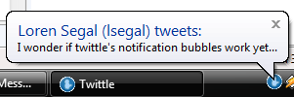  
  
 If you don’t want to see them, you can disable them here.

**Only show transparency when window is active:**

You can decide to make the window more transparent when inactive. This is useful if you have the window set to “Always on top” and you have other useful applications running under it.

**Window transparency:**

Makes the window slightly transparent. Try it out!

# Uninstalling Twittle

To uninstall Twittle simply remove the executable from your machine. You may also want to remove any saved settings that twitter stored on your machine. These can be found in the following locations (depending on your operating system):

**Windows XP** C:\Documents and Settings\YOURUSERNAME\Application Data\Twittle\

**Windows Vista** C:\Users\YOURUSERNAME\AppData\Roaming\Twittle\

**Mac OS X «**Application Support » in your Home directory

**Linux/UNIX** ~/.twittle/

***Note:*** *YOURUSERNAME refers to the logged in username in Windows XP/Vista, not your Twitter username.*

# Acknowledgements & Author

Twittle was developed by Loren Segal in 2008 for a C++ course. You can find out more about the author at <http://kthx.net>. Thanks to Myriam Malca for beta testing the initial release.

# Licensing Information

Twittle 0.5 beta   
Copyright © 2008 Loren Segal  
All rights reserved.

Twittle 0.5 beta can be downloaded freely from <http://kthx.net/twittle>.

Twittle will never store your private data on any of its servers.

Twittle may not be sold, resold, rented, leased, or lent without written authorization from the author.

Twittle is provided AS IS without warranties of any kind, either express or implied, including but not limited to the implied warranties of merchantability and fitness for a particular purpose. In no event shall the author be liable for any damages whatsoever including direct, indirect, incidental, consequential, loss of business profits or special damages, even if the author has been advised of the possibility of such damages.