===================================
1 of Canon FS-100 Flash Memory Camcorder (Silver) Price - $285
(has input for external microphone, records on SD - mpeg2)

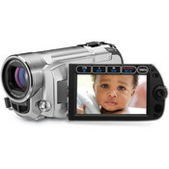
===================================
1 of Transcend HCSD card 8 GB. Price - $17

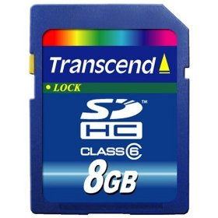

===================================
1 of Manfrotto 725B Digi Tripod with Integrated Ball Head with Dove Tail Plate and Carrying Bag (Black)
Price - $115
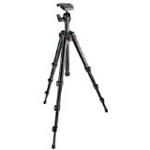
===================================
2 of Impact Umbrella - White Translucent (43") Mfr# S3243 B&H# IMU43T - Price:$ 14.95
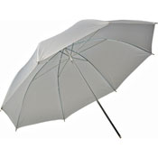

===================================
2 of Impact Light Stand - Black, 6' 1/4"-20 Threaded Top Mfr# 2205 B&H# IMLS6BQ - Price:$ 19.95
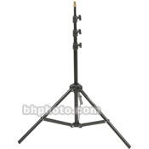

===================================
1 of Audio-Technica AT803B - Omni-Directional Lavalier Condenser Microphone - Price: $142

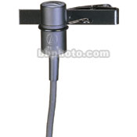

===================================
1 of Hosa Technology MIT-156 Low to High Impedance Matching Transformer with XLR Female to Stereo 1/8" Miniplug Male Connector Mfr# MIT-156 B&H# HOMIT156 - Price:$ 19.95
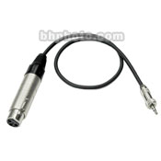
===================================
1 of Audio-Technica 3-pin XLR Male to 3-pin XLR Female Balanced Cable - 15 ft Mfr# AT8314-15 B&H# AUAT831415
Price:$ 16.99
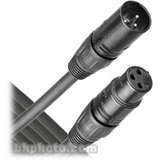
===================================
2 of Lowel Tota-Light Tungsten Flood Light (120-240VAC) CompactGull-Wing Pivoting Reflector360° Stay-Cool Tilt-KnobProtective Wire Mesh Screen. Mfr# T1-10 B&H# LOTL. Price:$ 113.95
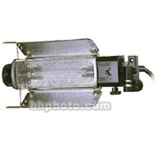
===================================
2 of General Brand EMD Lamp - 750 Watts/120 Volts B&H# GBEMD. Price:$ 17.95
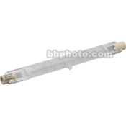
===================================
Adobe Premiere Elements - $70 on amazon
(or for Mac - ScreenFlow - $99
http://www.telestream.net/screen-flow/overview.htm)
===================================
Total - $1000 + tax + shipping
===================================

