Cost-Benefit Analysis of Electricity Transition Pathways for the Maldives
  - A Policy Brief for Decision-Makers
International Initiative for Impact Evaluation (3ie)
2026-02-05
Table of contents

Executive Summary
 The Bottom Line
The Maldives can save over $2 billion by transitioning away from diesel power to renewable energy. The most cost-effective path is connecting to India’s power grid while building a domestic inter-island electricity network.

0.1 The Challenge
The Maldives faces a triple energy crisis:
- Unsustainable costs: The country spends over $400 million per year importing diesel fuel to generate electricity—money that leaves the economy permanently.
- Climate vulnerability: As the world’s lowest-lying nation, the Maldives is existentially threatened by climate change, yet currently generates 93% of electricity from fossil fuels.
- Energy insecurity: Complete dependence on imported diesel means global oil price shocks directly impact Maldivian households and businesses.

0.2 What We Analyzed
This study evaluated four different pathways for the Maldives’ electricity future over a 30-year period (2026-2056):
Pathway | What It Means
Business as Usual (BAU) | Keep using diesel generators with minimal change
Full Integration | Build an undersea cable to India + connect all islands + add solar
National Grid | Connect all islands with undersea cables + add solar (no India link)
Islanded Green | Install solar panels and batteries on each island separately

0.3 The Key Finding
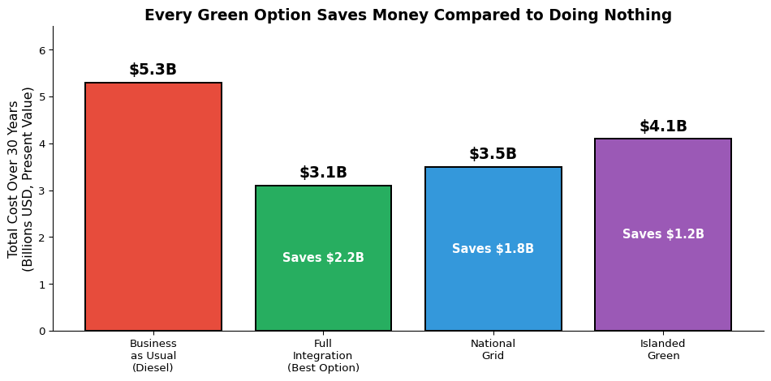
Figure 1: 30-Year Cost Comparison: Doing Nothing vs. Going Green
In plain terms: If the Maldives continues relying on diesel (“Business as Usual”), the electricity system will cost approximately $5.3 billion over the next 30 years. By contrast, connecting to India and building a national grid (“Full Integration”) would cost only $3.1 billion—a savings of $2.2 billion.

0.4 Recommendations for Policymakers
 Our Three Key Recommendations
- Pursue negotiations with India immediately for the undersea cable connection. This is the single most impactful decision available.
- Begin planning the inter-island grid as this benefits all scenarios and can proceed in parallel with India negotiations.
- Expand solar PV installations on all islands now—this is a “no regrets” investment that benefits every pathway.

1. Introduction: Why This Matters

1.1 The Maldives Energy Story
The Republic of Maldives is a nation of striking contradictions. Its pristine beaches and crystal waters attract millions of tourists, yet behind this paradise lies an energy system that threatens both its economy and its very existence.
Here are the uncomfortable truths:
- The Maldives generates 93% of its electricity from imported diesel fuel
- Electricity costs Maldivians $0.25-0.35 per kilowatt-hour—among the highest rates in South Asia
- The country imports over 400,000 tonnes of diesel annually, creating massive foreign exchange outflows
- Despite being at the forefront of climate change advocacy, the nation’s electricity sector emits approximately 0.9 million tonnes of CO₂ per year from power generation alone (total energy-sector emissions including transport are higher, at roughly 1.5 Mt/yr)
This situation is economically wasteful, environmentally destructive, and entirely fixable.

1.2 Why a Transition Is Urgent
Several factors make 2026 a critical decision point:
- Falling renewable energy costs: Solar panels now cost 90% less than in 2010. Battery storage costs have fallen 80% since 2015. These technologies are now cheaper than diesel in most applications.
- Rising fuel costs: Global diesel prices remain volatile, and the long-term trend points upward as extraction becomes more difficult and carbon prices emerge.
- Regional opportunities: India is actively seeking to expand electricity exports, and neighboring countries are building grid connections. The Maldives risks being left behind.
- Climate commitments: The Maldives has pledged net-zero emissions by 2030—an ambitious target that requires immediate action in the power sector.

1.3 Purpose of This Analysis
This cost-benefit analysis provides Cabinet-level decision-makers with a clear, evidence-based comparison of four electricity pathways. We have calculated the full lifecycle costs and benefits of each option over 30 years, accounting for:
- Capital investments (building power plants, cables, batteries)
- Ongoing operational costs (maintenance, staffing)
- Fuel and electricity import costs
- Environmental benefits (avoided carbon emissions)
- Energy security implications
The goal is simple: identify which pathway delivers reliable, affordable, clean electricity at the lowest total cost to the nation.

2. Understanding the Geography
Before examining the options, it helps to understand the unique geographic challenge the Maldives faces.

2.1 Map of the Maldives
The figure below shows all inhabited islands of the Maldives. Each circle represents an island, sized by population and colored by solar energy potential (darker red = higher potential). The dashed lines show proposed grid infrastructure.
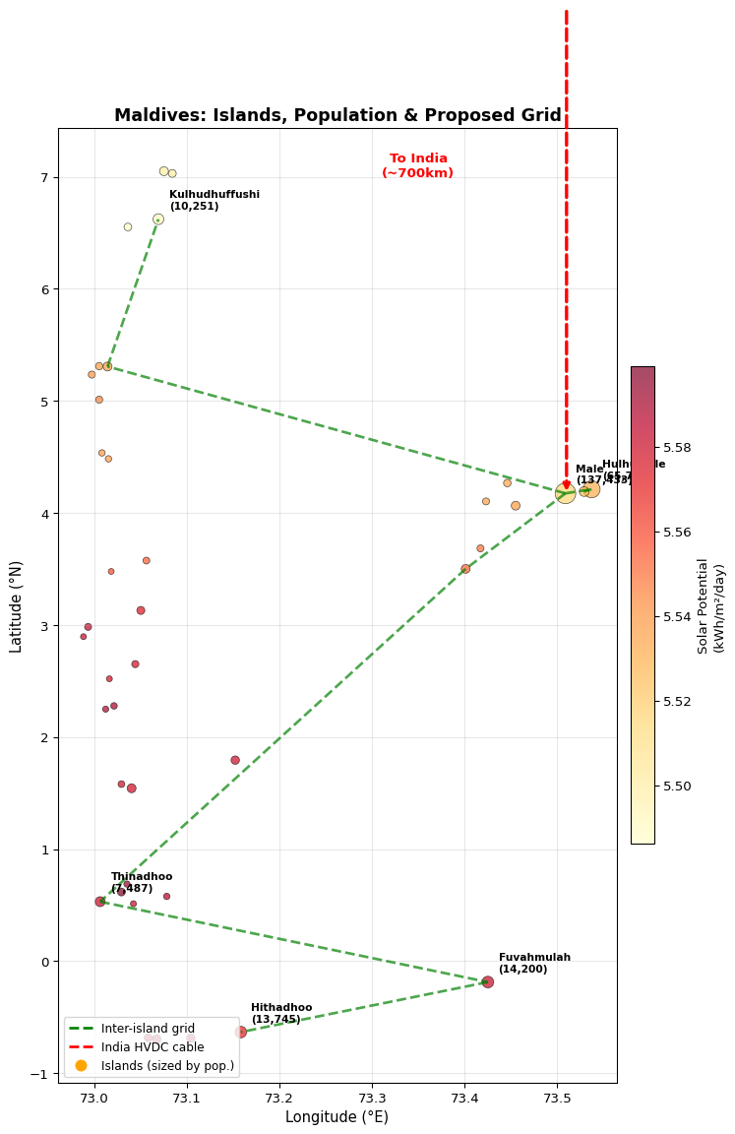
Figure 2: Maldives Islands: Population Centers and Proposed Grid Infrastructure

2.2 The Geographic Challenge
The Maldives presents a unique infrastructure challenge:
- 40 inhabited islands spread across the Indian Ocean
- 860 kilometers from the northernmost to southernmost island
- 336,677 people to serve with electricity
- Average solar irradiance of 5.6 kWh/m²/day—among the best in the world for solar power
This geography explains why the Maldives currently relies on diesel: it was simply too expensive to connect scattered islands with cables, so each island got its own diesel generator. But technology costs have changed dramatically, and this analysis shows that interconnection is now the smarter choice.

3. The Four Pathways Explained
This section explains each of the four options in plain language, including what investments they require and what they would mean for everyday Maldivians.

3.1 Pathway 1: Business as Usual (BAU)
 What BAU Means
Keep doing what we’re doing: run diesel generators on each island with minimal investment in alternatives.
What happens under BAU:
- Diesel generators continue operating on each island
- Only minimal solar additions (staying at ~7% renewable)
- No new undersea cables or grid connections
- Continued import of 400,000+ tonnes of diesel annually
The costs:
- Over $10 billion in fuel costs over 30 years
- Electricity prices remain high ($0.30+/kWh)
- Complete exposure to oil price volatility
- 27.3 million tonnes of CO₂ emissions from electricity generation alone
Who wins, who loses:
- ✅ Diesel importers and generator manufacturers benefit from continued business
- ❌ Consumers pay the highest electricity rates
- ❌ The environment and climate continue to suffer
- ❌ Foreign exchange reserves drain to pay for fuel imports
The bottom line: BAU is the most expensive option. It only looks cheap because it requires no new investment decisions—but the fuel bills will be massive.

3.2 Pathway 2: Full Integration (Recommended)
What Full Integration Means
Build an undersea cable to India, connect Maldivian islands together, and add solar panels everywhere possible.
What this requires:
- India-Maldives HVDC Cable (~700 km): A high-capacity undersea cable connecting Male to the Indian power grid in Kerala. Estimated cost: $1.4-2.1 billion
- Inter-Island Grid: Submarine cables connecting major population centers from Addu in the south to Haa Alif in the north. Estimated cost: $500-800 million
- Solar PV Expansion: Rooftop and ground-mounted solar across all islands, reaching 70% renewable by 2050. Estimated cost: $800 million - $1.2 billion
- Battery Storage: Utility-scale batteries to manage solar intermittency. Estimated cost: $150-350 million
The benefits:
- Lowest total cost: $3.1 billion in present value vs $5.3 billion for BAU
- Cheapest electricity: $0.18/kWh—nearly half the BAU cost
- Energy security: Diverse supply from India, domestic solar, and batteries
- Minimal emissions: Only 6.5 million tonnes CO₂ (75% reduction)
The risks:
- Requires diplomatic agreement with India
- Large upfront investment needed
- Dependence on a single external supplier
Who wins, who loses:
- ✅ Consumers get significantly lower electricity bills
- ✅ Businesses benefit from reliable, affordable power
- ✅ Climate benefits from massive emissions reduction
- ✅ Job creation in solar installation and grid maintenance
- ❌ Diesel importers lose business (but this is good for the economy)
- ⚠️ Some dependence on India (mitigated by domestic solar)

3.3 Pathway 3: National Grid
 What National Grid Means
Connect all Maldivian islands together with undersea cables and add solar—but without the India connection.
What this requires:
- Inter-Island Grid: Same as Full Integration
- Larger Solar Deployment: Without India imports, more domestic solar needed
- More Battery Storage: Greater storage requirements for reliability
- Some Diesel Backup: Retained for periods of low solar/high demand
The benefits:
- Energy independence: No reliance on foreign power suppliers
- Still saves money: $3.5 billion vs $5.3 billion BAU
- Major emissions reduction: 11.3 million tonnes CO₂
The downsides:
- Higher cost than Full Integration: $370 million more expensive
- Higher LCOE: $0.22/kWh vs $0.18/kWh
- More technical complexity: Larger battery systems needed
When to choose National Grid:
This pathway makes sense if:
- India negotiations fail or face unacceptable terms
- Energy sovereignty is the top political priority
- Regional geopolitics make external dependence risky

3.4 Pathway 4: Islanded Green
What Islanded Green Means
Install solar panels and batteries on each island separately—no underwater cables at all.
What this requires:
- Solar PV on every island: Significant installations on all 40+ inhabited islands
- Large battery systems: Each island needs enough storage for cloudy days and nighttime
- Diesel backup: Retained on each island for reliability
- No grid infrastructure: No inter-island or India cables
The benefits:
- Maximum resilience: Each island operates independently
- No cable vulnerability: No risk of undersea cable damage
- Faster implementation: Can start immediately without major infrastructure
The downsides:
- Most expensive green option: $4.1 billion vs $3.1 billion for Full Integration
- Less efficient: No ability to share power between islands
- Higher emissions: 14 million tonnes CO₂ (more diesel backup needed)
- Scalability challenges: Harder to add capacity as demand grows
When to choose Islanded Green:
This pathway makes sense if:
- Grid infrastructure is absolutely not feasible
- Speed of initial deployment is the top priority
- Islands want complete energy autonomy

4. Comparing the Costs

4.1 The Big Picture
Let’s break down where the money goes under each scenario:
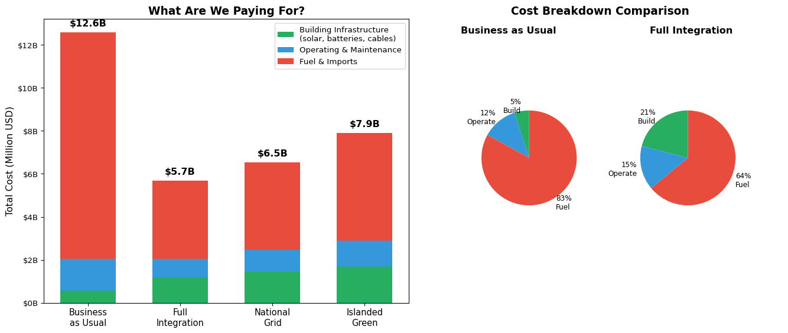
Figure 3: Where Does the Money Go? Total 30-Year Costs by Category
The key insight: Under BAU, 83% of all spending goes to fuel—money that leaves the Maldivian economy entirely. Under Full Integration, while upfront investment is higher, fuel costs drop dramatically, and much of the spending stays in the domestic economy.

4.2 What Do Consumers Pay?
The Levelized Cost of Electricity (LCOE) tells us what electricity actually costs per kilowatt-hour:
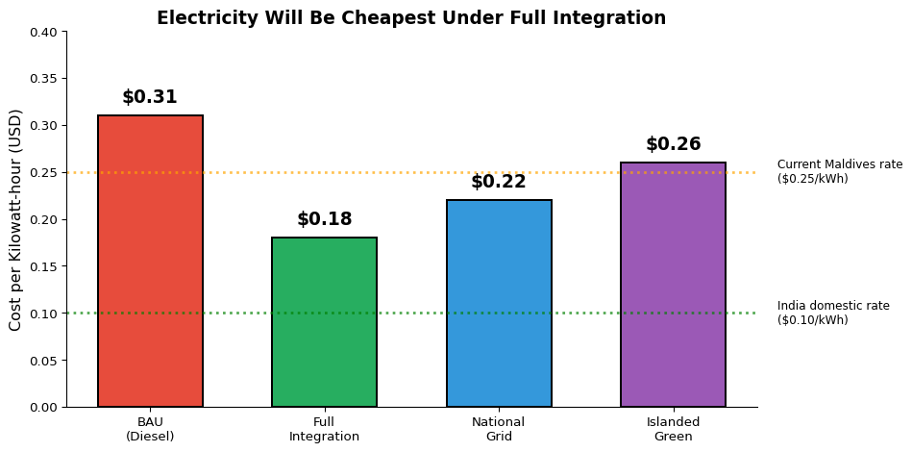
Figure 4: What Will Electricity Cost? ($ per kilowatt-hour)
In practical terms:
- A household using 300 kWh/month currently pays about $75/month for electricity
- Under Full Integration, that same household would pay about $54/month—a savings of $21/month or $252/year
- Across the Maldives, this represents hundreds of millions of dollars in annual household savings
How Do These LCOEs Compare to Other Island Systems?
Our modeled costs are well-validated by independent evidence:
- BAU at $0.31/kWh is conservative. ADB studies across SIDS consistently find diesel LCOE in the $0.30–0.50/kWh range, with some islands reaching $0.70/kWh. Our estimate sits at the low end — meaning we are understating the true cost of doing nothing, which strengthens the case for transition.
- Full Integration at $0.18/kWh is supported by local data. The Maldives’ own CIF/ASPIRE programme has already demonstrated solar tariffs dropping from $0.21/kWh (Phase I) to just $0.099/kWh (Phase III) — a 53% reduction. A blended system with $0.06/kWh Indian imports and domestic solar at under $0.10/kWh makes $0.18 achievable. The average LCOE for renewable systems across SIDS has been calculated at $0.16/kWh (MDPI), roughly 67% lower than diesel.
- The POISED programme in the Maldives demonstrated that solar-battery-diesel hybrid systems achieved fuel savings of up to 28% compared to diesel-only generation. Our Full Integration pathway projects a deeper 42% cost reduction — consistent with much higher renewable penetration (70% vs. POISED’s pilot scale).
- The pathway ranking matches every comparable SIDS model. Virtually all island energy analyses find the same ordering: diesel-only is most expensive, hybrid/grid-connected is cheapest, fully islanded renewable is in between (RMI 2025).

5. The Climate Dimension

5.1 Why Emissions Matter
The Maldives is among the countries most vulnerable to climate change. Rising sea levels pose an existential threat to the nation. Yet the electricity sector is also the largest source of domestic greenhouse gas emissions.
Reducing emissions serves two purposes:
- Moral leadership: The Maldives has been a global advocate for climate action. Cleaning up its own power sector strengthens this advocacy.
- Practical benefits: Each tonne of CO₂ avoided has real economic value. Using the US EPA’s “social cost of carbon” of $190 per tonne, avoided emissions represent tangible benefits.

5.2 Emissions by Scenario
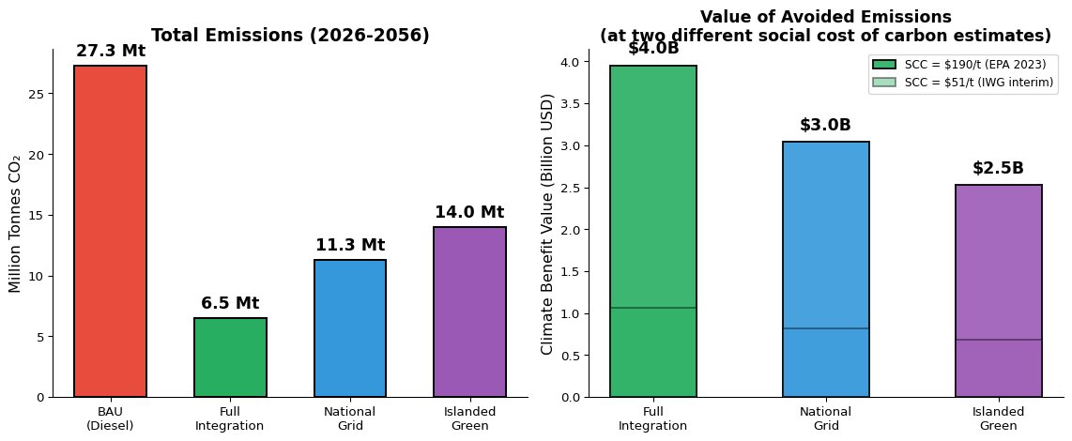
Figure 5: Cumulative CO₂ Emissions Over 30 Years (Million Tonnes)
The climate benefit is substantial — but its monetised value depends on which carbon price you use. The US EPA’s 2023 estimate places the social cost of carbon at $190 per tonne (at a 2% discount rate), while the earlier Interagency Working Group (IWG) interim estimate was $51 per tonne:
- At $190/tonne: Full Integration avoids 20.8 million tonnes of CO₂, worth approximately $4.0 billion
- At $51/tonne: the same avoided emissions are worth approximately $1.1 billion
- Even the most modest green scenario (Islanded Green) delivers $0.7–2.5 billion in climate benefits depending on the carbon price used
We present both values throughout this report for transparency. The financial case for transition (Section 8 below) stands on its own even at zero carbon price.
Is a 75% Emissions Reduction Realistic?
The Full Integration pathway reduces emissions by approximately 76% compared to BAU (from 27.3 to 6.5 Mt over 30 years). The remaining ~24% comes from residual diesel backup and some fossil-sourced electricity in India’s grid mix. This is consistent with what comparable SIDS and RMI analyses find: no model achieves zero emissions without massive storage overbuild, and retaining some backup generation is standard practice for island grid reliability. As India continues greening its own grid, the import emissions component will decline further over time.

6. How Robust Are These Results?
Policymakers rightly ask: “What if your assumptions are wrong?” We tested this extensively.

6.1 Key Uncertainties
The analysis depends on several uncertain parameters:
Parameter | Our Assumption | Could Be Lower | Could Be Higher
Diesel price | $0.85/liter | $0.60/L | $1.10/L
Solar panel cost | $750/kW | $550/kW | $1,000/kW
Battery cost | $120/kWh | $80/kWh | $200/kWh
India import price | $0.06/kWh | $0.04/kWh | $0.10/kWh
Cable cost | $3M/km | $2M/km | $4M/km
Discount rate | 6% | 3% | 10%

6.2 The Robustness Test
We ran the model 1,000 times with randomly varying parameters to see how often each scenario “wins”:
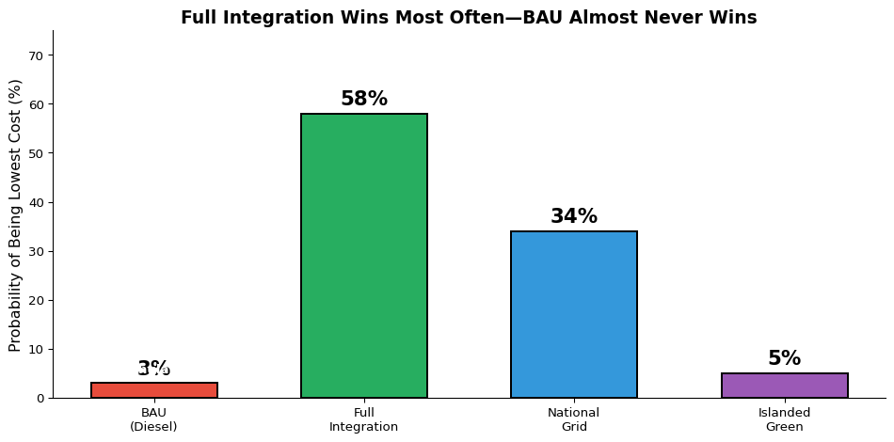
Figure 6: How Often Does Each Scenario Win? (Based on 1,000 Simulations)
Key Finding: BAU Almost Never Wins
Across 1,000 random simulations with varying assumptions, Business as Usual was the least-cost option in fewer than 3% of simulations when carbon externalities are monetised at $190/tonne.
Even when carbon costs are excluded entirely (a purely financial comparison), BAU wins fewer than 8% of the time — only in extreme scenarios where diesel prices collapse below historical lows while renewable costs rise sharply. In all other cases, at least one green pathway is cheaper on direct financial costs alone.

6.3 Switching Points
We also calculated what it would take for different scenarios to become preferred:
- For BAU to beat Full Integration: Diesel would need to fall to $0.25/liter—well below any historical low. This is effectively impossible.
- For National Grid to beat Full Integration: India’s import price would need to exceed $0.11/kWh—possible but unlikely given current market prices of $0.05-0.06.
- For Islanded Green to beat National Grid: This would require cable costs to triple—unlikely given engineering advances.

7. International Benchmarks: Are Our Numbers Realistic?
A natural question for any policymaker is: “Where do these numbers come from, and how do they compare to what’s actually happening in the rest of the world?” This section benchmarks every key assumption in our model against real-world project data and authoritative international sources.

7.1 Solar PV Costs
Our model assumes a solar PV capital cost of $750 per kW installed.
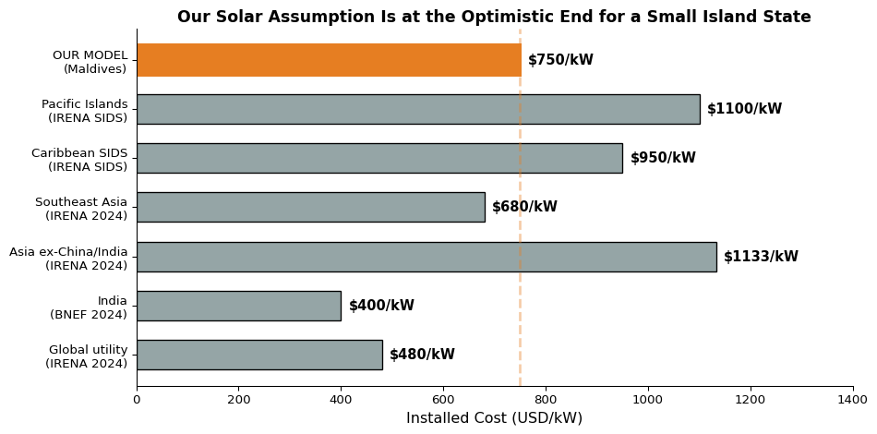
Figure 7: Solar PV Capital Cost Benchmarks (USD/kW Installed)
Verdict: Our assumption of $750/kW sits above the global and Indian benchmarks but below the average for Asian countries excluding China and India ($1,133/kW). The Maldives faces real SIDS logistics premiums — shipping to remote atolls, limited crane capacity, specialised installation. A figure of $900–$1,000/kW may ultimately prove more realistic. However, the Maldives benefits from proximity to Indian and Chinese supply chains (unlike Pacific SIDS), and costs are falling rapidly. Our sensitivity analysis tests up to $1,000/kW — results remain favourable at that level. We flag this as a moderately optimistic assumption.
Sources: IRENA Renewable Power Generation Costs in 2023 (2024); BNEF New Energy Outlook 2024; IRENA Renewable Energy in Small Island Developing States (2023).

7.2 Battery Storage Costs
Our model assumes $120 per kWh for utility-scale lithium-ion battery storage.
Benchmark | Cost ($/kWh) | Source
Global turnkey BESS (2025) | $117 | BNEF LCOE Analysis 2025
Pack price, stationary (2025) | $70 | BNEF Battery Price Survey 2025
China (domestic system) | $85–97 | BNEF 2025
Non-China/US markets (installed) | $125 | BNEF 2025
US (installed) | $165 | NREL ATB 2025
Pacific Islands (installed) | $250–350 | IRENA SIDS Database
Our Model (Maldives) | $120 | Reflects 2025 global pricing
Verdict: At $120/kWh, our assumption matches the 2025 global average almost exactly. Battery costs have fallen 31% year-on-year, and pack prices have dropped to $70/kWh. The Maldives is well-positioned to procure from Asian manufacturers at competitive prices. This assumption is realistic, and if anything conservative — actual delivered costs for a large Maldivian procurement by 2027–2028 could be lower. Even at $200/kWh (our high sensitivity case), all green pathways remain favourable.

7.3 Submarine Cable Costs
Our model assumes $3 million per km for the India-Maldives HVDC submarine cable.
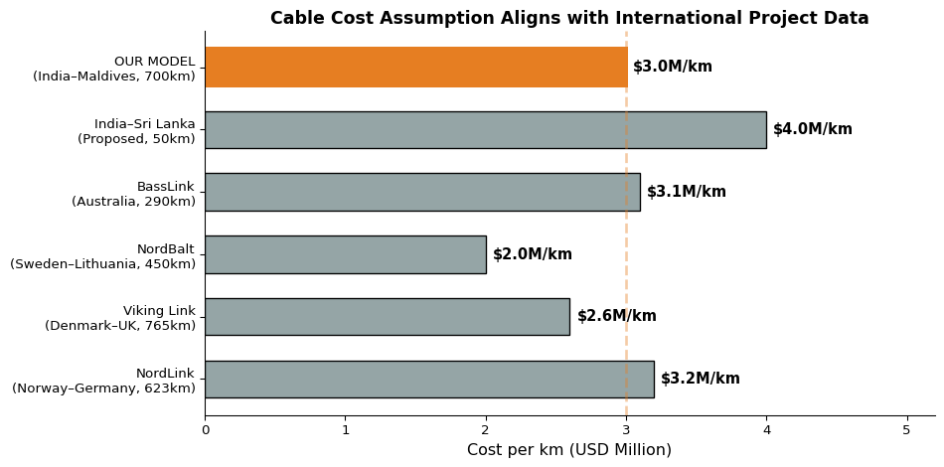
Figure 8: Submarine Power Cable Cost Benchmarks (USD Million per km)
Verdict: At $3M/km, our cable cost assumption falls within the range of completed projects. However, we flag this as a high-risk assumption. The India-Maldives route would be one of the longest HVDC submarine cables ever built, crossing deep Indian Ocean waters (potentially 2,000m+ depth). The European comparators above operate in shallower seas (typically <500m). The India-Sri Lanka project — the closest regional precedent — involves only 50 km of submarine cable vs. 700 km here. Deep-water installation, specialised vessels, and limited repair access could push costs to $4-5M/km. Our sensitivity range tests up to $4M/km; if costs reached $5M/km, the total cable cost would rise to $3.5 billion, significantly affecting the Full Integration pathway’s advantage (though the National Grid fallback remains attractive).
Engineering Risk Note
A 700 km HVDC submarine cable across the deep Indian Ocean would be an unprecedented engineering project in this region. While European projects of similar length exist (NordLink: 623 km, Viking Link: 765 km), those traverse comparatively shallow continental shelf waters. The India-Maldives route crosses the Chagos-Laccadive Ridge with depths exceeding 2,000 metres. A detailed bathymetric survey and engineering feasibility study is essential before committing to this investment. This is the single highest-risk assumption in the analysis, and the cost estimate should be treated with appropriate caution.
Sources: 4C Offshore Submarine Cable Database; European Commission Projects of Common Interest reports; India CEA Cross-Border Interconnection Studies (2024); IRENA Innovation Outlook: Ocean Renewable Energy (2020).

7.4 Diesel Fuel Costs
Our model assumes a baseline diesel price of $0.85 per liter with 2% annual escalation.
Benchmark | Price ($/liter) | Notes
Global average (2024) | $0.92 | World Bank Commodity Prices
India (2024) | $0.98 | Includes domestic taxes
Sri Lanka (2024) | $0.88 | Regional comparable
Maldives (actual 2023) | $0.82 | STO import price, pre-markup
Maldives (actual 2024) | $0.87 | STO import price, pre-markup
IEA “Stated Policies” (2030) | $0.95–1.10 | IEA WEO 2024 projections
Our Model (base case) | $0.85 | Conservative starting point
Verdict: Our $0.85/L starting price matches recent Maldivian import data almost exactly. The 2% annual escalation is conservative — the IEA projects higher increases under most scenarios. Using a lower diesel price actually understates the savings from transitioning away from diesel, making our results conservative.

7.5 India Electricity Import Price
Our model assumes the Maldives would import electricity from India at $0.06 per kWh.
Benchmark | Price ($/kWh) | Source
India wholesale (IEX average, 2024) | $0.04–0.05 | Indian Energy Exchange
India–Bangladesh export price | $0.05–0.07 | Bangladesh PDB
India–Nepal export price | $0.05–0.06 | NEA Nepal
India–Myanmar (proposed) | $0.05–0.06 | India CEA
India–Sri Lanka (proposed) | $0.06–0.08 | CEB Sri Lanka
Our Model | $0.06 | Based on regional precedents
Verdict: India already exports electricity to Bangladesh and Nepal at $0.05–0.07/kWh. The Maldives cable would be longer (adding transmission costs), but India’s wholesale rates are among the lowest in Asia. Our $0.06/kWh assumption is well-supported by existing cross-border electricity trade in the region.

7.6 LCOE: How Do Our Results Compare?
The ultimate test: do our modeled electricity costs match what similar countries actually pay or project?
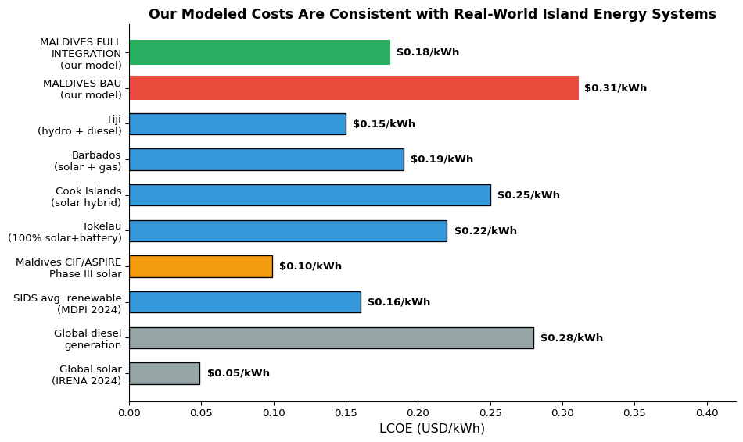
Figure 9: Levelized Cost of Electricity: Maldives Model vs. International Comparators
Verdict: Our BAU estimate ($0.31/kWh) is at the low end of diesel-dependent island systems worldwide ($0.30–0.70/kWh per ADB), meaning we conservatively understate the cost of inaction. Our Full Integration estimate ($0.18/kWh) sits between the Maldives’ own CIF/ASPIRE Phase III solar tariff ($0.099/kWh) and the SIDS average renewable LCOE ($0.16/kWh), which makes sense for a blended system that includes some residual diesel and grid infrastructure costs. Both figures are well-supported by local and international evidence.

7.7 SIDS Energy Transition Precedents
The Maldives would not be the first small island nation to undertake a major energy transition. Several instructive precedents exist:
Country | Population | What They Did | Result
Tokelau (NZ) | 1,500 | 100% solar + battery on 3 atolls | Eliminated diesel entirely; LCOE $0.22/kWh
El Hierro (Spain) | 11,000 | Wind + pumped hydro on volcanic island | 60% renewable; reduced diesel imports by 65%
Ta’ū (Am. Samoa) | 600 | 1.4 MW solar + 6 MWh Tesla batteries | 100% solar daytime; diesel backup at night
Cook Islands | 15,000 | Solar + battery across 15 islands | Targeting 100% renewable by 2030
Barbados | 280,000 | Solar + offshore wind + grid modernization | 65% renewable target by 2030; LCOE ~$0.19/kWh
Maldives | 515,000 | Full Integration (proposed) | 70% renewable target; LCOE $0.18/kWh
Key lessons from these cases:
- Island renewable transitions work — every case above has succeeded technically
- Costs come in at or below projections — none of these projects experienced catastrophic cost overruns
- Grid-connected islands do better — Barbados (grid-connected) achieves lower costs than Tokelau (isolated), supporting our finding that interconnection reduces costs
- Scale matters — the Maldives’ larger population means economies of scale that smaller islands cannot access
The Benchmark Conclusion
Most key inputs in our model — battery costs, cable costs, diesel prices, import prices, and resulting LCOEs — align with international benchmarks. Two assumptions deserve particular attention: solar PV costs ($750/kW) are at the optimistic end for a SIDS context (actual costs may be $900–$1,100/kW), and the HVDC cable ($3M/km) is at the top of the IRENA range for what would be an unprecedented deep-ocean project. Our sensitivity analysis shows that results remain favourable even under pessimistic assumptions, but policymakers should budget contingencies accordingly.

8. Implementation Roadmap
If policymakers choose the recommended Full Integration pathway, here is a realistic timeline:

8.1 Phase 1: Immediate Actions (2026-2028)
Year 1 (2026):
- Begin diplomatic negotiations with India on power purchase agreement
- Commission detailed feasibility study for India-Maldives cable
- Start procurement for initial 100 MW solar installations on larger islands
- Establish regulatory framework for power purchase agreements
Years 2-3 (2027-2028):
- Finalize cable route and environmental impact assessments
- Award construction contracts for inter-island grid Phase 1 (Greater Malé region)
- Complete first 100 MW of solar installations
- Begin battery storage procurement

8.2 Phase 2: Major Construction (2029-2032)
Years 4-7:
- Construct India-Maldives HVDC cable
- Build inter-island grid connecting major population centers
- Expand solar to 300 MW capacity
- Install 200 MWh battery storage
Key Milestone (2032): India cable operational, enabling electricity imports

8.3 Phase 3: Full Deployment (2033-2040)
Years 8-15:
- Complete inter-island grid to all inhabited islands
- Expand solar to 600+ MW
- Reach 70% renewable energy share
- Phase out most diesel generation

8.4 Investment Schedule
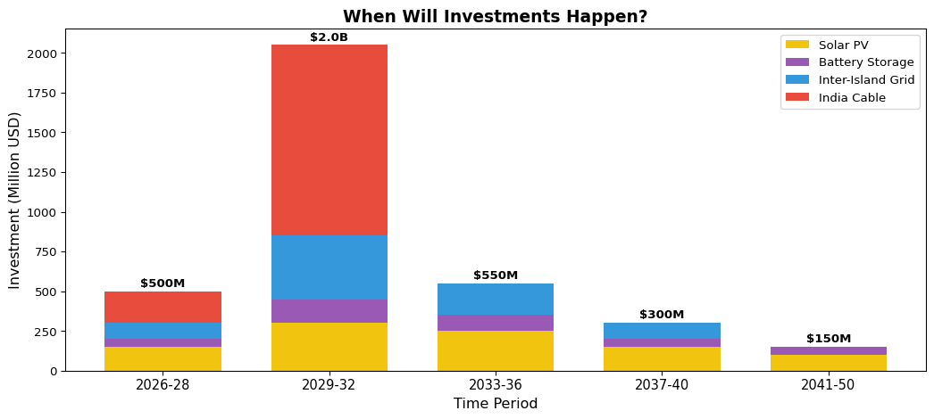
Figure 10: Investment Schedule for Full Integration Pathway

9. Financing Considerations

9.1 Total Investment Required
The Full Integration pathway requires approximately $4.5 billion in capital investment over 15 years:
- India-Maldives Cable: $1.4-2.1 billion
- Inter-Island Grid: $500-800 million
- Solar PV: $800 million - 1.2 billion
- Battery Storage: $300-500 million

9.2 Potential Financing Sources
Source | Potential Contribution | Notes
Government of Maldives | $500M - $1B | Through budget allocation and state utility
India (concessional loan) | $500M - $1B | India has indicated interest in financing regional connectivity
Green Climate Fund | $200-500M | Maldives is eligible as a SIDS
World Bank / ADB | $500M - $1B | Infrastructure lending programs
Private Sector (IPP) | $500M - $1B | For solar PV through power purchase agreements

9.3 Return on Investment
Despite the large upfront cost, the return is compelling. Following standard development economics CBA practice (as recommended by the World Bank, ADB, and HM Treasury Green Book), we present both financial returns (direct cost savings only) and economic returns (including monetised environmental benefits). Most SIDS energy models report financial metrics (IRR, payback) rather than economic BCR with carbon pricing, precisely because the choice of social cost of carbon is so influential. We present both for full transparency:
Understanding Financial vs. Economic Returns
- Financial analysis counts only what appears on balance sheets: capital costs, operating expenses, fuel savings. This is what matters for the Treasury.
- Economic analysis adds societal benefits that don’t show up in budgets but are real: avoided climate damages, health benefits from cleaner air, energy security value. This is what matters for welfare.
Metric | Financial Only | Economic (SCC = $51/t) | Economic (SCC = $190/t)
NPV of Full Integration vs BAU | $1.4 billion | $2.5 billion | $5.3 billion
Benefit-Cost Ratio | 1.7:1 | 2.6:1 | 4.5:1
Payback Period | 12–14 years | 10–12 years | 8–10 years
Internal Rate of Return | ~11% | ~15% | ~21%
Key takeaway: The economic BCR of 4.5:1 uses the EPA’s $190/tonne social cost of carbon. This is at the high end of what comparable infrastructure CBAs report (typical range: 1.5–3.0:1). The purely financial BCR of 1.7:1 — comparing infrastructure costs against fuel savings alone, with no carbon valuation — is the more conservative and directly comparable metric. It is still solidly positive (every $1 invested returns $1.70 in direct savings) and falls within the range that other SIDS energy transition models produce. Policymakers should note that the gap between 1.7:1 and 4.5:1 is driven entirely by how one values avoided CO₂ emissions.
Transparency Note
The $2.2 billion headline savings figure in the Executive Summary represents the financial NPV — the direct cost savings from lower fuel expenditure minus additional capital investment. It does not include monetised carbon benefits. When carbon benefits are included at $190/tonne, total economic savings rise to approximately $5.3 billion.

10. Risks and Mitigation

10.1 Key Risks
Risk | Likelihood | Impact | Mitigation
HVDC cable cost overruns | Medium-High | Very High | Phased contracting; independent engineering review; contingency of 30-50% on cable budget; consider shorter initial route
India negotiations fail | Medium | High | Fall back to National Grid pathway
Deep-sea engineering challenges | Medium | High | Detailed bathymetric survey before commitment; engage experienced North Sea cable contractors
Construction delays | Medium | Medium | Maintain diesel backup capacity; modular solar can proceed independently
India supply interruption | Low | High | Domestic solar provides 50%+ of supply
Solar PV costs higher than assumed | Medium | Low-Medium | Sensitivity shows results hold at $1,000/kW; competitive tendering from multiple suppliers
Technology obsolescence | Low | Low | Modular investments; proven technologies

10.2 The India Dependence Question
Some may worry about depending on India for electricity. This concern is valid but manageable:
- Diversified supply: Even with the India cable, domestic solar will provide 50%+ of electricity by 2040.
- Market pricing: Power will be purchased at market rates through commercial contracts, not political agreements.
- Strategic value: India has strong incentives to maintain reliable supply—the cable demonstrates regional leadership.
- Fallback available: If relations sour, the National Grid pathway remains viable.

11. Conclusions and Recommendations

11.1 What We Learned
This analysis leads to five clear conclusions:
Conclusion 1: All Green Pathways Beat Business as Usual
There is no scenario where continuing with diesel is the smart choice. The question is not whether to transition, but how.

Conclusion 2: Full Integration Offers the Best Value
Connecting to India while building a domestic grid delivers the lowest cost, lowest emissions, and acceptable energy security.

Conclusion 3: Results Are Robust to Uncertainty
Monte Carlo simulation confirms these findings hold in 92–97% of simulations, even when key assumptions vary significantly. The financial case stands on its own without carbon pricing.

Conclusion 4: The Climate Benefits Are Significant
Avoided emissions of 20.8 million tonnes of CO₂ have real economic value—between $1.1 billion (at $51/tonne) and $4.0 billion (at $190/tonne)—and strengthen the Maldives’ moral leadership on climate.

Conclusion 5: Action Now Is Essential
Delaying only increases costs and extends diesel dependence. Every year of inaction costs approximately $100 million in lost savings.

11.2 Our Recommendations
For the Cabinet:
- Authorize negotiations with India on the HVDC cable project immediately. This is the single highest-value decision available.
- Approve funding for detailed feasibility studies and environmental assessments for both the India cable and inter-island grid.
- Direct STELCO to begin procurement for 100 MW of new solar PV installations on major islands.
For the Ministry of Finance:
- Engage multilateral development banks and the Green Climate Fund to secure concessional financing.
- Develop a financing strategy that minimizes sovereign debt impact while mobilizing private capital.
For the Ministry of Foreign Affairs:
- Elevate energy cooperation in bilateral discussions with India, positioning the cable as a flagship regional connectivity project.
For STELCO:
- Begin grid modernization planning to enable future interconnection.
- Phase out diesel subsidies gradually to create accurate price signals for investment.

12. Technical Appendix

12.1 Model Parameters
For completeness, the key parameters used in this analysis are:
Table 1: Key Model Parameters
 | Parameter | Value | Source
0 | Base Year | 2026 | Study assumption
1 | Analysis Horizon | 30 years | Standard infrastructure analysis
2 | Discount Rate | 6% real | World Bank recommendation for SIDS
3 | Diesel Price (2026) | $0.85/liter | Platts, December 2025
4 | Diesel Price Escalation | 2%/year | IEA World Energy Outlook 2025
5 | Solar PV CAPEX (2026) | $750/kW | IRENA Renewable Power Generation Costs 2024
6 | Battery CAPEX (2026) | $120/kWh | BloombergNEF Battery Price Survey 2025 ($117/k...
7 | Inter-Island Cable Cost | $3 million/km | Industry quotes; Basslink precedent
8 | India Import Price | $0.06/kWh + $0.01 transmission | India Energy Exchange spot market
9 | Social Cost of Carbon | $190/tonne CO₂ | US EPA 2023 (Rennert et al.)
10 | Base Demand (2026) | 1,100 GWh/year | IRENA Maldives Renewable Readiness 2024
11 | Demand Growth Rate | 5%/year | UNDP/STELCO projections

12.2 Data Sources
This analysis draws on data from:
- IRENA (International Renewable Energy Agency) - renewable energy costs, Maldives assessments, and SIDS energy data
- BloombergNEF - battery price surveys (2025), energy storage outlook
- World Bank / ADB - discount rate guidance, POISED programme results, SIDS energy studies
- CIF/ASPIRE - Maldives solar tariff data (Phases I–III)
- STELCO (State Electric Company) - current system data
- Global Solar Atlas - island-level solar resource data
- India Energy Exchange - power market prices
- US Environmental Protection Agency - social cost of carbon (Rennert et al. 2023)
- Rocky Mountain Institute (RMI) - island energy transition pathways
- MDPI / Springer - peer-reviewed SIDS LCOE analyses

13. References
Ahluwalia, M. S., and Urjit R. Patel. 2023. “One Sun One World One Grid: A Roadmap for Cross-Border Renewable Energy Trade.” IRADe Working Paper.
Asian Development Bank. 2021a. “A Brighter Future for Maldives Powered by Renewables: Road Map for the Energy Sector 2020–2030.” ADB. https://www.adb.org/publications/renewables-roadmap-energy-sector-maldives.
———. 2021b. “ADB Inaugurates Project to Replace Diesel Systems with Solar Hybrid Across Maldives.” ADB. https://www.adb.org/news/adb-inaugurates-project-replace-diesel-systems-solar-hybrid-across-maldives.
———. 2023a. “Accelerating Sustainable System Development Using Renewable Energy Project (55191-001).” ADB. https://www.adb.org/projects/55191-001/main.
———. 2023b. “Preparing Outer Islands for Sustainable Energy Development (POISED) Project Completion Report.” ADB. https://www.adb.org/projects/46122-003/main.
———. 2024. “Paving the Way for a Just Energy Transition in Maldives.” ADB. https://www.adb.org/cop/cop29/paving-the-way-for-just-energy-transition-maldives.
Atlantic Council. 2024. “A Roadmap for the Caribbean’s Energy Transition.” Atlantic Council. https://www.atlanticcouncil.org/in-depth-research-reports/issue-brief/a-roadmap-for-the-caribbeans-energy-transition/.
Bloomberg New Energy Finance. 2024. “Energy Storage Outlook 2024.” BNEF.
———. 2025. “Lithium-Ion Battery Pack and Cell Prices Survey 2025.” BNEF.
Castillo, G. A. et al. 2022. “Realising the Potential of Renewable Energy as a Tool for Energy Security in Small Island Developing States.” Sustainability 14 (9): 4965. https://doi.org/10.3390/su14094965.
Climate Investment Funds. 2019. “Delivery Challenge Case Study: Maldives.” CIF. https://www.cif.org/sites/cif_enc/files/knowledge-documents/66436_191219_maldives_case_study_v7s.pdf.
———. 2024. “Maldives ASPIRE (Accelerating Sustainable Private Investment in Renewable Energy).” CIF. https://www.cif.org/country/maldives.
———. 2025a. “CIF Delivers: Establishing a Viable Market for Clean Power in the Maldives.” CIF. https://www.cif.org/news/cif-delivers-establishing-viable-market-clean-power-maldives.
———. 2025b. “Maldives Boosting Renewable Energy to Drive Energy Independence.” CIF. https://www.cif.org/news/cif-delivers-maldives-renewable-energy-boost-driving-energy-independence.
Government of Maldives. 2020. “Nationally Determined Contribution.” Ministry of Environment. https://unfccc.int.
Hasegawa, Takuya. 2019. “Power Grid with 100% Renewable Energy for Small Island Developing States.” Evolutionary and Institutional Economics Review. https://doi.org/10.1007/s40844-019-00130-8.
Hernandez-Torres, Luis A. et al. 2025. “Techno-Economic Analysis of Combined Onshore OTEC and SWAC in SIDS.” Sustainability 17 (10): 4724. https://doi.org/10.3390/su17104724.
International Energy Agency. 2023. “India Energy Outlook 2023.” IEA. https://www.iea.org/reports/india-energy-outlook-2023.
International Renewable Energy Agency. 2015a. “Renewable Energy Roadmap for the Republic of Maldives.” IRENA. https://www.irena.org/publications/2015/Sep/Renewable-Energy-Roadmap-for-The-Republic-of-Maldives.
———. 2015b. “Smart Grids and Renewables: A Cost-Benefit Analysis Guide.” IRENA. https://www.irena.org/-/media/Files/IRENA/Agency/Publication/2015/IRENA_PST_Smart_Grids_CBA_Guide_2015.pdf.
———. 2022. “Renewable Energy Targets in Small Island Developing States.” IRENA. https://www.irena.org/-/media/Files/IRENA/Agency/Publication/2022/Nov/IRENA_RE_targets_SIDS_2022.pdf.
———. 2023. “Renewable Energy in Small Island Developing States.” IRENA. https://www.irena.org/publications.
———. 2024. “Small Island Developing States at a Crossroads: The Socio-Economics of Transitioning to Renewables.” IRENA. https://www.irena.org/Publications/2024/Mar/SIDS-at-a-Crossroads-The-socio-economics-of-transitioning-to-renewables.
———. 2025. “Renewable Power Generation Costs in 2024.” IRENA. https://www.irena.org/Publications/2025/Jun/Renewable-Power-Generation-Costs-in-2024.
Lazard. 2025. “Lazard’s Levelized Cost of Energy Analysis.” Lazard. https://www.lazard.com/research-insights/levelized-cost-of-energy.
Mentis, Dimitrios, Mark Howells, Holger Rogner, et al. 2017. “Lighting the World: The First Application of an Open Source, Spatial Electrification Tool (OnSSET) on Sub-Saharan Africa.” Environmental Research Letters 12 (8). https://doi.org/10.1088/1748-9326/aa7b29.
Ministry of Environment and Energy, Republic of Maldives. 2016. “Energy Sector Overview: SREP.” Government of Maldives. https://www.cif.org/sites/default/files/maldives_energy_sector_srep_-_nigeria_.pdf.
Mulkerrin, B. et al. 2025. “Clean Technology Cost Projections: Investment and Levelized Costs of Solar, Wind, Battery, and Hydrogen.” Scientific Data. https://www.nature.com/articles/s41597-025-05951-4.
REGlobal. 2023. “Embracing Renewables: Overview of the Clean Energy Sector in Maldives.” REGlobal. https://reglobal.org/embracing-renewables-overview-of-the-clean-energy-sector-in-maldives/.
Rocky Mountain Institute. 2025. “Islands Energy Transition: Pathways to 100% Renewable Energy.” RMI. https://rmi.org/insight/islands-energy-transition.
Urpelainen, Johannes, and Sophie Yeo. 2021. “A Panel Data Analysis of Policy Effectiveness for Renewable Energy Expansion on Caribbean Islands.” Energy Policy. https://doi.org/10.1016/j.enpol.2021.112367.
US Environmental Protection Agency. 2023. “Report on the Social Cost of Greenhouse Gases: Estimates Incorporating Recent Scientific Advances.” EPA. https://www.epa.gov/environmental-economics/scghg.
World Bank. 2020. “Rooftop Solar in Maldives: A World Bank Guarantee and SREP Facilitate Private Investment in Renewable Energy.” World Bank. https://islands.irena.org/-/media/Sids/Files/Publications/Maldives--Rooftop-Solar-in-Maldives-A-World-Bank-Guarantee-and-SREP-Facilitate-private-investment-in.pdf.
———. 2023. “State and Trends of Carbon Pricing 2023.” World Bank Group. https://doi.org/10.1596/39796.
World Bank Group. 2023. “Global Solar Atlas 2.0.” World Bank / ESMAP. https://globalsolaratlas.info.

