GreenWaste reading workshop | Day 3 | Session 2

Read a chart before trusting its story
Mark what the chart actually shows before accepting its caption. Then repair a conclusion that goes beyond the evidence.
GreenWaste is a fictional training case.
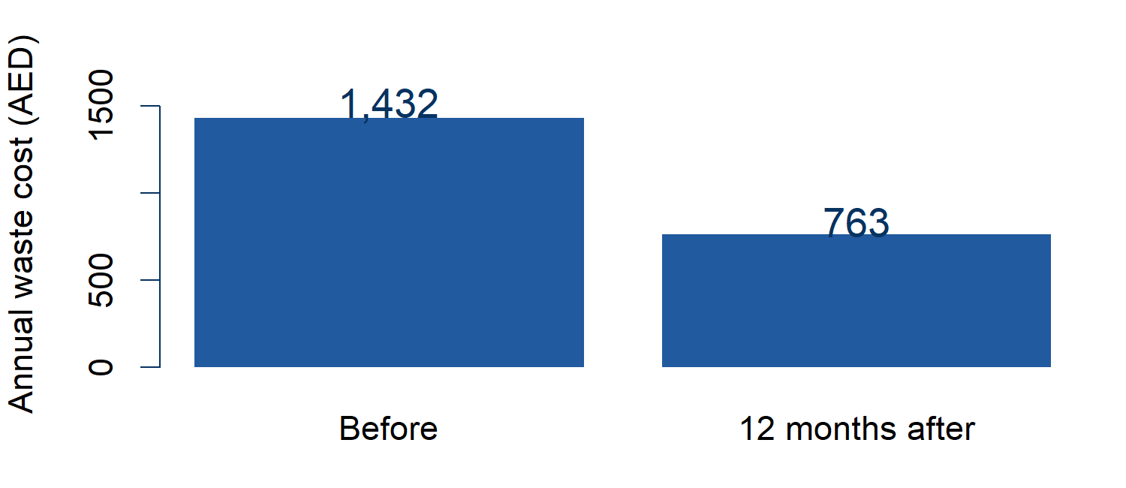
Source: fictional GreenWaste city participants, the same businesses before and 12 months after. Recorded mean annual waste cost per business, AED.
1 Mark the chart
Circle the units. Mark where the axis starts. Underline the comparison and period in the source caption.
2 What can it support
Write one supported statement and one conclusion it cannot establish.
_______________________________________________________
_______________________________________________________
_______________________________________________________

GreenWaste reading workshop | Day 3 | Session 2

Check the caption and denominator
Two summaries of participant landfill waste
Summary | Result | Weight
Fall in total tonnes | 49.5% | Larger starting tonnes count more
Mean of business percentage falls | 58.6% | Each business has equal weight
Both describe the same participants before and after. They answer different questions. Neither alone establishes cause. Ask what a percentage is a percentage of.
Repair the cost chart caption
"The cost chart proves GreenWaste caused the saving for every city business."
Write a caption naming source, units, comparison and one limit. Work with a partner.
_______________________________________________________
_______________________________________________________
_______________________________________________________
Repair an illustrative AI caption
"GreenWaste caused a fall of almost half in every business's landfill waste. The before/after chart proves the programme works."
Point to what the landfill summary supports. Cross out unsupported words and rewrite.
_______________________________________________________
_______________________________________________________
Your check from memory
Close Sheet 1. What would you check first, and why? Work alone.
_______________________________________________________

