GreenWaste reading workshop | Day 3 | Session 2

Read a chart before trusting its story
Mark what the chart actually shows before accepting its caption. Then repair a conclusion that goes beyond the evidence.
GreenWaste is a fictional training case.
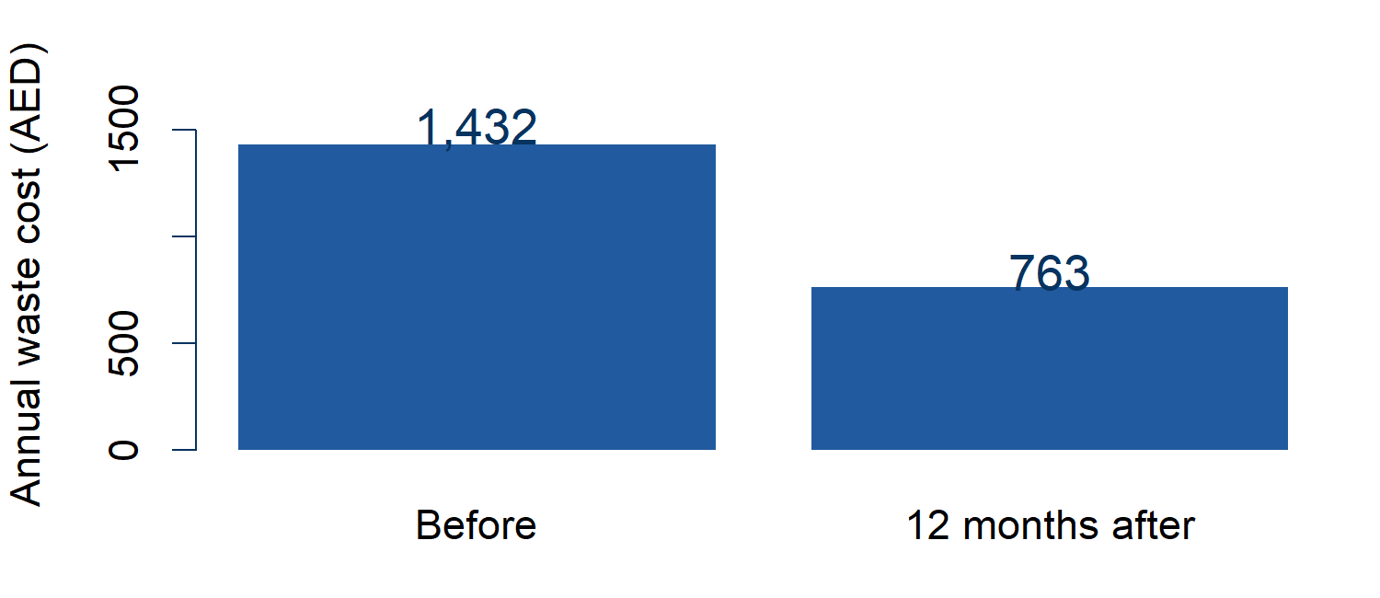
Source: fictional GreenWaste city participants, the same businesses before and 12 months after. Recorded mean annual waste cost per business, AED.
1 Mark the chart
Circle the units. Mark where the axis starts. Underline the comparison and period in the source caption.
2 What can it support
Write one supported statement and one conclusion it cannot establish.
_______________________________________________________
_______________________________________________________
_______________________________________________________

GreenWaste reading workshop | Day 3 | Session 2

Check the caption and denominator
Two summaries of participant landfill waste
Summary | Result | Weight
Fall in total tonnes | 49.5% | Larger starting tonnes count more
Mean of business percentage falls | 58.6% | Each business has equal weight
Both describe the same participants before and after. They answer different questions. Neither alone establishes cause. Ask what a percentage is a percentage of.
Repair the cost chart caption
"The cost chart proves GreenWaste caused the saving for every city business."
Write a caption naming source, units, comparison and one limit. Work with a partner.
_______________________________________________________
_______________________________________________________
_______________________________________________________
Repair an illustrative AI caption
"GreenWaste caused a fall of almost half in every business's landfill waste. The before/after chart proves the programme works."
Point to what the landfill summary supports. Cross out unsupported words and rewrite.
_______________________________________________________
_______________________________________________________
Your check from memory
Close Sheet 1. What would you check first, and why? Work alone.
_______________________________________________________

GreenWaste reading workshop | Day 3 | Session 2

Trainer key for chart reading
Participant pages 1 and 2 double-sided, one per person. This key is trainer only.
Axes and comparison
Recorded costs 1,432 before and 763 after, city participants only. The two screen charts have identical values; one starts at 700 AED, the other at zero. The truncated bars exaggerate the visual proportion of the fall. Neither comparison isolates GreenWaste's effect or describes every city business.
Average and denominator
The ten-business landfill teaching selection has mean 10.0 tonnes, nine below it and one at 46. It is not a representative city distribution. Participant total-tonnes fall 49.5%; mean business percentage fall 58.6%. The first weights by starting tonnes, the second equally by business.
Interval and captions
Pilot estimate and interval use the canonical lottery model from Day 1. The interval spans the saving rule. Repair the cost caption as an observed mean fall for city participants, without a causal or all-business claim. For landfill, retain the approximate total fall, remove every-business and proof-of-cause assurances.
Delivery
One trainer calculation, prediction before Run; native axis toggle and evidence reveals. No school-zone case, pie-chart detour or discount-rate repeat. Source labels and limits matter more than choosing a visually flattering chart. Total 60 minutes.

