Module 2 · Reading Impact Evaluation Results · the case for the week
The GreenWaste programme
GreenWaste helps businesses cut their waste costs. Here is how it reached them.
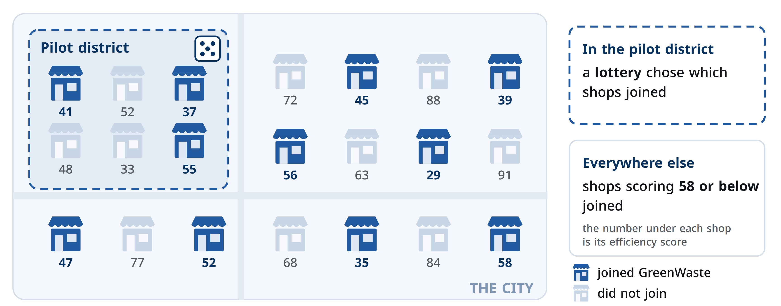

In the pilot district, a lottery chose which shops joined. Everywhere else, shops scoring 58 or below joined. Every business has an efficiency score from 0 to 100; higher means more efficient.
Invented for this training.

