GreenWaste: comparing groups | Day 1 | Session 2 | GreenWaste is a fictional training case.
Page 1 | H2-A: The city data tables and charts
GreenWaste offers equipment subsidies, installation help and staff training. All costs are annual waste management cost, in AED per business, measured before GreenWaste and 12 months after. GreenWaste is a fictional training case.
H2-A1: Four selected businesses: efficiency score, whether the business took part, and annual waste management cost before and 12 months after (AED)
Business | Efficiency score | Participation | Before (AED) | After (AED)
B00401 | 43.6 | Took part | 2,338 | 1,629
B00402 | 88.3 | Did not take part | 2,425 | 2,897
B00403 | 42.4 | Took part | 1,460 | 482
B00404 | 86.6 | Did not take part | 1,756 | 2,007

These four businesses were selected from the GreenWaste data for reading practice. They are not representative of all city businesses. Businesses with a score of 58 or below took part in GreenWaste, and businesses with a score above 58 did not. The pilot lottery uses a different set of businesses.
H2-A2: Mean annual waste management cost before and 12 months after GreenWaste, for participant businesses and comparison businesses (AED)
Group | Businesses | Before (AED) | After (AED) | Change (AED)
Participant businesses (took part) | 4,794 | 1,432 | 763 | -669
Comparison businesses (did not take part) | 5,206 | 2,258 | 2,401 | 143

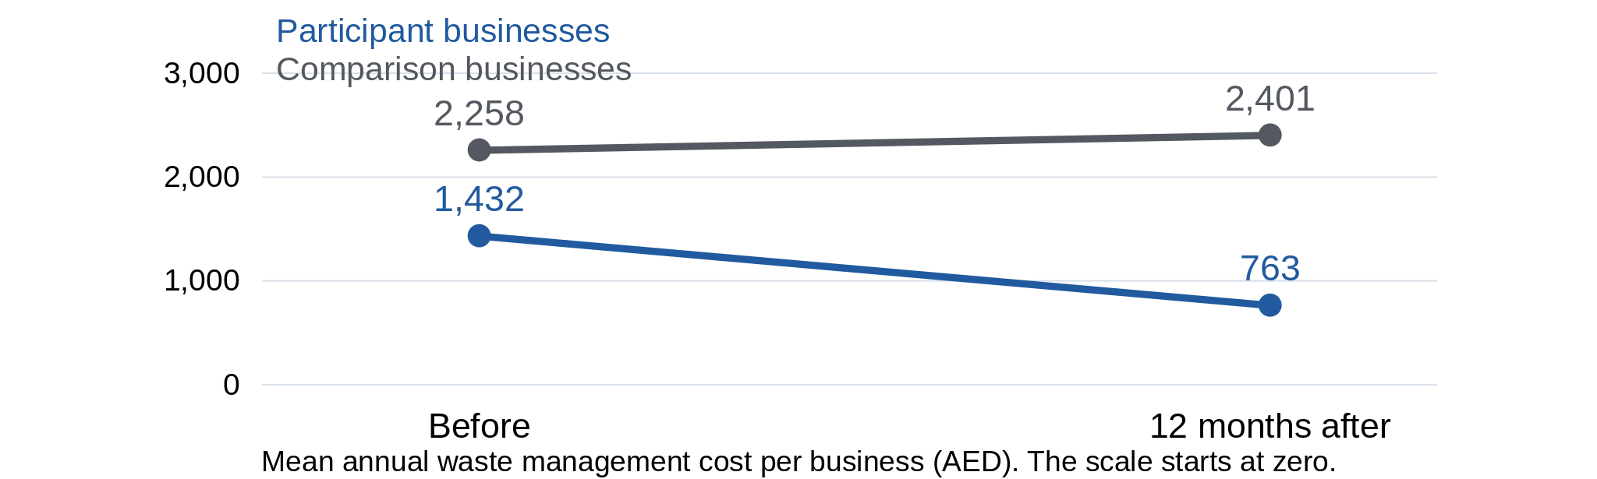
Each mean uses all the businesses in that group. Figures are rounded. A lottery did not decide which businesses took part, and the two groups had different costs before GreenWaste.
Before and after: for the same participant businesses, the mean cost after minus the mean cost before is -669 AED.
With and without: after the programme, the participant businesses’ mean cost minus the comparison businesses’ mean cost is -1,638 AED.
Neither comparison alone shows how much of the fall GreenWaste caused. Our rule is a reduction in annual waste management cost of at least 1,000 AED per business per year, caused by the programme.
Source key
Source: GreenWaste city data (10,000 businesses). Decision cards 2 and 3 use a before-and-after regression for the same 4,794 participant businesses, measured twice. It shows a change of -669 AED, with a 95% interval of -684 to -654 AED and p < 0.001. The interval describes the mean change. It does not describe individual businesses, and it does not show the effect of the programme.
GreenWaste: comparing groups | Day 1 | Session 2 | GreenWaste is a fictional training case.
Page 2 | Meet the records and the distribution
Opening judgement
The mean annual waste management cost of participant businesses fell by 669 AED. Does this tell us the effect of the programme? Write one reason. We will come back to it at the end of the session.

Q1 | Describe one business and the group it belongs to
Use H2-A1 on page 1.
(a) Write one sentence about business B00402. Say whether it took part, what its cost was before and after, and over what period.

(b) Which group of businesses does the participant average describe, and how many businesses are in it?

H2-A: Costs before GreenWaste
Histogram of annual waste management cost before GreenWaste for all 10,000 city businesses (AED, in bands of 250 AED)
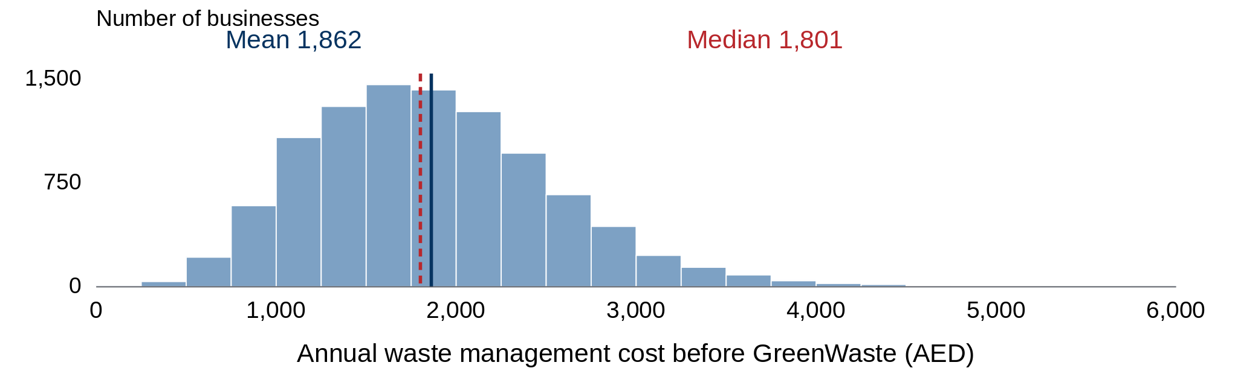
The mean and the median are marked on the histogram.
Q2 | What does the average hide?
(a) Write one description of the histogram that the data support.

(b) Write one thing that the mean alone cannot tell you.

GreenWaste: comparing groups | Day 1 | Session 2 | GreenWaste is a fictional training case.
Page 3 | Read two comparisons
H2-A3
Histogram of the change in annual waste management cost for the 4,794 participant businesses (AED)
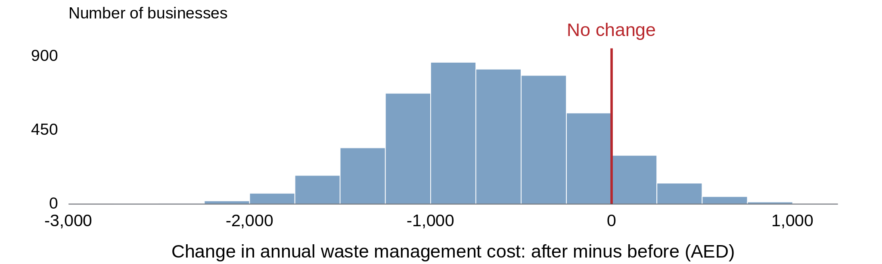
Each business’s change is its cost after minus its cost before. The histogram shows the changes that were recorded. It is not a confidence interval, and it does not show the effect of GreenWaste on each business.
Q3 | The same participant businesses, before and after
(a) Use H2-A2 (the table of mean costs by group) on page 1. Calculate the change in mean cost for participant businesses, and write what it shows, with units and period.

(b) Use the histogram. Did the cost fall for every business?

(c) Suppose waste-service prices changed during the year. This is a hypothetical example, not a fact about the case. What evidence would help separate a price change from the effect of GreenWaste?

Q4 | Comparison businesses and the difference after the programme
(a) Calculate the change in mean cost for comparison businesses.

(b) Calculate the difference between the mean cost of participant businesses and of comparison businesses after the programme.

(c) Explain why we cannot give GreenWaste the credit for the whole difference.

The two comparisons
Comparison | What it compares | What is missing
Before and after: -669 AED | The same participant businesses, cost after minus cost before | Their cost after a year without GreenWaste is not known.
With and without: -1,638 AED | Participant businesses compared with comparison businesses, after a year | We do not know whether these two groups are a fair comparison.

Before GreenWaste, the mean cost was 1,432 AED for participant businesses and 2,258 AED for comparison businesses. Different recorded changes do not by themselves prove that GreenWaste caused a change, or show which way any bias goes.
GreenWaste: comparing groups | Day 1 | Session 2 | GreenWaste is a fictional training case.
Page 4 | Q5: Four decision cards
Use the cards and H2-A (the city data tables and charts). For each card: (a) choose Act, Ask first or Do not act; (b) write what the source supports; (c) write one question you would ask and why the answer matters; (d) say which action you mean.
Card 1
Decision (Act, Ask first or Do not act) and the action you mean: _______________________________
What the source supports:

Your question and why the answer matters:

Card 2
Decision (Act, Ask first or Do not act) and the action you mean: _______________________________
What the source supports:

Your question and why the answer matters:

Card 3
Decision (Act, Ask first or Do not act) and the action you mean: _______________________________
What the source supports:

Your question and why the answer matters:

Card 4
Decision (Act, Ask first or Do not act) and the action you mean: _______________________________
What the source supports:

Your question and why the answer matters:

My final reading and request
Close the AI responses and turn over the decision cards, and keep H2-A2 (the table of mean costs by group) open.
(a) Write one conclusion that the data support.

(b) Write one specific piece of evidence you would request to help decide whether to expand GreenWaste.

(c) Compare this with the reason you wrote on page 2. What changed?

GreenWaste: comparing groups | Day 1 | Session 2 | GreenWaste is a fictional training case.
Page 5 | AI exercise
Part A: Mark the response
Naive prompt (a prompt with no context, as a busy person might type it): “Explain H2-A2 and advise whether to expand GreenWaste.” This response was written for the exercise. It is not a real AI answer. Underline the passages that H2-A2 supports. Cross out the claims that H2-A2 does not support.
The chart shows a strong improvement: participant businesses' average annual waste cost fell from 1,432 to 763 AED, while costs for comparison businesses rose from 2,258 to 2,401 AED. The participant reduction of 669 AED is therefore unlikely to be just a city-wide fall in waste costs.
After a year, participant businesses paid 1,638 AED less than comparison businesses. This is the saving attributable to GreenWaste, because the comparison businesses show what would have happened without it. It exceeds the authority's 1,000 AED annual saving rule.
The two groups began at different cost levels, so caution is appropriate. However, the chart's diverging lines confirm that the programme worked across participant businesses. A wider rollout should deliver similar savings, with monitoring to check delivery quality.
Part B: Run the improved prompt, then compare
Copy the prompt below and H2-A2 into Microsoft Copilot, and keep your AI good-practice card beside you. If you are not using Copilot, read the prepared response on page 6 after you finish Part A.
Improved prompt
Help a policy adviser read H2-A2 for a decision on expanding GreenWaste. The outcome is mean annual waste management cost per business in AED, measured before GreenWaste and 12 months after. The city has 4,794 participant businesses (score 58 or below) and 5,206 comparison businesses that did not receive GreenWaste (score above 58). They were selected by the score rule, not by a lottery. The groups started at different cost levels. Our rule is a reduction of at least 1,000 AED in annual waste management cost per business per year, caused by the programme.
Ask any essential clarifying questions first. Then give three short points: the before-and-after change and the difference between the two groups after the programme; what these comparisons cannot show; and one specific piece of evidence to request before making a recommendation. Cite H2-A2. Do not assume that the comparison businesses show what would have happened to participant businesses without GreenWaste. Do not assume that a mean describes every business. Do not assume that these results apply nationwide.
(a) What improved compared with Part A?

(b) Which claims are still unsupported?

(c) Which table or figure should you check each claim against?

GreenWaste: comparing groups | Day 1 | Session 2 | GreenWaste is a fictional training case.
Page 6 | Prepared response
Use this response if you are not using Copilot. Read it after you have marked the response on page 5. It is an example of a better answer. An AI tool may answer differently.
Before I advise on expansion, I would ask how the efficiency scores were determined, whether other changes affected the two groups differently, and what evidence supports using the comparison businesses to estimate participant businesses' costs without GreenWaste.
H2-A2 records a 669 AED mean fall among participant businesses and a 143 AED mean rise among comparison businesses. After the programme, the participant businesses' mean cost is 1,638 AED lower than the comparison businesses' mean cost. But the participant businesses already had lower mean costs before the programme (1,432 AED, compared with 2,258 AED). Neither the before-and-after change nor the difference between the groups after the programme is, on its own, a credible estimate of a saving caused by GreenWaste.
The group means do not show that every business improved or that national expansion would produce the same result. Before I judge whether GreenWaste meets our rule of at least a 1,000 AED reduction in annual waste management cost per business per year, I would request evidence for a fair comparison. The chart is useful descriptive evidence, but it is not enough by itself for a decision on expansion.
Check it against H2-A2 (the table of mean costs by group), as you would check a live AI answer.
(a) Does it separate what was observed, what a fair comparison would need, and what decision to make?

(b) Which clarifying question in the response is most helpful?

(c) What evidence is still needed before advising on expansion?

GreenWaste: comparing groups | Day 1 | Session 2 | GreenWaste is a fictional training case.
Page 7 | Check the data before you calculate
These questions go with the R slides on the file, the filter and the cleaning examples.
Q6 | What is in the file?
(a) How many rows and columns does the GreenWaste file have, and what does each row represent?

(b) How many of the rows are city businesses and how many are pilot businesses?

Q7 | Which businesses are in the calculation?
(a) Why do we keep only the city rows before we calculate the city averages?

(b) A colleague included the pilot businesses by mistake. How could you tell from the number of participant businesses?

Q8 | Invented cleaning examples
(a) Choose one of the four problems on the slide. Write what went wrong and how it changes the answer.

(b) Why is a wrong structure in the data more dangerous than a calculation that stops with an error message?

