Module 2 · Day 1, Session 2 · What Do the Numbers Say?
Annotate this output
The before-and-after regression for the road segments that got speed cameras. Outcome: injury collisions per road segment, 2019 (round 0) and 2021 (round 1). Standard errors are clustered by road segment. The p-value is the column R printed as Pr(>|t|).
 | Estimate | Std. Error | p-value | CI Lower | CI Upper
(Intercept) | 11.498 | 0.259 | <0.001 | 10.990 | 12.007
round | -2.525 | 0.240 | <0.001 | -2.996 | -2.054
Illustrative case, with invented figures. Not a real programme.
On the table above
1. Which number is the before-and-after change? Circle it.
2. Where is its confidence interval? Draw a box around it.
3. Which number is the 2019 average? Underline it. Why is it not an effect?
____________________________________________________________________________
____________________________________________________________________________
4. What comparison would you ask the evaluator for?
____________________________________________________________________________
____________________________________________________________________________

Module 2 · Day 1, Session 2 · What Do the Numbers Say?
AI Snapshot: ask AI to read the chart
Average injury collisions per road segment in the sectors that got speed cameras.
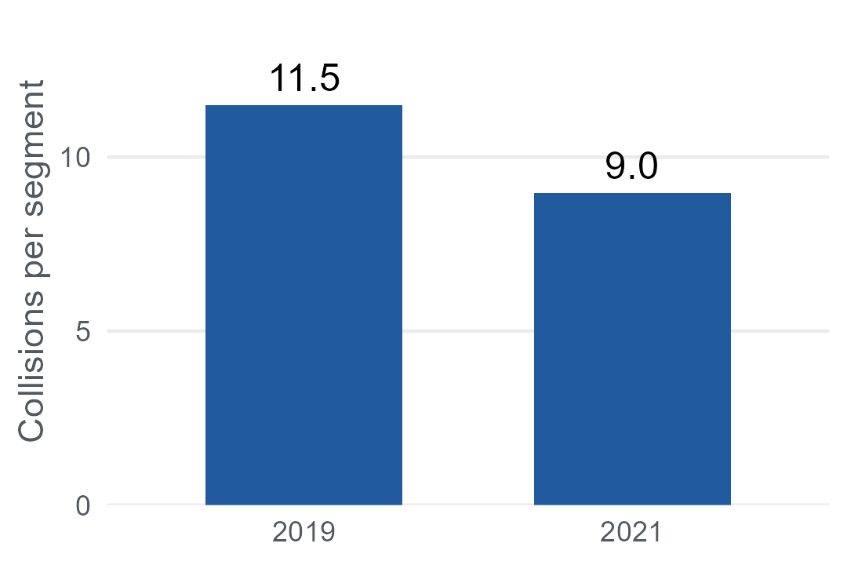
Illustrative case, with invented figures. Not a real programme.
To give the AI the chart, photograph the chart on this sheet and attach the photo to your prompt.
The prompt most people would type, with a picture of the chart:
"What does this chart show? Did the cameras work?"
A response like this is possible
"The chart shows a 22% reduction in injury collisions after speed cameras were installed, from 11.5 to 9.0 per road segment. This reduction is statistically significant (p < 0.001), confirming that the cameras caused the decline. The fall was consistent across all road types, which suggests the effect is robust. Given the size of the effect, the programme should be extended to the remaining sectors."
In pairs: which of these claims can you check against the chart, and which does the chart support?
____________________________________________________________________________
____________________________________________________________________________
____________________________________________________________________________
Then run this prompt instead, and compare
"This chart shows average injury collisions per road segment in the sectors that got speed cameras, in 2019 and 2021. Describe only what the chart shows. Then list what else could explain the change, and what comparison you would need before saying the cameras caused it. Before you answer, ask me any questions you need."
Run both prompts on the same chart. What does the second answer include that the first left out? Paste the second answer into a fresh chat: which claims does it flag that the chart cannot support?

Module 2 · Day 1, Session 2 · What Do the Numbers Say?
Take-away card: three questions to ask the evaluator
Three questions to ask the evaluator  1. How big? In the units the decision is written in, not a percentage.  2. How sure? Does the confidence interval clear the rule, not just zero?  3. Compared to what? Which group, which period, and did it move too?  On my desk: the last figure I was sent. Was it before-and-after? What would I compare it with?  ______________________________ | Three questions to ask the evaluator  1. How big? In the units the decision is written in, not a percentage.  2. How sure? Does the confidence interval clear the rule, not just zero?  3. Compared to what? Which group, which period, and did it move too?  On my desk: the last figure I was sent. Was it before-and-after? What would I compare it with?  ______________________________
Three questions to ask the evaluator  1. How big? In the units the decision is written in, not a percentage.  2. How sure? Does the confidence interval clear the rule, not just zero?  3. Compared to what? Which group, which period, and did it move too?  On my desk: the last figure I was sent. Was it before-and-after? What would I compare it with?  ______________________________ | Three questions to ask the evaluator  1. How big? In the units the decision is written in, not a percentage.  2. How sure? Does the confidence interval clear the rule, not just zero?  3. Compared to what? Which group, which period, and did it move too?  On my desk: the last figure I was sent. Was it before-and-after? What would I compare it with?  ______________________________
Three questions to ask the evaluator  1. How big? In the units the decision is written in, not a percentage.  2. How sure? Does the confidence interval clear the rule, not just zero?  3. Compared to what? Which group, which period, and did it move too?  On my desk: the last figure I was sent. Was it before-and-after? What would I compare it with?  ______________________________ | Three questions to ask the evaluator  1. How big? In the units the decision is written in, not a percentage.  2. How sure? Does the confidence interval clear the rule, not just zero?  3. Compared to what? Which group, which period, and did it move too?  On my desk: the last figure I was sent. Was it before-and-after? What would I compare it with?  ______________________________

