Module 2 · Day 3, Session 2 · What Can You Read? What Might Be Wrong?
Six pairs tracker
Each section of this session shows the same data drawn two ways. For every pair, in groups: what is this figure telling you, and what might be wrong or misleading?
Pair | What is it telling you? | What might be wrong or misleading?
1. The same gap, two axes
2. A bar of means, then the distributions
3. Percentages: zero bases, biggest wins, two averages
4. After only, then before and after
5. Savings added up, then discounted
6. The pie, then the counts
Predict before the reveal
Share of enrolled businesses that paid more than the average non-enrolled business: ________ %
The pooled change in child collisions and the average of each segment's change: close, or far apart? ________
The discount rate at which five years of savings no longer cover the 1,800 AED cost: ________ %

Module 2 · Day 3, Session 2 · What Can You Read? What Might Be Wrong?
AI Snapshot: which chart is fairer?
The two GreenWaste baseline figures: the same gap between enrolled and not-enrolled businesses, drawn twice.
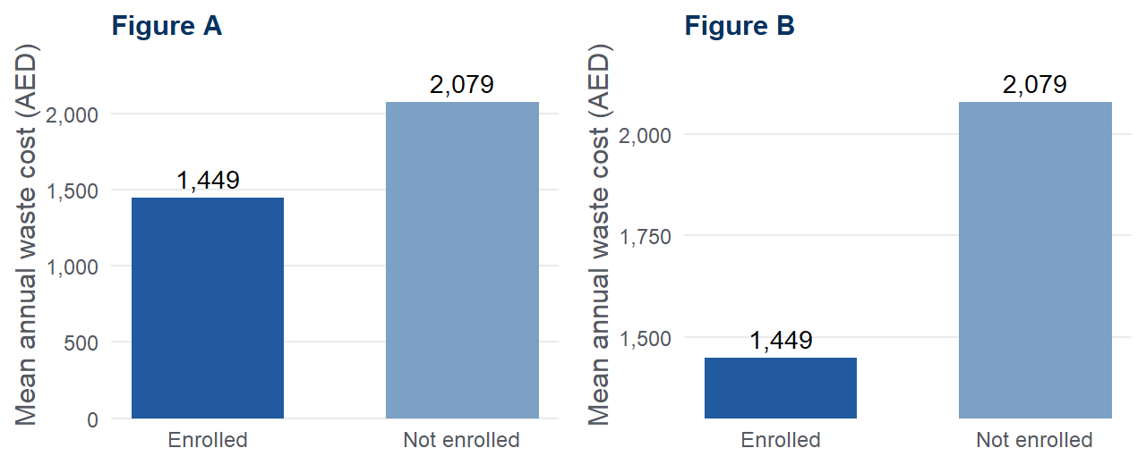
Give the model both figures and this prompt:
"Which of these two charts better represents the difference between the two groups, and why?"
A response like this is possible
Both charts present the same underlying data accurately. The truncated-axis chart is often preferable for a policy audience because it makes the difference visible, and a y-axis that starts at zero is not a requirement in professional data visualisation. On balance the truncated version communicates the finding more effectively, and a reader who wants the absolute values can consult the data labels.
Four minutes. Is it right? Does it answer the question that was asked? What does it explain well?
____________________________________________________________________________
____________________________________________________________________________
____________________________________________________________________________
Then run this prompt instead, and compare
"This chart will sit beside the claim 'the programme reduced costs substantially'. Is the axis appropriate for that claim, for a non-technical reader?"
Two habits: ask the AI to ask you questions before it answers, and paste its answer into a fresh chat to check it.

Module 2 · Day 3, Session 2 · What Can You Read? What Might Be Wrong?
Take-away card: five rules for any figure
Five rules for any figure  1. Read the axis before the shape.  2. Ask what the bar is averaging over.  3. Check the denominator.  4. Compare changes, not levels.  5. Discount the future in front of the reader.  The fastest check: read the y-axis, then the sentence under the figure. Large compared to what?  Questions I will bring to the clinic:  ______________________________  ______________________________ | Five rules for any figure  1. Read the axis before the shape.  2. Ask what the bar is averaging over.  3. Check the denominator.  4. Compare changes, not levels.  5. Discount the future in front of the reader.  The fastest check: read the y-axis, then the sentence under the figure. Large compared to what?  Questions I will bring to the clinic:  ______________________________  ______________________________
Five rules for any figure  1. Read the axis before the shape.  2. Ask what the bar is averaging over.  3. Check the denominator.  4. Compare changes, not levels.  5. Discount the future in front of the reader.  The fastest check: read the y-axis, then the sentence under the figure. Large compared to what?  Questions I will bring to the clinic:  ______________________________  ______________________________ | Five rules for any figure  1. Read the axis before the shape.  2. Ask what the bar is averaging over.  3. Check the denominator.  4. Compare changes, not levels.  5. Discount the future in front of the reader.  The fastest check: read the y-axis, then the sentence under the figure. Large compared to what?  Questions I will bring to the clinic:  ______________________________  ______________________________

