Behind the world’s COVID-19 vaccination target: a SEIR simulation of avoidable deaths and hospitalisations

Lucas Sempe[1]

Aravinda Guntupalli[2]

Peter Lloyd-Sherlock[3]

# 1 Introduction

A year after the launch of the COVID-19 vaccine immunisation process across countries, we note two facts. Vaccines have been proved very effective against existing variants of COVID-19 both in terms of preventing the acquisition of severe disease, hospitalisation and death; and also in terms of slowing down the spread of infections(Imai and Tanaka 2021).

Although the way out of the pandemics requires a worldwide solution, we note that the vaccine roll-out has been very inequality across countries. While many developed nations will have reached high vaccination coverages by the end of 2021 and before the upraise of the highly transmissible Omicron variant (Thakur et al. 2021), many low- and middle- income countries (LMICs) are still lagging in their vaccination process.

Until the vaccination coverage reaches the vast majority of the worldwide population, there will still be high uncertainty on the future development of the pandemics during the next years. Many factors may play a role as drivers of local or global outbreaks. Many countries have been already through more than one epidemic wave explained by factors such as the appearance of new variants or the easing of non-pharmaceutical interventions.

On 26 November 2021, the World Health Organization (WHO) designated the coronavirus SARS-CoV-2 B.1.1.529 a variant of concern, named Omicron (WHO 2021c). As of 22 December 2021, the Omicron variant was already identified in 110 countries across all six WHO Regions (WHO 2021a), becoming predominant across many countries in January 2022 (Hodcroft 2022). Prior research suggests higher levels of transmission, lower rates of hospitalisation, greater immune evasion and lower vaccine efficacy (Ferguson 2021a; Meng et al. 2021), although information is still limited to certain countries.

Considering the uncertainty of the upraise of Omicron, we simulate various scenarios to capture the potential magnitude on the number of deaths averted in the first semester of 2022 due to a potential vaccination raise towards fulfilling WHO’s goal. This uncertainty significantly increases in LMICs, where civil registration, vital statistics and epidemiological data is still not robust (Lloyd-Sherlock et al. 2020).

# 2 Empirical strategy

We simulated models based on a previously developed extended age-structured (5-year groups, where people over 80 are considered in one group) stochastic compartmental model of SARS-CoV-2 transmission that includes vaccinations (Hogan et al. 2021; Walker et al. 2020). The models considers the progression of the population across transmission compartments (susceptible, exposed, infected, recovered), clinical pathways (need for hospitalisation, oxygen and/or intensive care) and vaccination uptake considering factors such as vaccine availability, prioritisation and coverage. The infection transmission model also considers age-based contact matrices and the efficacy of the vaccine in terms of prevention of infection and severe disease.

SEIR models rely on an extensive set of parameters such as probabilities of hospitalisation, probability of severe disease, hospital capacity and ICU, reproduction rates, among others. Our simulated scenarios are built based on parameters chosen to represent critical factors affecting the evolution of the pandemics and the vaccination process.

Our outcomes of interest are avoidable hospitalisations and deaths. For that purpose, our research design compares estimations between two scenarios for each country: a baseline scenario that reflects the daily average vaccination in the last month and an optimal scenario where the uptake of vaccines is raised to achieved the goal set by the World Health Organisation to vaccinate 70% of the world’s population against COVID-19 by 1 July 2022 (WHO 2021b).For the optimal scenario, we differentiate between countries that did not started providing boosters to their population and those who already started, even being behind WHO’s goal. In the first case, we simulate models with a daily number of vaccines needed to reach two doses for 70% of the population by July 1st 2022, while in the second case, we increase the daily number of vaccines to cover three doses in the same period.

We model two different vaccination approaches. The first strategy prioritises sequentially the oldest age groups until a maximum set coverage is reached. For example, if we set the maximum coverage in 90%, the first age group to be solely vaccinated will be those over 85 years old until it reaches 90% of the age group population. Then, the following group, those aged 80 to 84 will follow on the vaccination process. This occurs until the whole eligible population is covered up to 90%. The second strategy does not prioritise any age groups and allows everyone to be vaccinated at the same time. This is consistent with an ongoing vaccination process in some countries where vaccines are offered simultaneously to the total adult population.

As more than 95% of the global procurement of vaccines require two-dose vaccines, our models assume a fully vaccinated person with two vaccines(IMF-WHO 2022; WHO 2022). Considering that the models used only simulate a single vaccine product, we consider the complexity of multiple vaccine products by weighting the vaccine effectiveness over time (MRC-IDE 2022). Our models assume a dual effect of vaccines effectiveness in terms of blocking infection and severe disease. We compute for each country the vaccination effectiveness decay and use the world average. This is based on the time since first vaccination and the time between first dose and second dose (we assume 90 days), the decay rate, and different efficacy parameters. Modelling countries that did not start providing boosters, we assume 30% and 60% of infection blocking effectiveness after one and two doses, respectively. In case of blocking disease, we assume 40% and 80%, respectively. For countries that started applying a booster dose, values are 60% and 80% for infection blocking, and 80% and 95% for severe disease blocking. We assume that individuals who have been vaccinated have a 40% reduction in infectiousness if infected. These chosen efficacy values broadly reflect the range of estimated efficacies seen in response to the Omicron variant (Ferguson 2021b, 2021c; “Report 12 - the Global Impact of COVID-19 and Strategies for Mitigation and Suppression,” n.d.; Khoury et al. 2021; Collie et al. 2021). These values do not reflect a specific vaccine as there are unknowns over each specific country vaccine roll out.

The probability of hospitalisation is reduced to 60% in comparison to the prior variants (Ferguson 2021c). We assume that the mean duration of vaccine and naturally acquired immunity goes beyond the number of days modelled.

We also simulate two set of starting number of infected cases: the officially reported number of cases of the last two weeks until February 8th 2022; this value is multiplied by 3, assuming the lack of massive testing and under-reporting of cases (Lau et al. 2021).

We use a constant effective reproduction number of 1.2 to 1.5, by .1 across the models time period (Wees et al. 2021; Huang et al. 2022; Ignatov and Trigger 2022). This assumes the pandemics is not suppressed during the first semester of 2022.

The number of people in the first state of the transmission model (those susceptible to the disease) corresponds to the country population. This value is based on the high levels of reinfection found across countries such as South Africa and England (Ferguson 2021b; Pulliam et al. 2021). We assume a uniform distribution of the vaccinations across adults due to the lack of available data.

Recent evidence converge in showing the generation time for the Omicron variant is shorter than the previous predominant variant Delta (Abbott et al. 2022; Liu et al. 2021). Following that, we assume the following parameters: mean duration of 2 days for the incubation period, mean of 2.6 days for a mild infection and a mean of 3.8 days for symptoms onset to admission to hospital.

The time period for the analysis is from 8 February 2022 to 1 July 2022, which is set by the World Health Organisation as the limit to vaccinate 70% of the world’s population against COVID-19 (WHO 2021b). Table 2.1 provides a summary of main parameters.Additional country-specific, epidemiological and vaccination parameters were compiled by Hogan et al (Hogan et al. 2021) and updated in the R package [‘nimue’](https://github.com/mrc-ide/nimue), where original sources of data are given. Infections and vaccine data are collected from Our World in Data (Roser et al. 2020). Probabilities of death according different states and age groups (severity of disease, treatment) can be found in the Appendix.

Table 2.1: Parameters used across simulation scenarios

| Parameter | Value | Reference |
| --- | --- | --- |
| R0 | 1.1; 1.2; 1.3; 1.4; 1.5 | (Wees et al. 2021; Huang et al. 2022; Ignatov and Trigger 2022) |
| Maximum vaccines per day | 0; average last month; needed to reach 70% goal (without and with booster) | (Roser et al. 2020; WHO 2021b) |
| Initial number of infected cases | Official country statistics (OCS); OCSx3 | (Roser et al. 2020) |
| Vaccinantion prioritisation strategy | No prioritisation; Age-group priority | (Hogan et al. 2021) |
| Maximum coverage per age group | 0.9 | Assumed |
| Vaccine efficacy against infection | See graph | Based on (MRC-IDE 2022) |
| Vaccine efficacy against severe disease (hospitalisation) | See graph | Based on (MRC-IDE 2022) |
| Mean duration of natural-acquired immunity | >155 days | Assumed |
| Mean duration of vaccine-derived immunity | >155 days | Assumed |
| Duration Incubation period | 2.1 days | (Abbott et al. 2022; Liu et al. 2021) |
| Mean duration of period from vaccination to vaccine protection | 14 days | (MRC-IDE 2022) |
| Mean duration of mild infection | 2.6 days | (Abbott et al. 2022; Liu et al. 2021) |
| Mean duration from symptom onset to hospitil admission | 3.8 days | (Abbott et al. 2022; Liu et al. 2021) |
| Probability of hospitalisation in comparison to previous variants | 0.6 | (Ferguson 2021c) |
| Modelling period | 144 days (February 8th to June 30th) | Assumed |
| Relative infectiousness vaccinated | 0.5 | Assumed |

# 3 Results

We find that, based on projecting each last month total doses remains constant until July 1st 2022, 94 countries are behind WHO’s goal (see Figure 3.1) distributed across the world: 47 counties in Africa, 14 in the Americas, 16 in Asia, 12 in Europe and 5 in Oceania. 21 countries are small islands with a population less than 600,000 people each. Additionally, 27 of these countries already started to provide boosters to their population although they do are behind track in terms of providing two doses for 70% of their population. The number of countries is inferior to the presented by [OWID](https://ourworldindata.org/covid-vaccination-global-projections), as they consider the average number of people who received their first dose of a vaccine per day, over the last 14 days, while our model considers the the average number of people who received any dose of a vaccine per day, over the last 30 days. See full list of countries in the Appendix.

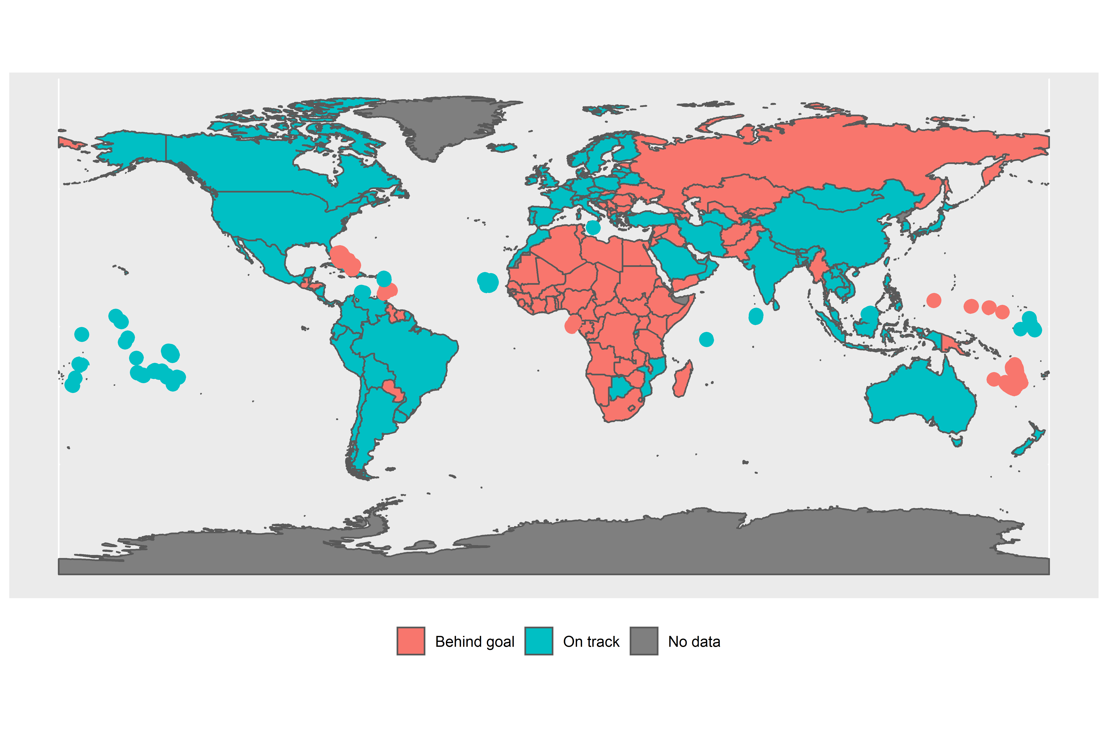

Figure 3.1: Countries status according to WHO’s vaccination goal based on last month vaccination uptake

Figure 3.2 shows that the gap between countries on track and those behind track is widening across the world as the average of daily vaccinations per population across countries is larger on those that are already on track. In all regions, we observe that the average of vaccination relative to the population is lower for the lagged countries. Based on the unvaccinated population and assuming the need of at least two doses per person during the first semester of 2022, we estimate that one billion, six hundred ninety million doses are needed to be administered in order to achieve the target of vaccinating 70% of these countries’ population. Considering a programmatic delivery cost of US$ 10 per dose (WHO 2021b), the estimation reaches sixteen billion, nine hundred million american dollars.

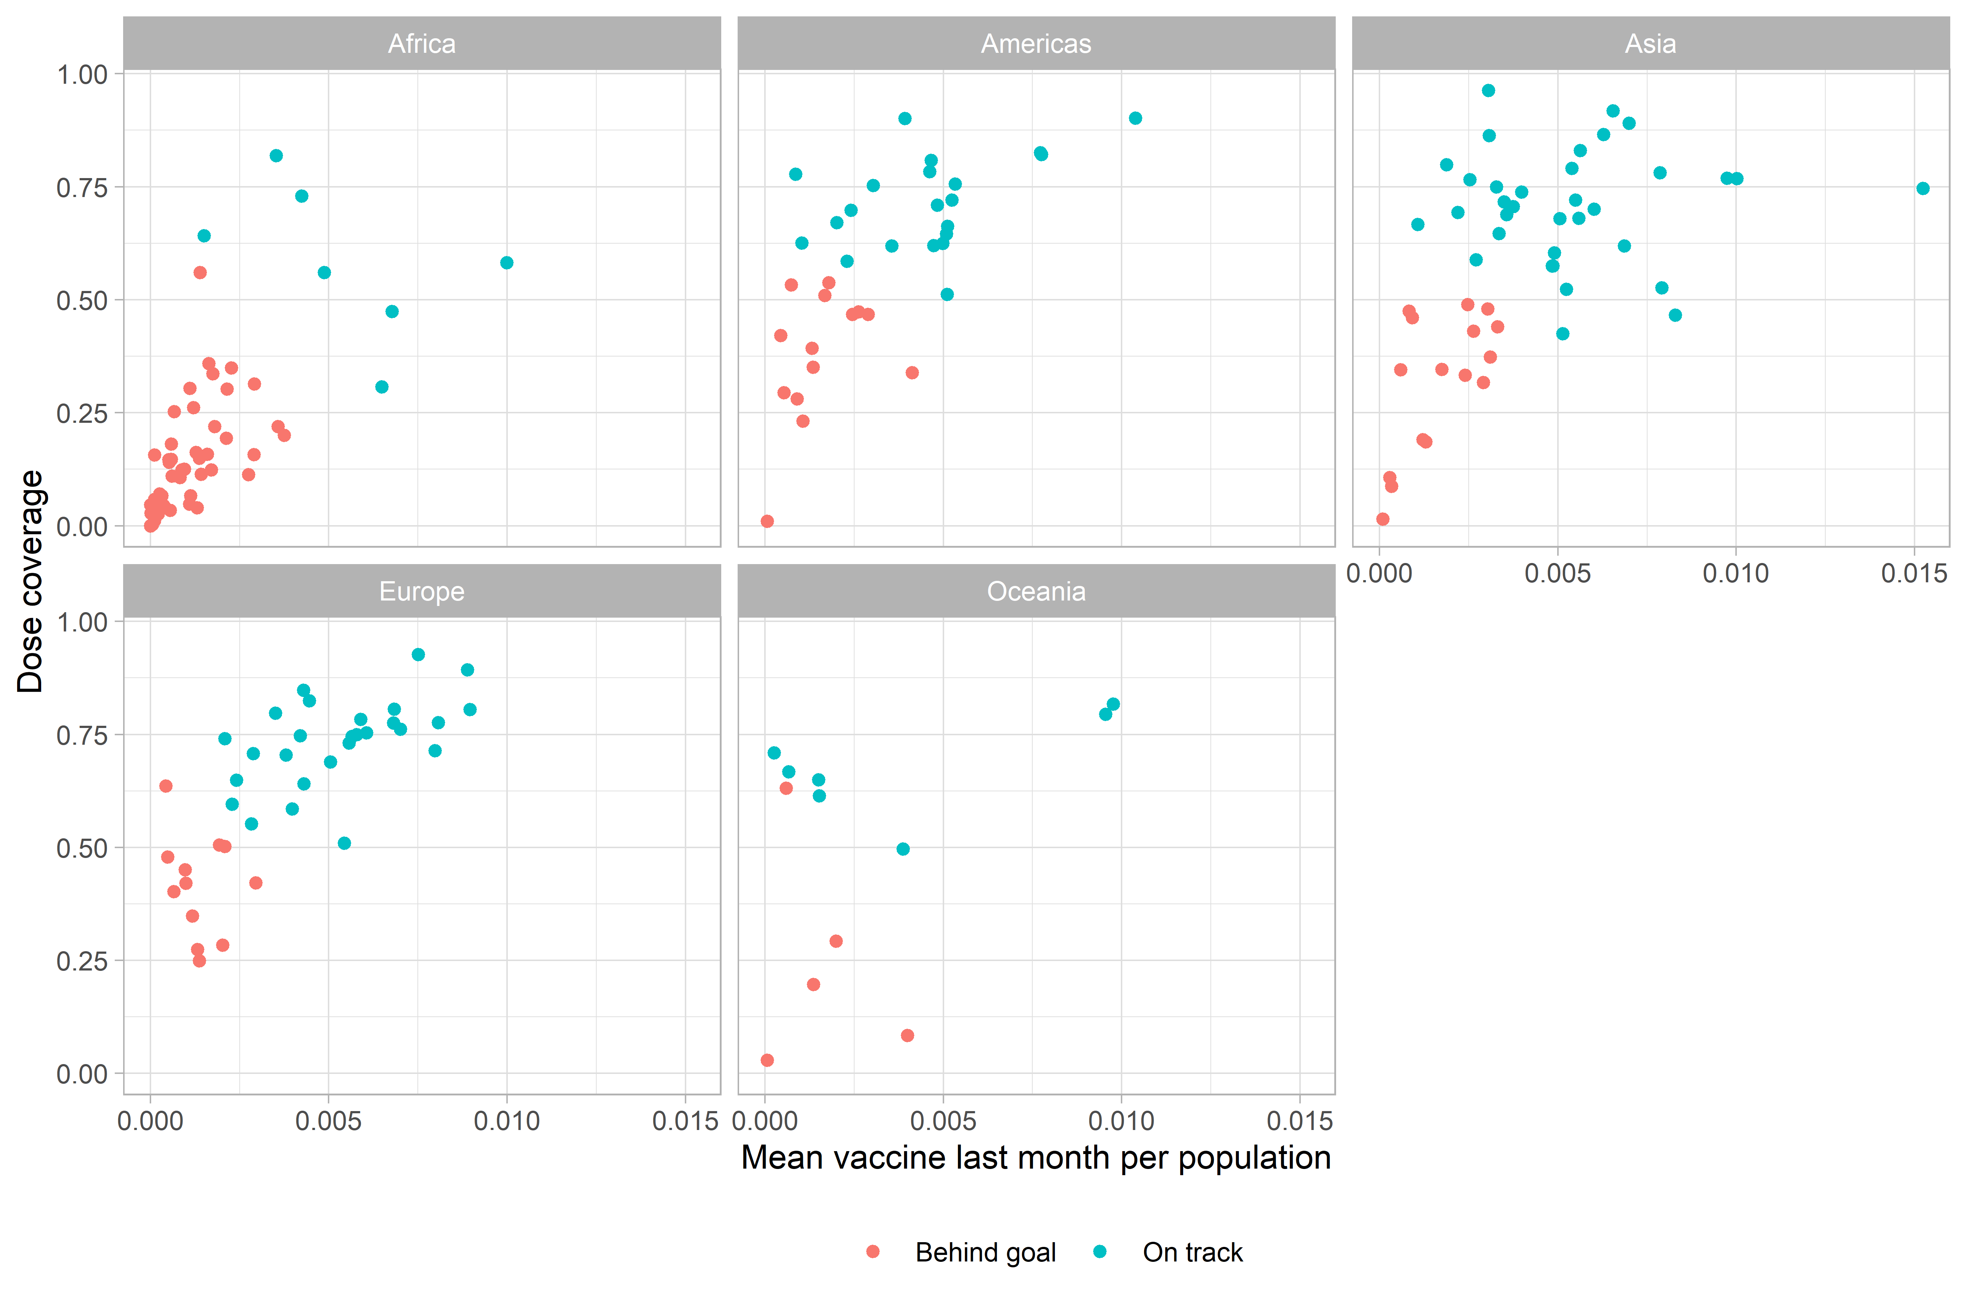

Figure 3.2: Countries last month vaccine uptake and coverage

The combination of the different model parameters provide 32 different scenarios for each country. By comparing a hypothetical scenarios without vaccinations and scenarios where the vaccination coverage reaches 70%, we estimated that vaccines save between 302,627 and 498,185 deaths and prevent 962,937 to 1,496,516 hospitalisations, depending on the combinations of parameters.

Simulations where we keep constant the last month vaccination uptake with a parameter R0 = 1.3 yield an estimated number of deaths ranging from 774,358 to 1,141,763. When compared to the optimal scenario, we estimate the number of avoidable deaths range from 203,965 to 331,617 and the number of avoidable hospitalisations spams from 726,254 to 1,091,376, depending on the combinations of parameters. Table 3.1 shows the maximum and minimum number of averted deaths and hospitalisations computed across different R0. In the case of the scenarios of averted deaths, the differences between values do not change substantially when R is 1.3 or higher. In the case of the simulation of averted hospitalisations, the minimum values tend to be stable across different, which is explained by the full occupancy of hospital and ICU beds and also the incomplete evolution of the infectious wave due to the period limit imposed to our models.

Table 3.1: Maximum and minimum averted deaths and hospitalisations

| R0 | Max averted deaths | Min averted deaths | Max averted hospitalisations | Min averted hospitalisations |
| --- | --- | --- | --- | --- |
| 1.2 | 159,247 | 79,880 | 690,738 | 412,617 |
| 1.3 | 331,617 | 203,965 | 1,091,376 | 726,254 |
| 1.4 | 385,729 | 253,376 | 1,109,974 | 744,869 |
| 1.5 | 371,573 | 238,609 | 952,584 | 642,555 |

To exemplify differences across scenarios, Figure 3.3 presents the estimation of avoidable deaths across scenarios for the countries with the highest number of avoidable deaths: Nigeria, Ethiopia,Pakistan and Democratic Republic of Congo. Together, they represent between 31% and 30% of the total estimated avertible deaths across different scenarios for R0 = 1.3.

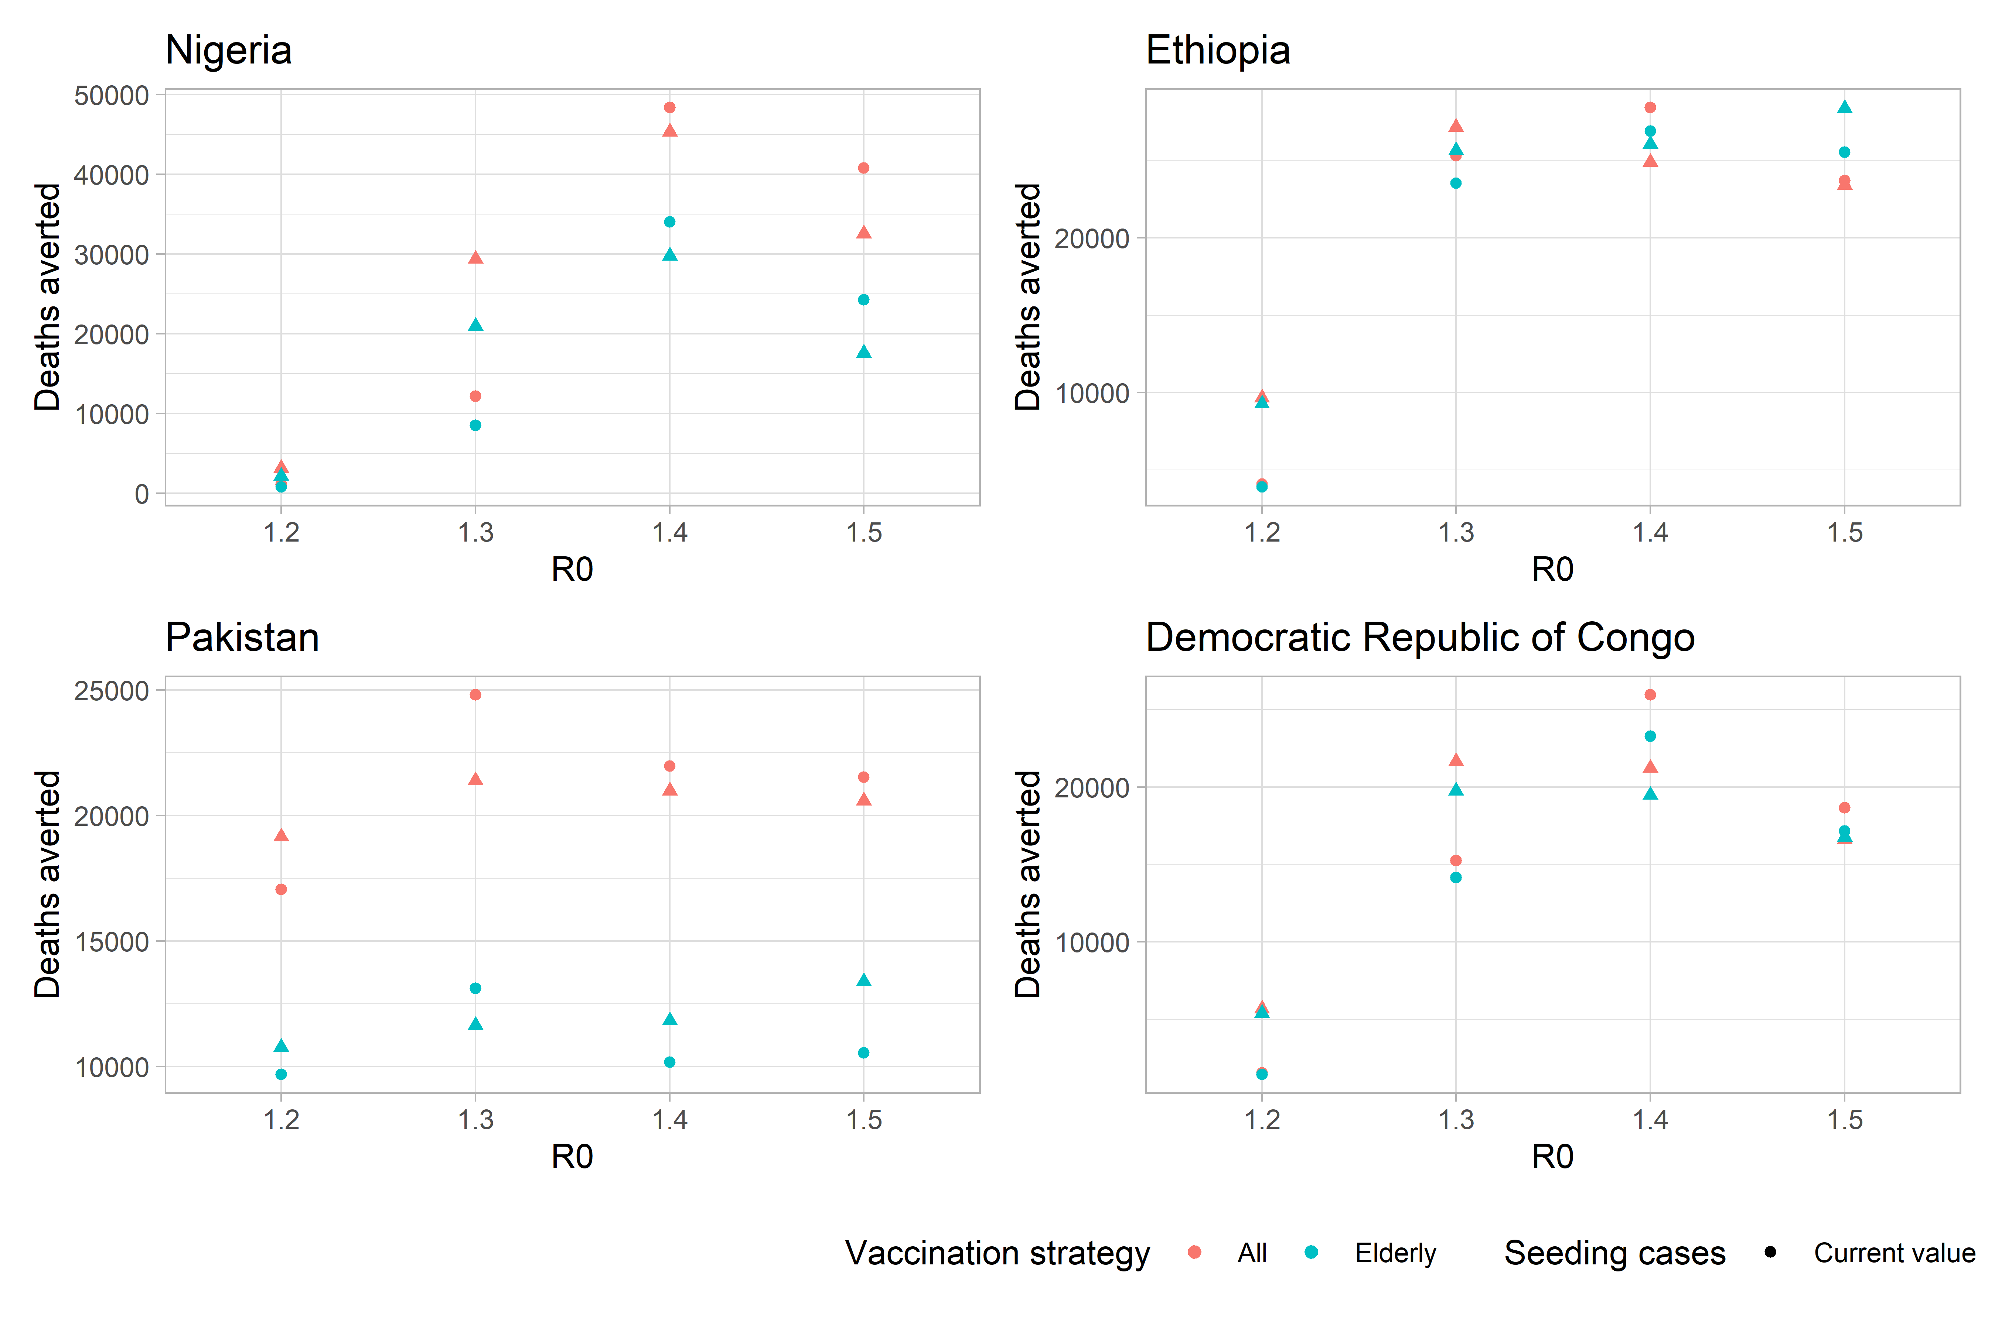

Figure 3.3: Deaths averted across scenarios - selected countries

Across the vast majority of models, between 60% and 70% of avoidable deaths correspond to people of 60 years old. This occurs even in majority of countries that currently portray a younger population age structure such cases of regions such as Africa and Asia. Table 3.2 summarises the scenarios in terms of total avoidable deaths and infections based on R0 = 1.3 for the population over and under 60 years old. We find that the proportion of avoidable deaths benefits older people, ranging from 61% to 65% of the total number of deaths while it is similar across age groups for the total number of hospitalisations, ranging from 47% to 51% for the older people group.

Table 3.2: Proportion of avoidable deaths of older people across simulations

| compartment | vaccine_coverage_mat | population group | value | Proportion older/younger |
| --- | --- | --- | --- | --- |
| deaths | All | older people | 547,181 | 65 |
| deaths | All | younger people | 295,191 | 35 |
| deaths | Elderly | older people | 451,347 | 61 |
| deaths | Elderly | younger people | 284,853 | 39 |
| hospitalisations | All | older people | 1,821,374 | 51 |
| hospitalisations | All | younger people | 1,735,684 | 49 |
| hospitalisations | Elderly | older people | 1,545,469 | 47 |
| hospitalisations | Elderly | younger people | 1,741,545 | 53 |

Figure 3.4 shows how the the selection of a vaccination strategy - in this case the lack of prioritisation versus the one prioritises the older population - have a significant impact in terms of the proportion of avoidable deaths and hospitalisations. Differences between strategies could imply up to 25% more deaths of older people. According to the population age structure, we find that about 25% countries still should prioritise older people in their vaccine strategy.

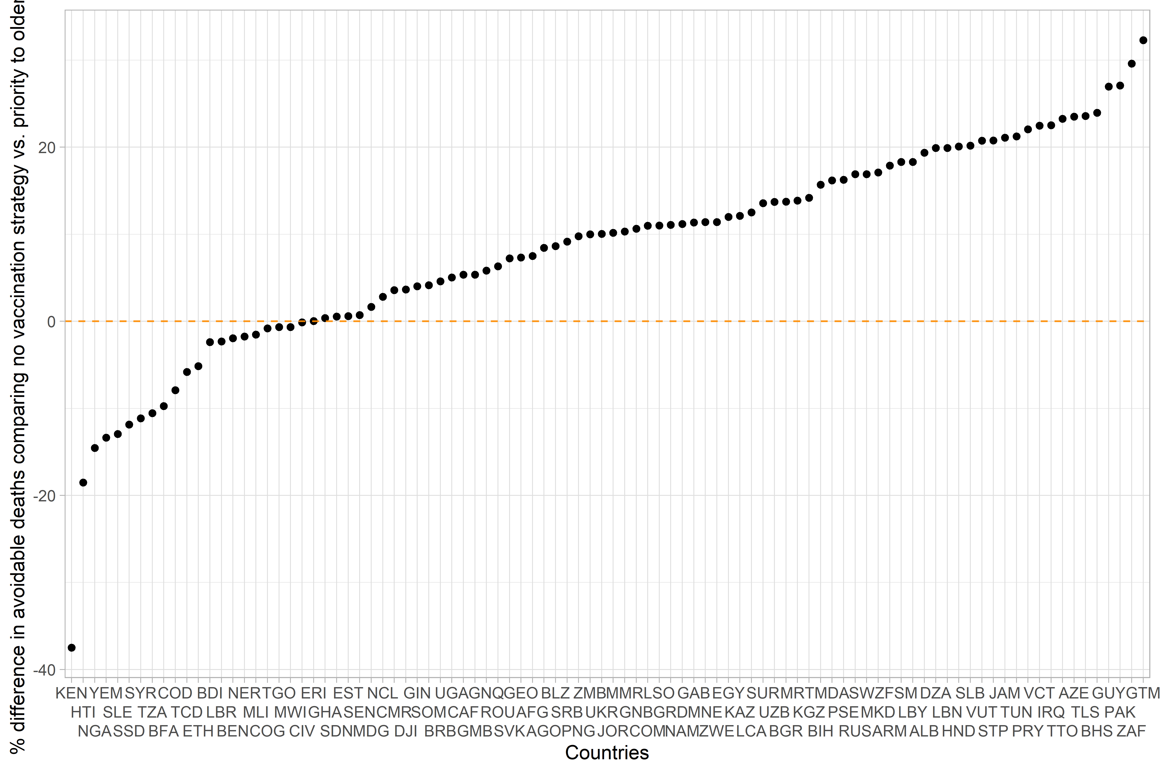

Figure 3.4: % difference in avoidable deaths comparing no vaccination strategy vs. priority to older people

Finally, we perform two different set of robustness checks. First, we perform similar analysis using a 15-days average of vaccines, yielding very similar results in terms of the number of countries behind WHO’s goal. Additionally, we compare our SEIR models results with those presented by the Institute of Health Metrics and Evaluation (IHME, n.d.) and the MRC-IDE at Imperial College (MRC-IDE 2022). As expected, there are not significant differences between models, which are explained by the choice of different parameters.

# 4 Conclusions

These scenarios are built to answer to an ethical framework that aims to find the best possible allocation of COVID-19 vaccines. Our ethical guidelines are the following: we aim to maximise societal health benefits; prioritise those worst-off without the vaccines; and promote equality, where individuals under circumstances shall be treated equally (Persad, Peek, and Emanuel 2020; Emanuel et al. 2020). These principles become operational in terms of saving the most lives; prioritise the most vulnerable populations such as older and immunodeficient people; and protecting health workers. Recently, the WHO SAGE group updated their roadmap for optimal allocation of vaccines across the world, where older adults, health workers, immunocompromised persons, adults with comorbidities, pregnant persons, teachers and other essential workers and disadvantaged subpopulations at higher risk of severe COVID-19 remain the higher priority groups for additional doses and boosters (SAGE 2022).

Our simulations suggest that even with relatively low transmission rates, upraising daily vaccinations could save between 200,000 and 300,000 lives in the analysed countries in the next five months. We also find that that, across all countries - even with different age-population structures - and across models using different parameters, results suggest consistently that older people account for the majority of averted deaths and hospitalisations.

Although accelerating the vaccination levels save thousands of lives, there is still a large number of people that is expected to die, with value spamming from 774,358 to 1,141,763. The only mechanism to avoid unnecessary and preventable deaths relies on countries ramping up the administration of vaccines to complete their population coverage in the shortest possible time.

As with any modelling study, we address several limitations. First, while vaccine efficacy parameters against infection and disease is proven for previous dominant variants, there is still not enough information to establish certain parameters. Estimates of hospitalisations and deaths may be inaccurate due to our working assumptions. However, the presented counterfactual analysis allows to measure the magnitude in terms of differences between vaccination roll-outs.

# 5 References

Abbott, Sam, Katharine Sherratt, Moritz Gerstung, and Sebastian Funk. 2022. “Estimation of the Test to Test Distribution as a Proxy for Generation Interval Distribution for the Omicron Variant in England.” <http://dx.doi.org/10.1101/2022.01.08.22268920>.

Collie, Shirley, Jared Champion, Harry Moultrie, Linda-Gail Bekker, and Glenda Gray. 2021. “Effectiveness of BNT162b2 Vaccine Against Omicron Variant in South Africa.” *New England Journal of Medicine*, December. <https://doi.org/10.1056/nejmc2119270>.

Emanuel, Ezekiel J., Govind Persad, Adam Kern, Allen Buchanan, Cécile Fabre, Daniel Halliday, Joseph Heath, et al. 2020. “An Ethical Framework for Global Vaccine Allocation.” *Science* 369 (6509): 1309–12. <https://doi.org/10.1126/science.abe2803>.

Ferguson, N. 2021b. “Report 49: Growth and Immune Escape of the Omicron SARS-CoV-2 Variant of Concern in England.” Imperial College London. <https://doi.org/10.25561/93038>.

———. 2021a. “Report 49: Growth and Immune Escape of the Omicron SARS-CoV-2 Variant of Concern in England.” <https://doi.org/10.25561/93038>.

———. 2021c. “Report 50: Effectiveness of SARS-CoV-2 Vaccines in England in 2021: A Whole Population Survival Analysis.” Imperial College London. <https://doi.org/10.25561/93035>.

Hodcroft, Emma. 2022. “CoVariants.” <https://covariants.org/>.

Hogan, Alexandra B., Peter Winskill, Oliver J. Watson, Patrick G. T. Walker, Charles Whittaker, Marc Baguelin, Nicholas F. Brazeau, et al. 2021. “Within-Country Age-Based Prioritisation, Global Allocation, and Public Health Impact of a Vaccine Against SARS-CoV-2: A Mathematical Modelling Analysis.” *Vaccine* 39 (22): 2995–3006. <https://doi.org/10.1016/j.vaccine.2021.04.002>.

Huang, Jianping, Yingjie Zhao, Li Zhang, Xu Li, Shuoyuan Gao, and Xiaodong Song. 2022. “Seasonal Prediction of Omicron Pandemic.” <http://dx.doi.org/10.1101/2022.01.13.22269198>.

Ignatov, A. M., and S. A. Trigger. 2022. “Two Viruses Competition in the SIR Model of Epidemic Spread: Application to COVID-19.” <http://dx.doi.org/10.1101/2022.01.11.22269046>.

IHME. n.d. “COVID-19 Projections.” <https://covid19.healthdata.org/>.

Imai, Kenichi, and Hajime Tanaka. 2021. “SARS-CoV-2 Infection and Significance of Oral Health Management in the Era of “the New Normal with COVID-19”.” *International Journal of Molecular Sciences* 22 (12): 6527. <https://doi.org/10.3390/ijms22126527>.

IMF-WHO. 2022. “IMF-WHO COVID-19 Vaccine Tracker.” <https://www.imf.org/en/Topics/imf-and-covid19/IMF-WHO-COVID-19-Vaccine-Tracker>.

Khoury, David S., Megan Steain, James A. Triccas, Alex Sigal, Miles P. Davenport, and Deborah Cromer. 2021. “A Meta-Analysis of Early Results to Predict Vaccine Efficacy Against Omicron.” <http://dx.doi.org/10.1101/2021.12.13.21267748>.

Lau, H., T. Khosrawipour, P. Kocbach, H. Ichii, J. Bania, and V. Khosrawipour. 2021. “Evaluating the Massive Underreporting and Undertesting of COVID-19 Cases in Multiple Global Epicenters.” *Pulmonology* 27 (2): 110–15. <https://doi.org/10.1016/j.pulmoe.2020.05.015>.

Liu, Lihong, Sho Iketani, Yicheng Guo, Jasper F-W. Chan, Maple Wang, Liyuan Liu, Yang Luo, et al. 2021. “Striking Antibody Evasion Manifested by the Omicron Variant of SARS-CoV-2.” *Nature*, December. <https://doi.org/10.1038/s41586-021-04388-0>.

Lloyd-Sherlock, Peter, Lucas Sempe, Martin McKee, and Aravinda Guntupalli. 2020. “Problems of Data Availability and Quality for COVID-19 and Older People in Low- and Middle-Income Countries.” Edited by Suzanne Meeks. *The Gerontologist* 61 (2): 141–44. <https://doi.org/10.1093/geront/gnaa153>.

Meng, Bo, Isabella A. T. M. Ferreira, Adam Abdullahi, Akatsuki Saito, Izumi Kimura, Daichi Yamasoba, Steven A. Kemp, et al. 2021. “SARS-CoV-2 Omicron Spike Mediated Immune Escape, Infectivity and Cell-Cell Fusion.” <https://www.biorxiv.org/content/10.1101/2021.12.17.473248v2>.

MRC-IDE. 2022. “Imperial College COVID-19 LMIC Reports.” <https://mrc-ide.github.io/global-lmic-reports/>.

Persad, Govind, Monica E. Peek, and Ezekiel J. Emanuel. 2020. “Fairly Prioritizing Groups for Access to COVID-19 Vaccines.” *JAMA* 324 (16): 1601. <https://doi.org/10.1001/jama.2020.18513>.

Pulliam, Juliet R. C., Cari van Schalkwyk, Nevashan Govender, Anne von Gottberg, Cheryl Cohen, Michelle J. Groome, Jonathan Dushoff, Koleka Mlisana, and Harry Moultrie. 2021. “Increased Risk of SARS-CoV-2 Reinfection Associated with Emergence of the Omicron Variant in South Africa.” <http://dx.doi.org/10.1101/2021.11.11.21266068>.

“Report 12 - the Global Impact of COVID-19 and Strategies for Mitigation and Suppression.” n.d. <http://www.imperial.ac.uk/medicine/departments/school-public-health/infectious-disease-epidemiology/mrc-global-infectious-disease-analysis/covid-19/report-12-global-impact-covid-19/>.

Roser, Max, Hannah Ritchie, Esteban Ortiz-Ospina, and Joe Hasell. 2020. “Coronavirus Pandemic (COVID-19).” *Our World in Data*.

SAGE, WHO. 2022. “WHO SAGE Roadmap for Prioritizing Uses of COVID-19 Vaccines.” <https://www.who.int/publications-detail-redirect/who-sage-roadmap-for-prioritizing-uses-of-covid-19-vaccines>.

Thakur, Amrit Kumar, Ravishankar Sathyamurthy, Velraj Ramalingam, Iseult Lynch, Swellam Wafa Sharshir, Zhenjun Ma, Ganeshkumar Poongavanam, Suyeong Lee, Yeseul Jeong, and Jang-Yeon Hwang. 2021. “A Case Study of SARS-CoV-2 Transmission Behavior in a Severely Air-Polluted City (Delhi, India) and the Potential Usage of Graphene Based Materials for Filtering Air-Pollutants and Controlling/Monitoring the COVID-19 Pandemic.” *Environmental Science: Processes & Impacts*. <https://doi.org/10.1039/d1em00034a>.

Walker, Patrick G. T., Charles Whittaker, Oliver J. Watson, Marc Baguelin, Peter Winskill, Arran Hamlet, Bimandra A. Djafaara, et al. 2020. “The Impact of COVID-19 and Strategies for Mitigation and Suppression in Low- and Middle-Income Countries.” *Science* 369 (6502): 413–22. <https://doi.org/10.1126/science.abc0035>.

Wees, Jan-Diederik van, Martijn van der Kuip, Sander Osinga, Bart Keijser, David van Westerloo, Maurice Hanegraaf, Maarten Pluymaekers, Olwijn Leeuwenburgh, Logan Brunner, and Marceline Tutu van Furth. 2021. “SIR Model for Assessing the Impact of the Advent of Omicron and Mitigating Measures on Infection Pressure and Hospitalization Needs.” <http://dx.doi.org/10.1101/2021.12.25.21268394>.

WHO. 2021a. “Enhancing Readiness for Omicron (B.1.1.529): Technical Brief and Priority Actions for Member States.” <https://www.who.int/publications/m/item/enhancing-readiness-for-omicron-(b.1.1.529)-technical-brief-and-priority-actions-for-member-states>.

———. 2021b. “Strategy to Achieve Global Covid-19 Vaccination by Mid-2022.” World Health Organisation.

———. 2021c. “Update on Omicron.” 2021. <https://www.who.int/news/item/28-11-2021-update-on-omicron>.

———. 2022. “COVID-19 Vaccination Data.” <https://app.powerbi.com/view?r=eyJrIjoiMWNjNzZkNjctZTNiNy00YmMzLTkxZjQtNmJiZDM2MTYxNzEwIiwidCI6ImY2MTBjMGI3LWJkMjQtNGIzOS04MTBiLTNkYzI4MGFmYjU5MCIsImMiOjh9>.

# 6 Appendix

## 6.1 Countries behing WHO’s vaccination goal

| iso_a3 | current_coverate | average_vac_month | population | vaccines_per_day_needed |
| --- | --- | --- | --- | --- |
| AFG | 0.1 | 11,291 | 38,928,340 | 320,861 |
| ALB | 0.4 | 8,504 | 2,877,799 | 11,127 |
| DZA | 0.1 | 22,589 | 43,851,042 | 337,318 |
| AGO | 0.2 | 117,543 | 32,866,267 | 219,450 |
| ARM | 0.3 | 8,638 | 2,963,233 | 15,752 |
| AZE | 0.5 | 25,102 | 10,139,174 | 29,692 |
| BHS | 0.4 | 518 | 393,247 | 1,676 |
| BRB | 0.5 | 212 | 287,370 | 666 |
| BLZ | 0.5 | 712 | 397,620 | 894 |
| BEN | 0.2 | 15,467 | 12,123,197 | 90,561 |
| BIH | 0.3 | 4,315 | 3,280,814 | 19,402 |
| BGR | 0.3 | 14,081 | 6,948,444 | 40,136 |
| BFA | 0.0 | 7,683 | 20,903,277 | 190,118 |
| BDI | 0.0 | 55 | 11,890,780 | 115,497 |
| CMR | 0.0 | 360 | 26,545,863 | 247,908 |
| CAF | 0.1 | 4,265 | 4,829,763 | 38,678 |
| TCD | 0.0 | 1,886 | 16,425,858 | 157,060 |
| COM | 0.4 | 1,421 | 869,594 | 4,118 |
| CIV | 0.1 | 13,815 | 26,378,274 | 205,054 |
| COD | 0.0 | 4,856 | 89,561,403 | 866,817 |
| DJI | 0.1 | 593 | 988,001 | 8,093 |
| EGY | 0.3 | 297,906 | 102,334,402 | 548,555 |
| GNQ | 0.2 | 165 | 1,402,984 | 10,578 |
| ERI | 0.0 | 0 | 3,546,426 | 34,479 |
| EST | 0.6 | 577 | 1,326,538 | 1,177 |
| SWZ | 0.3 | 2,489 | 1,160,163 | 6,403 |
| ETH | 0.0 | 868 | 114,963,582 | 1,043,374 |
| GAB | 0.1 | 3,165 | 2,225,727 | 18,118 |
| GMB | 0.1 | 2,299 | 2,416,663 | 19,294 |
| GEO | 0.3 | 6,982 | 3,989,174 | 19,599 |
| GHA | 0.2 | 90,181 | 31,072,944 | 233,996 |
| GRD | 0.4 | 151 | 112,518 | 546 |
| GTM | 0.3 | 73,858 | 17,915,566 | 89,913 |
| GIN | 0.2 | 49,197 | 13,132,791 | 91,154 |
| GNB | 0.2 | 1,149 | 1,967,997 | 14,188 |
| GUY | 0.5 | 1,927 | 786,558 | 2,535 |
| HTI | 0.0 | 769 | 11,402,532 | 109,226 |
| HND | 0.5 | 26,031 | 9,904,607 | 31,158 |
| IRQ | 0.2 | 48,859 | 40,222,502 | 284,602 |
| JAM | 0.2 | 3,145 | 2,961,160 | 19,247 |
| JOR | 0.4 | 26,907 | 10,203,139 | 38,148 |
| KAZ | 0.5 | 15,520 | 18,776,706 | 58,612 |
| KEN | 0.1 | 91,637 | 53,771,299 | 430,506 |
| KGZ | 0.2 | 8,484 | 6,524,190 | 46,589 |
| LBN | 0.3 | 16,374 | 6,825,441 | 34,781 |
| LSO | 0.3 | 4,854 | 2,142,251 | 10,424 |
| LBR | 0.2 | 10,776 | 5,057,676 | 35,572 |
| LBY | 0.2 | 12,348 | 6,871,286 | 45,851 |
| MDG | 0.0 | 5,786 | 27,691,018 | 256,334 |
| MWI | 0.1 | 2,242 | 19,129,954 | 170,522 |
| MLI | 0.0 | 26,603 | 20,250,833 | 185,745 |
| MRT | 0.3 | 5,597 | 4,649,659 | 28,308 |
| FSM | 0.1 | 459 | 115,020 | 984 |
| MDA | 0.2 | 5,545 | 4,033,962 | 25,251 |
| MNE | 0.5 | 612 | 628,061 | 2,175 |
| MMR | 0.4 | 168,868 | 54,409,793 | 246,619 |
| NAM | 0.1 | 3,481 | 2,540,915 | 19,418 |
| NCL | 0.6 | 170 | 285,490 | 272 |
| NER | 0.0 | 4,838 | 24,206,635 | 218,834 |
| NGA | 0.0 | 224,858 | 206,139,586 | 1,866,708 |
| MKD | 0.4 | 1,371 | 2,083,379 | 8,601 |
| PAK | 0.4 | 731,513 | 220,892,330 | 795,672 |
| PNG | 0.0 | 517 | 8,947,026 | 83,375 |
| PRY | 0.5 | 20,588 | 7,132,529 | 23,002 |
| COG | 0.1 | 4,589 | 5,518,091 | 45,474 |
| ROU | 0.4 | 19,183 | 19,237,681 | 74,492 |
| RUS | 0.5 | 281,699 | 145,934,459 | 394,023 |
| STP | 0.3 | 384 | 219,160 | 1,105 |
| SEN | 0.1 | 4,243 | 16,743,929 | 146,427 |
| SRB | 0.5 | 4,214 | 8,737,369 | 26,806 |
| SLE | 0.1 | 21,974 | 7,976,984 | 65,029 |
| SVK | 0.5 | 11,380 | 5,459,642 | 15,006 |
| SLB | 0.2 | 933 | 686,877 | 4,795 |
| SOM | 0.1 | 5,028 | 15,893,218 | 139,860 |
| ZAF | 0.3 | 65,319 | 59,308,689 | 326,074 |
| SSD | 0.0 | 2,469 | 11,193,728 | 104,708 |
| LCA | 0.3 | 98 | 183,628 | 1,034 |
| VCT | 0.3 | 100 | 110,946 | 646 |
| PSE | 0.3 | 3,012 | 5,101,415 | 25,113 |
| SDN | 0.1 | 9,905 | 43,849,268 | 394,917 |
| SUR | 0.4 | 258 | 586,633 | 2,274 |
| SYR | 0.1 | 5,836 | 17,500,656 | 148,804 |
| TZA | 0.0 | 33,124 | 59,734,212 | 552,002 |
| TLS | 0.5 | 1,213 | 1,318,441 | 4,390 |
| TGO | 0.1 | 4,864 | 8,278,736 | 63,596 |
| TTO | 0.5 | 2,344 | 1,399,490 | 3,696 |
| TUN | 0.6 | 16,482 | 11,818,617 | 22,857 |
| UGA | 0.2 | 72,835 | 45,740,999 | 343,851 |
| UKR | 0.3 | 51,267 | 43,733,758 | 213,414 |
| UZB | 0.5 | 101,370 | 33,469,198 | 102,452 |
| VUT | 0.3 | 612 | 307,149 | 1,737 |
| YEM | 0.0 | 2,822 | 29,825,967 | 283,636 |
| ZMB | 0.1 | 20,759 | 18,383,955 | 161,727 |
| ZWE | 0.3 | 9,870 | 14,862,926 | 92,346 |

## 6.2 Number of doses for ountries behing WHO’s vaccination goal

Table 6.1: Number of doses for ountries behing WHO’s vaccination goal

| country | vaccine_dose_needed |
| --- | --- |
| Afghanistan | 35,035,214 |
| Albania | 2,366,083 |
| Algeria | 39,465,661 |
| Angola | 29,458,909 |
| Armenia | 2,665,749 |
| Azerbaijan | 6,284,321 |
| Bahamas | 352,472 |
| Barbados | 94,572 |
| Belize | 126,574 |
| Benin | 10,910,885 |
| Bosnia and Herzegovina | 2,951,550 |
| Bulgaria | 6,250,172 |
| Burkina Faso | 18,813,084 |
| Burundi | 10,701,739 |
| Cameroon | 23,891,237 |
| Central African Republic | 4,346,738 |
| Chad | 14,783,343 |
| Comoros | 574,733 |
| Cote d’Ivoire | 23,740,420 |
| Democratic Republic of Congo | 80,605,634 |
| Djibouti | 889,184 |
| Egypt | 77,015,036 |
| Equatorial Guinea | 1,262,675 |
| Eritrea | 3,191,768 |
| Estonia | 167,134 |
| Eswatini | 893,300 |
| Ethiopia | 103,467,213 |
| Gabon | 2,003,091 |
| Gambia | 2,174,985 |
| Georgia | 3,586,570 |
| Ghana | 27,965,334 |
| Grenada | 77,277 |
| Guatemala | 16,123,257 |
| Guinea | 11,819,421 |
| Guinea-Bissau | 1,771,161 |
| Guyana | 536,463 |
| Haiti | 10,262,301 |
| Honduras | 6,569,898 |
| Iraq | 36,195,847 |
| Jamaica | 2,664,884 |
| Jordan | 5,360,027 |
| Kazakhstan | 8,303,178 |
| Kenya | 48,394,352 |
| Kyrgyz Republic | 5,871,465 |
| Lebanon | 6,139,688 |
| Lesotho | 1,464,071 |
| Liberia | 4,551,891 |
| Libya | 6,182,387 |
| Madagascar | 24,921,719 |
| Malawi | 17,216,989 |
| Mali | 18,225,791 |
| Mauritania | 3,934,355 |
| Micronesia | 103,516 |
| Moldova | 3,629,169 |
| Montenegro | 462,702 |
| Myanmar | 34,750,341 |
| Namibia | 2,286,770 |
| New Caledonia | 38,624 |
| Niger | 21,786,086 |
| Nigeria | 185,526,575 |
| North Macedonia | 1,827,261 |
| Pakistan | 167,122,882 |
| Papua New Guinea | 8,052,290 |
| Paraguay | 4,864,969 |
| Republic of the Congo | 4,966,265 |
| Romania | 10,576,858 |
| Russia | 83,874,387 |
| Sao Tome and Principe | 154,026 |
| Senegal | 15,069,531 |
| Serbia | 5,707,535 |
| Sierra Leone | 7,179,323 |
| Slovakia | 3,195,195 |
| Solomon Islands | 618,068 |
| Somalia | 14,303,888 |
| South Africa | 53,375,368 |
| South Sudan | 10,074,403 |
| St. Lucia | 146,248 |
| St. Vincent and the Grenadines | 99,826 |
| State of Palestine | 4,589,607 |
| Sudan | 39,464,225 |
| Suriname | 321,576 |
| Syria | 15,750,569 |
| Tanzania | 53,760,992 |
| Timor-Leste | 618,599 |
| Togo | 7,450,823 |
| Trinidad and Tobago | 786,150 |
| Tunisia | 4,862,178 |
| Uganda | 41,166,835 |
| Ukraine | 30,286,284 |
| Uzbekistan | 14,455,147 |
| Vanuatu | 242,297 |
| Yemen | 26,843,452 |
| Zambia | 16,545,402 |
| Zimbabwe | 12,805,245 |

## 6.3 Estimated vaccine effectivenes decay

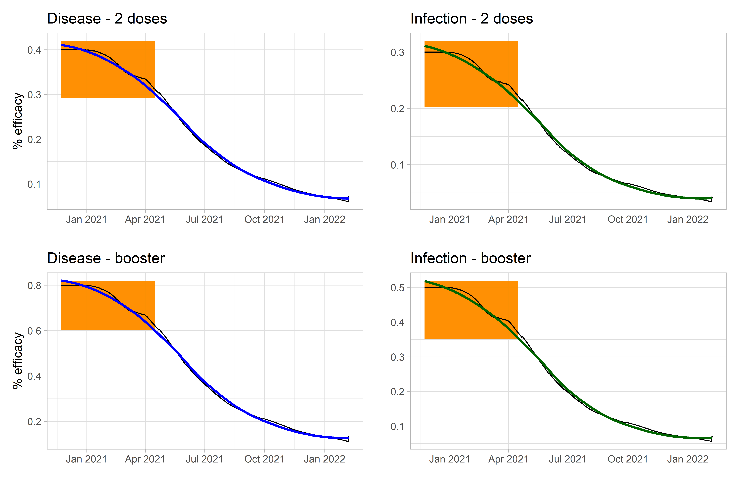

Figure 6.1: Estimate of vaccine efficacy waning

## 6.4 Additional parameters

Table 6.2: Modelling additional parameters

| Probabilities | 0 to 4 | 5 to 9 | 10 to 14 | 15 to 19 | 20 to 24 | 25 to 29 | 30 to 34 | 35 to 39 | 40 to 44 | 45 to 49 | 50 to 54 | 55 to 59 | 60 to 64 | 65 to 69 | 70 to 74 | 75 to 79 | 80+ |
| --- | --- | --- | --- | --- | --- | --- | --- | --- | --- | --- | --- | --- | --- | --- | --- | --- | --- |
| Probability of hospitalisation | 0.0 | 0.0 | 0.0 | 0.0 | 0.0 | 0.0 | 0.0 | 0.0 | 0.0 | 0.0 | 0.0 | 0.0 | 0.0 | 0.1 | 0.1 | 0.1 | 0.2 |
| Probability of severe disease | 0.2 | 0.2 | 0.2 | 0.1 | 0.1 | 0.1 | 0.1 | 0.2 | 0.2 | 0.2 | 0.3 | 0.3 | 0.3 | 0.3 | 0.2 | 0.2 | 0.1 |
| Probability of death given non severe disease and treatment | 0.0 | 0.0 | 0.0 | 0.0 | 0.0 | 0.0 | 0.0 | 0.0 | 0.0 | 0.0 | 0.0 | 0.0 | 0.1 | 0.1 | 0.1 | 0.2 | 0.3 |
| Probability of death given non severe disease and no treatment | 0.5 | 0.5 | 0.5 | 0.5 | 0.5 | 0.5 | 0.5 | 0.5 | 0.5 | 0.5 | 0.5 | 0.5 | 0.5 | 0.5 | 0.5 | 0.5 | 0.5 |
| Probability of death given severe disease and treatment | 0.2 | 0.3 | 0.3 | 0.4 | 0.5 | 0.6 | 0.6 | 0.5 | 0.5 | 0.4 | 0.4 | 0.4 | 0.4 | 0.5 | 0.6 | 0.6 | 1.0 |
| Probability of death given severe disease and no treatment | 0.9 | 0.9 | 0.9 | 0.9 | 0.9 | 0.9 | 0.9 | 0.9 | 0.9 | 0.9 | 0.9 | 0.9 | 0.9 | 0.9 | 0.9 | 0.9 | 0.9 |

Table 6.3: Modelling additional parameters - 2

| Age-Group | Proportion of Infections Hospitalised | Proportion of hospitalised cases requiring critical care | Proportion of hospital deaths occurring in ICU | Proportion of non-critical care cases dying | Proportion of critical care cases dying |
| --- | --- | --- | --- | --- | --- |
| 0 to 4 | 0.0 | 0.2 | 0.8 | 0.0 | 0.2 |
| 5 to 9 | 0.0 | 0.2 | 0.8 | 0.0 | 0.3 |
| 10 to 14 | 0.0 | 0.2 | 0.8 | 0.0 | 0.3 |
| 15 to 19 | 0.0 | 0.1 | 0.8 | 0.0 | 0.4 |
| 20 to 24 | 0.0 | 0.1 | 0.8 | 0.0 | 0.5 |
| 25 to 29 | 0.0 | 0.1 | 0.8 | 0.0 | 0.6 |
| 30 to 34 | 0.0 | 0.1 | 0.8 | 0.0 | 0.6 |
| 35 to 39 | 0.0 | 0.2 | 0.8 | 0.0 | 0.5 |
| 40 to 44 | 0.0 | 0.2 | 0.8 | 0.0 | 0.5 |
| 45 to 49 | 0.0 | 0.2 | 0.8 | 0.0 | 0.4 |
| 50 to 54 | 0.0 | 0.3 | 0.8 | 0.0 | 0.4 |
| 55 to 59 | 0.0 | 0.3 | 0.8 | 0.0 | 0.4 |
| 60 to 64 | 0.0 | 0.3 | 0.8 | 0.1 | 0.4 |
| 65 to 69 | 0.1 | 0.3 | 0.8 | 0.1 | 0.5 |
| 70 to 74 | 0.1 | 0.2 | 0.8 | 0.1 | 0.6 |
| 75 to 79 | 0.1 | 0.2 | 0.8 | 0.2 | 0.6 |
| 80+ | 0.2 | 0.1 | 0.8 | 0.3 | 1.0 |

1. Institute of Global Health and Development, Queen Margareth
2. Institute of Applied Health Sciences, School of Medicine, Medical Sciences and Nutrition, University of Aberdeen
3. School of International Development, University of East Anglia