Behind COVID-19 vaccination target: a SEIR simulation of avoidable deaths and hospitalisations in Grenada

Lucas Sempe[1]

Aravinda Guntupalli[2]

Peter Lloyd-Sherlock[3]

# 1 Introduction

A year after the launch of the COVID-19 vaccine immunisation process across countries, we note two facts. Vaccines have been proved very effective against existing variants of COVID-19 both in preventing the acquisition of severe disease, hospitalisation and death; and in terms of slowing down the spread of infections(Imai and Tanaka 2021). Although the way out of the pandemics requires a worldwide solution, we note that the vaccine roll-out has been very unequal across countries. While many high-income nations will have reached high vaccination coverages by the end of 2021 and before the emergence of the highly transmissible Omicron variant (Thakur et al. 2021), many low- and middle-income countries (LMICs) are still lagging in their vaccination process.

Until the vaccination coverage reaches the vast majority of the worldwide population, there will still be high of uncertainty regarding the future development of the pandemic. Many factors will play a role in local or global outbreaks. Many countries have been already through several epidemic waves, influenced by factors such as the appearance of new variants or the easing of non-pharmaceutical interventions.

On 26 November 2021, the World Health Organization (WHO) designated the coronavirus SARS-CoV-2 B.1.1.529, a variant of concern, named Omicron (WHO 2021c). As of 22 December 2021, the Omicron variant was already identified in 110 countries across all six WHO Regions (WHO 2021a), becoming predominant across many countries in January 2022 (Hodcroft 2022). On February 9, WHO reported that half a million COVID-19 deaths had been recorded since the Omicron variant was discovered (AFP 2022).

Prior research suggests higher levels of transmission, lower rates of hospitalisation, greater immune evasion and lower vaccine efficacy (Ferguson 2021a; Meng et al. 2021), although information is still limited to certain countries. This uncertainty significantly increases in LMICs, where civil registration, vital statistics, and epidemiological data is still not robust (Lloyd-Sherlock et al. 2020).

While high-income countries are focusing on boosters to protect their citizens, particularly older people, against severe disease, several low and middle-income countries are struggling to provide the first two doses to their vulnerable population. Considering the inequalities within and between countries for the vaccination coverage, In this research, we simulated various scenarios to capture the potential number of deaths and hospitalisations averted in the first semester of 2022 if vaccination levels would be raised to fulfilling WHO’s goal of vaccinating at least 70% of all populations by 1 July 2022.

# 2 Results

We find that, based on projecting each last month total doses remains constant until July 1st 2022, 94 countries are behind WHO’s goal (see Figure 2.1) distributed across the world: 47 counties in Africa, 14 in the Americas, 16 in Asia, 12 in Europe and 5 in Oceania. 21 countries are small islands with a population less than 600,000 people each. Additionally, 44 of these countries already started to provide boosters to their population although they do are behind track in terms of providing two doses for 70% of their population. The number of countries is inferior to the presented by [OWID](https://ourworldindata.org/covid-vaccination-global-projections), as they consider the average number of people who received their first dose of a vaccine per day, over the last 14 days, while our model considers the the average number of people who received any dose of a vaccine per day, over the last 30 days.

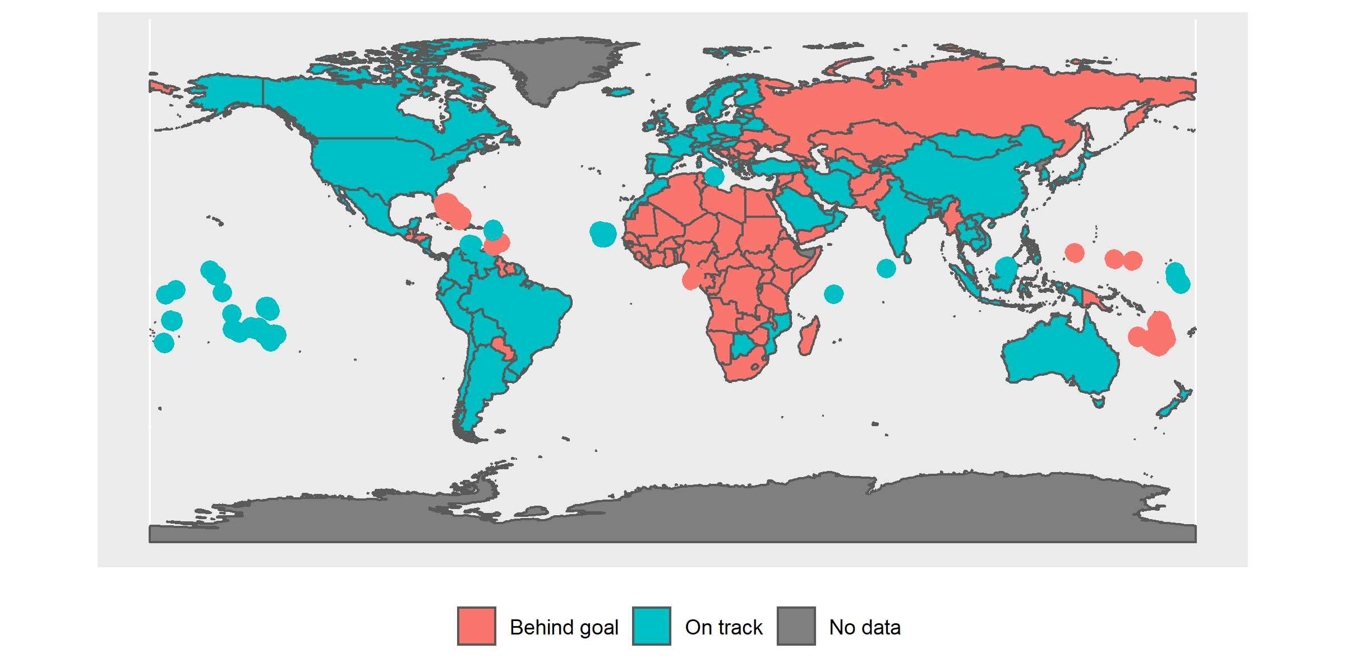

Figure 2.1: Countries status according to WHO’s vaccination goal based on last month vaccination uptake

Grenada COVID-19 vaccine population coverage in February 8th 2022 is estimated in 35.615. This is computed based on the assumption that every person requires two vaccine doses. The comparison between the historical daily vaccination uptake and the needed to reach WHO’s target goal for Grenada is presented in Figure 2.2. The horizontal lines represent the last month average and the daily needed number of doses. Based on the unvaccinated population and assuming the need of at least two doses per person during the first semester of 2022, we estimate that one hundred thousand doses are needed to be administered in order to achieve the target of vaccinating 70% of these countries’ population. Considering a programmatic delivery cost of US$ 10 per dose (WHO 2021b), the estimation reaches one million american dollars.

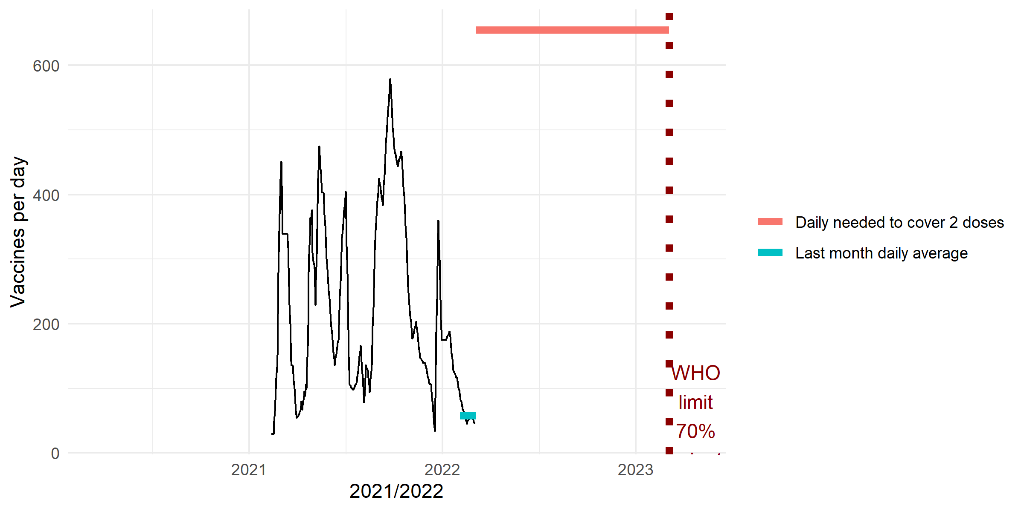

Figure 2.2: Current and needed daily vaccinations in r country

The combination of the different model parameters provide 27 different scenarios. Figure 2.3 presents one scenario as an example of the evolution of susceptible over the first semester of 2022: exposed, recovered and deaths, in this case, corresponding to the scenario with the larger number of deaths.

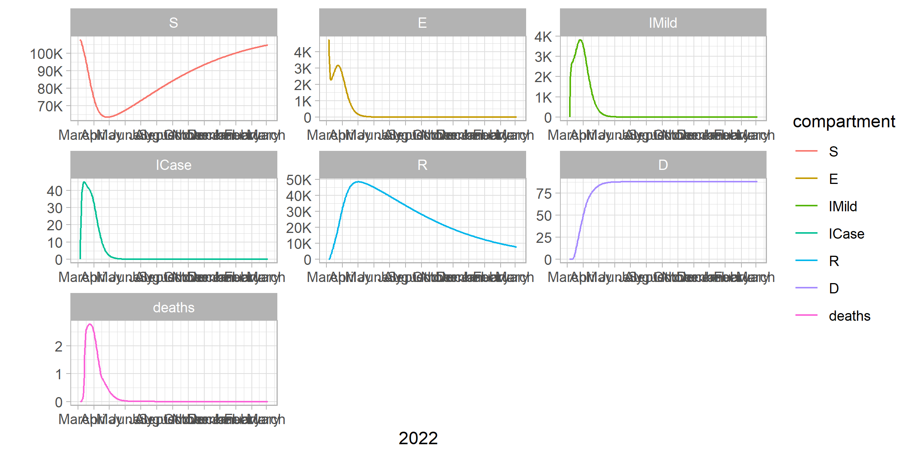

Figure 2.3: Number of people in different compartments across time - worst case scenario

By comparing a hypothetical scenario without vaccinations and other scenarios where the vaccination coverage reaches 70%, we can estimated that vaccines save between 48 and 88 deaths and prevent 131 to 281 hospitalisations in Grenada, depending on the combinations of parameters.

Simulations where we keep constant the last month vaccination uptake with a parameter R0 = 1.5 across the first semester of 2022 yield an estimated number of deaths ranging from 89 to 132. When compared to the optimal scenario, we estimate the number of avoidable deaths range from 43 to 68 and the number of avoidable hospitalisations spams from 121 to 259, depending on the combinations of parameters. Table ?? shows the maximum and minimum number of averted deaths and hospitalisations computed across different R0. In the case of the scenarios of averted deaths, the differences between values do not change substantially when R is 1.5 or higher. In the case of the simulation of averted hospitalisations, the minimum values tend to be stable across different, which is explained by the full occupancy of hospital and ICU beds and also the incomplete evolution of the infectious wave due to the period limit imposed to our models.

Table 2.1: Maximum and minimum averted deaths and hospitalisations

| R0 | Max averted deaths | Max averted deaths | Max averted hospitalisations | Max averted hospitalisations |
| --- | --- | --- | --- | --- |
| 1.3 | 37 | 29 | 199 | 93 |
| 1.5 | 68 | 43 | 259 | 121 |
| 2.0 | 127 | 62 | 328 | 158 |

Across the vast majority of models, between 60% and 70% of avoidable deaths correspond to people of 60 years old. This occurs even in majority of countries that currently portray a younger population age structure such cases of regions such as Africa and Asia. Table 2.2 summarises the scenarios in terms of total avoidable deaths and infections based on R0 = 1.5 for the population over and under 60 years old. We find that the proportion of avoidable deaths benefits older people, ranging from 13.07671% to 19.62983% of the total number of deaths while it is similar across age groups for the total number of hospitalisations, ranging from 80.37017% to 86.92329% for the older people group.

Table 2.2: Proportion of avoidable deaths of older people across simulations

| compartment | population group | value | Proportion older/younger |
| --- | --- | --- | --- |
| deaths | older people | 33.6 | 19.6 |
| deaths | younger people | 137.7 | 80.4 |
| hospitalisations | older people | 86.8 | 13.1 |
| hospitalisations | younger people | 576.9 | 86.9 |

Figure 2.4 presents three panels with the different simulated scenarios of the number of infections, hospitalisations and deaths averted if WHO’s goal of vaccinating 70% of the country population is reached by July 1st 2022. The horizontal axis portrays the different effective reproduction numbers. In the worst case scenario the total number of deaths is estimated to reach 126.9 where 90 affect people over 60 years old (70.9% of total) while an intermediate scenario suggests 68.43 deaths.

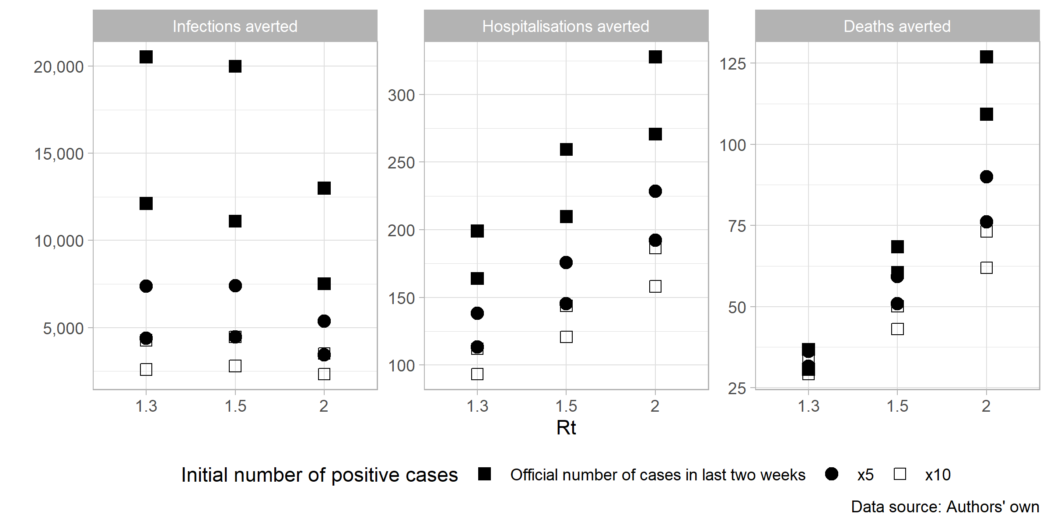

Figure 2.4: Estimation of infections, hospitalisations and deaths averted based on vaccinating 70% of population by July 1st 2022 - simulated scenarios

# 3 Conclusions

These scenarios are built to answer to an ethical framework that aims to find the best possible allocation of COVID-19 vaccines. Our ethical guidelines are the following: we aim to maximise societal health benefits; prioritise those worst-off without the vaccines; and promote equality, where individuals under circumstances shall be treated equally (Persad, Peek, and Emanuel 2020; Emanuel et al. 2020). These principles become operational in terms of saving the most lives; prioritise the most vulnerable populations such as older and immunodeficient people; and protecting health workers. Recently, the WHO SAGE group updated their roadmap for optimal allocation of vaccines across the world, where older adults, health workers, immunocompromised persons, adults with comorbidities, pregnant persons, teachers and other essential workers and disadvantaged subpopulations at higher risk of severe COVID-19 remain the higher priority groups for additional doses and boosters (SAGE 2022).

Vaccines save lives. We have estimated that between 48 and 88 deaths can be prevented and between 131 to 281 hospitalisations can also be avoided, depending on the combinations of parameters.

Finally, our simulated scenarios suggest the number of deaths could reach 224 deaths if the vaccination remains similar to the last month average. Instead, if the vaccination increases to 100,000 dose per day, we estimate 126.9 deaths averted where 90 will be people over 60 years old (70.9% of total). The cost associated with the strategy represents 1e+06 american dollars.

# 4 References

Abbott, Sam, Katharine Sherratt, Moritz Gerstung, and Sebastian Funk. 2022. “Estimation of the Test to Test Distribution as a Proxy for Generation Interval Distribution for the Omicron Variant in England.” <http://dx.doi.org/10.1101/2022.01.08.22268920>.

AFP. 2022. “WHO Laments 500,000 Covid-19 Deaths Since Omicron.” South China Morning Post. February 9, 2022. <https://www.scmp.com/news/world/article/3166321/who-laments-half-million-coronavirus-deaths-omicron>.

Collie, Shirley, Jared Champion, Harry Moultrie, Linda-Gail Bekker, and Glenda Gray. 2021. “Effectiveness of BNT162b2 Vaccine Against Omicron Variant in South Africa.” *New England Journal of Medicine*, December. <https://doi.org/10.1056/nejmc2119270>.

Emanuel, Ezekiel J., Govind Persad, Adam Kern, Allen Buchanan, Cécile Fabre, Daniel Halliday, Joseph Heath, et al. 2020. “An Ethical Framework for Global Vaccine Allocation.” *Science* 369 (6509): 1309–12. <https://doi.org/10.1126/science.abe2803>.

Ferguson, N. 2021b. “Report 49: Growth and Immune Escape of the Omicron SARS-CoV-2 Variant of Concern in England.” Imperial College London. <https://doi.org/10.25561/93038>.

———. 2021a. “Report 49: Growth and Immune Escape of the Omicron SARS-CoV-2 Variant of Concern in England.” <https://doi.org/10.25561/93038>.

———. 2021c. “Report 50: Effectiveness of SARS-CoV-2 Vaccines in England in 2021: A Whole Population Survival Analysis.” Imperial College London. <https://doi.org/10.25561/93035>.

Hodcroft, Emma. 2022. “CoVariants.” <https://covariants.org/>.

Hogan, Alexandra B., Peter Winskill, Oliver J. Watson, Patrick G. T. Walker, Charles Whittaker, Marc Baguelin, Nicholas F. Brazeau, et al. 2021. “Within-Country Age-Based Prioritisation, Global Allocation, and Public Health Impact of a Vaccine Against SARS-CoV-2: A Mathematical Modelling Analysis.” *Vaccine* 39 (22): 2995–3006. <https://doi.org/10.1016/j.vaccine.2021.04.002>.

Huang, Jianping, Yingjie Zhao, Li Zhang, Xu Li, Shuoyuan Gao, and Xiaodong Song. 2022. “Seasonal Prediction of Omicron Pandemic.” <http://dx.doi.org/10.1101/2022.01.13.22269198>.

Ignatov, A. M., and S. A. Trigger. 2022. “Two Viruses Competition in the SIR Model of Epidemic Spread: Application to COVID-19.” <http://dx.doi.org/10.1101/2022.01.11.22269046>.

Imai, Kenichi, and Hajime Tanaka. 2021. “SARS-CoV-2 Infection and Significance of Oral Health Management in the Era of “the New Normal with COVID-19”.” *International Journal of Molecular Sciences* 22 (12): 6527. <https://doi.org/10.3390/ijms22126527>.

IMF-WHO. 2022. “IMF-WHO COVID-19 Vaccine Tracker.” <https://www.imf.org/en/Topics/imf-and-covid19/IMF-WHO-COVID-19-Vaccine-Tracker>.

Khoury, David S., Megan Steain, James A. Triccas, Alex Sigal, Miles P. Davenport, and Deborah Cromer. 2021. “A Meta-Analysis of Early Results to Predict Vaccine Efficacy Against Omicron.” <http://dx.doi.org/10.1101/2021.12.13.21267748>.

Lau, H., T. Khosrawipour, P. Kocbach, H. Ichii, J. Bania, and V. Khosrawipour. 2021. “Evaluating the Massive Underreporting and Undertesting of COVID-19 Cases in Multiple Global Epicenters.” *Pulmonology* 27 (2): 110–15. <https://doi.org/10.1016/j.pulmoe.2020.05.015>.

Liu, Lihong, Sho Iketani, Yicheng Guo, Jasper F-W. Chan, Maple Wang, Liyuan Liu, Yang Luo, et al. 2021. “Striking Antibody Evasion Manifested by the Omicron Variant of SARS-CoV-2.” *Nature*, December. <https://doi.org/10.1038/s41586-021-04388-0>.

Lloyd-Sherlock, Peter, Lucas Sempe, Martin McKee, and Aravinda Guntupalli. 2020. “Problems of Data Availability and Quality for COVID-19 and Older People in Low- and Middle-Income Countries.” Edited by Suzanne Meeks. *The Gerontologist* 61 (2): 141–44. <https://doi.org/10.1093/geront/gnaa153>.

Meng, Bo, Isabella A. T. M. Ferreira, Adam Abdullahi, Akatsuki Saito, Izumi Kimura, Daichi Yamasoba, Steven A. Kemp, et al. 2021. “SARS-CoV-2 Omicron Spike Mediated Immune Escape, Infectivity and Cell-Cell Fusion.” <https://www.biorxiv.org/content/10.1101/2021.12.17.473248v2>.

MRC-IDE. 2022. “Imperial College COVID-19 LMIC Reports.” <https://mrc-ide.github.io/global-lmic-reports/>.

Persad, Govind, Monica E. Peek, and Ezekiel J. Emanuel. 2020. “Fairly Prioritising Groups for Access to COVID-19 Vaccines.” *JAMA* 324 (16): 1601. <https://doi.org/10.1001/jama.2020.18513>.

Pulliam, Juliet R. C., Cari van Schalkwyk, Nevashan Govender, Anne von Gottberg, Cheryl Cohen, Michelle J. Groome, Jonathan Dushoff, Koleka Mlisana, and Harry Moultrie. 2021. “Increased Risk of SARS-CoV-2 Reinfection Associated with Emergence of the Omicron Variant in South Africa.” <http://dx.doi.org/10.1101/2021.11.11.21266068>.

“Report 12 - the Global Impact of COVID-19 and Strategies for Mitigation and Suppression.” n.d. <http://www.imperial.ac.uk/medicine/departments/school-public-health/infectious-disease-epidemiology/mrc-global-infectious-disease-analysis/covid-19/report-12-global-impact-covid-19/>.

Roser, Max, Hannah Ritchie, Esteban Ortiz-Ospina, and Joe Hasell. 2020. “Coronavirus Pandemic (COVID-19).” *Our World in Data*.

SAGE, WHO. 2022. “WHO SAGE Roadmap for Prioritizing Uses of COVID-19 Vaccines.” <https://www.who.int/publications-detail-redirect/who-sage-roadmap-for-prioritizing-uses-of-covid-19-vaccines>.

Thakur, Amrit Kumar, Ravishankar Sathyamurthy, Velraj Ramalingam, Iseult Lynch, Swellam Wafa Sharshir, Zhenjun Ma, Ganeshkumar Poongavanam, Suyeong Lee, Yeseul Jeong, and Jang-Yeon Hwang. 2021. “A Case Study of SARS-CoV-2 Transmission Behavior in a Severely Air-Polluted City (Delhi, India) and the Potential Usage of Graphene Based Materials for Filtering Air-Pollutants and Controlling/Monitoring the COVID-19 Pandemic.” *Environmental Science: Processes & Impacts*. <https://doi.org/10.1039/d1em00034a>.

Walker, Patrick G. T., Charles Whittaker, Oliver J. Watson, Marc Baguelin, Peter Winskill, Arran Hamlet, Bimandra A. Djafaara, et al. 2020. “The Impact of COVID-19 and Strategies for Mitigation and Suppression in Low- and Middle-Income Countries.” *Science* 369 (6502): 413–22. <https://doi.org/10.1126/science.abc0035>.

Wees, Jan-Diederik van, Martijn van der Kuip, Sander Osinga, Bart Keijser, David van Westerloo, Maurice Hanegraaf, Maarten Pluymaekers, Olwijn Leeuwenburgh, Logan Brunner, and Marceline Tutu van Furth. 2021. “SIR Model for Assessing the Impact of the Advent of Omicron and Mitigating Measures on Infection Pressure and Hospitalization Needs.” <http://dx.doi.org/10.1101/2021.12.25.21268394>.

WHO. 2021a. “Enhancing Readiness for Omicron (B.1.1.529): Technical Brief and Priority Actions for Member States.” <https://www.who.int/publications/m/item/enhancing-readiness-for-omicron-(b.1.1.529)-technical-brief-and-priority-actions-for-member-states>.

———. 2021b. “Strategy to Achieve Global Covid-19 Vaccination by Mid-2022.” World Health Organisation.

———. 2021c. “Update on Omicron.” 2021. <https://www.who.int/news/item/28-11-2021-update-on-omicron>.

———. 2022. “COVID-19 Vaccination Data.” <https://app.powerbi.com/view?r=eyJrIjoiMWNjNzZkNjctZTNiNy00YmMzLTkxZjQtNmJiZDM2MTYxNzEwIiwidCI6ImY2MTBjMGI3LWJkMjQtNGIzOS04MTBiLTNkYzI4MGFmYjU5MCIsImMiOjh9>.

# 5 Empirical strategy

We simulated scenarios based on a previously developed an extended age-structured (5-year groups) stochastic compartmental models of SARS-CoV-2 transmission that includes vaccinations (Hogan et al. 2021; Walker et al. 2020). Older adults age 80 and above were considered in one group due to the smaller sample size in countries with lower life expectancy. The models consider the progression of the population across transmission compartments (susceptible, exposed, infected, recovered), clinical pathways (need for hospitalisation, oxygen and/or intensive care) and vaccination uptake considering factors such as vaccine availability, prioritisation and coverage. The infection transmission model also considers the probability of interactions between age-groups (contact matrices) and the efficacy of the vaccine in terms of prevention of infection and severe disease.

We employ Susceptible-Exposed-Infectious-Removed (SEIR) models as they rely on an extensive set of parameters such as probabilities of hospitalisation, probability of severe disease, hospital capacity and ICU, reproduction rates, among others. Our simulated scenarios are built based on parameters chosen to represent critical factors affecting the evolution of the pandemics and the vaccination process.

Our outcomes of interest are avoidable hospitalisations and deaths due to vaccination. For that purpose, our research design compares estimations between two scenarios for each country:

* a baseline scenario that assumes the currently average daily vaccination level is maintained, and
* an accelerated scenario where the daily vaccine level is raised to achieve the goal set by the World Health Organisation of vaccinating 70% of the world population against COVID-19 by 1 July 2022 (WHO 2021b).

For the accelerated scenario, we differentiate between countries that did yet not start providing boosters to their population, and those who already started, even though they are behind meeting the WHO goal. In the first case, we simulate models with a daily number of vaccines needed to reach two doses for 70% of the population by July 1st 2022, while in the second case, we increase the daily number of vaccines to cover three doses in the same period.

We model a vaccination strategy that prioritises the oldest age group sequentially until the maximum coverage per group is reached. For example, suppose we set the maximum coverage at 90%. In that case, the first age group to be solely vaccinated will be those over 80 and above until it reaches 90% of the age group population. Then, the following group, those aged 75 to 79, will follow the vaccination process followed by 70 to 74, until the youngest group of people get vaccinated. This occurs until the whole eligible population is covered up to 90%.

As more than 95% of the global procurement of vaccines require two-dose vaccines, our models assume a fully vaccinated person with two vaccines (IMF-WHO 2022; WHO 2022). Considering that the models were used only to simulate a single vaccine product, we consider the complexity of multiple vaccine products by weighting the vaccine effectiveness over time (MRC-IDE 2022). Our models assume a dual effect of vaccines’ effectiveness in blocking infection and severe disease. We compute the vaccination effectiveness decay for each country and use the world average. This is based on the time since the first vaccination and the time between the first and second doses (we assume 90 days), the decay rate, and different efficacy parameters. Modelling countries that did not start providing boosters, we assume 30% and 60% of infection blocking effectiveness after one and two doses, respectively. In the case of blocking disease, we assume 40% and 80%, respectively. For countries that started applying a booster dose, values assigned are 60% and 80% for infection blocking and 80% and 95% for severe disease blocking. We assume that individuals who have been vaccinated have a 40% reduction in infectiousness if infected. These chosen efficacy values broadly reflect the range of estimated efficacies seen in response to the Omicron variant (Ferguson 2021b, 2021c; “Report 12 - the Global Impact of COVID-19 and Strategies for Mitigation and Suppression,” n.d.; Khoury et al. 2021; Collie et al. 2021). These values do not reflect a specific vaccine as there are unknowns over each specific country vaccine rollout.

The probability of hospitalisation is reduced to 60% in comparison to the prior variants (Ferguson 2021c). We assume that the mean duration of naturally acquired immunity is 200 days.

We also simulate two sets of the number of infected cases: the officially reported number of cases of the last two weeks until 15 February 2022, and this value multiplied by 5 and 10, assuming the lack of massive testing and under-reporting of cases (Lau et al. 2021).

The number of people in the first state of the transmission model (those susceptible to the disease) corresponds to the country population. This value is based on the high levels of reinfection found across countries such as South Africa and England (Ferguson 2021b; Pulliam et al. 2021). We assume a uniform distribution of the vaccinations across adults due to the lack of available data. Recent empirical evidence shows that the generation time for the Omicron variant is shorter than the previous predominant Delta variant (Abbott et al. 2022; Liu et al. 2021). Following that, we assume the following parameters: mean duration of 2 days for the incubation period, mean of 2.6 days for a mild infection and a mean of 3.8 days for symptoms onset to admission to hospital.

The time period for the analysis is 1 year, from 15 February 2022 to 14 February 2023. This allows to capture both the date set by the World Health Organisation’s target to vaccinate 70% of the world’s population against COVID-19 by mid-2022 (WHO 2021b) and the decay rate of vaccine effectiveness across time.

We use a constant effective reproduction number of 1.3, 1.5 and 2 (Wees et al. 2021; Huang et al. 2022; Ignatov and Trigger 2022) across the first half of 2022. In the second part of the year, the reproduction number is set in .9, which implies the contraction of the pandemics over time.

Table 5.1 provides a summary of all the main parameters. Additional country-specific, epidemiological and vaccination parameters were compiled by Hogan et al. (2021) and updated in the R package [‘nimue’](https://github.com/mrc-ide/nimue), where original sources of data are given. Infections and vaccine data are collected from Our World in Data (Roser et al. 2020). Probabilities of death according different states and age groups (severity of disease, treatment and information source) can be found in the Appendix.

Table 5.1: Parameters used across simulation scenarios based on Omicron variant

| Parameter | Value | Reference |
| --- | --- | --- |
| R0 | 1.3;1.5;2 | (Wees et al. 2021; Huang et al. 2022; Ignatov and Trigger 2022) |
| Rt1 | 0.9 | Assumed |
| Maximum vaccines per day | 0; average last month; needed to reach 70% goal (without and with booster) | (Roser et al. 2020; WHO 2021b) |
| The initial number of infected cases | Official country statistics (OCS); OCSx5; OCSx10 | (Roser et al. 2020) |
| Vaccination prioritisation strategy | Age-group priority | (Hogan et al. 2021) |
| Maximum coverage per age group | 0.9 | Assumed |
| Vaccine efficacy against infection | See graph | Based on (MRC-IDE 2022) |
| Vaccine efficacy against severe disease (hospitalisation) | See graph | Based on (MRC-IDE 2022) |
| Mean duration of natural-acquired immunity | 200 days | Assumed |
| Duration Incubation period | 2.1 days | (Abbott et al. 2022; Liu et al. 2021) |
| Mean duration of the period from vaccination to vaccine protection | 14 days | (MRC-IDE 2022) |
| Mean duration of mild infection | 2.6 days | (Abbott et al. 2022; Liu et al. 2021) |
| Mean duration from symptom onset to hospital admission | 3.8 days | (Abbott et al. 2022; Liu et al. 2021) |
| Probability of hospitalisation in comparison to previous variants | 0.6 | (Ferguson 2021c) |
| Modelling period | 365 days (8 February 2022 to 7 February 2023) | Assumed |
| Relative infectiousness vaccinated | 0.5 | Assumed |

1. Institute of Global Health and Development, Queen Margareth
2. Institute of Applied Health Sciences, School of Medicine, Medical Sciences and Nutrition, University of Aberdeen
3. School of International Development, University of East Anglia