**AIRLINE RESERVATION SYSTEM**



**1. SESHAM LOKESH (AP18110010396)**

**2. KADIYALA SANTHOSH (AP18110010458)**

**3. CH. PANDU RANGA RAJU (AP18110010427)**

# SOFTWARE REQUIREMENTS SPECIFICATION



# **AIRLINE RESERVATION SYSTEM**

# Table of Contents

**1. Introduction............................................................................................................ 5**

1.1 Purpose 5

1.2 Scope 5

1.3 Definitions, Acronyms, and Abbreviations 6

1.4 References 6

1.5 Overview 6

**2. The Overall Description........................................................................................... 7**

2.1 Product Perspective 7

2.2 Product Functions 7

2.3 User Characteristics 7

2.4 Constraints 8

2.5 Assumptions and Dependencies 8

**3. External interface Requirements.............................................................................. 9**

3.1 User Interfaces 9

3.2 Hardware Interfaces 10

3.3 Software Interfaces 10

3.4 Communications Interfaces 10

**4. System Features...................................................................................................... 11**

**5. Other Non-Functional Requirements....................................................................... 12**

5.1 Performance Requirements 12

5.1.1 Capacity 12

5.1.2 Dynamic Requirements 12

5.1.3 Quality 12

5.2 Software System Attributes 13

5.2.1 Reliability 13

5.2.2 Availability 13

5.2.3 Security 13

5.2.4 Maintainability 13

5.3 Business Rules 14

**6. Other Requirements**.................................................................................................... 14

**1. INTRODUCTION**

Airline reservation system is a computerized system used to store and retrieve information and conduct transactions related to air travel. Airline reservation saves time and money for the customer as they can book the tickets whenever they want, wherever they are. Without contacting any travel agent, waiting for services.

The main purpose of this software is to reduce the manual errors involved in the airline reservation process and make it convenient for the customers to book the flights when they require.

**1.1 PURPOSE**

The following are some of the features provided by this project:

* Customers can:

1. Create an Account in the Airline Reservation System.
2. Search for available flights for a particular city pair.
3. Book tickets in the class of their choice.
4. Cancel booked tickets.
5. View booked tickets history.

* Administrators can:

1. View the booked tickets for a particular flight.
2. Cancel the flights.
3. Add/modify flight schedules.

**1.2 SCOPE**

The Primary function of ARS would be to enable a customer to book airline tickets(BT). It will allow the customer to make bookings, search for flights through different ways such as by choosing the convenient source(src) and destination(des) places or by favorable dates. The software allows customer to make reservation, modify reservations or cancel(ct) a particular reservation. Each new customer will be required to make a login account with their details, which enables them to reach the booking stage. The same account can be used again for future bookings.

**1.3 DEFINATIONS, ACRONYMS, ABBREVIATIONS**

**SRS Software Requirements Specification**

**ARS Airline Reservation System**

**SRC Source**

**DES Destination**

**BT Book ticket**

**RB Cancel ticket**

**1.4 REFERENCES**

[1] https://www.tutorialspoint.com/php/index.htm

[2] https://www.javatpoint.com/mysql-tutorial

[3] <https://www.w3schools.com/html/>

[4] https://www.w3schools.com/css/

**1.5 OVERVIEW**

Section 1 Discusses the purpose and scope of the software.

Section 2 Describes the overall functionalities and constraints of the software and user characteristics.

Section 3 Details all the requirements needed to design the software.

**2. THE OVERALL DESCRIPTION**

**2.1 PRODUCT PERSPECTIVE**

Airline Reservation System is an application which is used to search the flights between a particular pair of location and see if any flight are available and Book the tickets easily without going anywhere and it enable the customers to choose the class based on their interest and book the tickets and it also enables the users to cancel their trip if they have some work. They all need to do is to create an account to access these features.

**2.2 PRODUCT FUNCTIONS**

The following are some of the functions provided by this project:

1. The user can search the flight between a particular pair.
2. The user can choose the class like Economy, business etc.
3. The users can cancel their tickets.
4. The administrator can view the bookings of the flights.
5. The administrator can cancel the flights.
6. The administrator can Add/modify flights.

**2.3 USER CHARACTERISTICS**

The system provides different types of services based on the type of users. The administrator will be the controller and he will have all rights of the System like modifying flight timings or to cancel the flight. Whereas the customer can only search the flights and can book the tickets.

The features that are available to the administrator are:

* The Administrator can see the tickets booked for the particular flight.
* The Administrator can add the flights.
* The Administrator can modify the flight timings.
* The Administrator can cancel the flights.

The features that are available to the Customer are:

* The Customer has to create an account first to book the flight tickets.
* The Customer can search the flights for a particular pair.
* The Customer can book the flight tickets of different class.
* The Customer can cancel their bookings.

**2.4 CONSTRAINTS**

1. Complicated to operate
2. Online Systems require high-speed internet connectivity
3. Risk of computer virus
4. Risk of database crash
5. The only person who can change the flight timings is administrator only.

**2.5 ASSUMPTIONS AND DEPENDENCIES**

* The code should be error free.
* The system should be user-friendly so that it is easy to use for the users to operate easily.
* Each user must have valid user id and password
* GUI is only in English.
* The user should have a high speed internet connection.

**3. EXTERNAL INTERFACE REQUIREMENTS**

**3.1 User Interface Requirements**

The interface provided to the user should be a very user-friendly one and it should provide an optional interactive help for each of the service listed. The interface provided is a menu driven one and the following screens will be provided:-

A Home Page is provided at the beginning which contains four options like Home, Book Tickets, About Us, Contact, Login.

If the Customer has to do any of the following operations he/she should have to login using the Account details. If they don’t have an account then they should create an account by pressing the create account option in the login page.

If the user has successfully created an account then the user will be able to login the Airline Reservation System.

The user will get option like Home, Book Tickets, Contact us, logout Options.

In Home Page Contains the information About Airline reservation system.

In Contact us Page the user will be able to raise queries/Complaint.

If the user successfully completes the booking then the user will close session by pressing the logout option.

In the Book Tickets Page, the user will get three options like

Book Flight tickets by clicking this option the user we be redirected to first search the flight and if the flight is available then the user will select and book ticket by giving the details like how many number and their details and in which class they will travel and by filling all these details and paying the charges then they will be able to book the tickets successfully and they will receive the ticket with pnr number.

View Booked tickets by clicking this option user will be able to see the booked tickets by entering the pnr number.

Cancel Booked tickets by clicking this option user will be able to see cancel the tickets by entering the pnr number.

Above are the following Functions available if the user logins and selects as customer

In case Administrator login, A screen will be appeared which has options like view booked tickets, cancel flight, add flights, modify flight schedules.

In view booked tickets option the admin will be able to see the details of the booked tickets by entering the flight number and departure date.

In cancel flight option the admin will be able to cancel the particular flight by entering the flight number and departure date due to any weather issues etc.

In add /modify option the admin will be able to edit the flight details or add new flights.

* 1. **Hardware Interface Requirements:**

Hardware requirements for the Airline Reservation system for the users should have high speed internet connection and laptop .

Hardware requirements to deploy the project to the administrator should have a system with min 4gb ram and intel processor minimum i3 and hard disk of 1TB and it should have a domain address to host the system.

* 1. **Software Interface Requirements:**

Software used for the front end is HTML CSS and for backend is PHP and Database will be created and updated using MYSQL.

3.4 **Communication Interface** :

**4. System Features:**

**1. Online Ticket Booking for Airlines:**

The system is designed to provide the user with the facility of Booking the Airline tickets online various other functions at an interface without contacting any travel agent or any agency. The functioning of the system shall be as follows: -

First user should an account to access the Airline Reservation System and if the user doesn’t have account the user will be redirected to create an account first then come to login section.

After successfully logging into the Airline Reservation system the user will get the options like Book Tickets, View Booked tickets, Cancel Booked tickets, Contact us and logout.

If the User want to Book the tickets then the user should first search for the flights for his current location to destination location, after searching for the flights user will select the flight based on his requirements like low cost, high cost, timings and etc.

After Selecting the required flight, the user will be asked to fill the details like which class i.e economy or business and number of passengers and their details and If they Want food and other services like insurance etc. After successfully submitting the details user will be redirected to pay.

After the successful payment the user will get the ticket and pnr number, By that pnr number the user is able to view his ticket and if due to some reason the user wants to cancel the trip then the user will be able to cancel the ticket by that pnr number.

After the user has completed his ticket booking process successfully then the user will be able to close the session by simply clicking on the logout option.

**Validity Checks:**

In order to gain access to the system, the user is required to enter his/her correct user id/password failing which they will not be able to access the airline reservation system.

**Error Handling/ Response to Abnormal Situations:**

If any of the above validation does not hold true, appropriate error messages will be prompted to the user for doing the needful.

**5.Other Nonfunctional Requirements :**

**5.1 Performance Requirements :**

The following list provides a brief summary of the performance requirements for the software:

1. **CAPACITY:**

The Airline reservation system will provide users 24*7 services whenever user need and wherever they are.

1. **Dynamic requirements:**

* The user verification I.e login/sign up must not take exceed 9-11 sec. under normal condition and 15 sec. under peak server workload
* The time taken to search the flight should not exceed 9sec under normal conditions and 12 seconds under peak server workload.
* The time taken to book the flight ticket should not exceed 10 sec under normal conditions and 12 seconds under peak server workload.
* The time taken to cancel the ticket should not exceed 10 seconds under normal conditions and 12 seconds under peak sever workload.
  + 1. **Quality:**

The primary objective is to produce quality software. As the quality of a piece of software is difficult to measure quantitatively, the following guidelines will be used when judging the quality of the software:

Requirements Review

Design Reviews

Code Reviews and Testing

Features of the activity UML diagram of airline booking system:

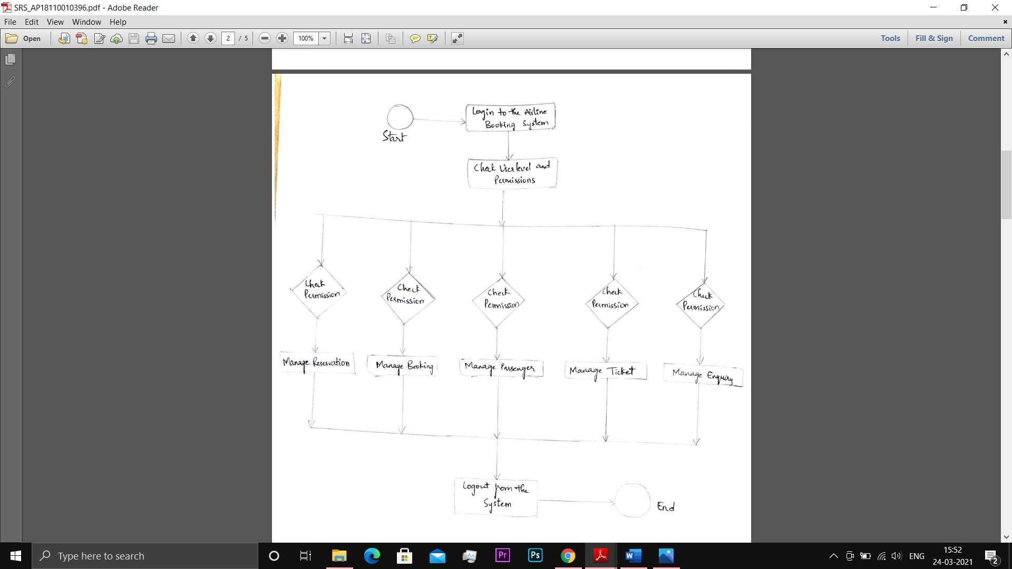

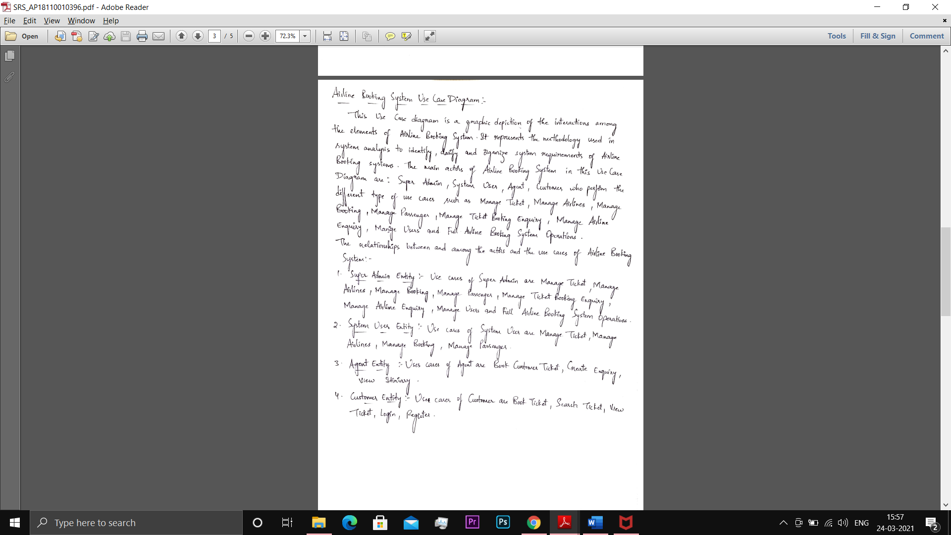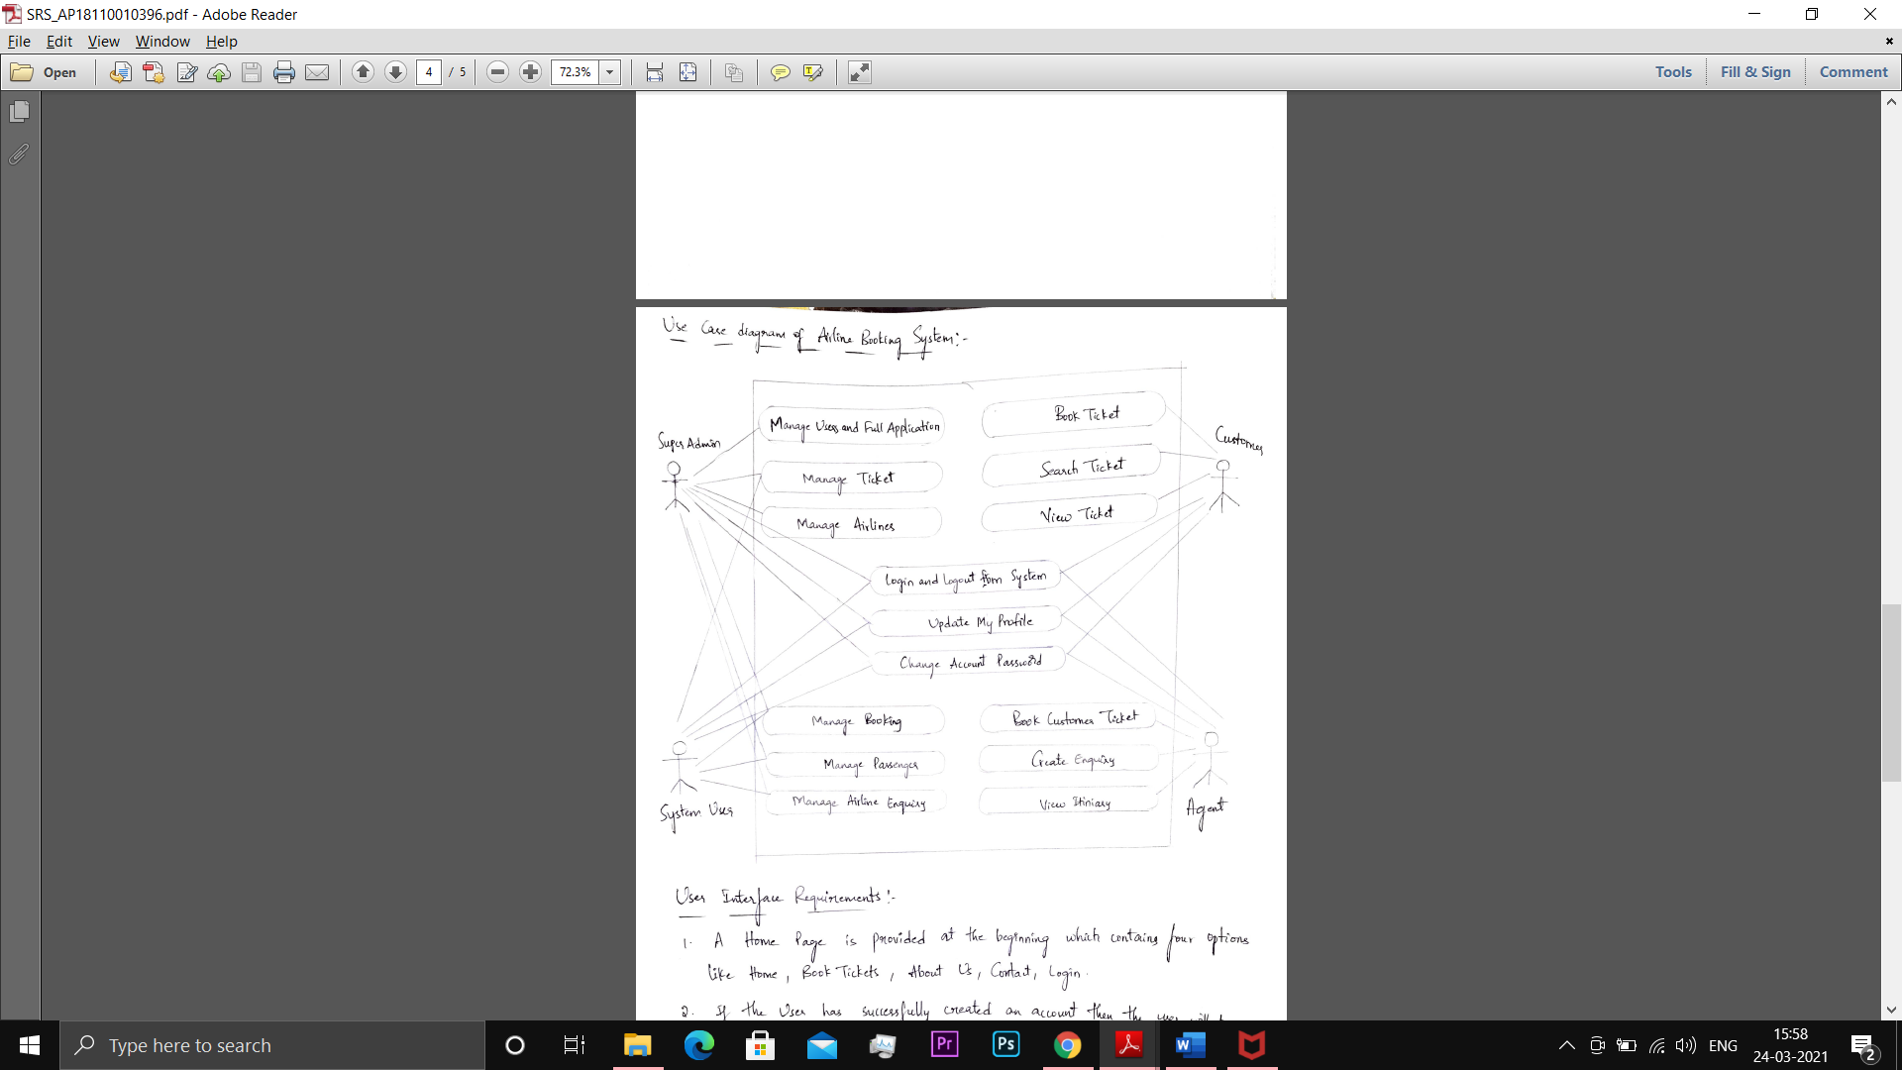

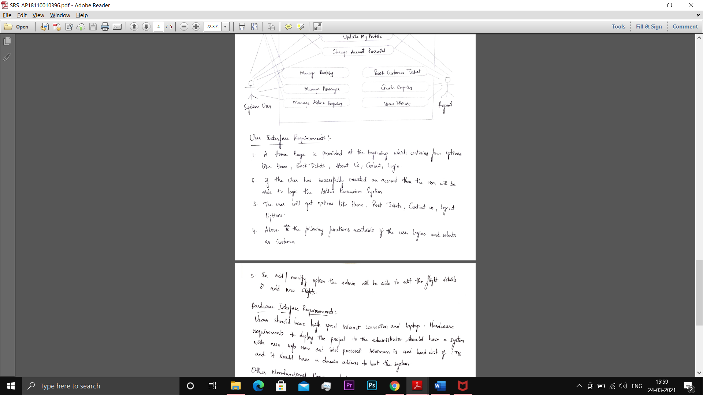

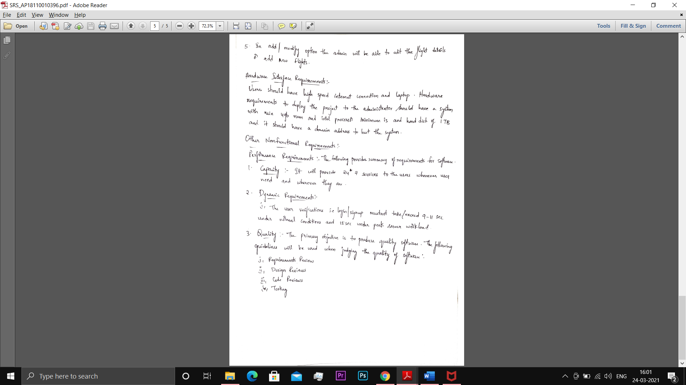



**5.2 Software System Attributes:**

1. **Reliability:**

* The system should be reliable means there should not be any chance for mistake or error or bugs.
* The memory system shall be of non-volatile type

1. **Availability:**

* The system should be available to user any time and it should be available 24*7.
* The product will have a backup power supply in case of power failures.

1. **Security:**

* The system should be secure like no user is allowed to use without proper authentication.
* Passwords should be hard and password should not be username as they are easy to be hacked.

1. **Maintainability:**

* The system components i.e. modem, memory, disk, drives shall be easily serviceable without requiring access to the vault
* The system should be maintainable like if any error has occurred then it should be easily rectified and the cost and time to solve it should be less.

**5.3 BUSINESS RULES:**

* The Administrator has the authority to fix the rules and regulations and to set or update the policies as and when required.
* The user should have an account to access the airline reservation system.
* Blocking or seizing of the account of user on discovery of any illegal activities.
* The user should immediately contact the support team if any fault has occurred by the system.
* Maintain the backup of all the accounts for reliability purposes.

**6**.**Other Requirements**:

* There should be a proper ups facility should be there in case of power supply failure.
* There should be more quality and efficient server in order to make the process go in a smooth way in the peak hours.
* Maintain the backup of all the accounts for reliability purposes like when the system gets crashed then backup is needed.